Queen Square Archives, UCL Queen Square Institute of Neurology and the National Hospital for Neurology and Neurosurgery (UCLH)

JNNP - A centenary of publishing neuroscience achievements
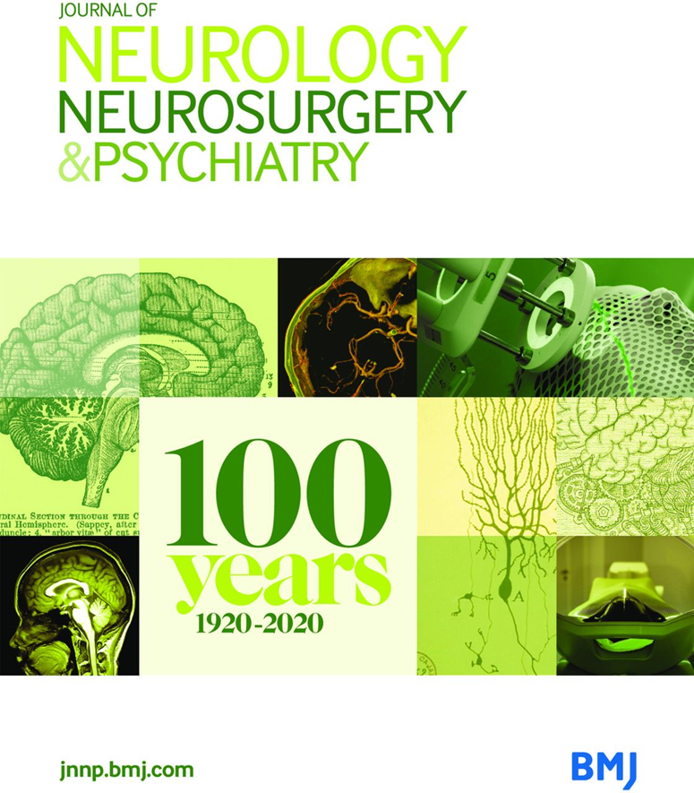

The exhibition is launched to mark the centenary of the Journal of Neurology, Neurosurgery and Psychiatry (JNNP) and will run in
Queen Square Library, 23 Queen Square until January 2022
The display features material from Queen Square Library and Archives, and highlights the journal’s many connections with Queen Square. Selected content from is also available at queensquare.org.uk/archives/visiting/exhibitions.
- Content from Journal of Neurology, Neurosurgery and Psychiatry reproduced here courtesy of BMJ. © BMJ Publishing Group Ltd. All rights reserved.

Please contact: neuroarchives@ucl.ac.uk for further information.
October 2021
“In 2020, the Journal of Neurology, Neurosurgery and Psychiatry (JNNP) will reach a significant milestone – 100 continuous years of publishing the innovations, medical breakthroughs and trailblazing studies that have made JNNP the go-to journal across the clinical neurosciences.” Matthew C Kiernan, Editor, 2010-

The founding of the journal : Kinnier Wilson
The first volume was published in May 1920, by the founding editor, Samuel Alexander Kinnier Wilson, a physician at the National Hospital, with a committee of nine, including Charles Symonds.
Kinnier Wilson had resurrected Edinburgh Review of Neurology and Psychiatry, (founded by his father in law Alexander Bruce) and renamed it the Journal of Neurology and Psychopathology. The publishers were John Wright and Sons from Bristol. The British Medical Association took the journal’s publication in 1926.

The initial editorial board was divided into neurology and psychopathology sections, although the distinction between these two in the frontispiece was dropped in 1924.

The editorial in the first issue “the real of neurology” is unsigned but presumably penned by Kinnier Wilson. The second issue included an article by Majorie Blandy – the first female registrar in Queen Square.

“How could he have predicted the path his journal would forge—from understanding the circuitry of memory, unlocking disease pathophysiology, the creation of rating scales (some with citation counts >48 000 to date) the role of neurosurgery, to the advent of new therapies, comprehending quality of life, addressing patient outcomes and establishing disease criteria” Matthew C Kiernan, Editor, 2010-

1938: new name, new publisher, new editor
The first volume of the new series in 1938 appeared under the title of Journal of Neurology and Psychiatry, edited by Dr EA Carmichael, also a physician at the National, and Director of the new MRC neurological research unit in Queen Square). Carmichael had 5 associate editors and 20 others including Denny-Brown, Jefferson, and Brain. The journal was published by BMJ for the first time, and included Kinnier Wilson’s obituary notice. That year there were 4 issues and 22 articles.The contents had a more modern tone, including a review of the applications of EEG by Grey Walter

Post war era : Ritchie Russell & Simpson
The Journal took its current title Journal of Neurology, Neurosurgery and Psychiatry in 1944, and Ritchie Russell (the first Professor of Neurology at Oxford University, and formerly RMO at the National), took over as editor in 1948, with a similar editorial committee. The addition of neurosurgery may have reflected the influence of the Second World War on clinical neuroscience, and many articles in the next decade related to neurosurgical aspects and sequalae of head trauma. The proceedings of the BNS were prominently reported.

In the 1970s, Professor Simpson (the first Professor of Neurology at Glasgow University, and formerly of MRC neurological research unit in Queen Square) took over the editorship, with a largely new committee, including Gilliatt, Walshe and McKissock. By this time there were 6 issues and 120 articles a year (in 1974 the journal went monthly to accommodate demand). These included papers by Marshall on radioisotope brain scans in stroke, and by Marsden on physiology of tremor in hyper- and hypothyroid patients.

1980s and 1990s: Marsden, Hughes & Kennard
Professor Marsden (who later became Dean of Institute of Neurology) became editor in the 1980s, with another largely new committee of 28, including Morgan Hughes, Newsom Davis and Symon. In Marsden’s first volume in 1980, there were 12 issues and about 180 articles. That volume included a special issue on myasthenia gravis in appreciation of Professor Simpson, and in 1981 the publication of the first Carmichael Memorial lecture.

Professor RAC Hughes (then Consultant Neurologist at Guy’s Hospital) was editor from 1989 (when the journal became A4 format) until 1996, and in addition to a committee of 32, including Anita Harding, and Elizabeth Warrington, there was also an associate editor, deputy editor and book review editor. In 1993 he introduced a series of regular reviews centred around the theme of “neurological emergencies” which were compiled into books at the end of each year.

This period also included the publication of two highly cited articles by Professor Andrew Lees, describing the clinico-pathological studies at the Queen Square Brain Bank that have led to improved diagnostic accuracy of Parkinson’s syndromes in neurological practice. Professor Kennard (then Professor of Clinical Neurology at Imperial College) took over as editor in 1997, with an editorial board including Aminoff, Rossor, Scarevelli and Schott.
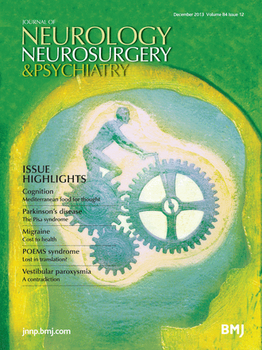

2000s to the present day: new editors, new formats
Over 1300 submissions a year, which increased to over 2000 p.a by the time Martin Rossor (Professor of Clinical Neurology at UCL Queen Square Institute of Neurology, and Consultant Neurologist at the National Hospital for Neurology and Neurosurgery) became editor in 2004, with Michael Hanna (now Director of UCL Queen Square Institute of Neurology) as deputy editor.

The journal introduced a new cover from 2004, highlighting the three clinical subjects of neurology, neurosurgery and neuropsychiatry, but “the green journal” maintains its green colour scheme to the present day. Since 2007 all papers are offered “online first”.

The current editor is Matthew C Kiernan (Bushell Chair of Neurology, University of Sydney) appointed in 2010 as its first non-British editor, introducing a new cover design, and the launch of podcasts. Matthew was a specialist registrar in Queen Square in 1998-1999, and subsequently a postdoc for 3 years in the Sobell Department at the Institute of Neurology.
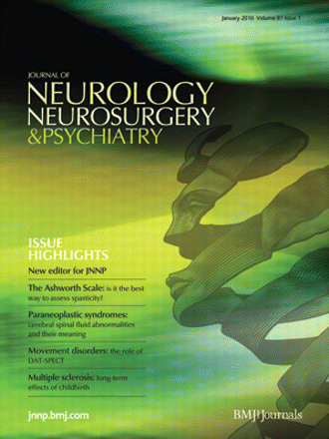

The journal now has an editorial team spanning the globe, including Associate Editor Nick Ward, as well as 4 web editors, 2 blog editors, 2 Facebook editors and a podcast editor.
There is also a Patient Editorial Board, introduced in 2019.

Submissions now exceed 3000 a year, with an acceptance rate of around 8%. The journal now has a large international audience, with 4.9 million page views in the last year alone.

In 2020, JNNP published a number of high impact articles by Queen Square authors on the impact of COVID-19– with publication times reduced in response to the pandemic.

The journal continues to be liberal in its coverage across the clinical neurosciences, honouring the broad-minded legacy of Kinnier Wilson’s aspirations.

Selected bibliography
- Hughes RAC. History of the journal and change of style., Journal of Neurology, Neurosurgery & Psychiatry 1990; 53: 1
- Hughes RAC Wind of change in neuroscientific information. Journal of Neurology, Neurosurgery & Psychiatry 1989; 52: 553
- Kiernan MC. (2020) Jewels in the crown: a century of achievement for the Journal of Neurology, Neurosurgery & Psychiatry. Journal of Neurology, Neurosurgery & Psychiatry 2020, 91 (1):1–2
- Kiernan, M.C. Milestones. Journal of Neurology, Neurosurgery & Psychiatry 2019; 90:1189, 1.
- Kiernan, M.C. The realm of neurology: past, present and future. Journal of Neurology, Neurosurgery & Psychiatry 2011; 82(1)
- Rossor, M. One hundred years of shared interest. Journal of Neurology, Neurosurgery & Psychiatry 2020; 91(3): 225-6

Appendix: items on display

The founding of the journal : Kinnier Wilson
- May 1920-Feb 1921 contents page
- Editorial: the realm of neurology The Journal of Neurology and Psychopathology May 1920 1(1) 67-69.
- M. A. Blandy Short Notes and Clinical Cases The Journal of Neurology and Psychopathology Aug 1920, s1-1 (2) 148-155;

1938: new name, new publisher, new editor
- Obituary notice: Kinnier Wilson Journal of Neurology and Psychiatry Jan 1938, 1 (1) 38
- W. Grey Walter CRITICAL REVIEW Journal of Neurology and Psychiatry Oct 1938, 1 (4) 359-385;

Post war era : Ritchie Russell & Simpson

- July / Oct 1944 contents page
- Richard A. Hunter, L. J. Hurwitz THE CASE NOTES OF THE NATIONAL HOSPITAL FOR THE PARALYSED AND EPILEPTIC, QUEEN SQUARE, LONDON, BEFORE 1900 Journal of Neurology, Neurosurgery & Psychiatry May 1961, 24 (2) 187-194;

1980s and 1990s: Marsden, Hughes & Kennard
- Merton, P.A. The first Carmichael Memorial Lecture. Neurophysiology on man. Journal of Neurology, Neurosurgery & Psychiatry 1981, 44, 861-70.
- Gibb WR, Lees AJ. The relevance of the Lewy body to the pathogenesis of idiopathic Parkinson’s disease. J Neurol Neurosurg Psychiatry 1988;51:745–52.
- Quinn, N.. Multiple system atrophy: the nature of the beast Journal of Neurology, Neurosurgery & Psychiatry 1989, June (supplement 78-89).
- Quinn, N. Multiple System Atropy: the nature of the beast revisited Journal of Neurology, Neurosurgery & Psychiatry 2020, 1(1), 3-4.
- Hughes RAC. History of the journal and change of style., Journal of Neurology, Neurosurgery & Psychiatry 1990; 53: 1
- A J Hughes, S E Daniel, L Kilford, A J Lees. Accuracy of clinical diagnosis of idiopathic Parkinson’s disease: a clinico-pathological study of 100 cases. J Neurol Neurosurg Psychiatry 1992;55:181–4.
- Lees, A.J. The relevance of the Lewy Body to the pathogenesis of idiopathic Parkinson’s disease:Accuracy of clinical diagnosis of idiopathic Parkinson’s disease. Journal of Neurology, Neurosurgery & Psychiatry 2012, 83(10) 954-5
- Hughes, R.A.C. Editorial : JNNP in the decade of the brain. Journal of Neurology, Neurosurgery & Psychiatry 1993, 56(1), 1.

2000s to the present day: new editors, new formats
- Kiernan, M.C. Why an Australian editor for JNNP? Journal of Neurology, Neurosurgery & Psychiatry 2010, 81(1), 1. Kiernan, M.C. The realm of neurology: past, present and future. Journal of Neurology, Neurosurgery & Psychiatry 2011; 82(1)
- Kiernan, M.C. Patient editorial board for JNNP. Journal of Neurology, Neurosurgery & Psychiatry 2019, 90(4) 1.
- Nick S Ward, Fran Brander, Kate Kelly Intensive upper limb neurorehabilitation in chronic stroke: outcomes from the Queen Square programme Journal of Neurology, Neurosurgery & Psychiatry May 2019, 90 (5) 498-506;
- Manji et al. Neurology in time of COVID 19. Journal of Neurology, Neurosurgery & Psychiatry 2020, 91(6), 568-70.
- Kiernan MC. (2020) Jewels in the crown: a century of achievement for the Journal of Neurology, Neurosurgery & Psychiatry. Journal of Neurology, Neurosurgery & Psychiatry 2020, 91 (1):1–2
- Perry et al. Characteristics and outcomes of COVID-19 associated stroke: a UK multicentre case-control study Journal of Neurology, Neurosurgery & Psychiatry 2021, 92(3), 242-8

