Queen Square Brain Bank for Neurological disorders
1

UCL QUEEN SQUARE Institute of Neurology

All correspondence to:
QUEEN SQUARE BRAIN BANK FOR NEUROLOGICAL DISORDERS
UCL QUEEN SQUARE INSTITUTE OF NEUROLOGY

1 WAKEFIELD STREET

LONDON WC1N 1PJ

TEL: 020 7837 8370
FAX: 020 7278 4993
e-mail: l.parsons@ucl.ac.uk

DIRECTORS:
Professor T Warner BM BCh PhD FRCP
Professor J Holton MB ChB PhD FRCPath
ADMINISTRATOR:
Mrs Lynn Haddon

MTA EXPIRY DATE: [INSERT DATE]. EXTL QSBB 2018-01-09, v04-D.

UCL Institute of Neurology HTA MTA Ext. Ref. No.: (including Tissue Bank name).

SUPPLY AGREEMENT FOR PROVISION OF HUMAN TISSUE SAMPLES AND

TISSUE DONOR INFORMATION FOR RESEARCH PURPOSES ONLY (IoN HTA)

BETWEEN:
1. Name and address of the Recipient Institution

(“RECIPIENT”)
AND
2. University College London, Gower Street, London WC1E 6BT, England.
("PROVIDER")

WHEREAS

A. This Material Transfer Agreement (MTA; “Agreement”) contains the terms and conditions under which the PROVIDER, acting through the UCL Institute of Neurology, 23 Queen Square, London, WC1N 3BG, has agreed to provide the RECIPIENT with human tissue samples consisting of or including whole cells, namely post-mortem tissue, surplus biopsy or surgical tissue, non-transplantable tissue, body fluids, primary cell cultures (whole explant/biopsy present) or microdissected cells as detailed in Appendix A and hereinafter referred to as “TISSUE".

B. The TISSUE is for use only in the research project as described in Appendix A (“RESEARCH PROJECT”) to be undertaken by [INSERT NAME] (the “PRINCIPAL RESEARCHER”) who is an employee of the RECIPIENT. If the PRINCIPAL RESEARCHER is replaced the RECIPIENT will provide the name of the replacement PRINCIPAL RESEARCHER to the PROVIDER.

C. The PROVIDER’S Tissue Bank MTA Approval Committee must approve the RESEARCH PROJECT. Research Tissue Banks (RTBs) are authorized by a NHS Research Ethics Committee (REC) to give generic ethical approval, but Standard Tissue Banks do not give generic ethical approval. If the Tissue Bank is a RTB the RECIPIENT may request in Appendix A that generic ethical approval is given for the RESEARCH PROJECT if conducted in the U.K.. This project-specific generic ethical approval will not be valid when this Agreement expires or is terminated. Where generic ethical approval is not given, the RECIPIENT'S NHS REC approval letter(s) for the RESEARCH PROJECT must be attached at Appendix E. If the RECIPIENT is based outside the U.K., a recognized Ethics Committee approval letter in English, or the Ethics Committee approval letter in the RECIPIENT’S native language with the certified English language translation, must be attached at Appendix E.

D. The term “TISSUE” means human material (excluding gametes, embryos or cells that have divided in culture) which consists of or includes human cells and so is considered to be “Relevant Material” for the purposes of the Human Tissue Act 2004 and the Human Tissue Authority (HTA). TISSUE would be provided by the PROVIDER together with related basic information (including age, sex, previous and current diseases, and drug history) of tissue donors (“DONOR INFORMATION”). The RECIPIENT will hold the TISSUE and DONOR INFORMATION on the terms of this Agreement and solely for the purpose of the RESEARCH PROJECT as described in Appendix A within the research group of the PRINCIPAL RESEARCHER.

IT IS HEREBY AGREED AS FOLLOWS

1. The PROVIDER represents and warrants that the consent obtained for TISSUE donation, and the procurement and storage of TISSUE and the DONOR INFORMATION, for research studies are in accordance with the Human Tissue Act 2004, the HTA Codes of Practice, the PROVIDER'S relevant NHS Research Ethics Committee (REC) approval(s), and other relevant laws and guidelines. The UCL Institute of Neurology has been granted the HTA Licence Number 12198 in the Research Sector. A copy of the PROVIDER’S Research Ethics Committee approval(s) which is relevant to the TISSUE and DONOR INFORMATION supplied is attached at Appendix B.

2. The TISSUE and DONOR INFORMATION supplied to the RECIPIENT have been obtained from living donors for whom written informed consent was given by the donor, next of kin or person with power of attorney for the donor's TISSUE and DONOR INFORMATION to be used for research purposes, and/or for whom written informed consent was given after the death of the donor by their next of kin or person with power of attorney. Sample copies of the current Tissue Bank, Laboratory or Hospital Consent Form(s) used by the PROVIDER are attached to this Agreement at Appendix C. Should an individual donor, or donor’s next of kin, rescind consent the PROVIDER will notify the RECIPIENT and the RECIPIENT will agree to discontinue use of the TISSUE and return any remaining TISSUE concerned to the PROVIDER in accordance with the PROVIDER’S instructions.

3. The PROVIDER warrants to the RECIPIENT that no payments were made or other inducements given to any donor or next of kin or other consenting person to procure the TISSUE or DONOR INFORMATION.

4. The RECIPIENT hereby agrees to comply, and procure that the PRINCIPAL RESEARCHER and all personnel who work with the TISSUE and DONOR INFORMATION comply with the terms and conditions in this Agreement. Where TISSUE under the RESEARCH PROJECT is outsourced to a third party for experimental work that cannot be carried out in the RECIPIENT’S Laboratories, the RECIPIENT shall ensure that relevant terms and conditions of this Agreement are formally agreed by the third party through a Third Party Agreement (TPA) between the RECIPIENT and the third party. The RESEARCH PROJECT may include RNA analysis and gene expression studies in line with the donor consent and the Codes of Practice of the Human Tissue Authority. All TISSUE is for research purposes only and the RECIPIENT will not use the TISSUE for Human Application (i.e. patient treatment) as that term is defined in the Human Tissue (Quality and Safety for Human Application) Regulations 2007 (or equivalent as may be replaced or amended from time to time), or for clinical or diagnostic purposes.

5. The RECIPIENT will make appropriate payment to cover reasonable administration costs for the storage and supply and preparation of the TISSUE and DONOR INFORMATION but the RECIPIENT shall make no payment for the TISSUE samples or DONOR INFORMATION. All costs for the TISSUE and DONOR INFORMATION will be agreed between the PROVIDER and the RECIPIENT prior to any transfer of the TISSUE and DONOR INFORMATION. No payment will be made to the PROVIDER by the RECIPIENT in respect of any invention or discovery arising from the use of the TISSUE and DONOR INFORMATION. The RECIPIENT shall own the results of the research and resulting intellectual property rights arising from the RECIPIENT’S use of the TISSUE and DONOR INFORMATION.

6. The TISSUE will be anonymised by coding and supplied when appropriate with basic DONOR INFORMATION. Under no circumstances shall the PROVIDER supply or shall the RECIPIENT accept personal information which in the PROVIDER'S opinion could identify the donor.

7. Upon the RECIPIENT'S request, the PROVIDER shall provide the RECIPIENT with technical information necessary for the safe handling, storage and use of the TISSUE. The PROVIDER will retain for reference any tissue sections which have been stained by the PROVIDER to characterize TISSUE passed to the RECIPIENT.

8. The PROVIDER will arrange for and the RECIPIENT will cover the costs for all transport of the TISSUE. The RECIPIENT will supply the PROVIDER with, or pay the PROVIDER for, all slides, tubes, containers, packaging and labelling as required by the PROVIDER to provide the RECIPIENT with the TISSUE. To minimize the possibility of damage or loss, the required packaging must be robust and clearly labelled with the RECIPIENT'S name, address and contact details. Prior to sample transport to the RECIPIENT, the PROVIDER will e-mail the RECIPIENT the "Dispatch and Confirmation of Receipt Form" attached to this Agreement at Appendix D. Also in advance of transportation the PROVIDER must give the courier company or the individual who would be transporting the samples detailed information on how the samples are to be preserved during transport, including maintenance of the correct temperature, and on any potential biological (e.g. infection), chemical (e.g. formalin) or other hazards (e.g. transport in dry ice).

9. The courier must endeavour to prevent damage, loss or theft of the transported TISSUE. It must be ensured by the courier that the transport containers are held in place securely to prevent them moving during transport, and that the specified optimal temperature conditions are maintained throughout all stages of the delivery process. The vehicle transport compartment must be windowless and kept locked until delivery to the RECIPIENT. To acknowledge the safe receipt of TISSUE, the RECIPIENT must as soon as possible send by e-mail or fax the completed "Dispatch and Confirmation of Receipt Form" to the PROVIDER. The storage conditions for preservation of the TISSUE SAMPLES by the RECIPIENT and any associated hazards are specified on this Form. If TISSUE is transported by a courier company RECIPIENT must also send a copy of the courier company’s signed delivery Form to the PROVIDER. The risk and responsibility (i.e. custodianship) for the TISSUE shall pass to the RECIPIENT when the courier company’s delivery form has been signed at the RECIPIENT’S institution, or the RECIPIENT has collected the TISSUE from the PROVIDER.

10. On receiving custodianship of the TISSUE and DONOR INFORMATION, the RECIPIENT will then be responsible for the appropriate storage and use of the TISSUE and the DONOR INFORMATION. The RECIPIENT may use the TISSUE and DONOR INFORMATION only in the RESEARCH PROJECT, and in accordance with the RECIPIENT’S Research Ethics Committee approval(s) if attached at Appendix E. The RECIPIENT agrees to obtain the written consent of the PROVIDER if there is any material change to the proposed use of the TISSUE and DONOR INFORMATION. The RECIPIENT may pass the TISSUE and DONOR INFORMATION on to its employees solely for performance of the RESEARCH PROJECT but may not sell, licence or otherwise transfer the TISSUE or DONOR INFORMATION to any third party, other than as permitted in this Agreement for the purpose of the outsourcing of experimental work, without prior written consent from the PROVIDER.

11. The RECIPIENT shall maintain at its own cost insurance to cover its full liability in respect of default, whether act or omission, for which it and its employees, consultants and agents may become liable as a result of its custodianship of the TISSUE and DONOR INFORMATION and for the use to which it puts the TISSUE and DONOR INFORMATION and shall indemnify the PROVIDER fully against all such liabilities, including any and all actions by third parties engaged by the RECIPIENT. Neither party shall be liable to the other for any consequential loss, damage, claims or demands which may arise from the use that the RECIPIENT may make of TISSUE and DONOR INFORMATION, whether direct or indirect.

12. Both Parties shall keep confidential all details of this Agreement and information relating to this Agreement unless prior written agreement is obtained in advance of any disclosure. This obligation of confidentiality shall survive termination of this Agreement indefinitely. The obligations of confidentiality shall not apply to any information (i) that the receiving party can show was known to the receiving party in advance of receipt from the disclosing party; (ii) is in the public domain or subsequently becomes publicly known through no fault, act or omission of the receiving party; (iii) is received by the receiving party without restriction from a third party lawfully entitled to make the disclosure to the receiving party without any such restriction; (iv) is developed by the receiving party independently and without the aid or benefit of the information obtained from the disclosing party; (v) the receiving party is required to disclose by law, government regulation or court order provided the receiving party notifies the disclosing party of such requirement in advance of disclosure.

13. Each Party shall ensure that its activity under this Agreement shall comply fully with applicable laws and guidance including but not limited to the current Codes of Practice of the Human Tissue Authority and all other relevant local, government and European Laws, regulations and guidelines which are applicable during the period of this Agreement, including health and safety, data protection and environmental laws with regard to the TISSUE and DONOR INFORMATION.

14. To comply with safety legislation, the RECIPIENT is required to carry out formal Risk Assessments and produce Standard Operating Procedures for all research work involving the TISSUE and DONOR INFORMATION. The RECIPIENT warrants to assume full responsibility for training all personnel in procedures for the safe handling of human tissues. The PROVIDER warrants to have taken all reasonable precautions in supplying the TISSUE to the RECIPIENT and accepts no liability for any potential risks associated with the RECIPIENT'S use of the TISSUE. Except as expressly stated herein, the RECIPIENT acknowledges that the TISSUE is experimental in nature and the PROVIDER makes no representation and gives no warranty or undertaking of quality or fitness of the TISSUE or DONOR INFORMATION for any particular purpose or that their use will not infringe any patent, copyright, trade mark or other property right owned by any third party.

15. The RECIPIENT will provide the PROVIDER with an Annual Report and the Final Report on the RESEARCH PROJECT described in Appendix A, to be held in confidence by the PROVIDER.

16. The PRINCIPAL RESEARCHER agrees to provide appropriate acknowledgement of the Tissue Bank as the source of the TISSUE and/or DONOR INFORMATION in all written publications or oral presentations reporting on the use of the TISSUE and/or DONOR INFORMATION. The PRINCIPAL RESEARCHER will provide a copy of such publications at least twenty days in advance of submission for publication. The PROVIDER agrees not to share such advance copy with any third party until published. The RECIPIENT shall not publish any confidential or proprietary information belonging to the PROVIDER without its prior written consent, including such information contained within the TISSUE and DONOR INFORMATION. At any time the PRINCIPAL RESEARCHER and Tissue Bank representative(s) may agree that collaborating with each other in the performance of this RESEARCH PROJECT will be of mutual benefit, further research objectives and foster the development of scientific knowledge. If this has been agreed the Tissue Bank representative(s) will be included in any publication as co-author(s), unless requested otherwise by a Tissue Bank representative. These obligations shall survive termination of this Agreement indefinitely.

17. Unused tissue must be returned when this Agreement expires, or the RECIPIENT notifies the PROVIDER that the RESEARCH PROJECT is completed or terminated, or if any remaining TISSUE is no longer required, or if the RECIPIENT’S non-generic Research Ethics Committee approval(s) attached at Appendix E expires, whichever is the sooner. Samples which have been homogenized or rendered acellular by other means should be disposed of by the RECIPIENT under the regulations of their establishment. However samples containing whole cells, or tissue sections on slides or in tubes, must be returned to the PROVIDER for disposal in a lawful and respectful manner in compliance with the Human Tissue Act 2004, HTA Codes and UCL Policies. The RECIPIENT must document in detail and return all unused TISSUE to the PROVIDER in appropriately labelled containers and packaging unless a new Agreement is approved by the PROVIDER, and/or new Research Ethics Committee approval is obtained. A copy of any non-generic new approval by the RECIPIENT’S Research Ethics Committee must be sent to the PROVIDER within 30 (thirty) days of notification of such approval.

18. This Agreement shall take effect from [insert date, 201x], and shall be for a maximum period of [insert number] years, expiring on [insert date, 20xx]. The RECIPIENT may wish to request small amounts of additional samples from the PROVIDER, and/or to make minor changes to the methodologies included in Appendix A (“RESEARCH PROJECT”) by utilizing a UCL Institute of Neurology Amendment document. This Agreement would be modified only to the extent expressly stated in the Amendment. All other provisions specified in the Agreement would remain unchanged and in full force and effect, including the expiry of the Amendment, Agreement and any generic ethical approval on the date stated in the original Agreement. In the event of breach of this Agreement, or any Amendment to this Agreement, by the RECIPIENT and following failure to remedy such breach within 30 days, the PROVIDER may terminate the Agreement on 30 days written notice being given to the RECIPIENT.

19. Neither party shall be entitled to assign its obligations under this Agreement save with the prior written consent of the other.

20. Nothing in this Agreement shall create or be deemed to create a partnership between the parties.

21. Each party acknowledges that in entering into this Agreement it does not do so on the basis of or rely on any representation warranty or condition except as expressly provided in this Agreement, and accordingly all conditions, warrants or other items implied by statute or common law are hereby excluded to the fullest extent permitted by law.

22. If any provision of this Agreement is held by any Court or other competent authority to be void or unenforceable in whole or in part, the other provisions of this Agreement and the remainder of the unaffected provision shall continue to be valid.

23. Official notices shall be in writing and may be given by hand or sent by first class post, as a PDF e-mail attachment, or facsimile addressed to the signatories of this Agreement. If delivered by hand, service shall be deemed to have been given upon delivery. If sent by post, service shall be deemed to have been given 48 hours after posting, and if sent electronically as a PDF attachment or facsimile shall be deemed to have been given on the date of transmission provided that a successful transmission report is held by the sender and a copy of the PDF attachment or facsimile and the transmission report is sent by post to the RECIPIENT. Informal comments and concerns may be made in writing by either party by post, e-mail or facsimile to the relevant Tissue Bank or Laboratory Manager, contact details for whom are given in Appendix A.

24. This Agreement shall be governed by the laws of England and Wales and the parties submit to the exclusive jurisdiction of the Courts in London, England.

IN WITNESS WHEREOF this Agreement has been signed by the duly authorised representatives of the RECIPIENT and the PROVIDER.
For and on behalf of the RECIPIENT

Title of the Recipient’s Legal Representative:

Signature:

Name in capitals:

Date:

Title: Principal Researcher.

Signature:

Name in capitals:

Date:

For and on behalf of the PROVIDER

Confirmation by the Director of Neuropathology in the Queen Square Brain Bank for Neurological Disorders at the 1, Wakefield Street Satellite Site under the UCL Institute of Neurology HTA Licence Number 12198 (Research Sector) that the RESEARCH PROJECT detailed in Appendix A has been approved by this tissue bank's MTA Approval Committee and has also been given Research Tissue Bank generic ethical approval, or NHS Research Ethics Committee ethical approval, or if the RECIPIENT is based outside the U.K., approval from a recognized Ethics Committee:

Signature:

Name in capitals: PROFESSOR JANICE HOLTON

Date:

Title: HTA Designated Individual, UCL Institute of Neurology HTA Licence number 12198.

Signature:

Name in capitals: PROFESSOR MARIA THOM

Date:

Title: Executive Director, UCLB.

Signature:

Name in capitals:

Date:

APPENDIX A
TO BE COMPLETED BY THE PRINCIPAL RESEARCHER FOR THIS PROJECT
TITLE OF RESEARCH PROJECT:

SCIENTIFIC BACKGROUND:

AIMS OF THE RESEARCH PROJECT:

INVESTIGATION PLAN:

INVESTIGATION PLAN - continued.

TISSUE SAMPLES REQUIRED:

Neurological disease(s) and number of cases from which TISSUE is required:

Number of normal control cases from which TISSUE is required:

Sample Preservation: Flash frozen, snap frozen, slow frozen, formalin-fixed and paraffin-embedded, formalin-fixed, other fixative, unpreserved or other format:

Sample Type: Tissue blocks, slices, finely dissected samples, sections on slides, sections in tubes, cells, primary cultures or other sample type:

Sample size, weight, thickness or volume:

CNS area(s) and number of samples from each CNS area:

PRINCIPAL RESEARCHER FOR RESEARCH PROJECT (Title; full name):

Position:

Laboratory address for TISSUE delivery:

e-mail address:
Tel. No.: Fax No.:

Name of research funding bodies for the proposed RESEARCH PROJECT:

- In signing this Agreement the PRINCIPAL RESEARCHER on behalf of the RECIPIENT confirms a Service Level Agreement will be in place prior to transfer of TISSUE under the RESEARCH PROJECT to any third party(ies) for the purpose of outsourcing experimental work.
- A report on the progress of the RESEARCH PROJECT will be provided to the PROVIDER every 12 months.
- The PROVIDER would appreciate information on individual anonymized cases obtained through the RECIPIENT'S research studies which could further characterize TISSUE held by the PROVIDER.
- I agree to acknowledge the Tissue Bank as the TISSUE and/or DONOR INFORMATION source in all publications, and provide a copy of all publications at least twenty days in advance of submission for publication. If this is a collaborative project, Tissue Bank representative(s) will be included as co-author(s).
PRINCIPAL RESEARCHER’S signature: …….…….…….……………………………………………………………..…………………

Name in capitals: …….…….…….……………………………………………………………..…………………………….…………………………….

Date: …….…….…….………………………………………………………………………………..……..…………………………………………………….…….

Please state Yes or No:
Generic ethics committee approval is being sought from the PROVIDER: YES / NO
A copy of the RECIPIENT’S current Research Ethics Committee Letter of Approval for this RESEARCH PROJECT is attached to this Agreement at Appendix E: YES / NO
If required this RESEARCH PROJECT has also been approved by the RECIPIENT’S Research and Development (R & D) Department.
Name and address of PROVIDER Tissue Bank/Laboratory Manager:
Linda Parsons, Queen Square Brain Bank for Neurological Disorders, UCL Institute of Neurology, 1 Wakefield Street, London WC1N 1PJ, England.
E-mail address: l.parsons@ucl.ac.uk
Tel. No.: +44 (0)20 7837 8370 Fax No.: +44 (0)20 7278 4993
APPENDIX B

B-1: COPY OF THE PROVIDER’S RELEVANT ETHICS COMMITTEE APPROVAL,
May 2018.

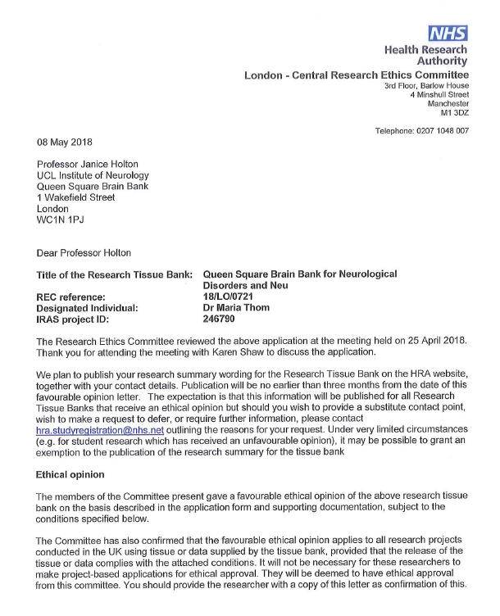
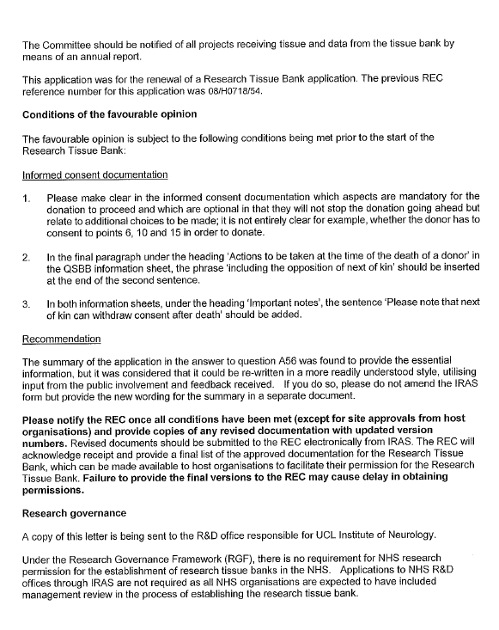

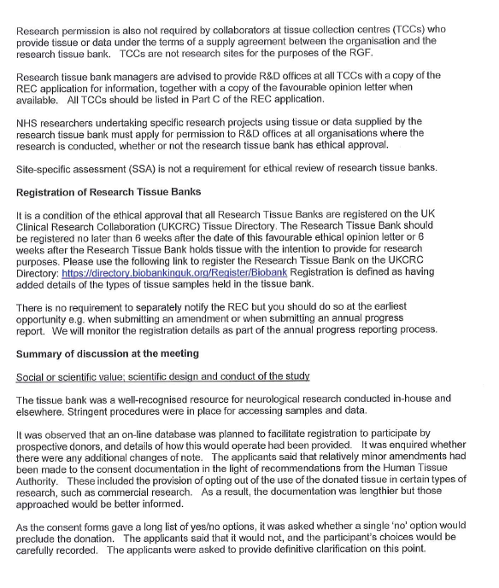

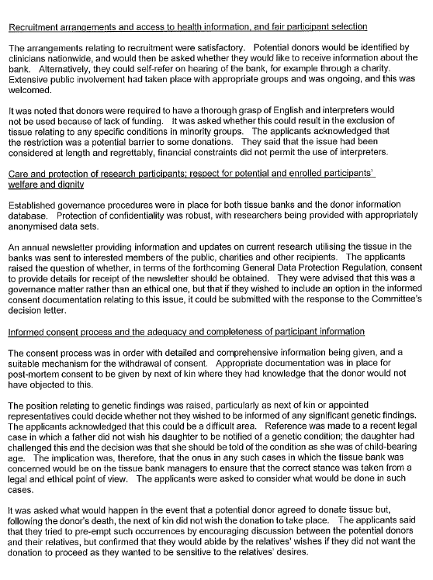

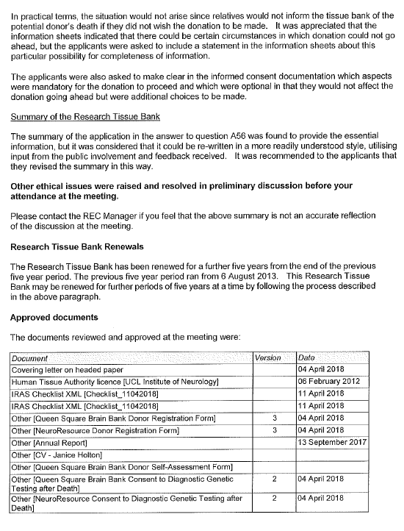

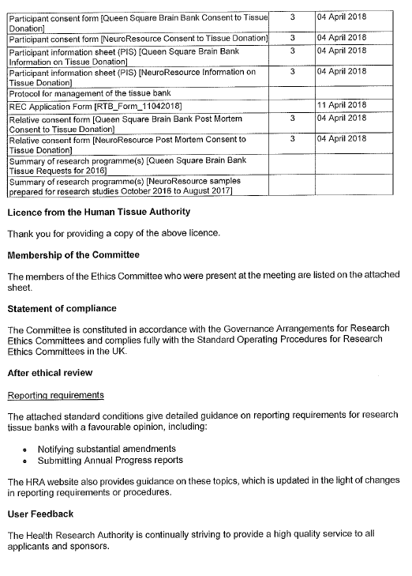

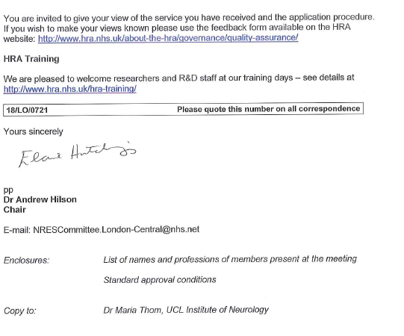

APPENDIX C
COPY OF THE PROVIDER’S CONSENT FORM

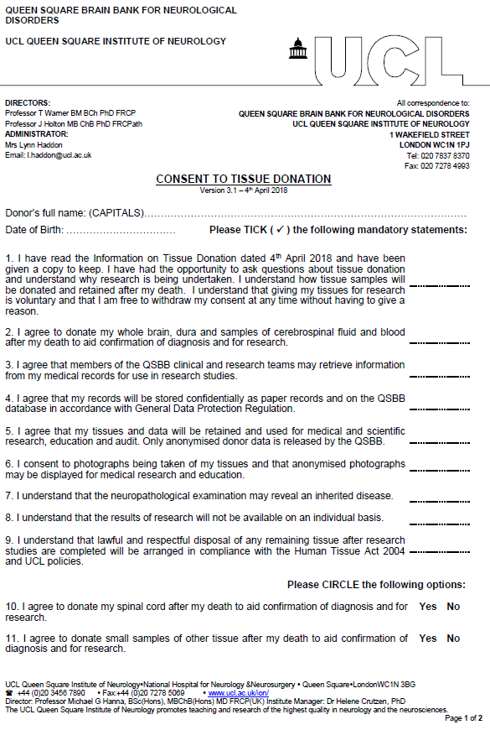

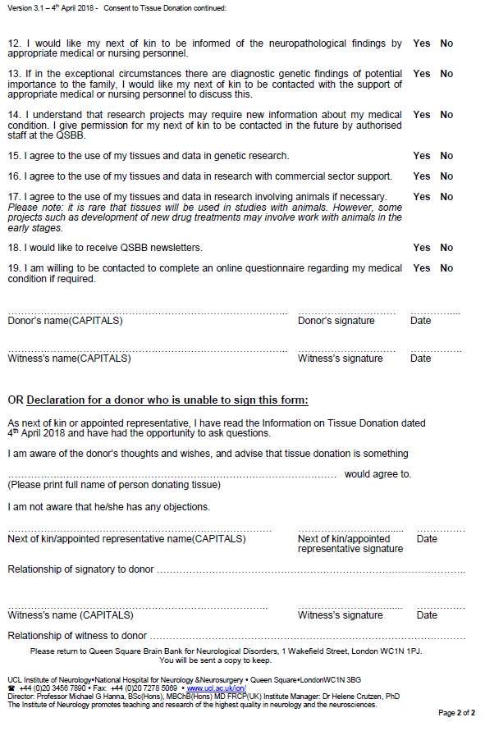
APPENDIX D
DISPATCH AND CONFIRMATION OF RECEIPT FORM FOR HUMAN SAMPLES SENT FROM THE UCL INSTITUTE OF NEUROLOGY
This form should be e-mailed to the recipient before samples are dispatched.
DISPATCH INFORMATION
Proposed date and time of dispatch:
Recipient name and address for delivery:

e-mail address and phone number:
Samples: Batch codes(s):
Format(s): Frozen and in dry ice □ In wet ice □ At room temperature □
In fixative: Type: Fragile contents, e.g. glass slides □
Any additional information, including potential biological hazards: None known or ......

Sender name and address:

e-mail address:
Phone and fax numbers:
Courier/collector name and phone number:
Courier tracking number: Airway bill number:
If to be tracked, this will be carried out by: Sender □ Recipient □ Both □

If any problems arise during transit, all parties should be alerted and action taken as necessary.

CONFIRMATION OF RECEIPT OF SAMPLES
Date and time of arrival: …………………………….…...................................…………….…………………
All samples were unpacked and stored under appropriate conditions at:
-80ºC □ +4ºC □ Room temperature □ Other ..........................................
In additional fixative: □ Fixative type: ........................................................................

Signed: ………………………...…………………………...................…….……………….…….......…….............

Name in capitals: …………………………….………..................….....………….…………...………………...…

Please would you scan and e-mail, or fax, this page to: Linda Parsons, Queen Square Brain Bank for Neurological Disorders, UCL Institute of Neurology, 1 Wakefield Street, London WC1N 1PJ, England. E-mail address: l.parsons@ucl.ac.uk
Tel. No.: +44 (0)20 7837 8370 Fax No.: +44 (0)20 7278 4993
APPENDIX E

COPY OF THE RECIPIENT’S RELEVANT RESEARCH ETHICS
COMMITTEE APPROVAL

The Human Tissue Act 2004 applies to the use of “Relevant Materials” which include human cells (but not cell lines), tissue and organs from a living or deceased person for the removal, storage and use in “Scheduled Purposes” which include research on disorders or the function of the human body, and education relating to human health (from the HTA Code A – Guiding Principles and the Fundamental Principle of Consent, and also Code E – Research Code of Practice). If a sample contains even a single cell from a human body it is classified as Relevant Material. On the HTA Website the Relevant Material definition and link to a Relevant Materials List is at: http://www.hta.gov.uk/legislationpoliciesandcodesofpractice/definitionofrelevantmaterial.cfm..
Applicable laws and guidance means all laws, rules, regulations, Codes of Practice, research governance or ethical guidelines, or other requirements of any Regulatory Authority, that may apply to the use of the Material by the RECIPIENT from time to time, including (but not limited to) the Human Tissue Act 2004 or the Human Tissue (Scotland) Act 2006, and the current HTA Directions and Codes of Practice.

