Neuroradiology & Functional Neuroanatomy:  Correlating Anatomical, Brain Imaging and Clinical Studies | 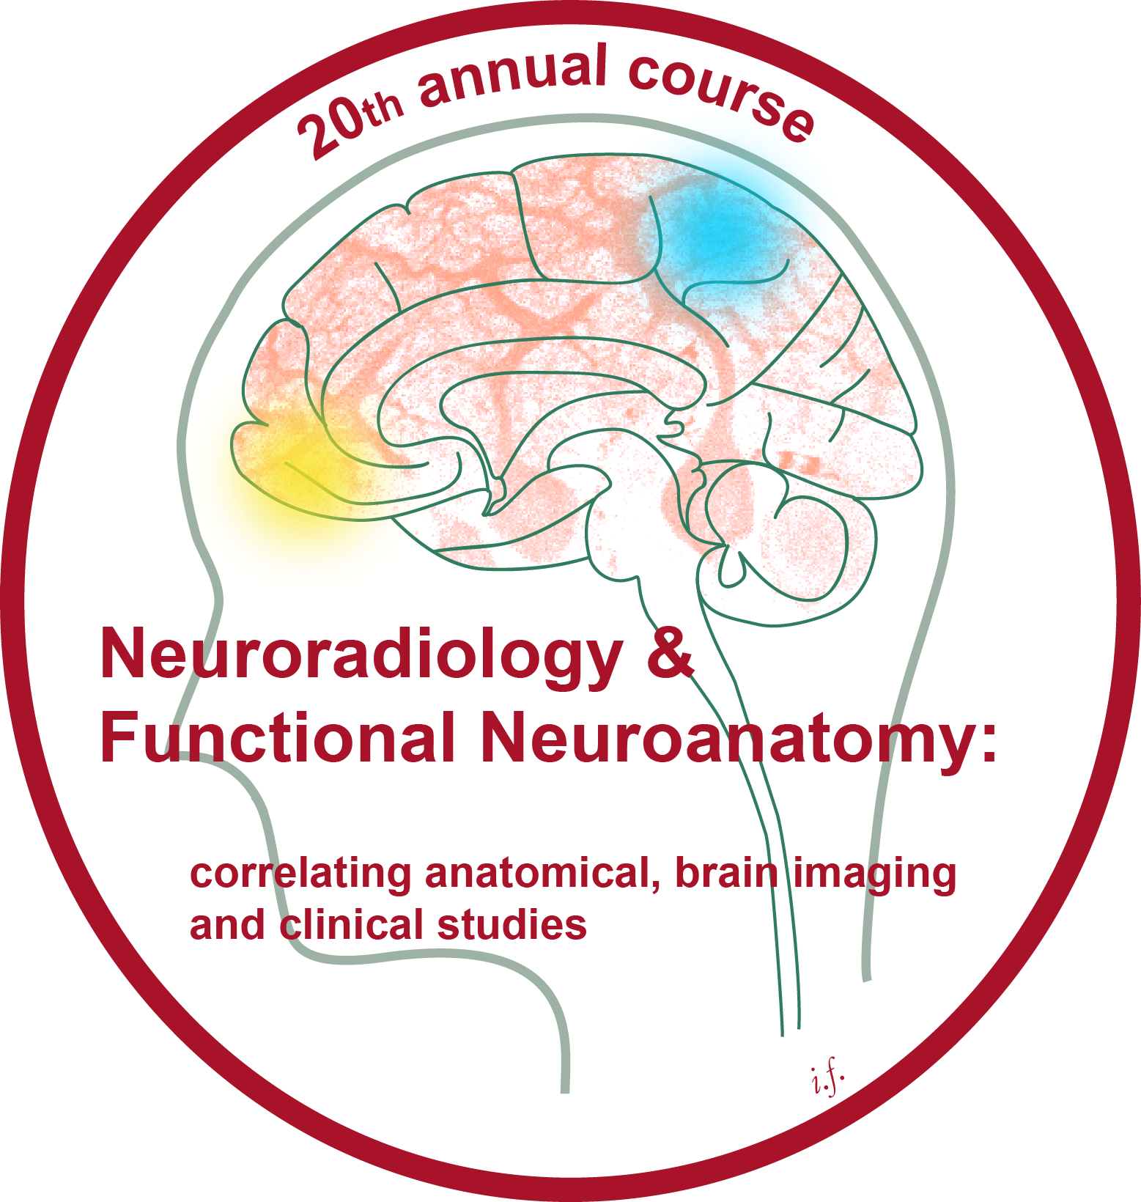
Organised by Prof T Yousry, Prof C Yeo and Prof T Naidich
Monday 28 March – Thursday 31 March 2022
Lecture Theatre, 33 Queen Square, London
Draft programme

Anatomical localisation of function is a fundamental principle in the neurosciences. This four-day course will correlate gross anatomy with neuroimaging and functional MRI to illustrate normal neurological function, the alterations that attend disease, and the bases for the clinical features seen in patients.

Monday 28 March 2022

09.00 – 09.05 Welcome address and Overview Prof T. Yousry

09.05 – 09.50 Surface anatomy of the brain on MRI Prof T. Naidich

09.50 – 10.30 Imaging the developing brain Prof P. Griffiths

10.30 – 11.00 Break

11.00 – 11.45 Developmental and acquired brain pathology in the fetus Prof P. Griffiths

11.45 – 12.30 Phylogenetic evolution of the brain in humanoids Prof M. Braun

12.30 – 13.30 Lunch Break

13.30 Assembly at the 33 Queen Square Foyer for the Anatomy workshop

14.00-15.30 “Hands on” anatomy laboratory
Anatomic demonstration: 30 minutes, then specimen reviews & dissections
Prof M Braun, Prof T. Naidich, Prof C. Yeo, Prof T. Yousry

15.30 – 16.00 Break

16.00 – 16.45 Motor Cortex and Descending Motor Pathways Prof R. Lemon

16.45 – 17.30 Functional anatomy of the cerebellum Prof C. Yeo

17.30 – 18.00 Arteries and veins of the brain Prof M Braun

Welcome Reception
Queen Square

Tuesday 29 March 2022

09.00 – 09.45 Methods of Identification of the central sulcus Prof T. Yousry

09.45 – 10.30 MR of the basal ganglia Prof T. Naidich

10.30 – 11.00 Break

11.00 – 11.45 Cytoarchitecture and brain mapping Prof K. Amunts

11.45 – 12.30 White matter tracts in the brainstem at 9.4T Prof T. Naidich

12.30 – 13.15 Myeloarchitecture, receptorarchitecture und multimodality Prof K. Amunts

13.15 – 14.15 Lunch Break

14.15 – 15.45 “Hands on” PACS workstations: Identification of brain structures
Prof M. Braun, Dr C. Hoskote, Dr S. Shah, Prof T. Naidich,
Prof T. Yousry

15.45 – 16.15 Break

16.15 – 16.45 Embryology, anatomy and phylogeny of the Prof T. Naidich anterior, hippocampal and great commissures

16.45 – 17.30 Association pathways Prof M Catani

Wednesday 30 March 2022

09.00 – 10.30 “Hands on” anatomy laboratory
Anatomic demonstration: 30 minutes, then specimen reviews & dissections
Prof M. Braun, Prof T. Naidich, Prof C. Yeo, Prof T. Yousry.

10.30 – 11.00 Break

11.00 – 11.45 Language areas: cyto- and receptorarchitecture Prof K. Amunts

11.45 – 12.30 Language networks and their myths Prof C Price

12.30 – 13.45 Group photo and Lunch Break

13.45 – 15.15 “Hands on” PACS workstations: Identification of brain structures
Prof M. Braun, Dr C. Hoskote, Prof T. Naidich, Dr S. Shah,
Prof T. Yousry

15.15 – 15.45 Break

15.45 – 16.30 Effect of damage to the language network Prof C Price

16.30 – 17.15 Preoperative use of fMRI and tractography Prof T. Yousry

17.15 – 17.45 Gross anatomy of the hippocampal formation Prof T. Naidich

17.45 Farewell Reception
Queen Square

Thursday 31 March 2022

09.00 – 09.45 MR imaging anatomy of the basal forebrain Prof T. Naidich

09.45 – 10.30 Functional anatomy of the corpus callosum Prof T. Yousry

10.30 – 11.00 Break

11.00 – 11.45 Microstructure Imaging Using MRI Prof N Weiskopf

11.45 – 12.30 Toward a better understanding of Hydrocephalus Prof T. Naidich

12.30 – 13.30 Lunch Break

13.30 – 14.00 Insights into the anatomy and function of VR-spaces Prof R. Weller

14.00 – 14.45 The Emotional Brain- Anatomic Bases Prof T. Naidich

14.45 – 15.30 The adolescent brain Prof S. Blakemore

15.30 End of Course – closing remarks from the organisers: Prof Yousry, Prof Yeo,
and Prof Naidich

N.B. Covid restrictions will be adhered to and thus the programme will be updated accordingly.

FACULTY

Prof K Amunts (Germany)
Prof S Blakemore (United Kingdom)
Prof M Braun (France)
Prof M Catani (United Kingdom)
Prof P Griffiths (United Kingdom)
Dr C Hoskote (United Kingdom)
Prof R Lemon (United Kingdom)
Prof T Naidich (United States)
Prof C Price (United Kingdom)
Dr S Shah (United Kingdom)
Prof N Weiskopf (Germany)
Prof R Weller (United Kingdom)
Prof C Yeo (United Kingdom)
Prof T Yousry (United Kingdom)

