MTA EXPIRY DATE: ........ UCL PI 2019-03-07 v.6A.

QUEEN SQUARE BRAIN BANK IoN HTA MTA UCL REF.: QSBB ........ 2019.

SUPPLY AGREEMENT FOR THE PROVISION OF HUMAN TISSUE SAMPLES
AND TISSUE DONOR INFORMATION WITHIN UNIVERSITY COLLEGE LONDON FOR RESEARCH PURPOSES ONLY (IoN HTA)
BETWEEN:
1. Name, Department and address of the Principal Researcher:

(“RECIPIENT”)
AND
2. University College London, Gower Street, London WC1E 6BT.
("PROVIDER")

WHEREAS

- This Material Transfer Agreement (MTA; “Agreement”) contains the terms and conditions under which the PROVIDER, acting through the UCL Queen Square Institute of Neurology, 23 Queen Square, London WC1N 3BG, has agreed to provide the RECIPIENT with human tissue samples consisting of or including whole cells, namely post-mortem tissue, surplus biopsy or surgical tissue, non-transplantable tissue, body fluids, primary cell cultures (whole explant/biopsy present) or microdissected cells as detailed in Appendix A and hereinafter referred to as “TISSUE".

- The TISSUE is for use only in the specific research project as described in Appendix A (“RESEARCH PROJECT”) to be undertaken by [INSERT NAME] (the “PRINCIPAL RESEARCHER”) who is an employee of University College London (UCL). If the PRINCIPAL RESEARCHER is replaced the RECIPIENT will provide the name of the replacement PRINCIPAL RESEARCHER to the PROVIDER.

C. The PROVIDER’S Tissue Bank MTA Approval Committee must approve the scientific merits of the RESEARCH PROJECT described in Appendix A. Research Tissue Banks (RTBs) are authorized by a NHS Research Ethics Committee (REC) to give ethical approval of the RESEARCH PROJECT, but Standard Tissue Banks do not have authorization to give ethical approval. If the Tissue Bank is a RTB, the RECIPIENT may request in Appendix A ethical approval from the PROVIDER’S Tissue Bank MTA Approval Committee for the RESEARCH PROJECT if conducted in the U.K.. If this project-specific ethical approval is granted by the RTB, it will not be necessary for the PRINCIPAL RESEARCHER to make a project-based NHS Research Ethics Committee application for ethical approval. The RTB ethical approval will not be valid when this Agreement expires or is terminated. Where ethical approval is not given by the Tissue Bank, the RECIPIENT'S NHS REC approval letter(s) for the RESEARCH PROJECT must be attached at Appendix E.

D. The term “TISSUE” means human material (excluding gametes, embryos, or cells that have divided in culture) which consists of or includes human cells and so is considered to be “Relevant Material” for the purposes of the Human Tissue Act 2004 and the Human Tissue Authority (HTA). The TISSUE would be provided by the PROVIDER together with related basic information (including age, sex, previous and current diseases, and drug history) of tissue donors (“DONOR INFORMATION”). The RECIPIENT will hold the TISSUE and DONOR INFORMATION on the terms of this Agreement and solely for the purpose of the RESEARCH PROJECT as described in Appendix A within the research group of the PRINCIPAL RESEARCHER.

IT IS HEREBY AGREED AS FOLLOWS

1. The PROVIDER represents and warrants that the consent obtained for TISSUE donation, and the procurement and storage of TISSUE and the DONOR INFORMATION, for research studies are in accordance with the Human Tissue Act 2004, the HTA Codes of Practice, the PROVIDER'S relevant NHS Research Ethics Committee approval(s), and

other relevant laws and guidelines. The UCL Queen Square Institute of Neurology has been granted the HTA Licence Number 12198 in the Research Sector. A copy of the PROVIDER’S NHS Research Ethics Committee approval(s) which is relevant to the TISSUE and DONOR INFORMATION supplied is attached at Appendix B.

2. The TISSUE and DONOR INFORMATION supplied to the RECIPIENT have been obtained from living donors for whom written informed consent was given by the donor, next of kin or person with power of attorney for the donor's TISSUE and DONOR INFORMATION to be used for research purposes, and/or for whom written informed consent was given after the death of the donor by their next of kin or person with power of attorney. Sample copies of the current Tissue Bank, Laboratory or Hospital Consent Form(s) used by the PROVIDER are attached to this Agreement at Appendix C. Should an individual donor, or donor’s next of kin, rescind consent the PROVIDER will notify the RECIPIENT and the RECIPIENT will agree to discontinue use of the TISSUE and return any remaining TISSUE concerned to the PROVIDER in accordance with the PROVIDER’S instructions.

3. The PROVIDER warrants to the RECIPIENT that no payments were made or other inducements given to any donor or next of kin or other consenting person to procure the TISSUE or DONOR INFORMATION.

4. The RECIPIENT hereby agrees to comply, and procure that the PRINCIPAL RESEARCHER and all personnel who work with the TISSUE and DONOR INFORMATION comply with the terms and conditions in this Agreement. Where TISSUE under the RESEARCH PROJECT is outsourced to a third party for experimental work that cannot be carried out in the RECIPIENT’S Laboratories, the RECIPIENT shall ensure that relevant terms and conditions of this Agreement are formally agreed by the third party through a Third Party Agreement (TPA) between University College London and the third party. The RESEARCH PROJECT may include RNA analysis and gene expression studies in line with the donor consent and the Codes of Practice of the Human Tissue Authority. All TISSUE is for research purposes only and the RECIPIENT will not use the TISSUE for Human Application (i.e. patient treatment) as that term is defined in the Human Tissue (Quality and Safety for Human Application) Regulations 2007 (or equivalent as may be replaced or amended from time to time), or for clinical or diagnostic purposes.

5. The RECIPIENT will make appropriate payment to cover reasonable administration costs for the storage and supply and preparation of the TISSUE and DONOR
INFORMATION but the RECIPIENT shall make no payment for the TISSUE samples or DONOR INFORMATION. All costs for the TISSUE and DONOR INFORMATION will be agreed between the PROVIDER and the RECIPIENT prior to any transfer of the TISSUE and DONOR INFORMATION. No payment will be made to the PROVIDER by the RECIPIENT in respect of any invention or discovery arising from the use of the TISSUE and DONOR INFORMATION. The RECIPIENT shall own the results of the research and resulting intellectual property rights arising from the RECIPIENT’S use of both the TISSUE and DONOR INFORMATION.

6. The TISSUE will be anonymised by coding and supplied when appropriate with basic DONOR INFORMATION. Under no circumstances shall the PROVIDER supply or shall the RECIPIENT accept personal information which in the PROVIDER'S opinion could identify the donor.

7. Upon the RECIPIENT'S request, the PROVIDER shall provide the RECIPIENT with technical information necessary for the safe handling, storage and use of the TISSUE. The PROVIDER will retain for reference any tissue sections which have been stained by the PROVIDER to characterize TISSUE passed to the RECIPIENT.

8. The PROVIDER will arrange for and the RECIPIENT will cover the costs for all transport of the TISSUE. The RECIPIENT will supply the PROVIDER with, or pay the PROVIDER for, all slides, tubes, containers, packaging and labelling as required by the PROVIDER to provide the RECIPIENT with the TISSUE. To minimize the possibility of damage or loss, the required packaging must be robust and clearly labelled with the RECIPIENT'S name, address and contact details. Prior to sample transport to the RECIPIENT, the PROVIDER will e-mail the RECIPIENT the "Dispatch and Confirmation of Receipt Form" attached to this Agreement at Appendix D. Also in advance of transportation the PROVIDER must give the courier company or the individual who would be transporting the samples detailed information on how the samples are to be preserved during transport, including maintenance of the correct temperature, and on any potential biological (e.g. infection), chemical (e.g. formalin) or other hazards (e.g. transport in dry ice).

9. The courier must endeavour to prevent damage, loss or theft of the transported TISSUE. It must be ensured by the courier that the transport containers are held in place securely to prevent them moving during transport, and that the specified optimal temperature conditions are maintained throughout all stages of the delivery process. The vehicle transport compartment must be windowless and kept locked until delivery to the RECIPIENT. To acknowledge the safe receipt of TISSUE, the RECIPIENT must as soon as possible send by e-mail or fax the completed "Dispatch and Confirmation of Receipt Form" to the PROVIDER. The storage conditions for preservation of the TISSUE SAMPLES by the RECIPIENT and any associated hazards are specified on this Form. If TISSUE is transported by a courier company RECIPIENT must also send a copy of the courier company’s signed delivery Form to the PROVIDER. The risk and responsibility (i.e. custodianship) for the TISSUE shall pass to the RECIPIENT when the courier company’s delivery form has been signed at the RECIPIENT’S institution, or the RECIPIENT has collected the TISSUE from the PROVIDER.

10. On receiving custodianship of the TISSUE and DONOR INFORMATION, the RECIPIENT will then be responsible for the appropriate storage and use of the TISSUE and the DONOR INFORMATION. The RECIPIENT may use the TISSUE and DONOR INFORMATION only in the RESEARCH PROJECT, and in accordance with the RECIPIENT’S NHS Research Ethics Committee approval(s) if attached at Appendix E. The RECIPIENT agrees to obtain the written consent of the PROVIDER if there is any material change to the proposed use of the TISSUE and DONOR INFORMATION. The RECIPIENT may pass the TISSUE and DONOR INFORMATION on to its employees solely for performance of the RESEARCH PROJECT but may not sell, licence or otherwise transfer the TISSUE or DONOR INFORMATION to any third party, other than as permitted in this Agreement for the purpose of the outsourcing of experimental work, without prior written consent from the PROVIDER.

11. Both Parties shall keep confidential all details of this Agreement and information relating to this Agreement unless prior written agreement is obtained in advance of any disclosure. This obligation of confidentiality shall survive termination of this Agreement indefinitely. The obligations of confidentiality shall not apply to any information (i) that the receiving party can show was known to the receiving party in advance of receipt from the disclosing party; (ii) is in the public domain or subsequently becomes publicly known through no fault, act or omission of the receiving party; (iii) is received by the receiving party without restriction from a third party lawfully entitled to make the disclosure to the receiving party without any such restriction; (iv) is developed by the receiving party independently and without the aid or benefit of the information obtained from the disclosing party; (v) the receiving party is required to disclose by law, government regulation or court order provided the receiving party notifies the disclosing party of such requirement in advance of disclosure.
12. Each Party shall ensure that its activity under this Agreement shall comply fully with applicable laws and guidance, including but not limited to the current Codes of Practice of the Human Tissue Authority and all other relevant local, government and European Laws, regulations and guidelines which are applicable during the period of this Agreement. These include Health and Safety, environmental laws, and the E.U. General Data Protection Regulation (GDPR) 2018 together with the U.K. Data Protection Act 2018 with regard to data on the TISSUE samples and the DONOR INFORMATION.

13. To comply with safety legislation, the RECIPIENT is required to carry out formal Risk Assessments and produce Standard Operating Procedures for all research work involving the TISSUE and DONOR INFORMATION. The RECIPIENT warrants to assume full responsibility for training all personnel in procedures for the safe handling of human tissues. The PROVIDER warrants to have taken all reasonable precautions in supplying the TISSUE to the RECIPIENT and accepts no liability for any potential risks associated with the RECIPIENT'S use of the TISSUE. Except as expressly stated herein, the RECIPIENT acknowledges that the TISSUE is experimental in nature and the PROVIDER makes no representation and gives no warranty or undertaking of quality or fitness of the TISSUE or DONOR INFORMATION for any particular purpose or that their use will not infringe any patent, copyright, trade mark or other property right owned by any third party.

14. The RECIPIENT will provide the PROVIDER with an Annual Report and the Final Report on the RESEARCH PROJECT described in Appendix A, to be held in confidence by the PROVIDER.

15. The PRINCIPAL RESEARCHER agrees to provide appropriate acknowledgement of the Tissue Bank as the source of the TISSUE and/or DONOR INFORMATION in all written publications or oral presentations reporting on the use of the TISSUE and/or DONOR INFORMATION. The PRINCIPAL RESEARCHER will provide a copy of such publications at least twenty days in advance of submission for publication. The PROVIDER agrees not to share such advance copy with any third party until published. The RECIPIENT shall
not publish any confidential or proprietary information belonging to the PROVIDER without its prior written consent, including such information contained within the TISSUE and DONOR INFORMATION. At any time the PRINCIPAL RESEARCHER and Tissue Bank representative(s) may agree that collaborating with each other in the performance of this RESEARCH PROJECT will be of mutual benefit, further research objectives and foster the development of scientific knowledge. If this has been agreed the Tissue Bank representative(s) will be included in any publication as co-author(s), unless requested otherwise by a Tissue Bank representative. These obligations shall survive termination of this Agreement indefinitely.

16. Unused tissue must be returned when this Agreement expires, or the RECIPIENT notifies the PROVIDER that the RESEARCH PROJECT is completed or terminated, or if any remaining TISSUE is no longer required, or if the RECIPIENT’S NHS Research Ethics Committee approval(s) attached at Appendix E expires, whichever is the sooner. Samples which have been homogenized or rendered acellular by other means should be disposed of by the RECIPIENT under the regulations of their establishment. However samples containing whole cells, or tissue sections on slides or in tubes, must be returned to the PROVIDER for disposal in a lawful and respectful manner in compliance with the Human Tissue Act 2004, HTA Codes and UCL Policies. The RECIPIENT must document in detail and return all unused TISSUE to the PROVIDER in appropriately labelled containers and packaging unless a new Agreement is approved by the PROVIDER, and/or new NHS Research Ethics Committee approval is obtained. A copy of any new approval by the RECIPIENT’S NHS Research Ethics Committee must be sent to the PROVIDER within 30 (thirty) days of notification of such approval.

17. This Agreement shall take effect from [insert date, 201x], and shall be for a maximum period of [insert number] years, expiring on [insert date, 20xx]. The RECIPIENT may wish to request small amounts of additional samples from the PROVIDER, and/or to make minor changes to the methodologies included in Appendix A (“RESEARCH PROJECT”) by utilizing a UCL Queen Square Institute of Neurology Amendment document. This Agreement would be modified only to the extent expressly stated in the Amendment. All other provisions specified in the Agreement would remain unchanged and in full force and effect, including the expiry of the Amendment, Agreement and any ethical approval on the date stated in the original Agreement. In the event of breach of this Agreement, or any Amendment to this Agreement, by the RECIPIENT and following failure to remedy such breach within 30 days, the PROVIDER may terminate the Agreement on 30 days written notice being given to the RECIPIENT.
18. Official notices shall be in writing and may be given by hand or sent by first class post, as a PDF e-mail attachment, or facsimile addressed to the signatories of this Agreement. If delivered by hand, service shall be deemed to have been given upon delivery. If sent by post, service shall be deemed to have been given 48 hours after posting, and if sent electronically as a PDF attachment or facsimile shall be deemed to have been given on the date of transmission provided that a successful transmission report is held by the sender and a copy of the PDF attachment or facsimile and the transmission report is sent by post to the RECIPIENT. Informal comments and concerns may be made in writing by either party by post, e-mail or facsimile to the relevant Tissue Bank or Laboratory manager, contact details for whom are given in Appendix A.

IN WITNESS WHEREOF this Agreement, QUEEN SQUARE BRAIN BANK IoN HTA MTA UCL REF.: QSBB ........ 2019, has been signed by the duly authorised representatives of the RECIPIENT and the PROVIDER.

For and on behalf of the RECIPIENT

Title: Principal Researcher.

Signature:

Name in capitals:

Date:

For and on behalf of the PROVIDER

Confirmation by the HTA Person Designated (PD) for the Queen Square Brain Bank for Neurological Disorders at the 1, Wakefield Street Satellite Site under the UCL Institute of Neurology HTA Licence number 12198 (Research Sector) that the RESEARCH PROJECT detailed in Appendix A has been approved by this tissue bank's MTA Approval Committee, and has also been given Research Tissue Bank generic ethical approval or NHS Research Ethics Committee approval:

Signature:

Name in capitals: DR. ZANE JAUNMUKTANE

Date:

Title: HTA Designated Individual for the UCL Institute of Neurology HTA Licence number 12198.

Signature:

Name in capitals: PROFESSOR MARIA THOM

Date:

QUEEN SQUARE BRAIN BANK IoN HTA MTA UCL REF.: QSBB ........ 2019

APPENDIX A
TO BE COMPLETED BY THE PRINCIPAL RESEARCHER FOR THIS PROJECT
TITLE OF RESEARCH PROJECT:

OUTLINE OF YOUR PROJECT IN LAY TERMS

SCIENTIFIC BACKGROUND:

AIMS OF THE RESEARCH PROJECT:

Continued:

Appendix A Continued:
INVESTIGATION PLAN:

Continued:

Appendix A Continued:
TISSUE SAMPLES REQUIRED:

Neurological disease(s) and number of cases from which TISSUE is required:

Number of normal control cases from which TISSUE is required:

Sample Preservation: Flash frozen, snap frozen, slow frozen, formalin-fixed and paraffin-embedded, formalin-fixed, other fixative, unpreserved or other format:

Sample Type: Tissue blocks, slices, finely dissected samples, sections on slides, sections in tubes, cells, primary cultures or other sample type:

Sample size, weight, thickness or volume:

CNS area(s) and number of samples from each CNS area:

Continued:

Appendix A Continued:

PRINCIPAL RESEARCHER FOR RESEARCH PROJECT (Title; full name):

Position:

Laboratory address for TISSUE delivery:

e-mail address:
Tel. No.: Fax No.:

Name of research funding bodies for the proposed RESEARCH PROJECT:

- In signing this Agreement the PRINCIPAL RESEARCHER on behalf of the RECIPIENT confirms a Service Level Agreement will be in place prior to transfer of TISSUE under the RESEARCH PROJECT to any third party(ies) for the purpose of outsourcing experimental work.
- A report on the progress of the RESEARCH PROJECT will be provided to the PROVIDER every 12 months.
- The PROVIDER would appreciate information on individual anonymized cases obtained through the RECIPIENT'S research studies which could further characterize TISSUE held by the PROVIDER.
- I agree to acknowledge the Tissue Bank as the TISSUE and/or DONOR INFORMATION source in all publications, and provide a copy of all publications at least twenty days in advance of submission for publication. If this is a collaborative project, Tissue Bank representative(s) will be included as co-author(s).
PRINCIPAL RESEARCHER’S signature: …….…….…….…………….……………………….......………………………..…………………

Name in capitals: …….…….…….……………………………………………………………..………………........…………….…………………………….

Date: …….…….…….………………………………………………………………………………..……..……………………………………………………...............

Please state Yes or No:
Generic ethics committee approval is being sought from the PROVIDER: YES / NO
A copy of the RECIPIENT’S current Research Ethics Committee Letter of Approval for this RESEARCH PROJECT is attached to this Agreement at Appendix E: YES / NO
If required this RESEARCH PROJECT has also been approved by the RECIPIENT’S Research and Development (R & D) Department.
Name and address of PROVIDER Tissue Bank/Laboratory Manager:
Linda Parsons, Queen Square Brain Bank for Neurological Disorders, UCL Institute of Neurology, 1 Wakefield Street, London WC1N 1PJ. E-mail address: l.parsons@ucl.ac.uk
Tel. No.: +44 (0)20 7837 8370 Fax No.: +44 (0)20 7278 4993

APPENDIX B

COPY OF THE NHS ETHICS COMMITTEE APPROVAL FOR THE PROVIDER’S RESEARCH TISSUE BANKS, MAY 2018
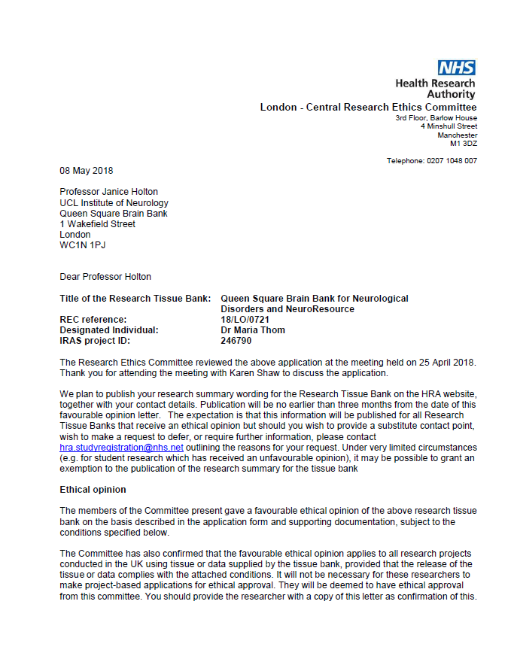

The Committee should be notified of all projects receiving tissue and data from the tissue bank by means of an annual report.
This application was for the renewal of a Research Tissue Bank application. The previous REC reference number for this application was 08/H0718/54.
Conditions of the favourable opinion
The favourable opinion is subject to the following conditions being met prior to the start of the Research Tissue Bank:
Informed consent documentation
- Please make clear in the informed consent documentation which aspects are mandatory for the donation to proceed and which are optional in that they will not stop the donation going ahead but relate to additional choices to be made; it is not entirely clear for example, whether the donor has to consent to points 6, 10 and 15 in order to donate.
- In the final paragraph under the heading ‘Actions to be taken at the time of the death of a donor’ in the QSBB information sheet, the phrase ‘including the opposition of next of kin’ should be inserted at the end of the second sentence.
- In both information sheets, under the heading ‘Important notes’, the sentence ‘Please note that next of kin can withdraw consent after death’ should be added.
Recommendation
The summary of the application in the answer to question A56 was found to provide the essential information, but it was considered that it could be re-written in a more readily understood style, utilising input from the public involvement and feedback received. If you do so, please do not amend the IRAS form but provide the new wording for the summary in a separate document.
Please notify the REC once all conditions have been met (except for site approvals from host organisations) and provide copies of any revised documentation with updated version
numbers. Revised documents should be submitted to the REC electronically from IRAS. The REC will acknowledge receipt and provide a final list of the approved documentation for the Research Tissue Bank, which can be made available to host organisations to facilitate their permission for the Research Tissue Bank. Failure to provide the final versions to the REC may cause delay in obtaining permissions.
Research governance
A copy of this letter is being sent to the R&D office responsible for UCL Institute of Neurology.
Under the Research Governance Framework (RGF), there is no requirement for NHS research permission for the establishment of research tissue banks in the NHS. Applications to NHS R&D offices through IRAS are not required as all NHS organisations are expected to have included management review in the process of establishing the research tissue bank.

Research permission is also not required by collaborators at tissue collection centres (TCCs) who provide tissue or data under the terms of a supply agreement between the organisation and the research tissue bank. TCCs are not research sites for the purposes of the RGF.
Research tissue bank managers are advised to provide R&D offices at all TCCs with a copy of the REC application for information, together with a copy of the favourable opinion letter when available. All TCCs should be listed in Part C of the REC application.
NHS researchers undertaking specific research projects using tissue or data supplied by the research tissue bank must apply for permission to R&D offices at all organisations where the research is conducted, whether or not the research tissue bank has ethical approval.
Site-specific assessment (SSA) is not a requirement for ethical review of research tissue banks. Registration of Research Tissue Banks
It is a condition of the ethical approval that all Research Tissue Banks are registered on the UK Clinical Research Collaboration (UKCRC) Tissue Directory. The Research Tissue Bank should be registered no later than 6 weeks after the date of this favourable ethical opinion letter or 6 weeks after the Research Tissue Bank holds tissue with the intention to provide for research purposes. Please use the following link to register the Research Tissue Bank on the UKCRC Directory: https://directory.biobankinguk.org/Register/Biobank Registration is defined as having added details of the types of tissue samples held in the tissue bank.
There is no requirement to separately notify the REC but you should do so at the earliest opportunity e.g. when submitting an amendment or when submitting an annual progress
report. We will monitor the registration details as part of the annual progress reporting process.
Summary of discussion at the meeting
Social or scientific value; scientific design and conduct of the study
The tissue bank was a well-recognised resource for neurological research conducted in-house and elsewhere. Stringent procedures were in place for accessing samples and data.
It was observed that an on-line database was planned to facilitate registration to participate by prospective donors, and details of how this would operate had been provided. It was enquired whether there were any additional changes of note. The applicants said that relatively minor amendments had been made to the consent documentation in the light of recommendations from the Human Tissue Authority. These included the provision of opting out of the use of the donated tissue in certain types of research, such as commercial research. As a result, the documentation was lengthier but those approached would be better informed.
As the consent forms gave a long list of yes/no options, it was asked whether a single ‘no’ option would preclude the donation. The applicants said that it would not, and the participant’s choices would be carefully recorded. The applicants were asked to provide definitive clarification on this point.

Recruitment arrangements and access to health information, and fair participant selection
The arrangements relating to recruitment were satisfactory. Potential donors would be identified by clinicians nationwide, and would then be asked whether they would like to receive information about the bank. Alternatively, they could self-refer on hearing of the bank, for example through a charity. Extensive public involvement had taken place with appropriate groups and was ongoing, and this was welcomed.
It was noted that donors were required to have a thorough grasp of English and interpreters would not be used because of lack of funding. It was asked whether this could result in the exclusion of tissue relating to any specific conditions in minority groups. The applicants acknowledged that the restriction was a potential barrier to some donations. They said that the issue had been considered at length and regrettably, financial constraints did not permit the use of interpreters.
Care and protection of research participants; respect for potential and enrolled participants’ welfare and dignity
Established governance procedures were in place for both tissue banks and the donor information database. Protection of confidentiality was robust, with researchers being provided with appropriately anonymised data sets.
An annual newsletter providing information and updates on current research utilising the tissue in the banks was sent to interested members of the public, charities and other recipients. The applicants raised the question of whether, in terms of the forthcoming General Data Protection Regulation, consent to provide details for receipt of the newsletter should be obtained. They were advised that this was a governance matter rather than an ethical one, but that if they wished to include an option in the informed consent documentation relating to this issue, it could be submitted with the response to the Committee’s decision letter.
Informed consent process and the adequacy and completeness of participant information
The consent process was in order with detailed and comprehensive information being given, and a suitable mechanism for the withdrawal of consent. Appropriate documentation was in place for post-mortem consent to be given by next of kin where they had knowledge that the donor would not have objected to this.
The position relating to genetic findings was raised, particularly as next of kin or appointed
representatives could decide whether not they wished to be informed of any significant genetic findings. The applicants acknowledged that this could be a difficult area. Reference was made to a recent legal case in which a father did not wish his daughter to be notified of a genetic condition; the daughter had challenged this and the decision was that she should be told of the condition as she was of child-bearing age. The implication was, therefore, that the onus in any such cases in which the tissue bank was concerned would be on the tissue bank managers to ensure that the correct stance was taken from a legal and ethical point of view. The applicants were asked to consider what would be done in such cases.
It was asked what would happen in the event that a potential donor agreed to donate tissue but, following the donor’s death, the next of kin did not wish the donation to take place. The applicants said that they tried to pre-empt such occurrences by encouraging discussion between the potential donors and their relatives, but confirmed that they would abide by the relatives’ wishes if they did not want the donation to proceed as they wanted to be sensitive to the relatives’ desires.

In practical terms, the situation would not arise since relatives would not inform the tissue bank of the potential donor’s death if they did not wish the donation to be made. It was appreciated that the information sheets indicated that there could be certain circumstances in which donation could not go ahead, but the applicants were asked to include a statement in the information sheets about this particular possibility for completeness of information.
The applicants were also asked to make clear in the informed consent documentation which aspects were mandatory for the donation to proceed and which were optional in that they would not affect the donation going ahead but were additional choices to be made.
Summary of the Research Tissue Bank
The summary of the application in the answer to question A56 was found to provide the essential information, but it was considered that it could be re-written in a more readily understood style, utilising input from the public involvement and feedback received. It was recommended to the applicants that they revised the summary in this way.
Other ethical issues were raised and resolved in preliminary discussion before your attendance at the meeting.
Please contact the REC Manager if you feel that the above summary is not an accurate reflection of the discussion at the meeting.
Research Tissue Bank Renewals
The Research Tissue Bank has been renewed for a further five years from the end of the previous five year period. The previous five year period ran from 6 August 2013. This Research Tissue Bank may be renewed for further periods of five years at a time by following the process described in the above paragraph.
Approved documents
The documents reviewed and approved at the meeting were:
Document | Version | Date
Covering letter on headed paper |  | 04 April 2018
Human Tissue Authority licence [UCL Institute of Neurology] |  | 06 February 2012
IRAS Checklist XML [Checklist_11042018] |  | 11 April 2018
IRAS Checklist XML [Checklist_11042018] |  | 11 April 2018
Other [Queen Square Brain Bank Donor Registration Form] | 3 | 04 April 2018
Other [NeuroResource Donor Registration Form] | 3 | 04 April 2018
Other [Annual Report] |  | 13 September 2017
Other [CV - Janice Holton]
Other [Queen Square Brain Bank Donor Self-Assessment Form]
Other [Queen Square Brain Bank Consent to Diagnostic Genetic Testing after Death] | 2 | 04 April 2018
Other [NeuroResource Consent to Diagnostic Genetic Testing after Death] | 2 | 04 April 2018

Participant consent form [Queen Square Brain Bank Consent to Tissue Donation] | 3 | 04 April 2018
Participant consent form [NeuroResource Consent to Tissue Donation] | 3 | 04 April 2018
Participant information sheet (PIS) [Queen Square Brain Bank Information on Tissue Donation] | 3 | 04 April 2018
Participant information sheet (PIS) [NeuroResource Information on Tissue Donation] | 3 | 04 April 2018
Protocol for management of the tissue bank
REC Application Form [RTB_Form_11042018] |  | 11 April 2018
Relative consent form [Queen Square Brain Bank Post Mortem Consent to Tissue Donation] | 3 | 04 April 2018
Relative consent form [NeuroResource Post Mortem Consent to Tissue Donation] | 3 | 04 April 2018
Summary of research programme(s) [Queen Square Brain Bank Tissue Requests for 2016]
Summary of research programme(s) [NeuroResource samples prepared for research studies October 2016 to August 2017]

Licence from the Human Tissue Authority
Thank you for providing a copy of the above licence.
Membership of the Committee
The members of the Ethics Committee who were present at the meeting are listed on the attached sheet.
Statement of compliance
The Committee is constituted in accordance with the Governance Arrangements for Research Ethics Committees and complies fully with the Standard Operating Procedures for Research Ethics Committees in the UK.
After ethical review Reporting requirements
The attached standard conditions give detailed guidance on reporting requirements for research tissue banks with a favourable opinion, including:
• Notifying substantial amendments
• Submitting Annual Progress reports
The HRA website also provides guidance on these topics, which is updated in the light of changes in reporting requirements or procedures.
User Feedback
The Health Research Authority is continually striving to provide a high quality service to all applicants and sponsors.

You are invited to give your view of the service you have received and the application procedure. If you wish to make your views known please use the feedback form available on the HRA website: http://www.hra.nhs.uk/about-the-hra/governance/quality-assurance/
HRA Training
We are pleased to welcome researchers and R&D staff at our training days – see details at http://www.hra.nhs.uk/hra-training/
18/LO/0721 Please quote this number on all correspondence
Yours sincerely
pp
Dr Andrew Hilson Chair
E-mail: NRESCommittee.London-Central@nhs.net
Enclosures: List of names and professions of members present at the meeting
Standard approval conditions
Copy to:
Dr Maria Thom, UCL Institute of Neurology

AMENDMENT TO THE PROVIDER’S NHS ETHICS COMMITTEE APPROVAL, MARCH 2019
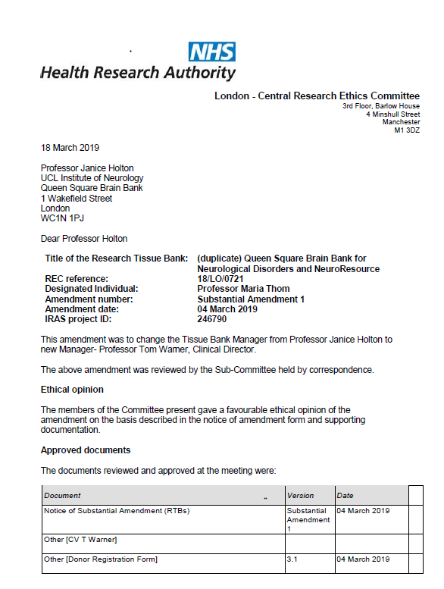

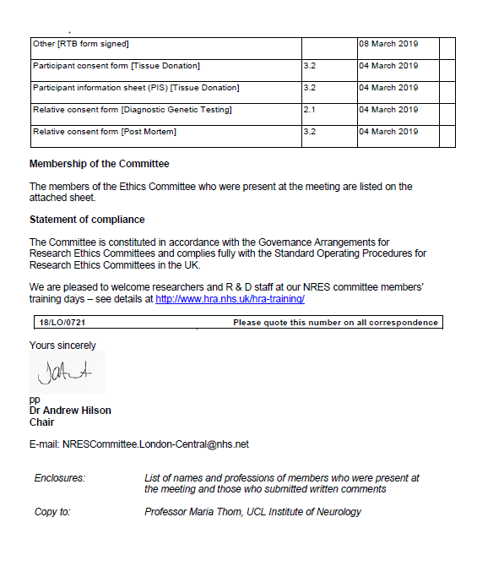

APPENDIX C: COPY OF THE PROVIDER’S CONSENT FORM

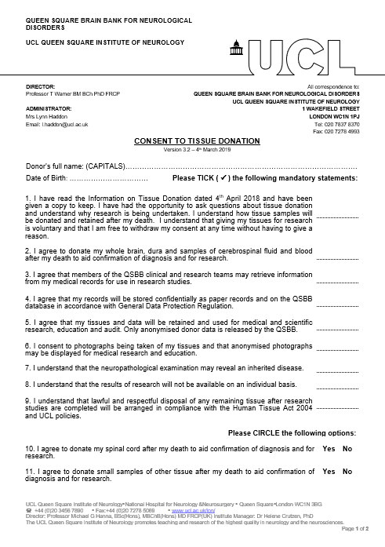

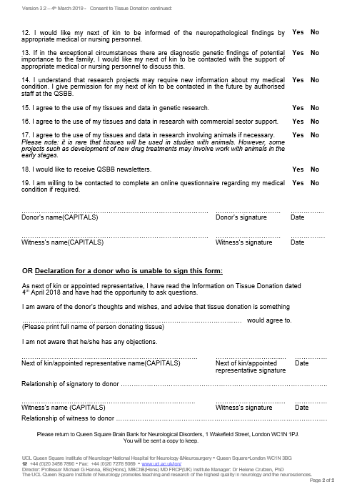

2018-10-24, v.05-B. APPENDIX D Page 1 of 1.

DISPATCH AND CONFIRMATION OF RECEIPT FORM: HUMAN SAMPLES SENT FROM THE QUEEN SQUARE BRAIN BANK FOR NEUROLOGICAL DISORDERS
This form should be e-mailed to the recipient before samples are dispatched.
DISPATCH INFORMATION
Proposed date and time of dispatch:
Recipient name and address for delivery:

e-mail address and phone number:
Samples: Batch codes(s):
Format(s): Frozen and in dry ice □ In wet ice □ At room temperature □
In fixative: Type: Fragile contents, e.g. glass slides □
Any additional information, including potential biological hazards: None known □ or:
...........................................................................................................................................
Sender name and address:

e-mail address and phone number:
Courier/collector name and phone number:

Courier tracking number: Airway bill number:
If to be tracked, this will be carried out by: Sender □Recipient □ Both □

If any problems arise during transit, all parties should be alerted and action taken as necessary.

CONFIRMATION OF RECEIPT OF SAMPLES
Date and time of arrival: ………………………….….….................................……………….…………………
All samples were unpacked and stored under appropriate conditions at:
-80ºC □ +4ºC □ Room temperature □ Other .......................................
In additional fixative: □ Fixative type: ........................................................................

Signed: ………………………...………………………….................…….………………….…….......…….............

Name in capitals: ……………….…………….………..................….....……….……………...………………...…
Please would you scan and e-mail, or fax, this page to: Linda Parsons, E-mail address: l.parsons@ucl.ac.uk Fax No.: +44 (0)20 7278 4993

APPENDIX E

COPY OF THE RECIPIENT’S RELEVANT NHS RESEARCH ETHICS
COMMITTEE APPROVAL

(If applicable)

The Human Tissue Act 2004 applies to the use of “Relevant Materials” which include human cells (but not cell lines), tissue and organs from a living or deceased person for the removal, storage and use in “Scheduled Purposes” which include research on disorders or the function of the human body, and education relating to human health (from the HTA Code A – Guiding Principles and the Fundamental Principle of Consent, and also Code E – Research Code of Practice). If a sample contains even a single cell from a human body it is classified as Relevant Material. On the HTA Website the Relevant Material definition and link to a Relevant Materials List is at: http://www.hta.gov.uk/legislationpoliciesandcodesofpractice/definitionofrelevantmaterial.cfm.
Applicable laws and guidance means all laws, rules, regulations, Codes of Practice, research governance or ethical guidelines, or other requirements of any Regulatory Authority, that may apply to the use of the Material by the RECIPIENT from time to time, including (but not limited to) the Human Tissue Act 2004 or the Human Tissue (Scotland) Act 2006, and the current HTA Directions and Codes of Practice.

