UCL Feminisms Reading Group - October 4th

‘A Vision of Loneliness and Riot’: Fame, Friendship, and Fear in Margaret Cavendish’s Sociable Letters (1664)

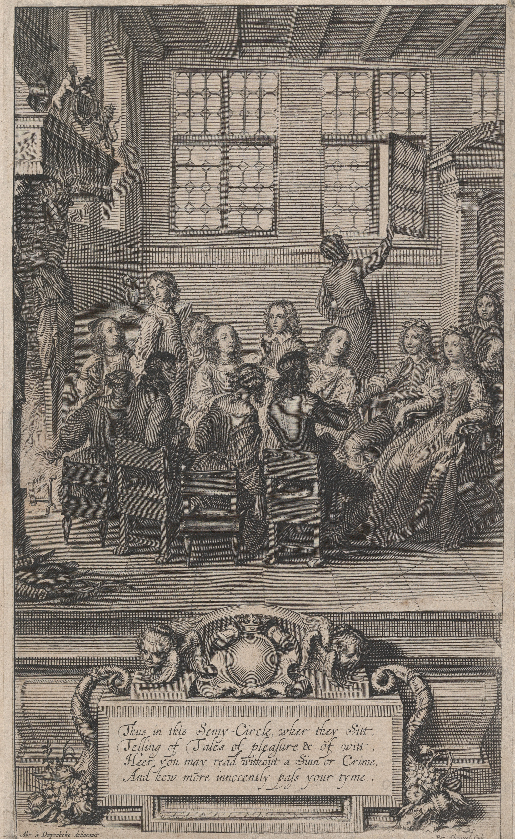
The Frontispiece to Natures Pictures (1656) by Margaret Cavendish

As the bold ‘Authoress’ behind numerous volumes of poetry, prose, plays, essays, letters, and scientific treatises, Margaret Cavendish (1623-1673) defied both the gendered and generic norms of the seventeenth century. Her boldness earned her the epithet ‘Mad Madge’ and the biting rebuke of critics throughout history – in A Room of One’s Own, Virginia Woolf dismissed Cavendish as ‘a giant cucumber’ whose writing was ‘noble and Quixotic and high-spirited, as well as crack-brained and bird-witted’. And yet, while Cavendish certainly had her eccentricities, her work also shone with unique creativity, wit, and sensitivity. Nowhere is Cavendish’s dazzling imagination more evident than in her 1664 Sociable Letters – a collection of fictional correspondences which touch upon topics as varied as atomic theory, medicine, astrology, beauty regimes, food, gossip, marriage, death, childbirth, and history. While Woolf might have described Cavendish as a ‘vision of loneliness and riot’, Cavendish’s Sociable Letters speak instead to her passionate desire for friendship and fame, as well as her vulnerability as a writer and her wariness of the scathing eye of the public. The following packet contains the prefatory material to Sociable Letters, as well as a few selections from the epistles themselves.
TO HIS EXCELLENCY THE LORD MARQUESS OF NEWCASTLE.

MY LORD,
It may be said to me, as one said to a Lady, Work Lady, Work, let writing Books alone, For surely Wiser Women ne’r writ one; But your Lordship never bid me to Work, nor leave Writing, except when you would perswade me to spare so much time from my Study as to take the Air for my Health; the truth is, My Lord, I cannot Work, I mean such Works as Ladies use to pass their Time withall, and if I could, the Materials of such Works would cost more than the Work would be worth, besides all the Time and Pains bestow’d upon it. You may ask me, what Works I mean; I answer, Needle-works, Spinning-works, Preserving-works, as also Baking, and Cooking-works, as making Cakes, Pyes, Puddings, and the like, all which I am Ignorant of; and as I am Ignorant in these Imployments, so I am Ignorant in Gaming, Dancing, and Revelling; But yet, I must ask you leave to say, that I am not a Dunce in all Imployments, for I Understand the Keeping of Sheep, and Ordering of a Grange, indifferently well, although I do not Busie my self much with it, by reason my Scribling takes away the most part of my Time. Perchance some may say, that if my Understanding be most of Sheep, and a Grange, it is a Beastly Understanding; My answer is, I wish Men were as Harmless as most Beasts are, then surely the World would be more Quiet and Happy than it is, for then there would not be such Pride, Vanity, Ambition, Covetousness, Faction, Treachery, and Treason, as is now; Indeed one might very well say in his Prayers to God, O Lord God, I beseech thee of thy Infinite Mercy, make Man so, and order his Mind, Thoughts, Passions, and Appetites, like Beasts, that they may be Temperate, Sociable, Laborious, Patient, Prudent, Provident, Brotherly-loving, and Neighbourly-kind, all which Beasts are, but most Men not. But leaving most Men to Beasts, I return to your Lordship, who is one of the Best of men, whom God hath fill’d with Heroick Fortitude, Noble Generosity, Poetical Wit, Moral Honesty, Natural Love, Neighbourly-kindness, Great Patience, Loyal Duty, and Celestial Piety, and I pray God as Zealously and Earnestly to Bless you with Perfect Health and Long Life, as becomes

Your Lordships Honest Wife and Humble Servant M. Newcastle.

TO ALL PROFESSORS OF Learning and Art.

Most Famously Learned,
I wish I could Write so Wisely, Wittily, Eloquently, and Methodically, as might be Worthy of your Perusal; but if any of your Noble Profession should Humble themselves so Low as to Read my Works, or part of them, I pray Consider my Sex and Breeding, and they will fully Excuse those Faults which must Unavoidably be found in my Works. But although I have no Learning, yet give me leave to Admire it, and to wish I were one of your Society, for certainly, were I Emperess of the World, I would Advance those that have most Learning and Wit, by which I believe the Earth would rather be an Heaven, since both Men and Government would be as Celestial, for I am Confident that Wisdom, and for the most part Virtue, is Inherent in those that are Masters of Learning, and Indued with Wit; And to this sort of Persons I do Offer my Works, although to be Condemned on the Altar of their Censure, and rest Satisfied with the Honour that they thought them Worthy to be Iudged. Thus, whether my Works Live or Dye, I am Devoted to be

Your Servant M.N

THE PREFACE.

Noble Readers,
I hope you will not make the Mistake of a Word a Crime in my Wit, as some former Readers have done, for in my Poems they found Fault that the Number was not Just, nor every Line Matched with a Perfect Rime
[…]
As for the Present Book of Letters, I know not as yet what Aspersion they will lay upon it, but I fear they’l say, they are not written in a Modestyle, that is, in a Complementing, and Romancical way, with High Words, and Mystical Expressions, as most of our Modern Letter-writers use to do; But, Noble Readers, I do not intend to Present you here with Long Complements in Short Letters, but with Short Descriptions in Long Letters; the truth is, they are rather Scenes than Letters, for I have Endeavoured under the Cover of Letters to Express the Humors of Mankind, and the Actions of Man’s Life by the Correspondence of two Ladies, living at some Short Distance from each other, which make it not only their Chief Delight and Pastime, but their Tye in Friendship, to Discourse by Letters, as they would do if they were Personally together, so that these Letters are an Imitation of a Personal Visitation and Conversation, which I think is Better (I am sure more Profitable) than those Conversations that are an Imitation of Romancical Letters, which are but Empty Words, and Vain Complements. But the Reason why I have set them forth in the Form of Letters, and not of Playes, is, first, that I have put forth Twenty Playes already, which number I thought to be Sufficient, next, I saw that Variety of Forms did Please the Readers best, and that lastly they would be more taken with the Brevity of Letters, than the Formality of Scenes, and whole Playes, whose Parts and Plots cannot be Understood till the whole Play be Read over, whereas a Short Letter will give a Full Satisfaction of what they Read. And thus I thought this to be the Best Way or Form to put this Work into, which if you Approve of, I have my Reward.

UPON HER EXCELLENCY THE AUTHORESS.

This Lady only to her self she Writes,
And all her Letters to her self Indites;
For in her self so many Creatures be,
Like many Commonwealths, yet all Agree.
Man’s Head’s a World, where Thoughts are Born and Bred,
And Reason’s Emperour in every Head;
But in all Heads doth not a Caesar Reign,
A Wise Augustus hath not every Brain,
And Reason in some Brains from Rule’s put out.
By Mad, Rebellious Thoughts, and Factious Rout;
And Great Disorder in such Brains will be,
Not any Thought with Reason will Agree;
But in her Brain doth Reason Govern well,
Not any Thought ‘gainst Reason doth Rebell,
But doth Obey what Reason doth Command,
When ’tis his Will, doth Travel Sea and Land,
As some do Travel out to Kingdomes far,
And Guided are by Observation’s Star,
They bring Intelligence from every State,
Their Peace, their Wars, their Factions, and their Hate,
And into every City Travel free,
Relate their Customs, Trafficks, Policy,
Observe each Magistrate, their Formal Face,
And what Authority they bear, or Place,
Whether they Covetously do Extort,
Or are Ambitious, giving Bribes at Court,
To Raise to Places, or to Hide their Crime,
For thus Men do to Wealth and Office Clime;
And some into the Churches go to see
Who Kneels in Pray’r, or comes for Company,
Who Courts his Mistress as his only Saint,
Implores her Favour, and makes his Complaint
Be Known, Or who doth turn her eyes about,
To shew her Face, or seek a Lover out;
And some to Balls, and Masks, and Playes do go,
And some do Crowd to see a Pagan Shew,
And some within Kings Courts do get a Place,
Observe the Grandeur, and the Courtly Grace,
The Ceremony and Splendor of a Court,
Their Playes, Balls, Masks, and every several Sport,
And all their Amorous Courtships which they make,
And how the Ladies do each Courtship take,
The Antick Postures of the Younger Race,
Their Mimick Gestures, and Affected Pace,
Their Amorous Smiles, and Glancing Wanton Eyes,
All which do Noble Souls Hate and Despise;
And some amongst the Privy-Counsel get,
Where round a Table Prince and Nobles sit,
Hear what they say, Observe their Cross Debates,
And mark which speaks through Faction, or which Hates
Some Lord that is in Favour more than he,
For in States Matters seldom they Agree.
And thus Her Thoughts, the Creatures of her Mind,
Do Travel through the World amongst Mankind,
And then Return, and to the Mind do bring
All the Relations of each several thing;
And Observation Guides them back again
To Reason, their Great King, that’s in the Brain:
Then Contemplation calls the Senses straight,
Which Ready are, and Diligently Wait,
Commanding Two these Letters for to Write,
Touch in the Hand, as also the Eye-sight,
These Two the Soul’s Clerks are, which do Inscribe,
And Write all Truly down, having no Bribe.

TO THE CENSORIOUS READER.

Reader, you’l think, perchance, my Wit in Fault,
Like Meat that’s too much Brin’d, and Oversalt,
But better Poets far than I have been,
Have written Sharper, and with Greater Splene,
Yet they have much been Prais’d for writing so,
And on Advancing Stigues of Fame do go;
But my Poor Writings they no Malice know,
Nor on a Crabbed Nature did they Grow;
I to Particulars give no Abuse,
My Wit Indites for Profitable Use,
That Men may see their Follies, and their Crimes,
Their Errours, Vanities, and Idle Times,
Not that I think they do not Know them well,
But lest they should Forget, Im’ Bold to tell,
For to Remember them, like those that Ride,
Not thinking, on their Way, may chance to Slide,
Or Fall into a Ditch, so I for Fear
Bid them take Heed, Beware, and have a Care,
For there are Stumps of Trees, or a Deep Pit,
Or Dangerous Passages where Thieves do sit
And Wait, or Ravenous Beasts do lye for Prey,
Or such a Lane where’s Foul and Dirty Way,
And so of Waters, and each Dangerous place:
But I write not to any mans Disgrace;
Then Censure not my Satyr-wit for Crime,
Nor putting this Epistle into Rime.

Sociable Letters

I.
MADAM,
You were pleas’d to desire, that, since we cannot converse Personally, we should converse by Letters, so as if we were speaking to each other, discoursing our Opinions, discovering our Designs, asking and giving each other Advice, also telling the several Accidents, and several Imployments of our home-affairs, and what visits we receive, or entertainments we make, and whom we visit, and how we are entertaind, what discourses we have in our gossiping-meetings, and what reports we hear of publick affairs, and of particular Persons, and the like; so that our Letters may present our personal meetings and associatings. Truly, Madam, I take so much delight in your wise, witty, and virtuous Conversation, as I could not pass my life more pleasing and delightfully; wherefore I am never better pleased, than when I am reading your Letters, and when I am writing Letters to you; for my mind and thoughts are all that while in your Company: the truth is, my mind and thoughts live alwayes with you, although my person is at distance from you; insomuch, as, if Souls die not as Bodies do, my Soul will attend you when my Body lies in the grave; and when we are both dead, we may hope to have a Conversation of Souls, where yours and mine will be doubly united, first in Life, and then in Death, in which I shall eternally be,
Madam,
Your faithful Friend and humble Servant.

XV.
MADAM,
Yesterday was the Lord N.W. to visit me, where amongst other Discourses we talk’d of the Lady T.M. not sooner was her name mentioned, but he seem’d to be rapt up into the third Heaven, and from thence to descend to declare her Praises; and to repeat his Expressions, they were so extraordinary, as they will not easily go out of my Memory, so as you shall have them word for word. First, he said, She was a Lady fit to be the Empress of the whole world, for though Fortune had not given her a Temporal Imperial Crown, Dignity and Title, as neither by Inheritance, Victory, nor Choice, nor had not advanced her to a Temporal Imperial Power, nor placed her on a Temporal Imperial Throne, nor held she a Temporal Imperial Scepter, yet she was Crown’d at her Birth the Empress of her Sex; for though Fortune had not Crown’d her Body, yet Nature had Crown’d her Soul with a Celestial Crown, made of Poetical Flame, instead of Earthly Gold that Crown’s the Body; and instead of Diamonds, Pearls, and other pretious Stones set in Golden Crowns, her Celestial Crown was set with Understanding, Judgement and Wit, also with clear Distinguishings, oriental Similizings, and sparkling Fancies, a Crown more glorious than Ariadne’s Crown of Stars; and though she was not advanced on a Temporal Imperial Throne, yet she was set higher, as on a Throne of Applause; and though she possess’d not a Temporal Imperial Power, nor held a Temporal Imperial Scepter, yet she had a powerful Perswasion and the tongue of Eloquence; and though she was not adorn’d with Imperial Robes, yet she was adorn’d with Natural Beauty; and though she had not a Temporal and Imperial Guard, yet she was guarded with Virtue; and though she was not attended, waited and served with and by Temporal and Imperial Courtiers, yet she was attended, waited on, and served by and with the sweet Graces, and her Maids of Honour were the Muses, and Fame’s house was her Magnificent Palace. Thus was she Royally Born, and Divinely Anointed or Indued, and Celestially Crown’d, and may Reign in the memory of every Age and Nation to the world’s end; and not onely Reign, but Reign Happily, Gloriously, and Famously. But when he had said what I have related, I could not chuse but smile, to hear such Poetical commendations of a Woman, doubting none of our Sex was worthy of such high, and far-fetch’d Praises; he ask’d me why I smil’d? I told him, I smil’d to observe how the Passion of Love had bribed his Tongue; he said, he was not guilty of partial Bribes, but Justice had commanded his Tongue to speak the Truth: I told him, I was glad to find, at least to hear, that there was Justice in Men, and Merit in Women, as the one to Praise, the other to be Praise-worthy; but I pray’d him to give me leave, or to pardon me, if I told him, that his Speech shew’d, or express’d him not a Temporal and Imperial Courtier, as to praise one Lady to another, and to give so many Praises to an absent Lady, as to leave no Praises for the present Lady: He pray’d me to pardon him that Errour, and that hereafter he would alwayes Praise that Lady he was present with. But, Madam, those Praises given the Lady T.M.had I been apt to Envy, it had turn’d me all into Vinegar, or dissolv’d me into Vitriol; but being unspotted, and free from that speckled Vice, I am heighten’d with joy to hear any of our Sex so Celestial, as to deserve a Celestial Praise: And leaving you to the same Joy, I rest,
Madam,
Your faithful Friend and Servant.

XXII.
MADAM,
You said in your last Letter, that Sir G.A. doth so brag of his own gallant Actions, as he saves his neighbour the labour to report them; I am sorry to hear gallant men should brag of their own Actions, for their bragging takes off the gloss of their Courage; for as Time takes off Youth or fresh Colour off Beauty, so Self-praise takes off the Esteem and Honour of Merit: But as some will boast of their own Worth, so others will boast of their own Baseness, as what subtil Cheats they have practised, or whom they have Betrayed, or how ingenious they were in telling Lies, or how many Robberies they have committed; as also of their Disobedience, Disloyalty, and the like; others will boast of their Debaucheries, as how often they have had the French Disease, how many Women they have Debauch’d, how much they can Drink before they are Drunk, and how long they can sit a Drinking, what Monies they have Won or Lost at Play, how Vain and Expensive they are, or have been, and many the like, which I wonder at, that men should Glory and take a Pride in that which is Base or Foolish: But this argues some men to have mean Souls and foolish Brains, full of idle Discourses, wanting Judgement and Wit; also unprofitable Lives, and when they Die there is a good riddance, for they were but as Rubbish in the World, which Death, like as an honest painful Labourer, takes up like as Dunghils, and throws them into the Grave, and buries them in Oblivion, not being worthy of a monument of Remembrance, in which Grave I leave those that are Dead, and those that Live I wish may be Reformed to more Purity; so I rest,
Madam,
Your faithful Friend and Servant.

XXIX.
MADAM,
I heard by your last, that the Lady S.P. was to visit you, where, amongst her other Discourses, she spoke of me, and was pleased to Censure and Condemn, as to Censure the Cause, and Condemn the Manner of my Life, saying, that I did either Retire out of a Fantastick Humour, or otherwise I was Constraind, in not having the Liberty, that usually other Wives have, to go Abroad, and receive what Visitors they please: But if she did but know the sweet Pleasures, and harmless Delights I have by this Retirement, she would not have said what she did; and to answer to what she said, This course of Life is by my own voluntary Choice, for I have liberty to do any Thing, or to go any Where, or to keep any Company that Discretion doth Allow, and Honour Approve of; and though I may err in my Discretion, yet not in cases of Honour, for had I not onely Liberty, but were Perswaded or Inticed by all the World’s Allurements, or were Threatned with Death, to Do, or Act any thing against Honour, or to do any Thing or Act, Honour did not Approve of, I would not Do it, nay, I would Die first: But in that which is called Honour, are many Ingrediencies, as Justice, Chastity, Truth, Trust, Gratitude, Constancy, and many the like. Next I answer, That it is not out of a Fantastick Humour, that I live so much Retired, which is to keep my House more than go Abroad, but out of Self-love, and not out of Self-opinion, and it is Just and Natural for any one to Love himself: Wherefore, for my Pleasure and Delight, my Ease and Peace, I live a Retired Life, a Home Life, free from the Intanglements, confused Clamours, and rumbling Noise of the World, for I by this Retirement live in a calm Silence, wherein I have my Contemplations free from Disturbance, and my Mind lives in Peace, and my Thoughts in Pleasure, they Sport and Play, they are not Vext with Cares nor worldly Desires, they are not Covetous of worldly Wealth, nor Ambitious of empty Titles; they are not to be catch’d with the Baits of Sensual Pleasures, or rather I may say, Sensual Follies, for they Draw my Senses to them, and run not out to the Senses; they have no quarrelling Disputes amongst them; they live Friendly and Sociably together; their onely Delight is in their own Pastimes and harmless Recreations; and though I do not go Personally to Masks, Balls, and Playes, yet my Thoughts entertain my Mind with such Pleasures, for some of my Thoughts make Playes, and others Act those Playes on the Stage of Imagination, where my Mind sits as a Spectator, Thus my Mind is entertain’d both with Poets and Players, and takes as much Delight as Augustus Caesar did to have his Mecaenas, the Patron of Poets, sit and hear Virgil and Horace read their Works unto them…

[…]

…and thus I take as much Pleasure within my self, if not more, as the Lady S.P. doth without her self; indeed none enjoyes truly himself, but those that live to themselves, as I do, and it is better to be a Self-lover in a Retired Life, than a Self-seeker in a Wandring Humour, like a Vagabond, for they go from Place to Place, from one Company to another, and never are at rest in their Minds nor Bodies; and how should it be otherwise? for they lose themselves in Company, and keeping much Company, they know not where to find themselves, for as for their Dwelling-place, they are sure to miss of themselves there; but indeed they have no constant Dwelling, for going much Abroad, they dwell Every where, and yet to speak Metaphorically, No where. But every ones Delights are different, for the Lady S.P. delights her self with Others, and I delight my self with my Self; Some delight in Troubles, I delight in Ease, and certainly much Company and Conversation cannot chuse but be Troublesome; for in much Company are many Exceptions, much Envy, much Suspicion, much Detraction, much Faction, much Noise, and much Non-sense, and it is impossible, at least improbable, for any particular Person to please all the several Companies they come into, or are visited by, if the Resort be many, by reason every one hath as different Humours as Faces, wherein some will be Displeased, if others should be Pleased, and most commonly they are so far from pleasing All, as None is Pleased; for if any particular Person should Praise Every one, it would be thought Flattery, if he should Praise None, it would be conceived to be Envy, if he should Praise but Some, it would be judged to be Partiality; the like for Discourse; if one should Address his Discourse to any One, or to Some more than to Others, it would be taken as a Disrespect, if Generally, to the whole Company, it would be accounted Pride, as taking ones self to be the onely Singular Person that must have a General Audience; neither can any one Person fit his Discourse to every one’s Humour, Fancy, Capacity, Understanding, Knowledge or Delight, nay, most commonly, whatsoever is Spoken, is Interpreted to the worst Sense, at least, Contradicted, and when they are parted, their Words or Discourse is Repeated to their Disadvantage, and Commented on, and Interpreted to an evil Sense; and if they say Nothing, or but Little, they are accounted Ill-natured, or thought Fools, and yet they love not to hear any one speak but themselves, every one desires to be heard, yet takes it ill not to be spoken to; also if particular Persons make an Entertainment, if they invite not those they have no acquaintance with, as well as those of their Acquaintance, if they are within the distance of coming to the Entertainment, they take it for an Affront, but if they should leave out any Acquaintance, it is a Breach for ever, and they become their Enemies: also if particular Persons be accoustred Bravely, they are Envied, if they be attired in plain, mean Garments, they are Despised; and if any Woman be more Beautiful than commonly the rest are, if she appears to the World, she shall be sure to have more Female Detractors and Slanderers, to ruin her Reputation, than any Monarch hath Souldiers to fight an Enemy, & if any Woman be Ill-favoured, it is mentioned as a Reproach, although it be Nature’s fault, and not hers, and if she be indifferently Handsom, they speak of her as Regardless; if she be in Years, they will say, she is fitter for the Grave than Company, if Young, fitter for a School than Conversation, if of middle Years, their Tongues are the Fore-runners of her Decay; if she have Wealth, and no Titles, she is like Meat, all Fat and no Blood, and if great Title with small Wealth, they say, she is like a Pudding without Fat, and if she hath both Wealth and Title, they Shun her as the Plague, they Hate to see her, as Owls hate the Light, and if she hath neither Wealth nor Title, they Scorn her Company, and will not cast an eye towards her; and thus the Generality is to every Particular: wherefore it is impossible for any Particular either to Please the Humours, or Avoid the Slanders or Reproaches of the Generality, for every One is against Another; indeed, every One is against All, and All against every One, and yet through the itch of Talk, Luxury, Wantonness and Vanity, they will Associate into Companies, or rather I may say, Gather into Companies, and Frequent each others Houses, whereas those that endeavour to be truly Happy, will not be Troubled with such Follies, nor Disturbed with such Toyes: But I am not so Retir’d, as to bar my self from the Company of my good Friends, or such as are free from Exception, as not to Translate harmless and simple Words, to an evil Sense or Meaning, or such as are so Noble, as not to Dispraise, or Detract from such Persons as they are pleas’d to take the pains to Visit, or from such as will not take it for a Neglect, if I do not punctually return their Visit, or perhaps not Visit them at any time, but will Excuse or Pardon my Lazy Humour, and not account it a Disrespect, as truly it is none, for I do Honour and Admire all Civil, Worthy, and Honourable Persons, and would be ready at all times Honestly to Serve them. But this Retired Life is so Pleasing to me, as I would not change it for all the Pleasures of the Publick World, nay, not to be Mistress of the World, for I should not desire to be Mistress of that which is too Big to be Commanded, too Self-willed to be Ruled, too Factious to be Govern’d, too Turbulent to live in Peace, and Wars would Fright, at least Grieve me, that mankind should be so Ill-natur’d and Cruel to Destroy each other. To conclude, I am more Happy in my Home-retirement, than I believe the Lady S.P. is in her Publick Frequentments, having a Noble and Kind Husband, who is Witty and Wise Company, a Peaceable and Quiet Mind, and Recreative Thoughts, that take harmless Liberty; and all this I have declar’d to you, that you may let the Lady S.P. know that my Retirement from the publick Concourse and Army of the World, and Regiments of Acquaintance, is neither through Constraint, nor Fantastick Humour, but through a Love to Peace, Ease, and Pleasure, all which you Enjoy; which is the fulfilling of your Ladiships faithful Friend and Servant’s Happiness.

LXXXIII.
MADAM,
In your last Letter you Chid me for Loving too Earnestly, saying, Extreme Love did Consume my Body and Torment my Mind, and that whosoever Love to a High Degree are Fools; If so, I Confess, Madam, I am as much a Fool as ever Nature made, for where I set my Love, it is Fix’d like Eternity, and is as Full as Infinite; My Love is not Fix’d Suddenly, for it takes Experience and Consideration to help to Place it, both which have been my Guides and Directors to Love you, which makes me Love you Much, and shall make me Love you Long, if Souls Die not, and so I shall alwayes, and in all occasions be,
Madam,
Your Constant Friend and Humble Servant.

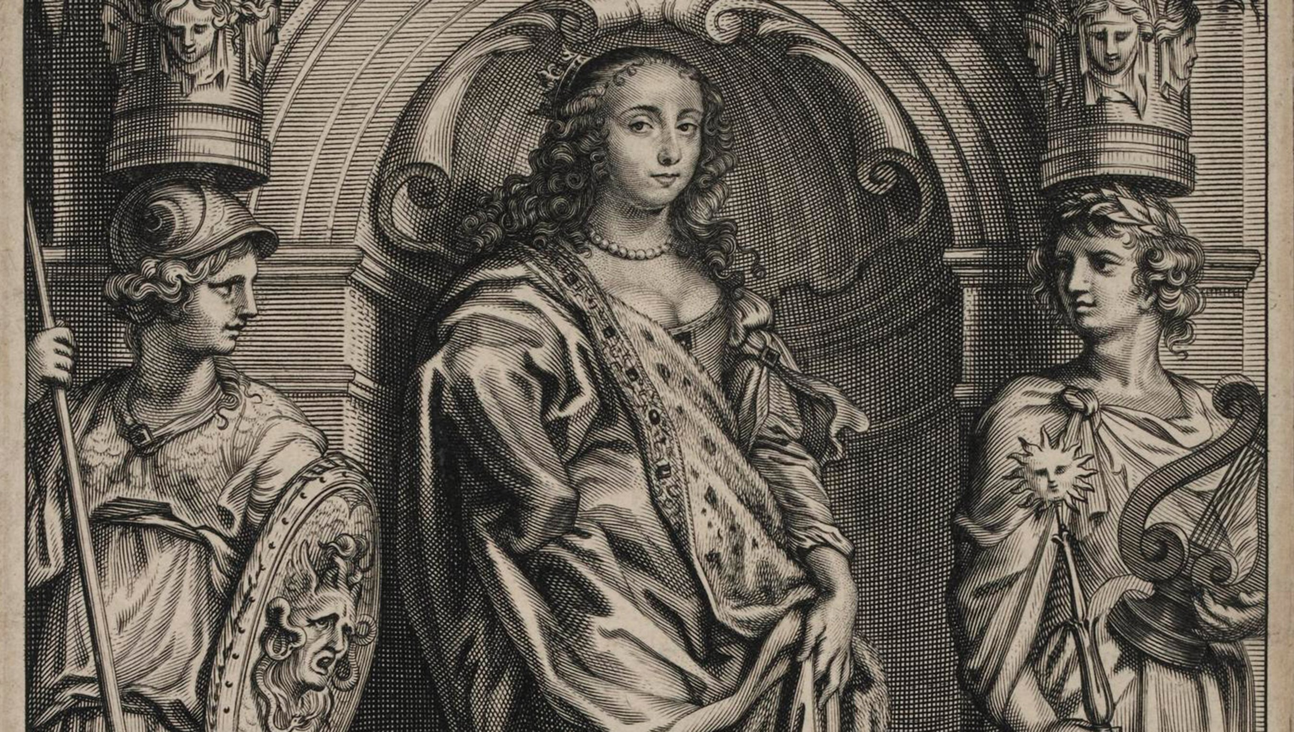
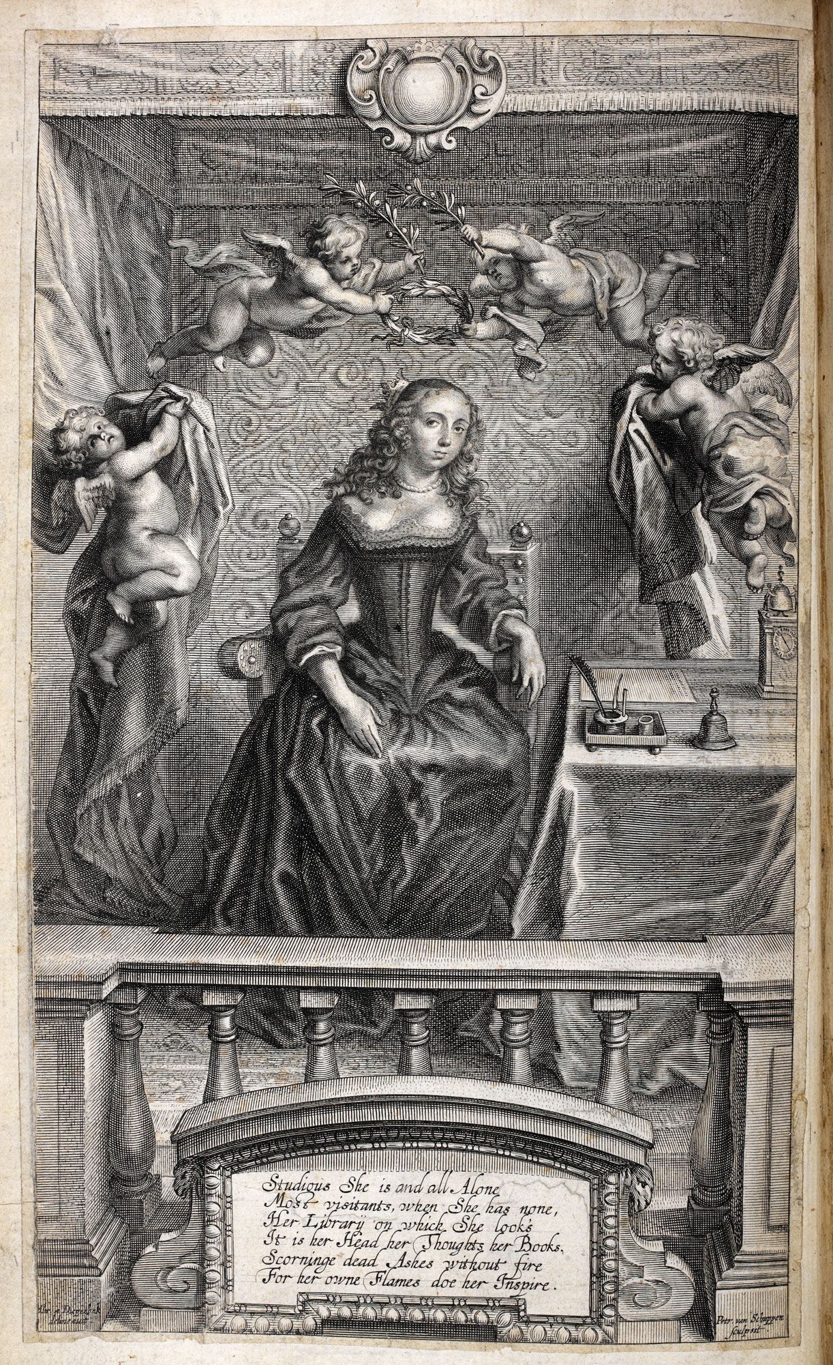
Frontispiece to The World’s Olio (1671)

