The Screen Media and Theory Workshop: Uncertainty, Turbulence and Moving Image Archives was held between the 11th and 12th June 2019 at University College London and King’s College London. It was a collaboration between three research groups: the German Screen Studies Network current research project ‘Circulating Cinema’, the Uncertain Archives international research collective and the UCL Turbulence research project. In the context of the digital revolution, with the new possibilities for data manipulation and anxieties about a post-truth era it has brought with it, the workshop considered themes of uncertainty, turbulence and the archive from the perspective of arts and humanities research, film and cultural theory in a rich and varied dialogue between academics and practitioners.

The event started with two reading workshops discussing recent publications in archive, documentary and new media theory including theorists such as Hito Steyerl, Wendy Hui Kyong Chun and Elisabeth Cowie. After a short introduction to the respective texts, participants formed discussion circles to engage in thought-provoking debates on the turbulence and uncertainty created by new technological and social evolutions and by changing techniques of archiving in relation to their individual research and the themes of the workshop.

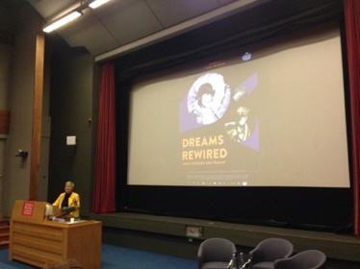
During the workshop, two artists contributed talks and screenings from their moving image works. Artist and academic Rose Butler contributed a talk to the workshop, guiding listeners through her use of historical moving-image material from the Stasi archives and her experimental photography using antique spy cameras to handle contemporary surveillance problematics resulting from the UK Investigatory Powers Act. Members of the public joined participants of the workshop on the evening of 11th June for a keynote and screening by filmmaker and artivist Manu Luksch, who presented her work with found CCTV and film footage in experimental documentaries such as Faceless (2007) and Dreams Rewired (2015) and introduced her most recent film project Algo-Rhythm (2018), which draws on Senegalese rap and point cloud data visualisations and won the ZONTA Award at the Oberhausen short film festival in 2019.

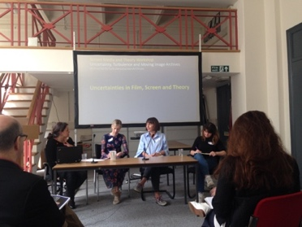
The second day of the workshop took on a more classic conference format, with four panels on media theory, contemporary screen practices, right- and left-wing mobilisations of archives, data and images, and a specialist panel on the video installations of Hito Steyerl. Engaging with the impact of turbulence and uncertainty in new media, presenters touched upon virtual archives such as Instagram and reddit, topics of race and gender in new screen practices and right-wing manipulations of new internet platforms.

The workshop was made possible by funding from the University College London Global Engagement Fund, the German Academic Exchange Service (DAAD), University College London Institute of Advanced Studies and Uncertain Archives. It was convened by Dr Annie Ring and Dr Lucy Bollington, with research assistance by Laura Lux and Franziska Noessig.

