Employee Self Service - Viewing Leave Balances

This guide will show you how to view your annual leave balances for the current leave year. This will include the annual leave entitlement, leave carried over from the previous year, any adjustments and the number of hours leave that have been booked.

Viewing Your Leave Balances in MyHR

- From the MyHR home screen, navigate to UCL Employee Self Service > My Absence > Absence Calendar

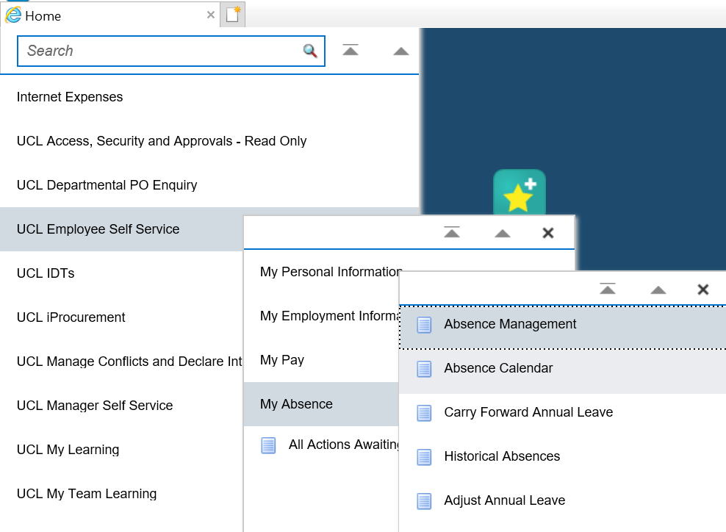
c
Figure 1: UCL Employee Self Service Menu

- Enter the date on which you would like to view the leave calendar.

For the purposes of viewing the leave balances you can select the current date.

Note: Note: If you wish to view your leave calendar, select ‘Detail’ in the Calendar Type and click on Display Calendar. This will show you a month’s view of absences, based on the date entered. If you select ‘Summary’ in the Calendar Type then this will display absences or anyone who also reports to your line manager and any of their direct reports. This view shows dates only and does not give any information on absence reasons.

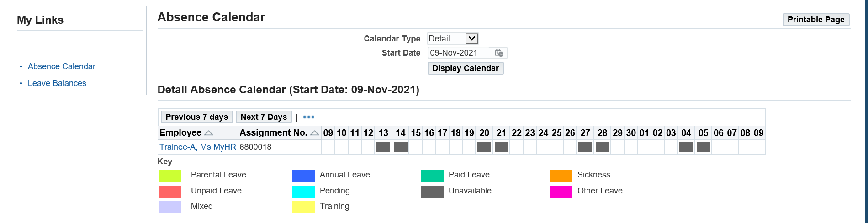
c
Figure 2: UCL Employee Self Service Menu > MyAbsence>Absence Calendar

- Click on ‘Leave Balances’ on the left-hand side

c
Figure 3: UCL Employee Self Service Menu > MyAbsence>Absence Calendar > Select Leave Balances

- The Leave Balances screen will show the following information:

  - Entitlement = the leave entitlement for the leave year, pro-rated where appropriate
  - Carried Over/Bought = any additional leave carried over
  - Adjustment = any adjustment that has been applied, in addition to any carry over
  - Total Entitlement = the total entitlement for the leave year, calculated based on the Entitlement, Carried Over/Bought and Adjustment values
  - Booked = Any leave booked for the current leave year
  - Remaining = The total amount to annual leave remaining for the current leave year

Please Note:

Leave balances are calculated per assignment. If you have more than one assignment, you will need to view each leave balance individually. See below for guidance on how to view multiple leave balances.

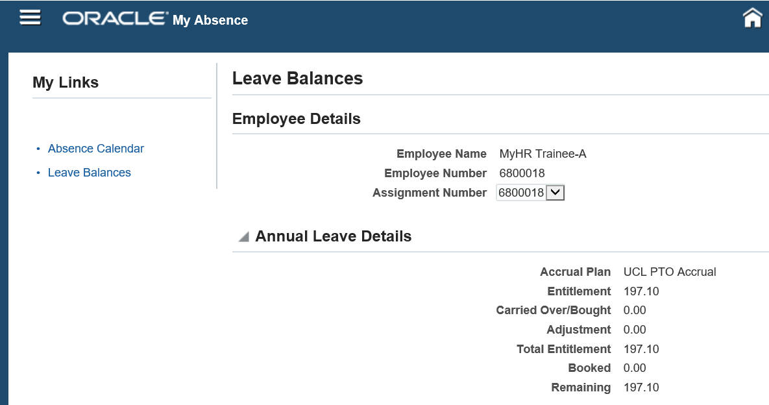
Figure 4: UCL Employee Self Service Menu > MyAbsence>Absence Calendar > View Leave Balances

To View Leave Balances with Multiple Assignments

- From the MyHR home screen, navigate to UCL Employee Self Service > My Absence > Absence Calendar > Leave Balances

- On the Leave Balances screen, select the different assignment numbers in the ‘Assignment Number’ field

Each time a different assignment is selected, the leave balances will update to show the information for the selected assignment.

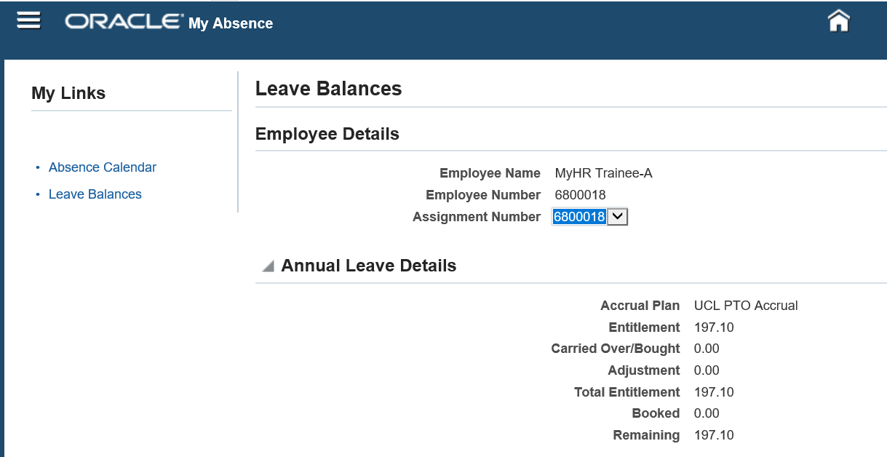
c
Figure 5: UCL Employee Self Service Menu > MyAbsence>Absence Calendar > View Leave Balances > Multiple Assignments

