**Employee Self Service - View Payslip**

This guide will show you how to view your payslips in MyHR Employee Self Service.

It is broken down in to 2 sections:

Section 1 : How to view payslips from 1 February 2020 payroll or later

Section 2 : How to view payslips from January 2020 payroll or earlier

**Please note:**

If you are a casual worker you will not be able to access your payslips via Employee Self Service. Payslips will be securely emailed to you with the details of how to access these.

**Section 1 – How to view payslips from 1 February 2020 payroll or later**

* From the MyHR home screen navigate to UCL Employee Self Service > My Pay > UCL Online Payslip

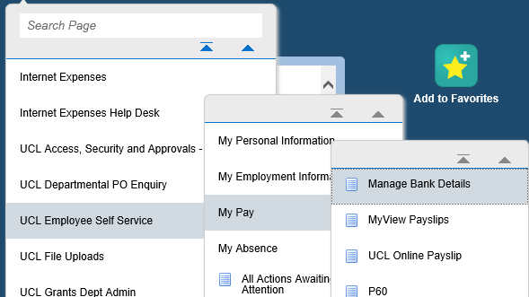

*Figure 1: UCL Employee Self Service Menu*

* From the drop down list select of the payslip you wish to view

The date displayed will the last calendar date of the payroll month.

* Click ‘Get Payslip’

*Figure 2: UCL Employee Self Service : My Pay : UCL Online Payslip*

* The following message will pop up. Select the relevant option to open the payslip:



* Once the option has been selected the payslip will become visible and this can either be printed or saved.

**Section 2 – How to view payslips from January 2020 or earlier**

* From the MyHR home screen navigate to UCL Employee Self Service > My Pay > MyView Payslips



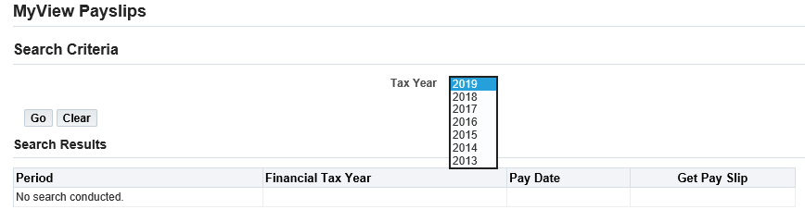

* From the drop down list select the year in which the tax year started for the month you would like to view.
* Click on 

The UK tax year runs from April – March.

For example, January 2020 is linked to tax year that started in April 2019, therefore, you would select 2019 from the drop down list.

* Identify the correct payslip and click on the in the ‘Get payslip’ column for this month.
* The following message will pop up. Select the relevant option to open the payslip:



* Once the option has been selected the payslip will become visible and this can either be printed or saved.
* Click on  to return to the main MyHR home page.