WELCOME TO NATURE MASTERCLASSES ON-DEMAND

Use this guide to set up your Nature Masterclasses On-Demand account to gain access to the online courses.

HOW TO ACCESS NATURE MASTERCLASSES ON-DEMAND

Step 1.

Please go to https://masterclasses.nature.com/ and click the ‘Register’ icon on the top right.

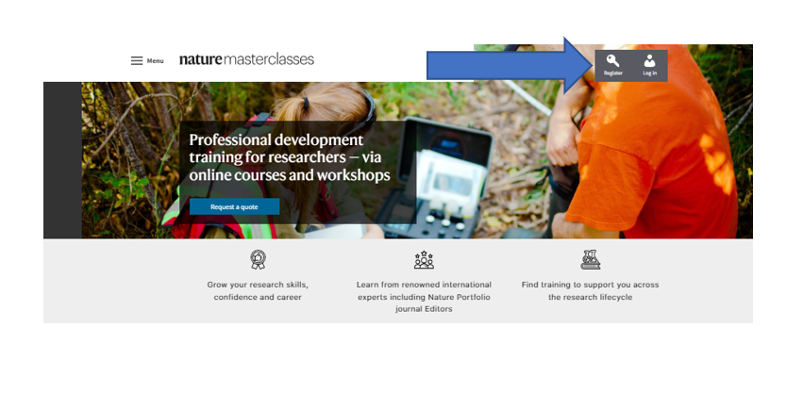

Step 2.

On the Register page, click ‘Your institution’ and select your institution from the drop-down menu. Alternatively, you can start typing the name of your institution and select from the options that will appear.

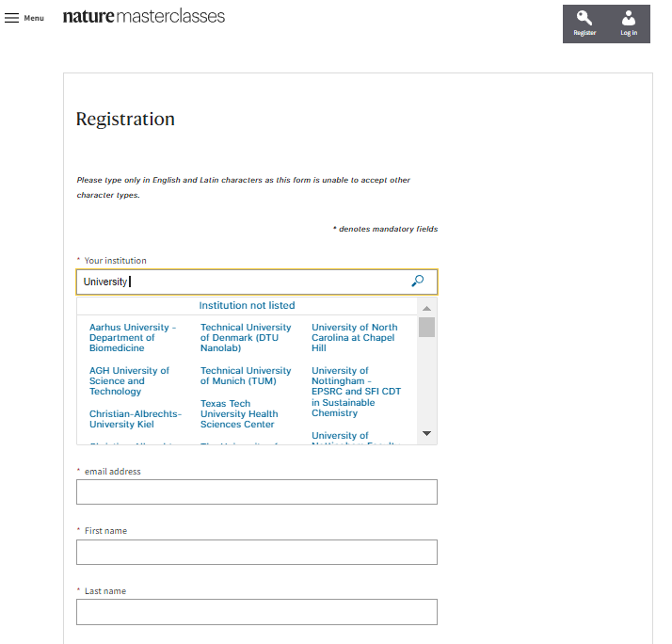

Step 3.

Complete the form with your personal information.

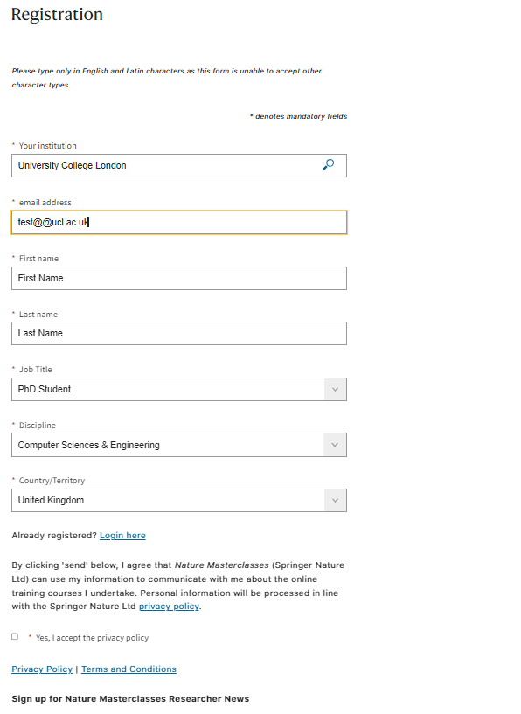

Step 4.

Read the Privacy Policy and tick that you accept it. Then click the ‘Register’ button.

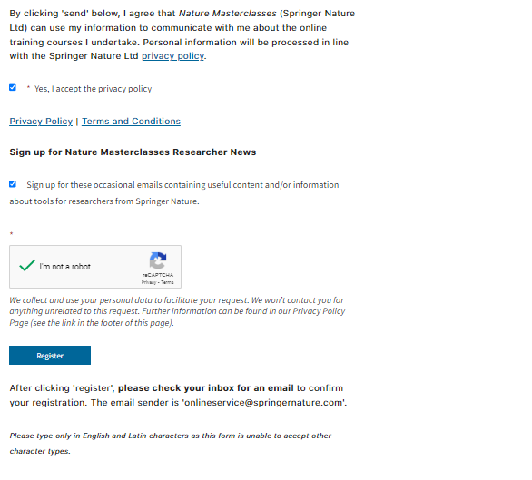

Step 5.

This will take you to your institution’s Single Sign-On page. Enter your network ID and password and click ‘Login’.

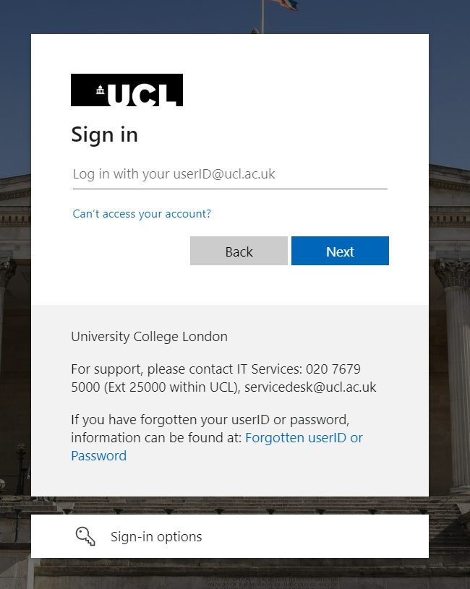

Step 6.

This will take you to the following page, where you’ll be asked to check your mailbox for a confirmation email from Nature Masterclasses On-Demand. If you can’t find the email, click ‘Resend Email’.

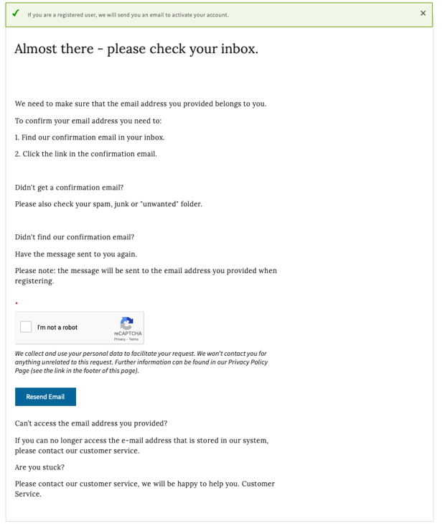

Step 7.

Open the confirmation email from Nature Masterclasses On-Demand and click the verification link. If the link doesn’t work, copy and paste the provided link in your browser.

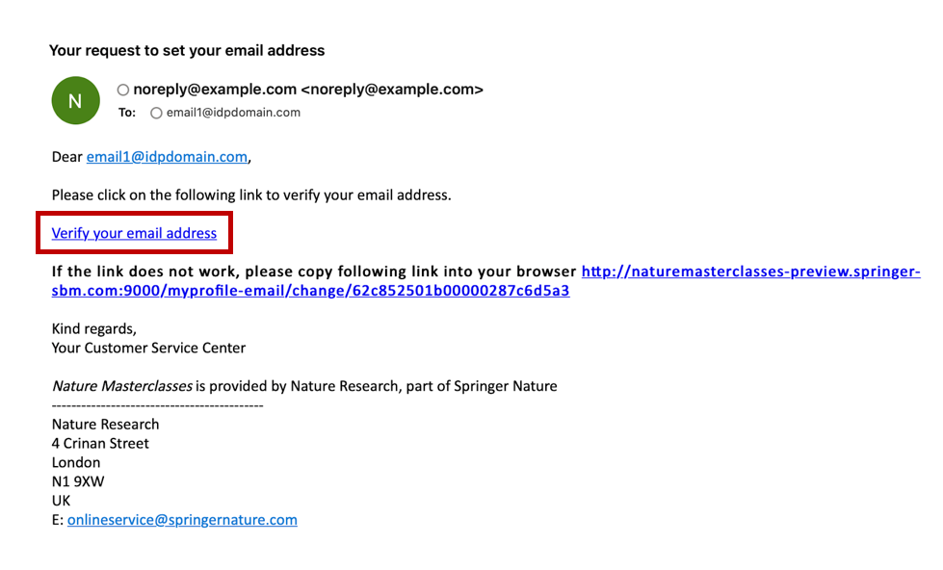

Step 8.

The verification link will lead you back to Nature Masterclasses On-Demand website where you are now automatically logged in. You are ready to visit the course pages and start learning!

Step 9.

If you log out of your account, you can login again by clicking the ‘Login’ icon at the top right (see the picture of Step 1). On the login page, go to the ‘Institutional login (Single Sign-On)’ section and click ‘Select your Institution’. Select your institution from the list and you will be redirected to your Institution Single Sign-On page, where you need to provide your ID and password. Once this is done, you will be back to the Nature Masterclasses On-Demand website as a logged in user and you can continue learning with us!

IMPORTANT: please do NOT try to login via the regular login, since your institution has Single Sign-On access for Nature Masterclasses On-Demand.

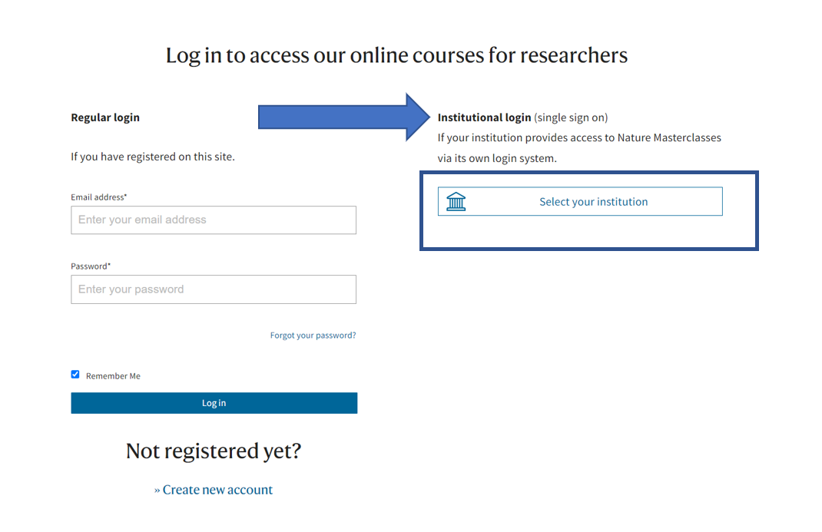

IMPORTANT: There is also another way of gaining access to the courses, if you try by mistake to login with your institutional credentials before registering.

Step 1(b).

On the login page, go to the ‘Institutional login (Single Sign-On)’ section and click ‘Select your Institution’. Select your institution and you will be redirected to your Institution Single Sign-On page, where you need to provide your ID and password.

Step 2 (b).
This will take you to your institution’s Single Sign-On page. Enter your network ID and password and click ‘Login’.

Step 3(b).

This will take you to the following page, where you’ll be asked to complete a registration form with your personal information. From now on, follow the steps 3, 4 and then 6-8.

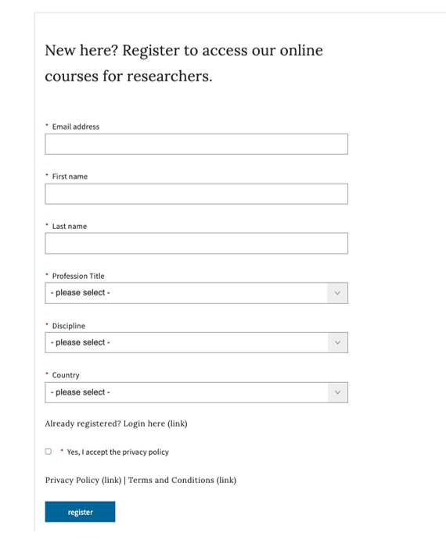

You’ll find further useful information, FAQs and contact details for our support teams on our Help page. We hope you enjoy the courses!

