How to use Training Points to track researcher development

What are Training Points, and how do we calculate them
At UCL, we primarily use Training Points to illustrate the intensity and variety of the development of postgraduate researchers (doctoral candidates), although they can also be used by research staff to demonstrate their engagement with their development.
Training point values are calculated based on time committed to participating in the activities (duration of the activity). The minimum value of a developmental activity is one point, which is awarded after attending any short engagement between 1 and 4 hours.
For longer or recurring activities, Training Points are calculated based on how intensive and participative the activities are, as well as their direct relevance to the research process. This allows the Training Points system to reflect the differences between, for example, attending a seminar series versus actively leading a skills development session for your peers.
You are encouraged to engage with a wide range of activities to develop balanced and varied skills across the Researcher Development Framework (RDF). You may find the self-assessment questions in the Research Student Log, and the formal review process helpful in prioritising the skills you need to progress and creating your developmental plan.

Who needs to accrue Training Points
All postgraduate researchers at UCL are expected to take full advantage of the training and should aim to participate in development equivalent to two weeks per year (corresponding to 20 Training Points).
Research Council funded students are required by their funding bodies to participate in an appropriate developmental training to a degree equivalent to two weeks per year of their funded studentship.
Departments may require that postgraduate researchers reach a specific number of Training Points (usually 20) before allowing upgrade presentation. Please check the specific requirements with your supervisors.

How to record your development
Any training booked or recorded on Inkpath will be automatically synchronised with the Skills & Courses section in the Research Student Log.
After you have set up your profile on Inkpath, you will also be able to add activities you have completed with your department, or any external developmental activities.

Adding departmental training
- On the Inkpath home page, click on Find Activities button.
- Click on Self Study and scroll down the list to find your course. You can also use the search box.
- Choose the relevant activity and click on Mark activity as complete to confirm your attendance.
- If your departmental training is not listed, you can add it using adding external activity route.

Adding external activity
- On the Inkpath home page, click on Create Activity button.
- Use the drop-down list to choose the Activity Type and then the Skills to choose the RDF domain – this will be prefiltered for you based on your activity. Your points will be added automatically, depending on the activity type.
- Complete the rest of the form.
- If you don’t want this activity to appear in your Research Student Log, check the box Mark as private.
- Click Save to my activities to confirm it.

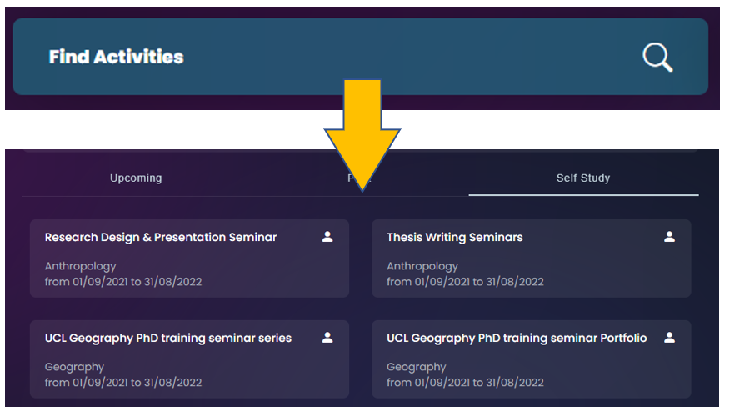

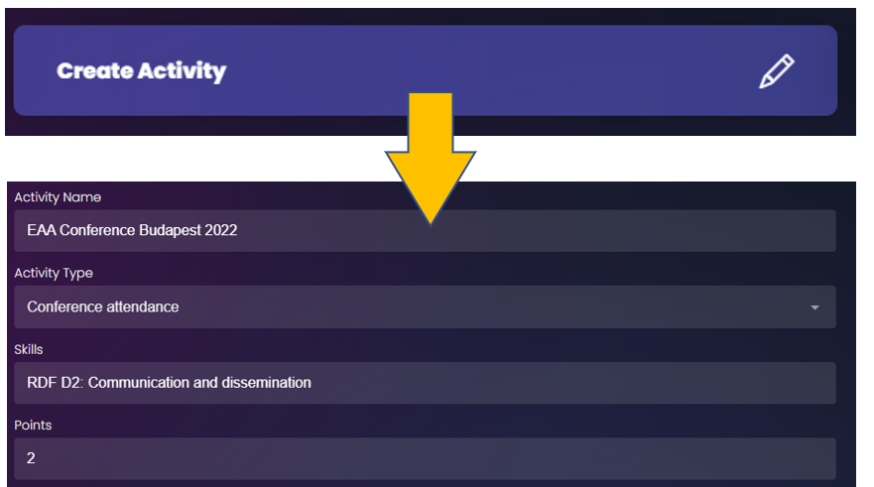

List of activities with Training Point values
- External training
Organised courses with a cap at 10 points (active attendance) or 4 points (auditing) per training.
  - Attending seminar series – 1 point per term
  - Auditing Master’s module – 4 points
  - Attending short session (up to 4 hours) – 1 point
  - Attending training adding up to a full day (or two short sessions delivered across two days) – 2 points
  - Attending training with three short sessions delivered across more than one day – 3 points
  - Attending training with four short sessions delivered across more than one day – 4 points
  - Attending training with five short sessions delivered across more than one day – 5 points
  - Attending training with six short sessions delivered across more than one day – 6 points
  - Attending training with seven short sessions delivered across more than one day – 7 points
  - Attending training with eight short sessions delivered across more than one day – 8 points
  - Attending training with nine short sessions delivered across more than one day – 9 points
  - Attending training with ten or more short sessions delivered across more than one day – 10 points
  - Attending Master’s module including labs/coursework – 10 points

- Skills in practice
Activities in this group are capped at 10 points (projects) or 5 points (fieldwork/archive research teaching).
  - Conference attendance – 2 points
  - Paper preparation and presentation – 3 points
  - Poster preparation and presentation – 3 points
  - Earning UCL Arena Fellowship – 3 points
  - Participating in UCL Hackathon – 2 points
  - Delivering UCL Changemaker project – 6 points
  - Teaching per term – 5 points
  - Fieldwork/archive research per term – 5 points
  - Experiment planning – 4 points
  - Participating in 3MT competition – 3 points
  - Delivering RLI Award project – 4 points
  - Submitting an application to UCL Ethics Committee – 1 point
  - Teaching through The Brilliant Club – 5 points per module
- Community building and volunteering
Activities are caped at 5 points per function/role per year within UCL, or 1 point for an external engagement.
  - Membership in a student club/society – 1 point per year
  - Recognised role in a student club/society – 5 points per year
  - Student representative on a committee/working group – 5 points per year
  - Acting as a mentor or tutor – 5 points per year
  - Volunteering – 1 point per term

