Corporate Relocation Personalised
In partnership with University College London

About Sterling Lexicon

Delivering happy, productive employees ready to take your business to the next level requires something extra.
At Sterling Lexicon, that something extra is the passion, care and commitment our team brings to everything we do.

55,000
relocations annually

14
global offices

180
countries serviced

500
employees

Mobility Optimised

Sterling Lexicon is setting the new global standard in optimised mobility solutions. From bespoke executive relocations to mobilising an entire workforce, we offer innovative, end-to-end solutions tailored to your goals. By personalising our services to meet your unique needs, we deliver happy, productive people around the world. That’s Mobility Optimised.

Personalised service delivered with the human touch
By acting as an extension of your culture and business, our caring, knowledgeable team delivers the highest level of customer service. Consultative experts provide strategic insights to help you make the right business decisions, while your employees benefit from dedicated, multicultural relocation professionals who are fluent in a variety of languages.

Global reach, local expertise
With regional headquarters in the Americas, EMEA and APAC, we offer businesses a global reach and have the resources and longstanding partnerships to deliver on-the-ground, local expertise.

Consultative, flexible approach
The boutique nature of our business allows us to take a consultative, flexible approach and design an end-to-end solution appropriate to Sanofi and provide a truly personalized service to your employees.

Responsible Business
Sterling Lexicon's Environment, Social and Governance program is not an isolated initiative at Sterling Lexicon, it is integrated into our culture, strategy, and business decisions. Sterling Lexicon follows guidelines from the most respected organisations to ensure responsible environmental, social and governance management systems.

Global Footprint, Local Expertise

Sterling Lexicon has offices in the following locations:
Our global footprint and the knowledge and
experience of our local experts, combined with the support of our trusted supply chain network, will ensure University College London and assignees will receive services tailored to your specific requirements and delivered to the highest of quality.

In locations where we do not have a presence, we work with an established network of trusted suppliers to deliver services.
University College London can be assured that we will never outsource the management of services; this will be delivered by our in-house service delivery teams.

EMEA Americas APAC
London, United Kingdom Jacksonville, Florida New Delhi, India
Frankfurt, Germany Atlanta, Georgia Shanghai, China
Geneva, Switzerland Cincinnati, Ohio Singapore
Madrid, Spain Coppell, Texas
Paris, France Houston, Texas
Irvine, California
Shelton, Connecticut
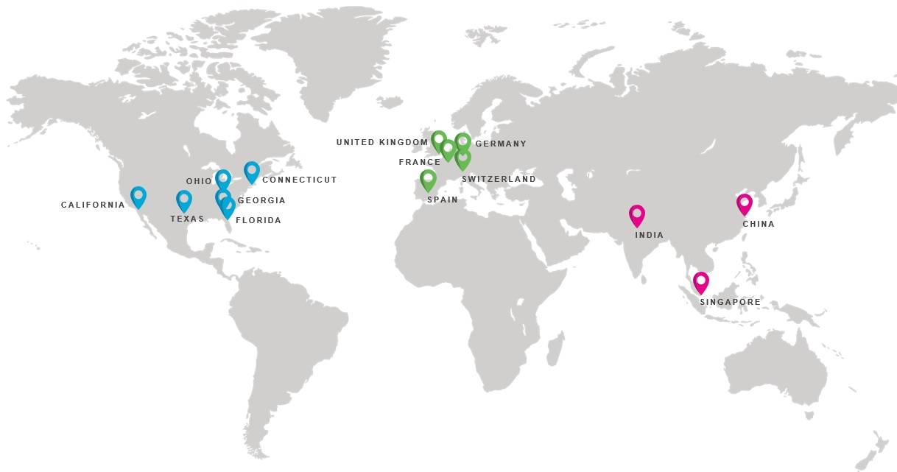

Household Goods Services – Service Descriptions

Moving Services

- Pre-move survey at the assignee’s origin and detailed quotation
- Counselling on customs procedures and restricted items specific to the move
- Assistance with the completion and collation of all required documentation to include, but not limited to, transit cover and customs documents
- The export packing and protection of all items being moved, with expert care of delicate or specialist goods (e.g. pianos)
- Complete inventory of effects as they are packed for transportation
- Transportation of effects using the full variety of transportation methods (land, sea and air)
- Overseeing of customs clearance
- Storage and transit cover protection (as required)
- Trained and experienced packing and moving teams
- Delivery services include unloading, un-crating, setting and placement of furniture in the new home, reassembly of furniture disassembled by the crew during the pack (handyman costs may be incurred), unpacking of cartons to nearest flat surface, removing empty packing material on the day of delivery

Move Management Services

- Provide access to qualified moving companies in every location
- Assess which offers best value based on the client’s and assignee’s needs
- Estimate the volume of household goods to be moved
- Explain the move process to the assignee and answer any queries
- Obtain and compare an agreed number of quotations from appropriate suppliers
- Make a recommendation based on allowance and policy
- Place the order with the preferred supplier
- Liaise with approved supplier to ensure that all requirements for the move are met
- Provide support and guidance throughout the process
- Audit supplier invoices against quotes
- Ensure provision of invoice backups
- Pay supplier against audited invoice and backup documentation
- Recharge moving cost(s) to the client along with Sterling Lexicon’s agreed management fee(s)

Assignment Lifecycle – Moving
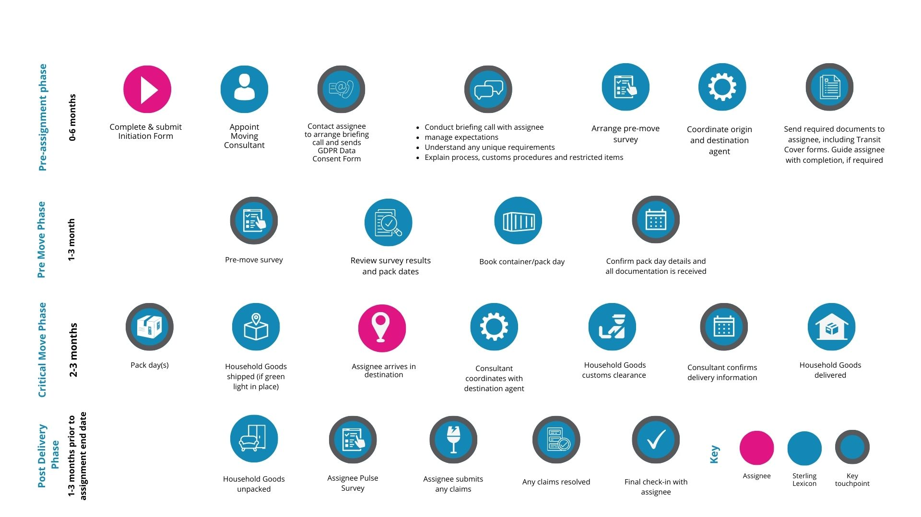

We offer a full Global Relocation Service for your convenience
Below is an outline of the Relocation Services we can offer, a full description of each service can be found on pages 7-9

Home Search
- Source properties within the client policy and allowance guidelines, and assignee requirements. Accompanied service to view available properties
School Search
- Discuss education options in the new country and differences between the home and host countries
Tenancy Management
- Sterling Lexicon act as a point of contact between the tenant and the landlord, with ongoing telephone support and the co-ordination of tradesman
Lease Renewal
- Negotiate most favourable renewal terms with Managing Agent/Landlord
Departure / Repatriation
- Closing down of lease housing contract Liaise with moving services Written notification to landlord/managing agent Negotiate return of rental deposits

Area Orientation
- Orientation is typically pre-assignment
Temporary Accommodation
- Research and shortlist options according to assignees criteria
Settling-in
- Provide personalised information about the new surroundings in line with assignee and family requirements
Furniture Rental
- Liaise with furniture rental company to deliver/collect rental furniture as appropriate
Cultural Training
- Provide comparisons between the home and host countries, cultural and behavioural differences and the possible need to adjust
Language Training
- Arrange online lessons on a one to one basis as required for the assignee per policy allowance
Partner Support
- Career assessment, exploration of career alternatives and training

General International Relocation Services – Assignment Lifecycle
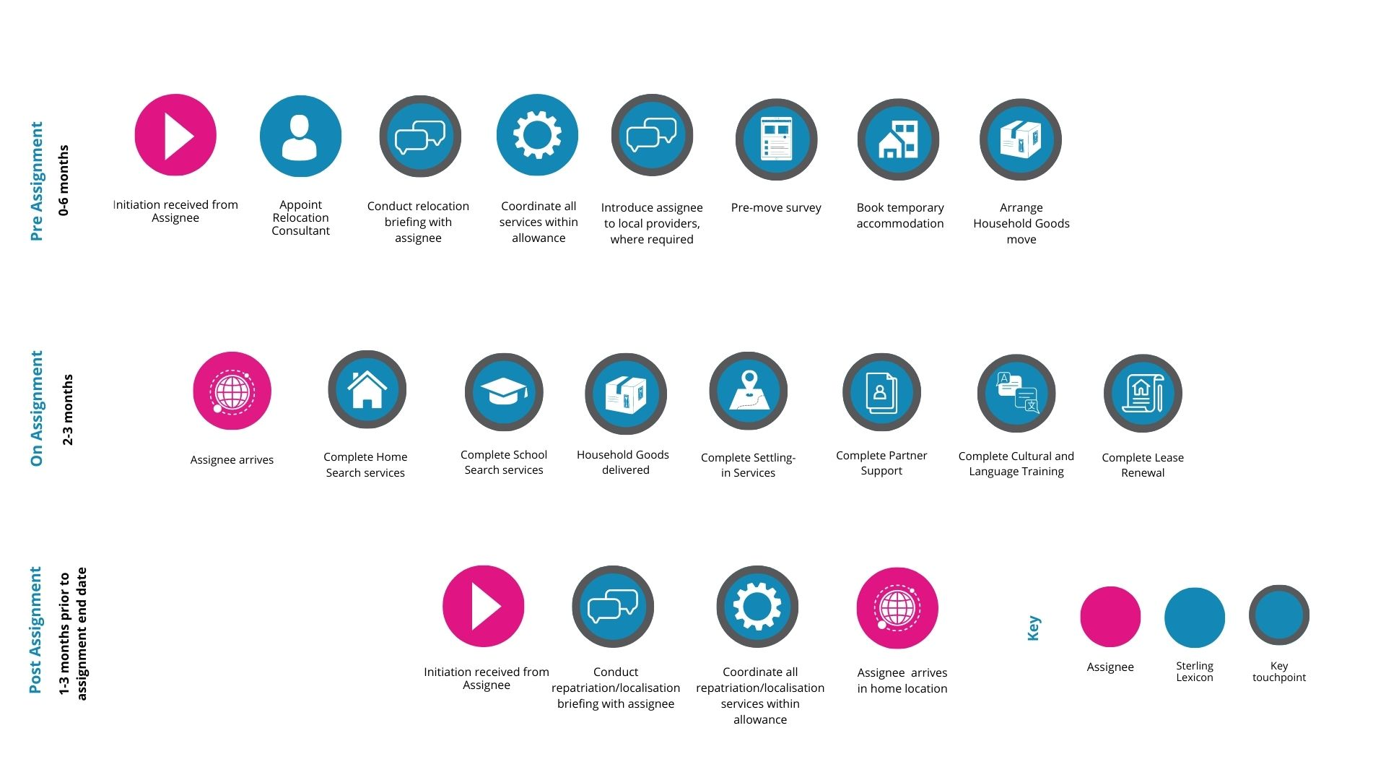

Relocation Services – Service Descriptions

Home Search

- Local market/neighbourhood overview
- Provision of country information
- Collect and return assignee to hotel / office
- Source properties within the client policy and allowance guidelines, and assignee requirements
- Accompanied service to view available properties and provide a local orientation
- Negotiation of lease to best outcome for the assignee
- Explanation to the assignee of the legal formalities of the lease
- Arrange for the assignee to sign an indemnity letter (where applicable)
- Liaise with client/assignee to facilitate payment of deposit and initial monies
- Co-ordinate and arrange the move in inspection and hand over of keys to the assignee
- Facilitate connection of utilities and phone lines and bank accounts (as per host country norm)
- Provide details for local registration requirements e.g. social security, doctor, dentist, tax card, bank (where necessary by country)

Area Orientation

- Orientation is typically pre-assignment
- Pre-departure briefing on destination city, local lifestyle and local information provided
- Collect and return assignee to hotel/office
- Accompanied, customised tour of required area

Temporary Accommodation

- Research and shortlist options according to assignees criteria, client policy and availability
- Book chosen accommodation and facilitate payment
- Arrange handover of keys/send move in instructions to assignee (as appropriate)
- Re-booking of further accommodation will require a new fee
- Translation of documents or leases are not included
- Extensions of bookings may incur an additional fee (one extension is included in the fee)

Relocation Services – Service Descriptions

Departure / Repatriation

- Written notification to landlord/managing agent
- Liaise with moving services
- Advice with de-registrations e.g., city hall, pets, cars
- Advise on termination of insurance agreements, memberships, credit cards, bank accounts etc.
- Facilitate mail re-direction services and end of tenancy cleaning
- Closing down of lease housing contract (where necessary / possible)
- Negotiate minimum damages settlement to landlord
- Negotiate return of rental deposits
- Determine rental furniture requirements once effects have been shipped
- Client/assignee to be informed once standing order is concluded and final payment to be made
- Facilitate close down of utilities (where necessary / possible by country)
- Accompanied de-registration is a separate service
- Inventory check outs and end of tenancy cleaning, where applicable, incur an additional charge
- Damages settlement negotiations are based on a maximum of four hours. If further negotiations are required additional fees may be incurred
- Renovation, redecoration, and damages are not included in the fee

Lease Renewal

- Provide written notification to managing agent/landlord of the client/assignee’s intention/request to renew the lease
- Negotiate most favourable renewal terms with Managing Agent/Landlord
- Ensure any outstanding Tenant issues are resolved with Landlord prior to lease being extended
- Compilation of renewal documentation showing extended term dates, confirmation of break clauses, revised rent figure and payment dates
- Obtain any necessary legal consent
- Ensure property complies with legal safety requirements
- Arrange for signature by both parties
- Advise assignee and/or client of any changes in terms such as break clauses, payments and notice dates for further extensions

Relocation Services – Service Descriptions

Cultural Training

- Either e-delivery or face-to-face session(s)
- Provide comparisons between the home and host countries, cultural and behavioural differences and the possible need to adjust
- Overview of working with other nationalities and multi-cultural teams

Furniture Rental

- Provide options within client policy and allowance guidelines
- Liaise with furniture rental company to deliver/collect rental furniture as appropriate
- Facilitate payment of rental furniture with client or assignee

Language Training

- Arrange online lessons on a one to one basis as required for the assignee per policy allowance
- Record and report against usage of language training up to the value of assignee’s allowance

Tenancy Management

- Sterling Lexicon act as a point of contact between the tenant and the landlord, with ongoing telephone support and the co-ordination of tradesman
- The tracking of leases and renewal dates
- Tenancy negotiation
- Property reviews for damages and maintenance issues can be arranged if required and will incur additional charge(s)
- Feedback for both parties on relevant issues

Partner Support

- Conduct needs analysis and research.
- CV development, career assessment, exploration of career alternatives and training
- Labour market research, including referrals to jobs and associations
- Assistance with determining work permit requirements
- Options of either e-delivery or face to face

Corporate Relocation Personalised

We look forward to hearing from you to discuss your individual requirements

Building 4, Uxbridge Business Park
Sanderson Road
Uxbridge
UB8 1DH
United Kingdom

+44 (0)208 841 7000
UCLUK@sterlinglexicon.com
www.sterlinglexicon.com

