SENIOR PROMOTIONS ANNEXURE C
Publications List Preparation
for Senior Promotions cases.

General

The mandatory requirement to produce the publications list using UCL’s Research Publications Service (RPS) was introduced in 2007 following feedback from the Promotion Committee members. This is to be included in the candidate’s promotions submission as a separate document and uploaded as part of the web-based application.
This should be a full list of publications and/or a full list of equivalent academic/professional output (in circumstances where publication is not the prime or only measure of academic standing for example conference papers). Do NOT include items that are “in progress” as these cannot be assessed by the School/Promotion Committees. You may include items submitted for publication, but they will not necessarily support your case as impact will be unknown.
In preparing your Publications List allow for assessment by an inter-disciplinary team and therefore avoid using abbreviations without explanation and in some instances explain significance of placing in author order etc. Please ensure you produce a list of all your publications in alphabetical order by type (e.g. book, book chapters, conference papers, journal articles, patents etc.). The contents for each type should be in chronological order with most recent first.
Note: Please note that candidates will be asked to resubmit their publication list if it is not presented within these guidelines.

Instructions for exporting publications lists from RPS for Senior Academic Promotions

- Log in to RPS (https://rps.ucl.ac.uk/) using your standard IT credentials.

- From your RPS homepage, click “Publications” at the bottom-left.

- If your publications list is not accurate, you can amend it here by creating new records, or amending or rejecting existing ones. Contact the Open Access Team (openaccess@ucl.ac.uk) if you have any questions about managing your publications in RPS.

- When your list is ready to be exported, go to the “sort by” options at the top-left of the list, and select the “Type (A to Z)” option.
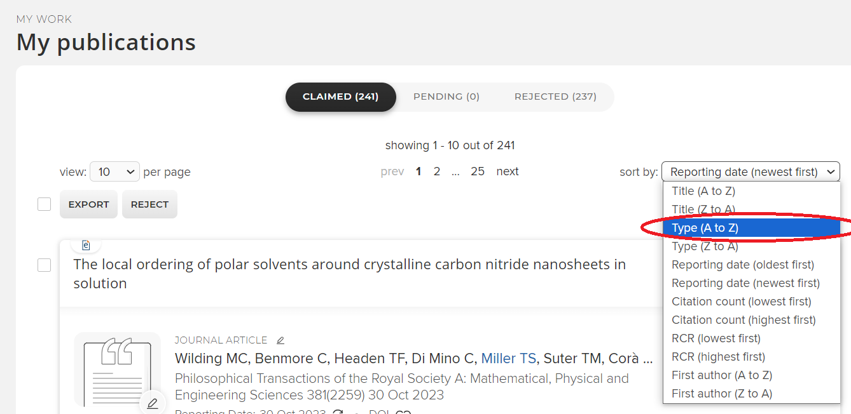

- Click the “EXPORT” button at the top of the list. This will export all publications by default if none are individually selected.
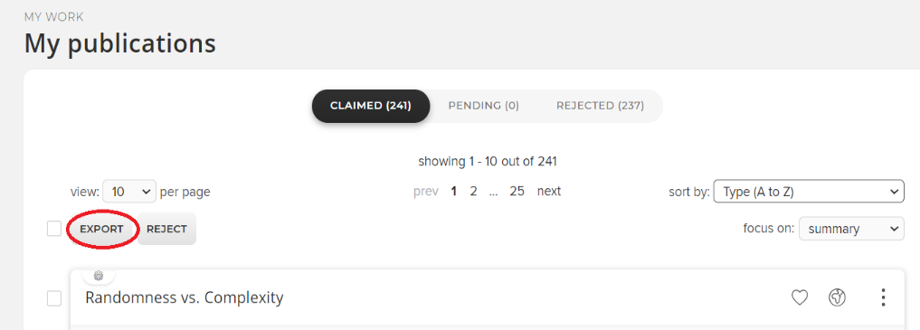

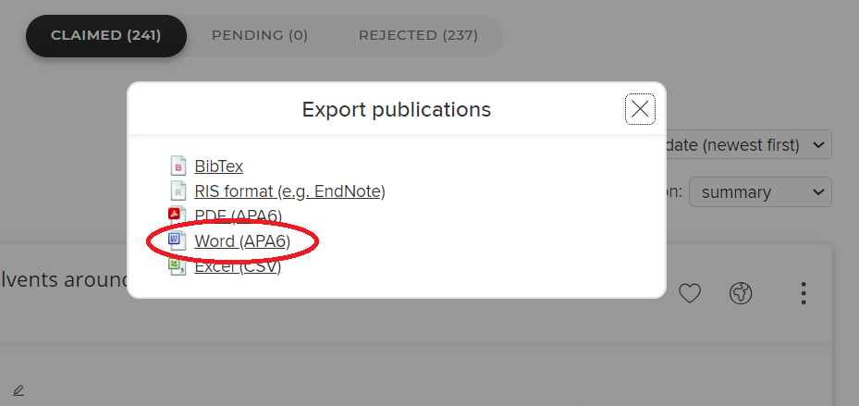
- An “Export publications” dialogue box will open. Select the “Word (APA6)” option: this exports a Rich Text Format (rtf) document that can be further amended.

- Save the file in a suitable location.

Please note that due to a change in the RPS system, not all the publications in this list will have live links, so add your Profiles page link so that referees and committee members are able to view your publications.

https://profiles.ucl.ac.uk/[name]/publications
(Or go to https://profiles.ucl.ac.uk/ and search by your name)

Add the note: ‘Please go to my UCL Profiles page to access links to my publications’

Please also add your name and Publications List as a title at the top of the page.

Example:
[Your name]
Publications List
Please go to my UCL Profiles page to access links to my publications:
https://profiles.ucl.ac.uk/[name]/publications

- Book
- Chapter
- Journal Article

Number of publications:

