Register for redeployment job alerts and apply for jobs on TalentLink

Search for Suitable Jobs
- Select the Vacancy Type, Job Type, and Grade of jobs you wish to see; or to see all jobs keep the selection on Any. Click on Search.
- Click on ‘See job details’ to see the full job advert and job description of jobs you are interested in.

- You can also check for any vacancies which have moved beyond the redeployment process and are currently generally advertised for which you will have missed the alert. Visit https://www.ucl.ac.uk/work-at-ucl/redeployment/. Under ‘Contract Type’ filter, select permanent or fixed term jobs.

- You can also check for any Secondment opportunities which you may take up as a fixed term contract, by selecting ‘Yes’ under the ‘Available for Secondment’ filter.
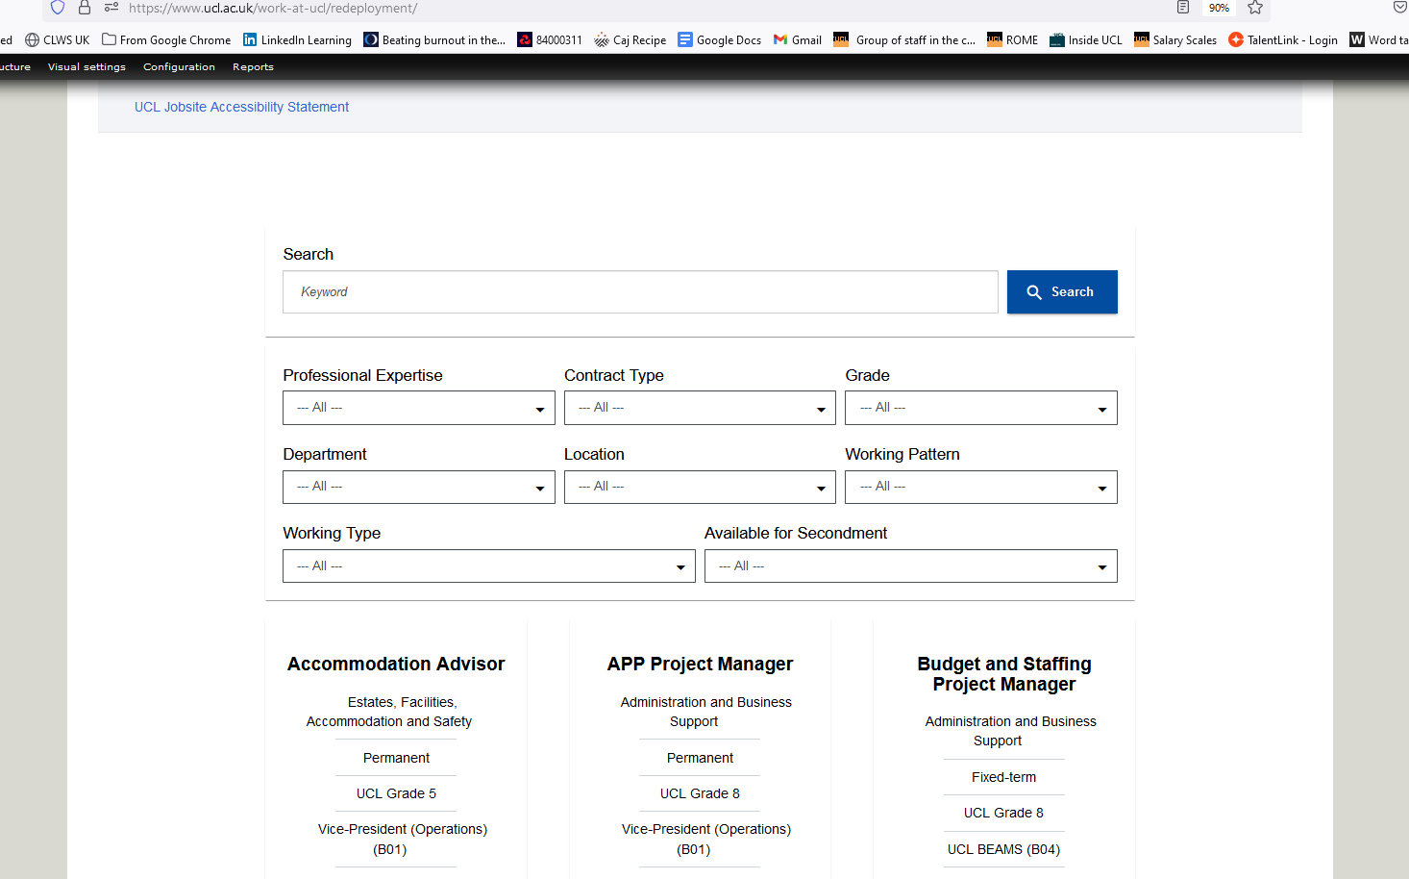

How to register for redeployment job alerts:
- Visit https://www.ucl.ac.uk/work-at-ucl/redeployment/
- Enter key words and select search
- Select relevant filters and grade preferences you wish to receive redeployment alerts for. Redeployees may only apply for jobs at or below their current grade.
- Scroll down and select ‘Show more results’ to see more jobs
- Scroll down to the bottom and select ‘send me notifications of new and matching jobs:’
- Next to this box, you will find a small toggle switch which you need to select
- Select the frequency of job alert notifications, when notifications should stop and enter your email address.
- Click the Button below the form labelled ‘Sign up for UCL job alerts’
- You will see then see a green button with the text ‘Thank you for subscribing’ to confirm your details have been registered. (Please note, filters selected will determine job alerts received)

- Check the details are correct and click on ‘Sign up for UCL job alerts’.
You should receive a confirmation email of your registration for job alerts. You will now receive alerts whenever a new redeployment opportunity is posted which meets your criteria. Alerts are sent out overnight.
You can also check for redeployment vacancies which are currently advertised for which you may have missed the alert.
- All redeployment jobs will be advertised on https://www.ucl.ac.uk/work-at-ucl/redeployment/

How To Apply for a Redeployment Job
- Click Apply Now, at the top or bottom of the advert
- On the next page, confirm that you are eligible for redeployment by completing the last 6 questions within the personal information section.
- When completing the questionnaire section to explain why you have applied for the role, remember to address how you meet each of the Person Specification criteria, or could do with reasonable training.

