Create Employee Performance Appraisal Review

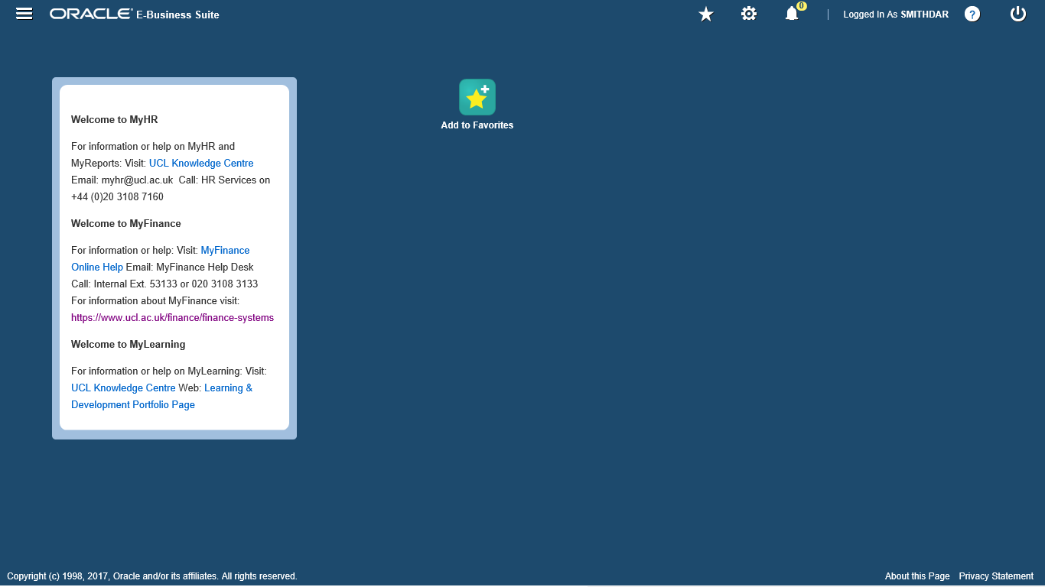

Step | Action
Select the Navigator menu.

Click the Navigator icon.
The list of Responsibilities displayed in the main menu is dependent on your role within UCL.

Next, you will navigate to the UCL Manager Self Service responsibility in order to create an employee performance appraisal meeting.
Select the required sub folder.

Click the UCL Manager Self Service link.
Select the required sub folder.

Click the My Team Employment Information link.
Select the required web page.

Click the Appraisal Dates link.
Note: A list of your current direct reports will be displayed. If any employee has more than one assignment (job role) this will be indicated by a suffix e.g. 123456-2.

Next, Select the Action icon alongside the chosen employee to create/update employee review dates.

In this example we are viewing information for the employee Simon Dobins.

Step | Action
Select the required icon.

Click the Action icon.

Step | Action
Performance Appraisal is automatically populated in the Review Type box.

Click the Create Appraisal button.

Step | Action
Select the field to enter a review date.

Click in the Date of Review field.
Step | Action
Enter the performance appraisal review date.

Enter the Date of Review: 02-Aug-2019
Choose whether to notify the employee of the review (this may not be necessary if review has already taken place).

Checking the box will send a notification of the review date, time, and location to the employee. They will receive a notification in their Worklist.

Step | Action
 | Click the Notify Employee being Reviewed option.

Step | Action
 | If required, an additional Reviewer can be added. This could be someone assisting in the review meeting.
Select the icon to add an additional reviewer.

Click the Add Reviewers button.
Enter a name.

Enter the Name: Flowers, Mrs
Select the name from the list.

Click the Flowers, Mrs May link.
Save your changes.

Click the Continue button.
 | Review the details for the created meeting before you Submit the Review Meeting.

Step | Action
Submit your review dates.

Click the Submit button.
Return to the Home page.

Click the Home button.
This topic showed you how to create an employee performance appraisal record.
End of Procedure.

