**Process to Carry Over Annual Leave in to the next Leave Year**

At the end of the leave year, MyHR will automatically carry over up to five days outstanding annual leave, pro-rated for part time staff, in to the following leave year.

For those on non standard UCL terms and conditions the carryover will be as per your contract of employment.

**Creating a Request to Carry Over Additional Annual Leave**

From the MyHR main menu, navigate to UCL Employee Self Service > My Absence > Carry Forward Annual Leave.

**Carry Forward Annual Leave**

Click on ‘Create Request’

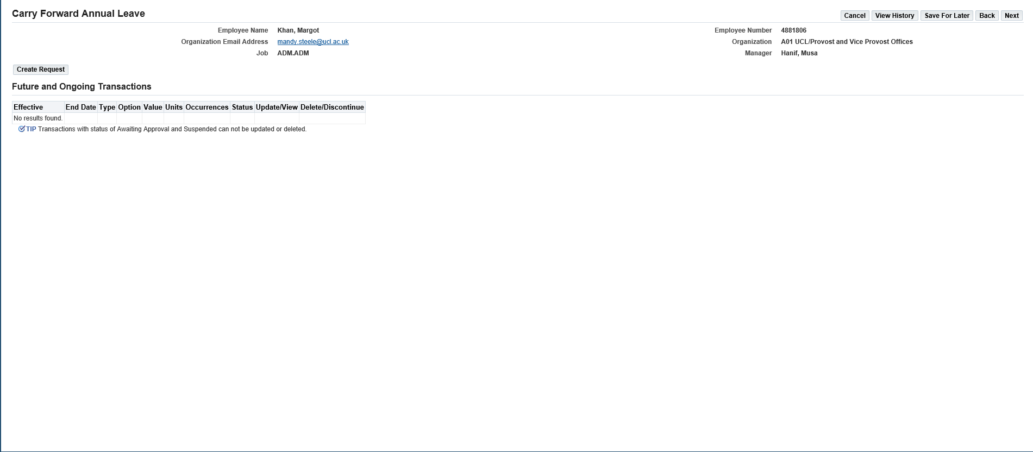

*Figure 1: Carry Forward Annual Leave: Create Request*

**Compensation Details**

* In the ‘Type’ field select ‘UCL PTO Accrual Carried Over’

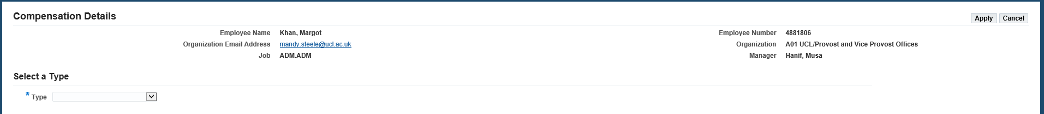

*Figure 2: Carry Forward Annual Leave: Compensation Details: Type*

**Details**

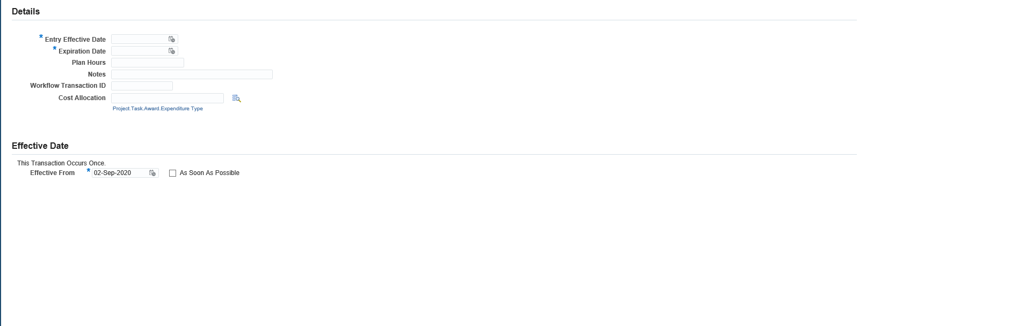

*Figure 3: Carry Forward Annual Leave: Compensation Details: Details*

Complete the following details:

* **Entry effective date:** Enter the first day of the next leave year, i.e. 01-OCT-XX.
* **Expiration Date:** Enter the last day of the next leave year, i.e. 30-SEP-XX.
* **Plan Hours:** Enter the total number of hours that are to be carried over, that are in addition to the standard carry over which would have already been applied.
* **Notes:** Enter any notes to support the request.
* **Workflow Transaction ID:** This field does not need to be completed.
* **Cost Allocation:** This field does not need to be completed.
* **Effective Date:** This can be left on the date pre-populated.

Click on ‘Apply’ in the top right hand corner

**Future and Ongoing Transactions**

*Figure 4: Future and Ongoing Transactions*

This page will show any transactions that are currently in progress, including the one being completed, or any that have been approved for the future.

* Review the details and select one of the following options:
* Where the request needs amending click on ‘Back’ in the top right hand corner
* Where the request is to be cancelled click on ‘Cancel’
* Where the request is ready to be submitted click on ‘Next’ in the top right hand corner

**Please note:** Where ‘Save for Later’ is selected, the request will be saved in a pending status until this is re-opened and submitted or cancelled.

**Carry Forward Annual Leave Review**

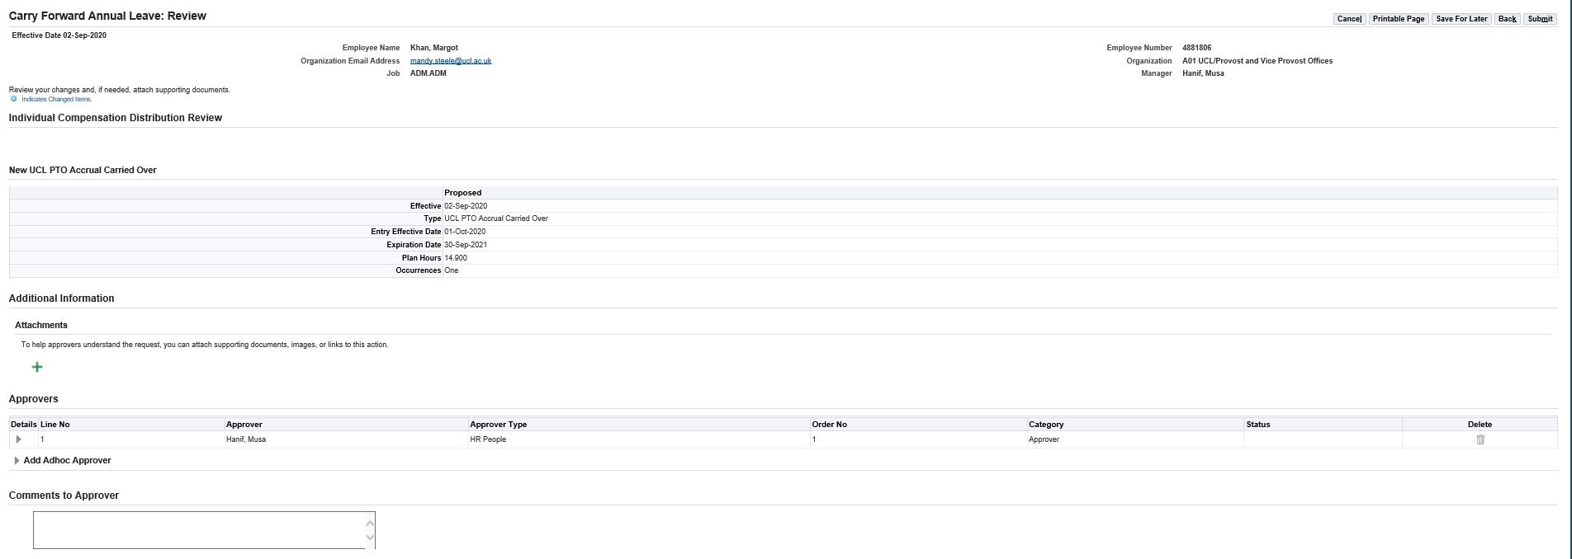

*Figure 5: Carry Forward Annual Leave: Review*

This page allows for a final review of the request which is to be submitted, including the name of the approver who will receive the request.

**Please note:** Do not add any attachments to the submission, as these will not be saved anywhere.

* **Comments to Approver:** Enter any comments to support the request for the approvers.
* Review the details and select one of the following options:
* Where the request needs amending click on ‘Back’ in the top right hand corner
* Where the request is to be cancelled click on ‘Cancel’
* Where the request is ready to be submitted click on ‘Submit’ in the top right hand corner

**Please note:** Where ‘Save for Later’ is selected, the request will be saved in a pending status until this is re-opened and submitted or cancelled.

The request has now been submitted for approval.