MyHR Read Only for Departmental HR Users

This will give the user access to the following individual data found at an Employee or visitor/contingent worker record. This includes historical, current and future data.

Personal – Names, Address(es), Phone Number(s), UPI and Start/Service Dates

Employment – Supervisor, Assignment Costing, Working hours (100% FTE equivalent), Work Pattern, FTE, Grade and Salary information, Probation and Notice Period, Projected End Date and Job Title, Clinical Contract, Fellowships and Teaching Fellow information.

Please note: The information provided in the ‘Departmental Finance User’ access is present within the ‘Departmental HR User’ access.

General Guidance

Date Tracking

This enables the data on a person’s record to be viewed as at a particular date or point-in time. Any search, unless the date track is changed, will return results as per the date the search is undertaken.

Once you have entered a person record there will be an ‘Effective Start Date’ and Effective End Date’ field. This will signal the dates for which the data being viewed is relevant.

- if you date track to the date the day before the ‘Effective Start Date’ you will see the data before the most recent change

- if you date track to the date 1 day after the ‘Effective End Date’ you will see any future changes on the individuals record

To Date Track on a record

Unless an Effective Date is changed at the start of the search, the Effective Date of a MyHR record will be today’s date.

- Click on the date in the top left hand of the screen
- Enter the date you wish to date track to
- Click on ‘Go’
- This will update the details on the record, across all tabs, to the date entered

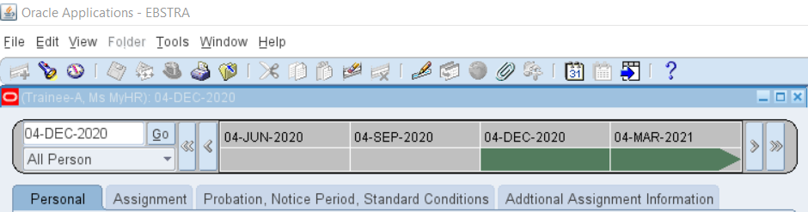
Figure 1: Date Tracking within a MyHR record

Note: An Effective Date away from today’s date will show in the header against the name of the record.
Navigation

Viewing Person and Assignment Details

This allows the system user to access Person Details at a MyHR Record for a member of staff whose record is within the viewer’s MyHR security hierarchy.

To search for a MyHR Record

- Select Person from the UCL HR Departments Read Only menu.

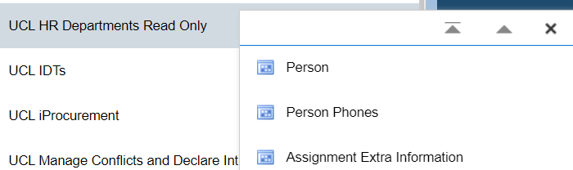
Figure 2: UCL HR Departments Read Only Menu

- This launches the Java application download – select Run if using Microsoft Edge to open the application. If using another browser, such as Google Chrome, you will have to Save, then select Open to launch the application.

Decision: at the start of the application you have an option to date track to a date other than today’s date.

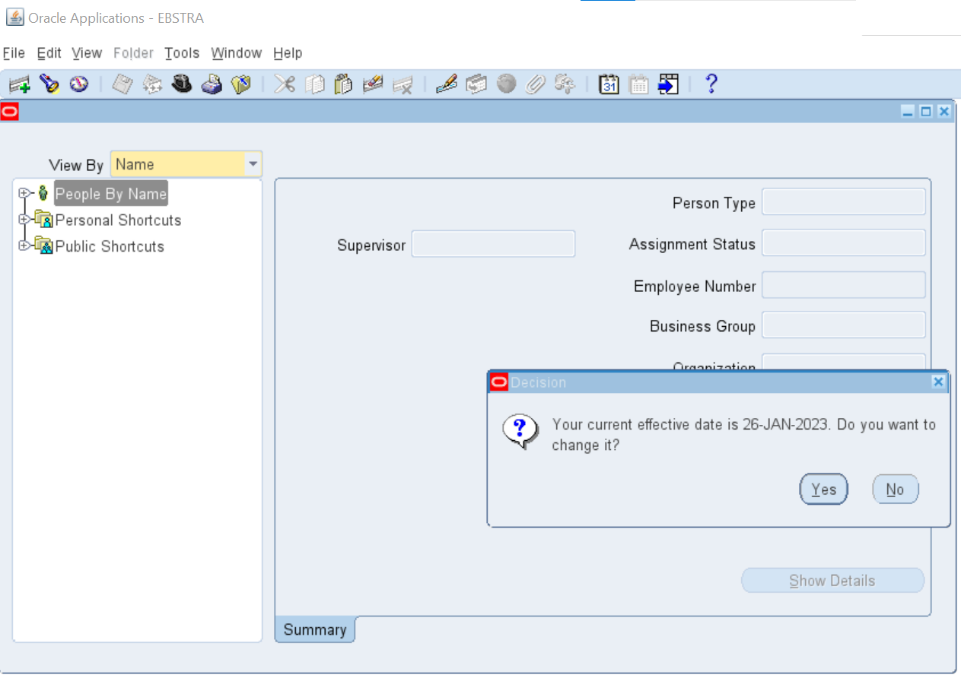
Figure 3: Date Track options

- Select ‘No’ to keep the Effective Date as viewing data effective as of today’s date.

- Selecting ‘Yes’ allows the Effective Date of searching the system to be a different date. Enter the new Effective Date in the style DD-MMM-YYYY and press ‘OK’.

- Pressing ‘Reset’ will keep today’s date or press ‘Cancel’ to exit this box without saving the changes.

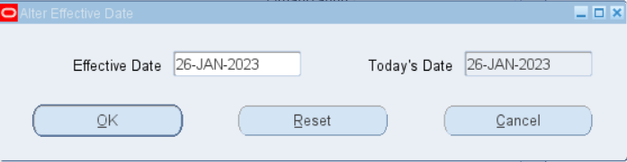
Figure 4: Effective Date changes

- To search for an individual’s MyHR record, select the ‘+’ symbol beside ‘People By Name’ to expand the A-Z Folder Tree.

Note: an alternative search method is available (See Appendix B: Searching via the Search Screen).
Figure 5: Folder Tree Search

- Expand the first letter of the person’s surname to further expand the Folder Tree, then locate the person’s name in this list.

- Select the person’s name to reveal their assignment(s).

- Select the appropriate assignment to show a summary on the right hand side of the screen.

- Select ‘Show Details’ to open this assignment record.

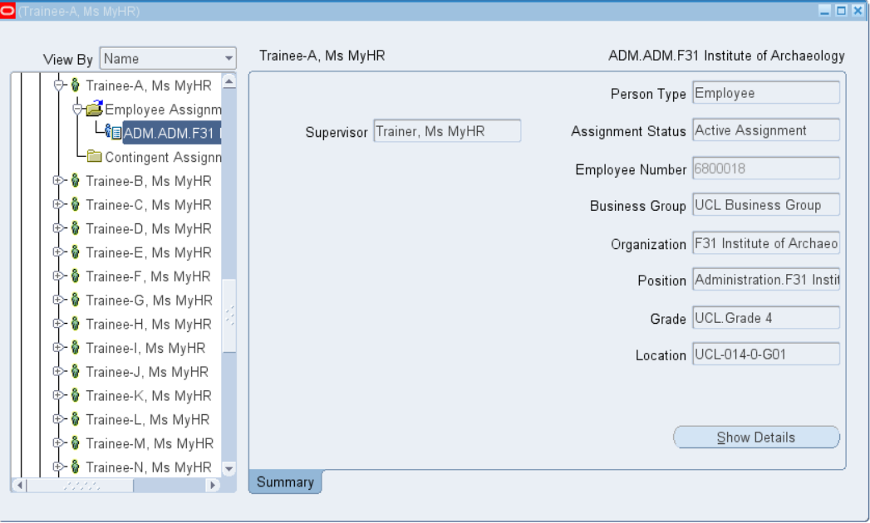
Figure 6: Summary of MyHR HR record

Viewing a MyHR Record

- To view an individual’s MyHR record, select ‘Show Details’

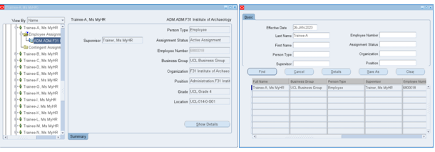
Figure 7: Accessing a MyHR record

Note: a list of fields and their locations is available (See Appendix C: Glossary of fields available)

The record for the individual is broken down into the following tabs:

‘Personal’ details

This tab will show the following information:
- First Name
- Middle Name
- Last Name
- Employee Number
- UPI Number
- Adjusted Service Date – reflects the continuous service at UCL
- Latest Start Date – the latest start for the member of staff and could reflect the date the Person Type changed, e.g. from Ex-Employee to Employee.
- Effective Start Date and End Date – reflects the period for the displayed Personal details.

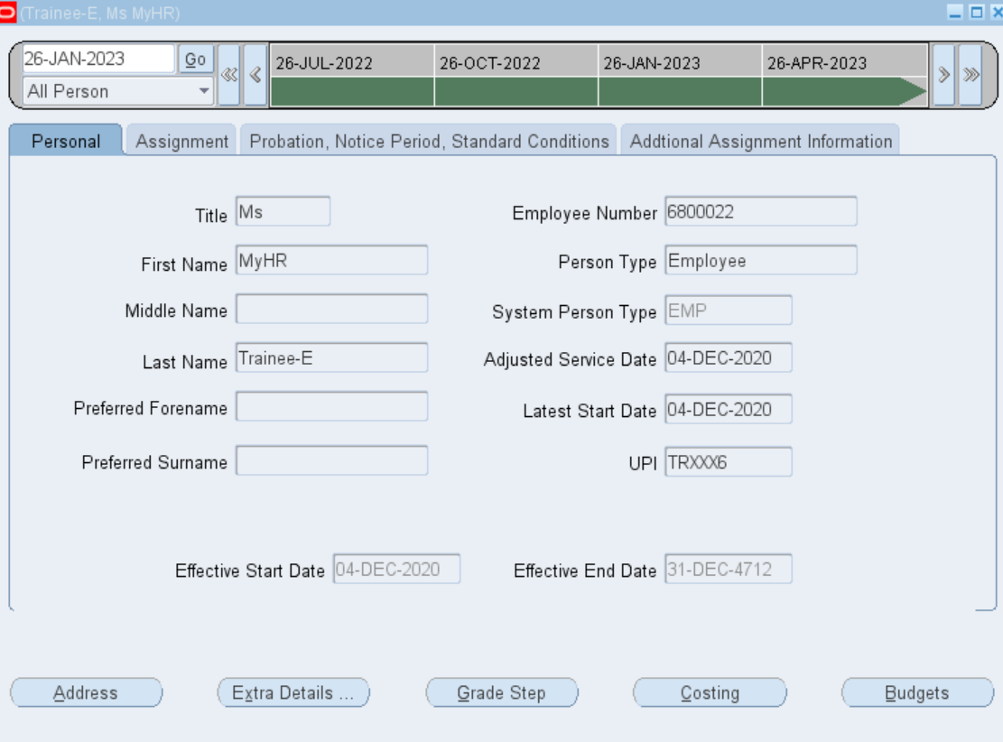
Figure 8: Personal Details screen

‘Assignment’ details

This tab will show the following information:
- Position number
- Grade
- Assignment number
- Salary – this will show a non spinal salary amount.
- Assignment category – this will show if the appointment is Full time, Part time, etc
- Supervisor
- Assignment status
- Effective Start Date and End Date – reflects the period for the displayed Assignment details

Note: Spinal salary details are visible on the ‘Position, Notice Period, Standard Conditions tab.

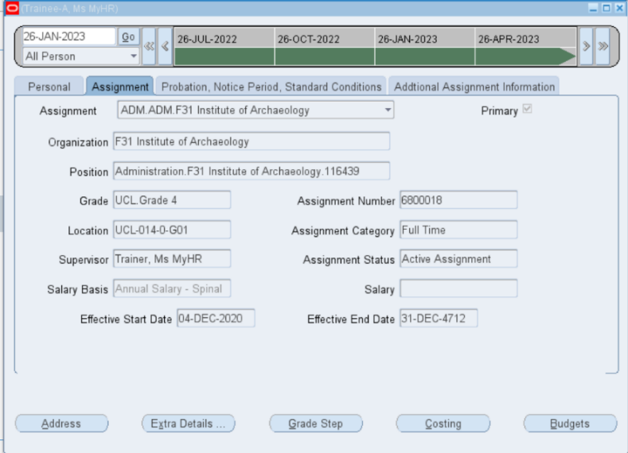
Figure 9: Assignment screen

‘Probation, Notice Period, Standard Conditions’ details

This tab will show the following information:
- Weekly working hours
- Probation duration
- Probation end date

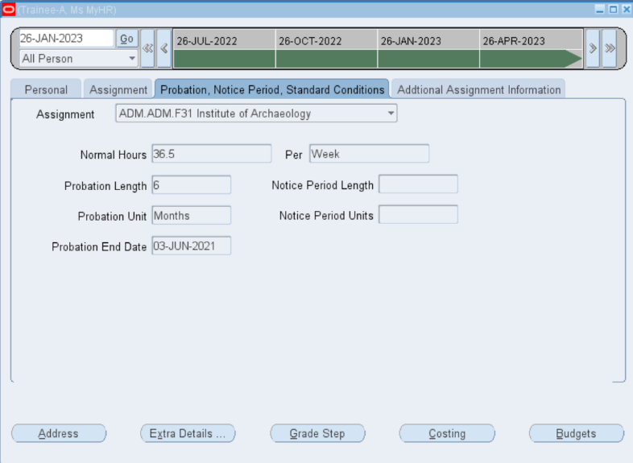
Figure 10: Probation, Notice Period, Standard Conditions screen

‘Additional Assignment Information’ details

This tab will show the following information:
- Projected End Date (and Reason)
- Job Title
- Staff Category

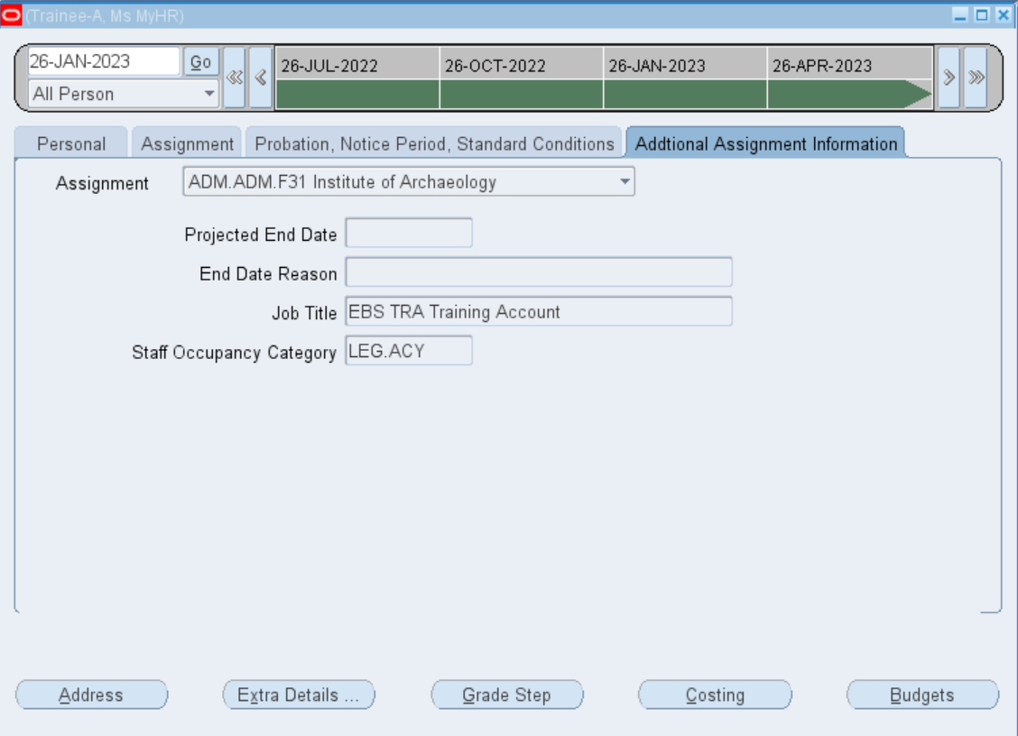
Figure 11: Additional Assignment Information screen

Additional Information Available
At any of the tabbed screens the following details can be accessed from the buttons at the bottom of the screen.

Figure 12: Additional Personal and Assignment Information

‘Address’

This tab will show the following details:
- Home address

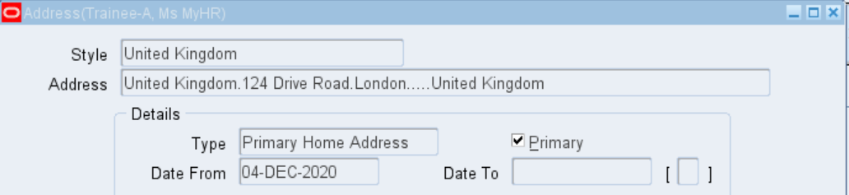
Figure 13: Address

Note: The number of records, e.g. 1/1 is displayed within the footer at the bottom of the screen, expand the screen to see these details. If more than one item is present at the screen you are accessing – use the up/down buttons on your keyboard to toggle between the entries.

‘Extra Details…’

This tab will show the following details:
- Contract Type – standard full time working hours for the individual’s contract
- Work Pattern
- Start Day number pertaining to the Effective Date, e.g. an Effective Date of 04-Dec-2020 occurred on a Friday (Day 06).
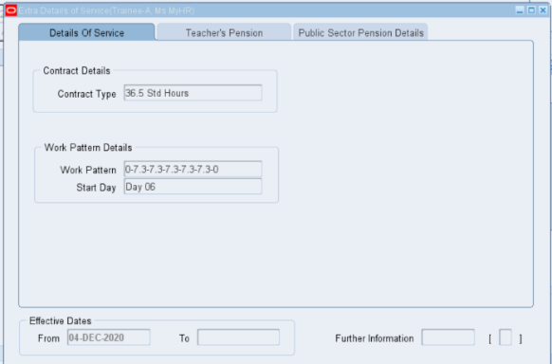

Day 01 = Sunday
Day 02 = Monday
Day 03 = Tuesday
Day 04 = Wednesday
Day 05 = Thursday
Day 06 = Friday
Day 07 = Saturday

Figure 14: Extra Details of Service

Grade Step

This tab will show the following information:
- Grade
- Spinal point
- Annual full time salary for the spine point
- Effective date

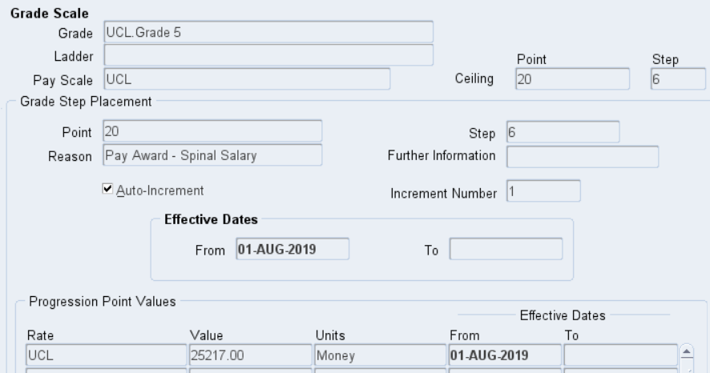
Figure 15: Grade Step

Costing

This tab will show the following details:
- Cost code(s) – to which the salary details for the assignment is charged to
- Proportion – the percentage of the cost code being charged
- Effective date – the start date, and end date, for the cost code(s)

Figure 16: Costings

Budgets

This tab will show the following details:
- Value – the FTE for the assignment

Figure 17: Budgets

Person Phones

This allows the system user to access the Phone details at a MyHR Record for a member of staff whose record is within the viewer’s MyHR security hierarchy.

Search for a MyHR Record

- Select Person Phones from the UCL HR Departments Read Only menu.

Figure 18: UCL HR Departments Read Only Menu

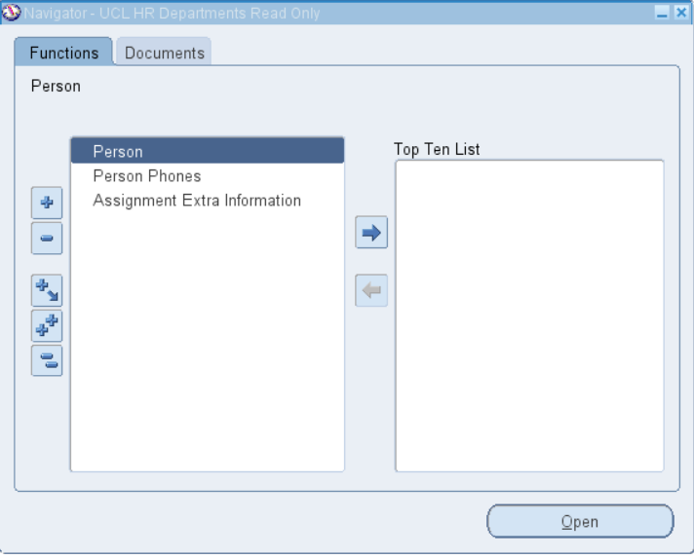
Figure 19: Navigator screen

- Double click on ‘Person Phones’ or highlight and press Open

- Search for the member of staff’s Phone details either using their Name or Employee Number.

Note: % wildcards can be used to facilitate the search (See Appendix A: Using a Wildcard Search).

- Select from a list of values the individuals record you wish to view and click on ‘Ok’

Note: If you are searching for a Visitor/Contingent Worker record please change the Type from ‘Employee’ (default value) to ‘Contingent Worker’ before entering a search term.

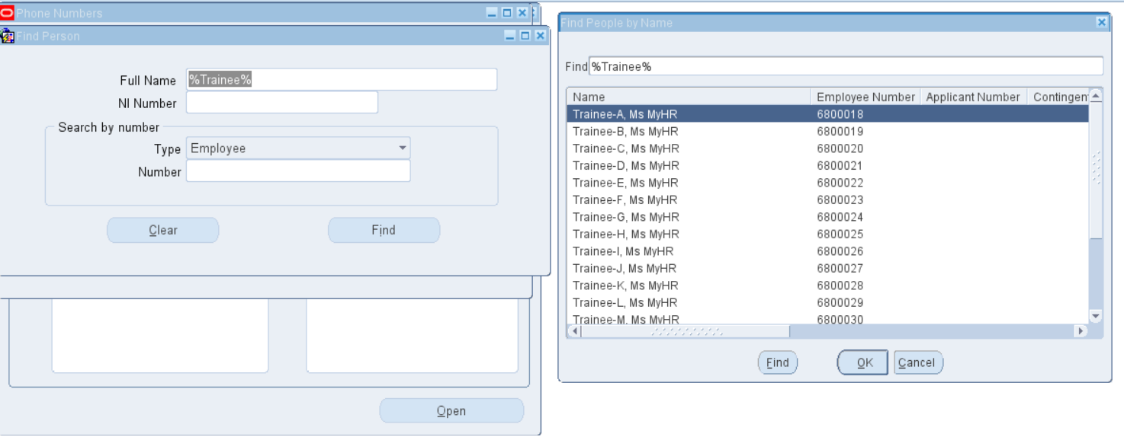
Figure 20: Searching for a MyHR record

Phone Numbers

This tab will show the following details:
- Primary Home Number
- Personal Mobile
- Work Number

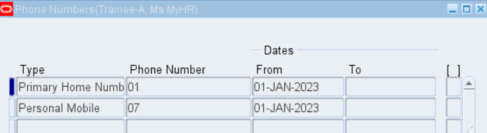
Figure 21: Phone Numbers at a MyHR Record

Assignment Extra Information

This section allows you to access the following details:
  - Clinical Contract
  - Fellowships
  - Teaching Fellow

Search for a MyHR Record

- Select Assignment Extra Information from the UCL HR Departments Read Only menu.

Figure 22: UCL HR Departments Read Only Menu

Figure 23: Navigator screen

- Select ‘Assignment Extra Information’ and press Open

- Search for the individual by either using their Name or Employee Number.

Note: % wildcards can be used to facilitate the search (See Appendix A: Using a Wildcard Search).

- Select from a list of values the individuals record you wish to view and click on ‘OK’

Note: If you are searching for a Visitor/Contingent Worker record, please change the Type from ‘Employee’ (default value) to ‘Contingent Worker’ before entering a search term.

Figure 24: Searching for a MyHR record

Extra Assignment Information

This tab will show the following details:
- Clinical Contract
- Fellowships
- Teaching Fellow

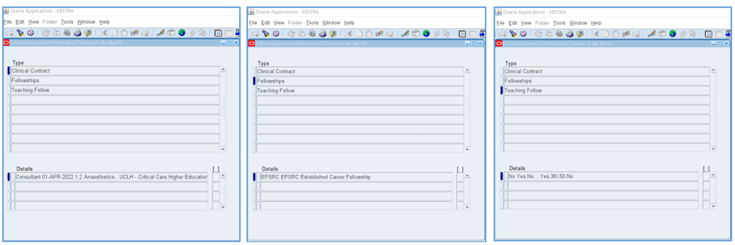
Figure 25: Extra Assignment Information

- To expand the on-screen details click into the individual Details line to generate the pop up box shown below.

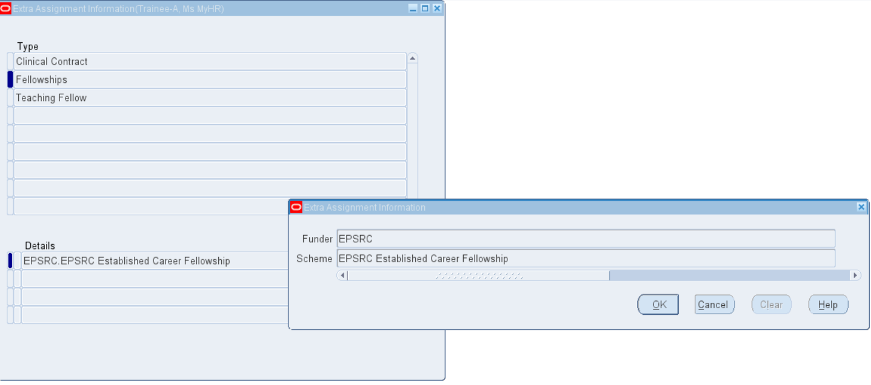
Figure 26: Extra Assignment Information search screen – expanding the details

Toggle between Screens and Exiting
- To exit a screen select the Close Form button located on the top menu bar.

Figure 27: Close Form button located on top menu bar

- On reaching the Functions screen shown below, you can toggle to one of the other three screens within this area (Person, Person Phones or Assignment Extra Information) by double clicking on the item, or highlighting the item and selecting ‘Open’.

- To exit Oracle Applications press ‘File > Exit Oracle Applications’ and select ‘OK’ to confirm.

Appendix A: Using a Wildcard Search

Using a ‘%’ as a wildcard will broaden the search results as this will return individuals where part of the search information is present.

Where the wildcards are used in the Last Name field:

- %<Surname> will return names where Williams is pre-fixed will other characters
- <Surname>% will return name where Williams is the followed by other characters’
- %<Surname>% will return names where Williams is in the middle of other characters

For example, the following would be returned where ‘Williams’ is entered for each scenario:

a) Jones-Williams
b) Williamson
c) Jones-Williamson

Select ‘Find’ to commit your search.

The search results will be shown at the bottom of the page.

Appendix B: Searching via the Search Screen

Searching for an individual’s record

Records can be viewed by navigating to the ‘Search’ screen.

- Click on the Search Icon and enter the search details:

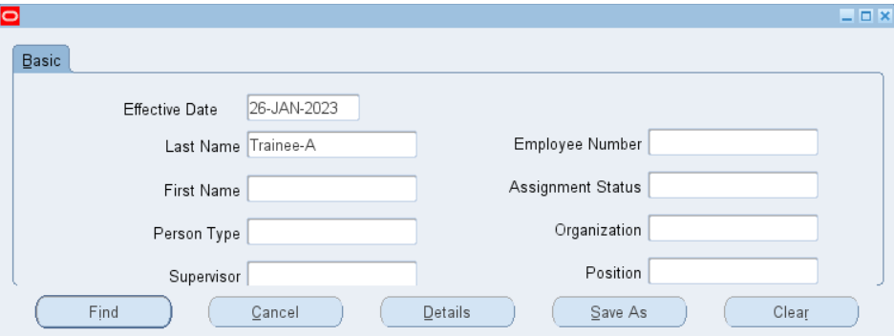
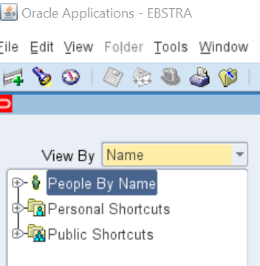
Figure 28: Searching via the Search Icon

Records can be searched using one of the following key pieces of information:
- Last name
- Frist Name
- Employee Number
- Supervisor
- Organisation Unit

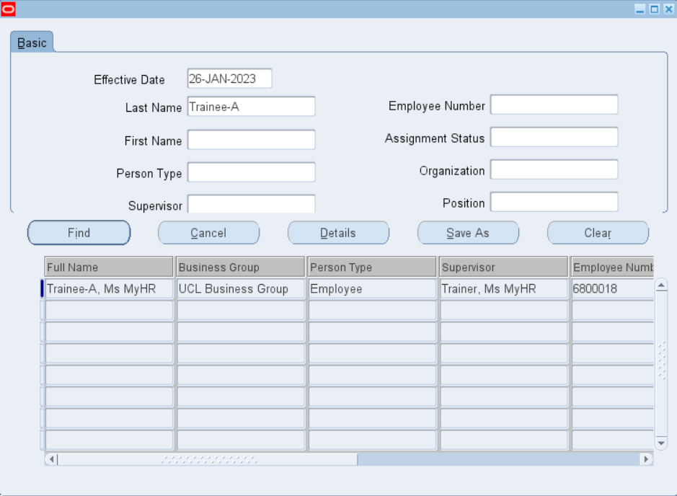
Figure 29: Summary of MyHR HR record

- Click on the name of the individuals record you want to view

- Click on ‘Details’
Figure 30: Accessing a MyHR record

Appendix C: Glossary of fields available

Field Breakdown and Location

Person Menu Item

Field Name | Location
Title | Personal
First Name | Personal
Middle Name | Personal
Last Name | Personal
Preferred Forename | Personal
Preferred Surname | Personal
Employee Number | Personal
Person Type | Personal
Adjusted Service Date (continuous service date) | Personal
Latest Start Date | Personal
UPI | Personal
Address | Personal > Address
Contract Type (standard full time contract hours) | Personal > Extra Details
Work Pattern | Personal > Extra Details
Start Day | Personal > Extra Details
Grade Spinal Point | Personal > Grade Step
Costing (PTAE) | Personal > Costing
Budget (FTE) | Personal > Budget
Assignment (position number) | Assignment
Organisation Unit | Assignment
Position ID | Assignment
Grade | Assignment
Supervisor | Assignment
Salary Basis | Assignment
Assignment Number | Assignment
Assignment Category (full time, part time) | Assignment
Assignment Status | Assignment
Salary (non-spinal only) | Assignment
Normal Hours (weekly working hours) | Probation, Notice Period, Standard Conditions
Probation Length | Probation, Notice Period, Standard Conditions
Probation End Date | Probation, Notice Period, Standard Conditions
Projected End Date | Additional Assignment Information
End Date Reason | Additional Assignment Information
Job Title | Additional Assignment Information
Staff Occupancy Category | Additional Assignment Information

Person Phones Menu Item

Field Name | Location
Type of number | Phones
Phone Number | Phones

Assignment Extra Information Menu Item

Field Name | Location
Clinical Contract Details | Assignment Extra Information
Fellowship Details | Assignment Extra Information
Teaching Fellow Details | Assignment Extra Information

