MyHR Read Only for Departmental Finance Users

This will give the user access to the following individual data found at an Employee or visitor/contingent worker record. This includes historical, current and future data.

Employment – Assignment Costing, Working hours (100% FTE equivalent), Work Pattern, FTE, Grade and Salary information.

Please note: The information provided in the ‘Departmental Finance User’ access is present within the ‘Departmental HR User’ access.

General Guidance

Date Tracking

This enables the data on a person’s record to be viewed as at a particular date or point-in time. Any search, unless the date track is changed, will return results as per the date the search is undertaken.

Once you have entered a person record there will be an ‘Effective Start Date’ and Effective End Date’ field. This will signal the dates for which the data being viewed is relevant.

- if you date track to the date the day before the ‘Effective Start Date’ you will see the data before the most recent change

- if you date track to the date 1 day after the ‘Effective End Date’ you will see any future changes on the individuals record

To Date Track on a record

Unless an Effective Date is changed at the start of the search, the Effective Date of a MyHR record will be today’s date.

- Click on the date in the top left hand of the screen
- Enter the date you wish to date track to
- Click on ‘Go’
- This will update the details on the record, across all tabs, to the date entered

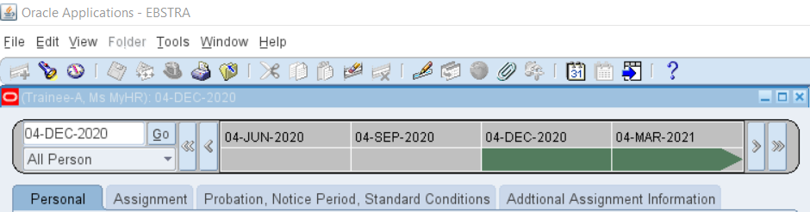
Figure 1: Date Tracking within a MyHR record

Note: An Effective Date away from today’s date will show in the header against the name of the record.

Navigation

Viewing Assignment Details

This allows the system user to access Assignment Details at a MyHR Record for a member of staff whose record is within the viewer’s MyHR security hierarchy.

To search for a MyHR Record

- Select Person from the UCL HR Departments Read Only menu.

Figure 2: UCL HR Departments Read Only Menu

- This launches the Java application download – select Run if using Microsoft Edge to open the application. If using another browser, such as Google Chrome, you will have to Save, then select Open to launch the application.

Decision: at the start of the application you have an option to date track to a date other than today’s date.

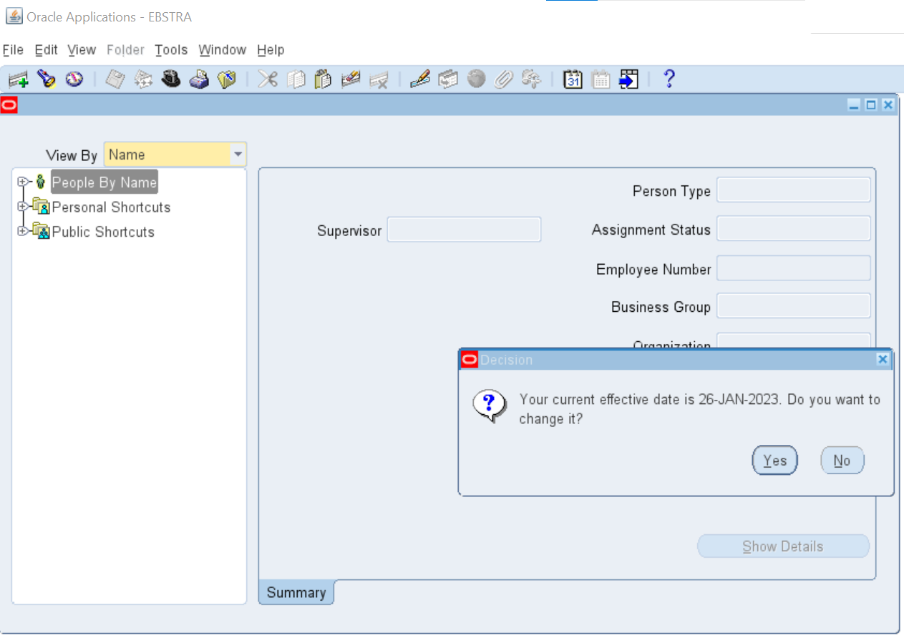
Figure 3: Date Track options

- Select ‘No’ to keep the Effective Date as viewing data effective as of today’s date.

- Selecting ‘Yes’ allows the Effective Date of searching the system to be a different date. Enter the new Effective Date in the style DD-MMM-YYYY and press ‘OK’.

- Pressing ‘Reset’ will keep today’s date or press ‘Cancel’ to exit this box without saving the changes.

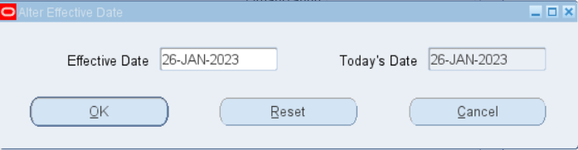
Figure 4: Effective Date changes

- To search for an individual’s MyHR record, select the ‘+’ symbol beside ‘People By Name’ to expand the A-Z Folder Tree.

Note: an alternative search method is available (See Appendix B: Searching via the Search Screen).

Figure 5: Folder Tree Search

- Expand the first letter of the person’s surname to further expand the Folder Tree, then locate the person’s name in this list.

- Select the person’s name to reveal their assignment(s).

- Select the appropriate assignment to show a summary on the right hand side of the screen.

- Select ‘Show Details’ to open this assignment record.

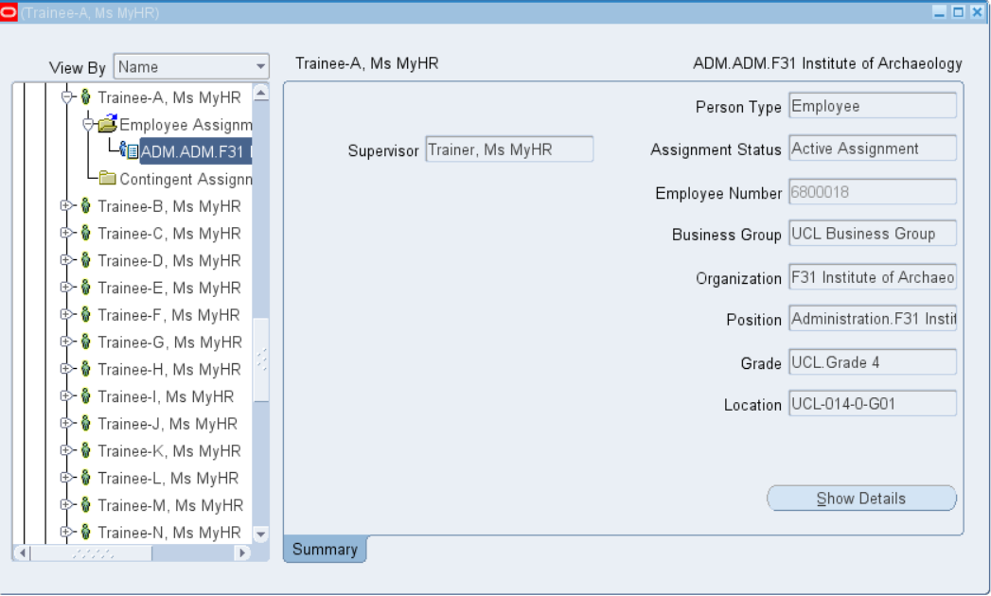
Figure 6: Summary of MyHR HR record

Viewing a MyHR Record

- To view an individual’s MyHR record, select ‘Show Details’

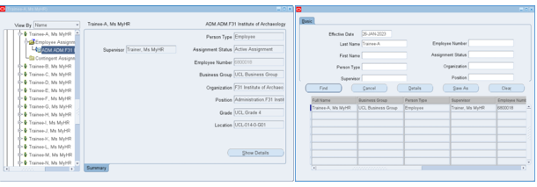
Figure 7: Accessing a MyHR record

Note: a list of fields and their locations is available (See Appendix C: Glossary of fields available)

The record for the individual is broken down into the following tabs:

‘Assignment’ details

This tab will show the following information:
- Assignment number
- Salary – this will show a non spinal salary amount.
- Assignment status
- Effective Start Date and End Date – reflects the period for the displayed Assignment details

Note: Spinal salary details are visible on the ‘Position, Notice Period, Standard Conditions tab.

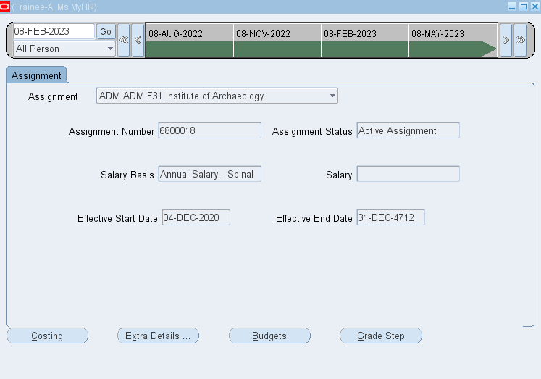
Figure 8: Assignment screen

Additional Information Available

At any of the tabbed screens the following details can be accessed from the buttons at the bottom of the screen.

Figure 9: Additional Personal and Assignment Information

Costing

This tab will show the following details:
- Cost code(s) – to which the salary details for the assignment is charged to
- Proportion – the percentage of the cost code being charged
- Effective date – the start date, and end date, for the cost code(s)

Figure 10: Costings

‘Extra Details…’

This tab will show the following details:
- Contract Type – standard full time working hours for the individual’s contract
- Work Pattern
- Start Day number pertaining to the Effective Date, e.g. an Effective Date of 04-Dec-2020 occurred on a Friday (Day 06).

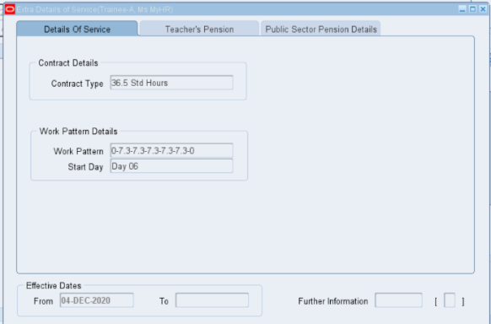
Day 01 = Sunday
Day 02 = Monday
Day 03 = Tuesday
Day 04 = Wednesday
Day 05 = Thursday
Day 06 = Friday
Day 07 = Saturday

Figure 11: Extra Details of Service

Budgets

This tab will show the following details:
- Value – the FTE for the assignment

Figure 12: Budgets

Grade Step

This tab will show the following information:
- Grade
- Spinal point
- Annual full time salary for the spine point
- Effective date

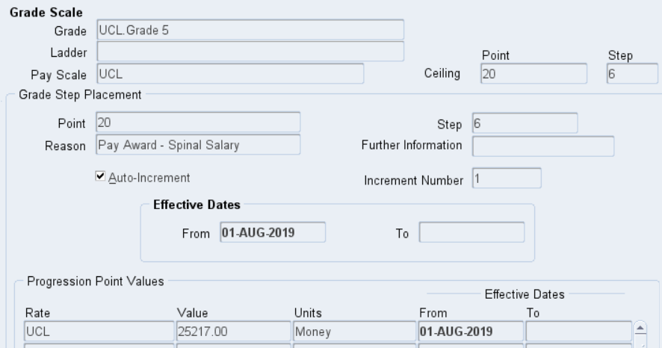
Figure 13: Grade Step

Toggle between Screens and Exiting

- To exit a screen select the Close Form button located on the top menu bar.

Figure 14: Close Form button located on top menu bar

- On reaching the Functions screen shown below, you can toggle to one of the other three screens within this area (Person, Person Phones or Assignment Extra Information) by double clicking on the item, or highlighting the item and selecting ‘Open’.

- To exit Oracle Applications press ‘File > Exit Oracle Applications’ and select ‘OK’ to confirm.

Appendix A: Using a Wildcard Search

Using a ‘%’ as a wildcard will broaden the search results as this will return individuals where part of the search information is present.

Where the wildcards are used in the Last Name field:

- %<Surname> will return names where Williams is pre-fixed will other characters
- <Surname>% will return name where Williams is the followed by other characters’
- %<Surname>% will return names where Williams is in the middle of other characters

For example, the following would be returned where ‘Williams’ is entered for each scenario:

a) Jones-Williams
b) Williamson
c) Jones-Williamson

Select ‘Find’ to commit your search.

The search results will be shown at the bottom of the page.

Appendix B: Searching via the Search Screen

Searching for an individual’s record

Records can be viewed by navigating to the ‘Search’ screen.

- Click on the Search Icon and enter the search details:

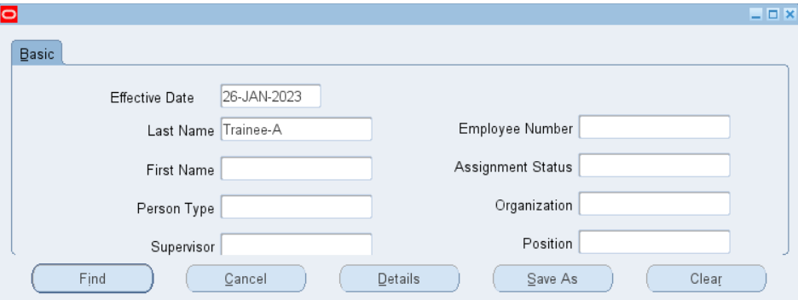
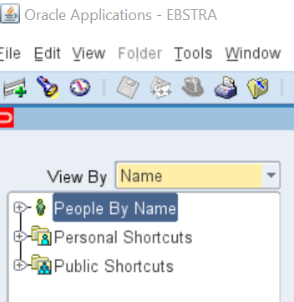
Figure 15: Searching via the Search Icon

Records can be searched using one of the following key pieces of information:
- Last name
- Frist Name
- Employee Number
- Supervisor
- Organisation Unit

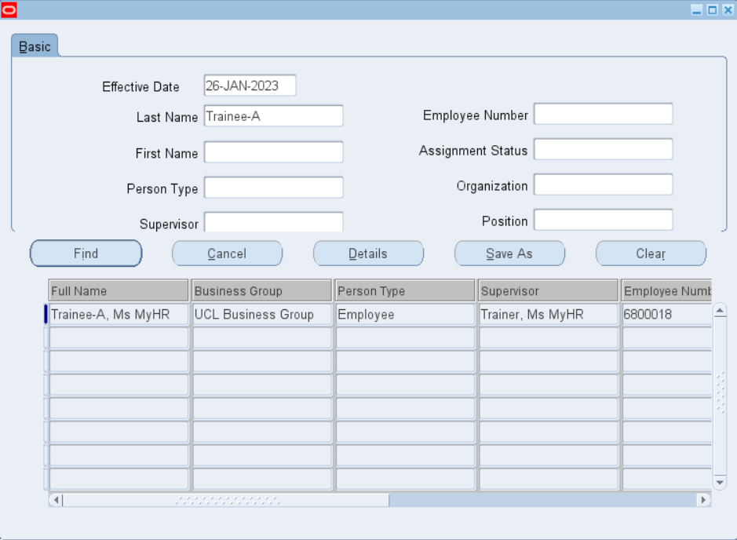
Figure 16: Summary of MyHR HR record

- Click on the name of the individuals record you want to view

- Click on ‘Details’

Figure 17: Accessing a MyHR record

Appendix C: Glossary of fields available

Field Breakdown and Location

Person Menu Item

Field Name | Location
Assignment Number | Assignment
Assignment Status | Assignment
Salary Basis | Assignment
Salary (non-spinal only) | Assignment
Costing (PTAE) | Assignment > Costing
Contract Type (standard full time contract hours) | Assignment > Extra Details
Work Pattern | Assignment > Extra Details
Start Day | Assignment > Extra Details
Budget (FTE) | Assignment > Budgets
Grade | Assignment > Grade Step
Grade Spinal Point | Assignment > Grade Step

