Department Transaction – Transaction Tracker

The Transaction Tracker enables you to see the current status of any transactions that have been submitted by you as well as any transactions that have been submitted by other users against any organisation units to which you have been given access.

Using the Transaction Tracker

- Select Transaction Tracker from the Departmental Transactions menu.
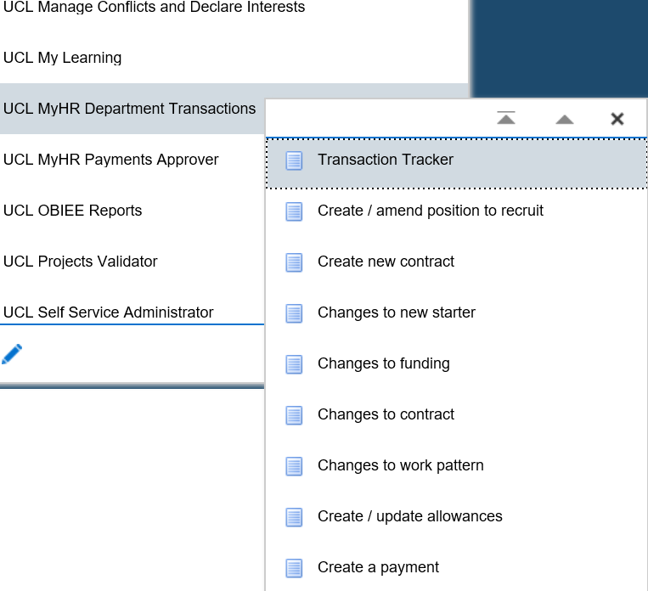
Figure 1 : Department Transactions Menu

How to Filter the Search Results

The Transaction Tracker will show any transactions that have been started, submitted, approved, recalled or cancelled.

Please note: on accessing the Transaction Tracker the ‘Originator’ value will be set to yourself and unless changed a search will return transactions that were started by yourself.

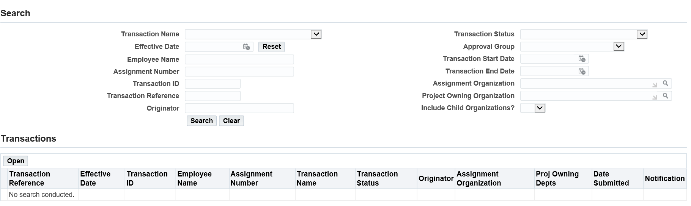
Figure 2 : Transaction Tracker – Searching for a Transaction

To see all transactions: Do not enter any filter data and click on search.

To narrow the search results you can filter by one, or many, of the following fields:

Transaction Name: To see all requests of a particular type, for example, Create new contract:

- Select the type of transactions that you would like to see

- Click on ‘Search’

All transactions of a particular type, irrespective of status, will be returned.

Transaction status: To see all requests at a particular status, for example, ‘On Approval (Finance)’. See Appendix 1, Table 1 for a breakdown of statuses.

- Select the particular status of Form that you would like to see

- Click on Search

All transactions at a particular status will be returned.

Transaction ID: Every transaction is given a unique transaction Id. To see a particular transaction:

- Enter the Transaction ID number

- Click on Search

Originator: To see all transactions that were started by a particular user:

- Enter the users surname with a % either side, for example %Smith%

- Click on Search

The results will return all forms that have been submitted by a particular user which have been submitted against a hierarchy unit to which you have been given access, irrespective of the status form or the transaction name.

Employee number: To see all transactions that have been submitted for a particular employee:

- Enter the employees surname with a % either side, for example %Smith%

- Click on Search

The results will return all forms that have been submitted for the employee which have been submitted against a hierarchy unit to which you have been given access, irrespective of the status form or the transaction name.

How to Sort the Search Results

It is possible to sort the search results by each column header, for example, Transaction Status.

Figure 3 : Transaction Tracker – Sorting the Search Results

To filter by a particular column:

- Complete a particular search, see Filtering in this document

- Click on the column header that you would like to search the results by, for example, Transaction Status.

- Click on the arrow next to the Column Header

The search results will be sorted either by type, alphabetically or chronologically depending on the column header filtered.

How to Check Where a Request is for Approval

You can tell from the transaction status where the request is in the process, for example ‘On Approval (Finance), but to see which team within this section the request is with, for example ‘Professional Services Finance’ :

- Complete a search in the Transaction Tracker to identify the request

- Click on the ‘Transaction Status’ of the listed transaction

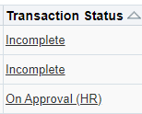

- The ‘Approval Details’ pop up will provide the following information:

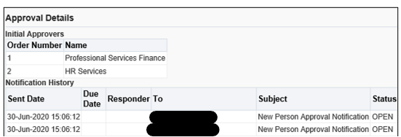
The names of the approvers in the approval group where the form is currently for approval
The sections who will approve the request and the order of approval
Figure 4: Transaction Tracker : Checking where a request is for approval

To Access an Existing Transaction

To access an existing transaction to either see the details of the request submitted or to complete an ‘Incomplete’ request so this is ready for submission:

- Complete a search in the Transaction Tracker to identify the request

- Click on the radio button to the left of the appropriate Transaction Reference

- Click on ‘Open’.

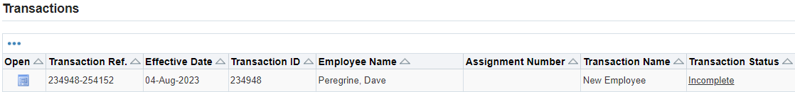
Figure 5: Transaction Tracker : Accessing an existing transaction

How to Recall or Cancel an Existing Transaction

A transaction can be stopped from progressing by undertaking on of the following actions:

Recall transaction – to recall a transaction that has been submitted but is yet to be approved.

Cancel transaction – to cancel a transaction that has been started, but not submitted, but is no longer required.

To Recall a Transaction

If you have submitted a transaction that is no longer required, this can be recalled whilst it with the first approver after submission. To recall a transaction:

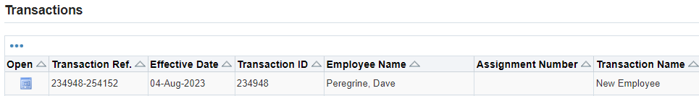
Figure 5: Transaction Tracker : Recalling a transaction

- Identify the transaction in the transaction tracker by completing a search

- Click on the radio button on the left hand side

- Click open

- Click the Action button in the top right hand corner.

Figure 6: Transaction Tracker : Recalling a transaction : Action

- Select Recall Transaction

- Click on ok
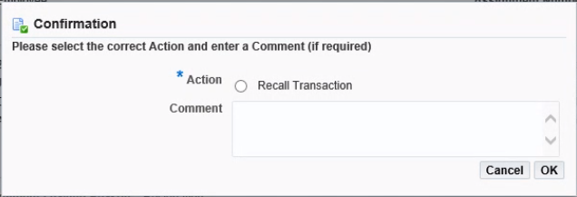
Figure 7: Transaction Tracker : Recalling a transaction :Confirmation

To cancel a transaction

If you have started a transaction that is no longer required, this can be cancelled.

- Identify the transaction in the transaction tracker by completing a search

- Click on the radio button on the left hand side

- Click open

- Click the Action button in the top right hand corner of the page

Figure 8: Transaction Tracker : Cancel a Transaction

- Select cancel transaction

- Click on ok

Appendix 1 – Transaction Statuses

Transaction Status | Explanation
Closed by HR Services | The request has been Closed by HR and the action processed manually in the core system
Closed/Approved (Finance) | The request has been approved by Finance
Closed/Approved (HR) | The request has been approved by HR
Incomplete | The request has been started by the department and is awaiting information and submitted and therefore incomplete
On Approval (Finance) | The request is with Finance to approve
On Approval (HR) | The request is with HR to approve
On Approval (Payment Approver) | The request is with the Payment Approver to approve
Recalled by User | The request was submitted and recalled by the department
Transaction Cancelled | The request has been started and cancelled by the department before submission
Under Query (Finance) | The request has been place under query by Finance
Under Query (HR) | The request has been placed under query by HR
Under Query (Payment Approver) | The request has been placed under query by the payment approver
Workflow Error | The request has been approved with the final approver (HR or Finance) and due to a problem with the transaction the request has failed on the upload to the HR system
Table 1 : Department Transaction : Transaction status explanations

Version Control

Version | Date Created
1.0 | July 2020
2.0 | June 2021
3.0 | August 2023

