Department Transactions – Process a Leaver

General Guidance

Individuals can be future terminated. For leavers in the past, a request can be submitted where the leave date falls within the current or previous payroll month. For any leavers where their leave dates are earlier than one month prior to the date the request is being processed, please contact HR Services (hr-services@ucl.ac.uk) to process the leaver’s request.

You should not submit a leaver request for an employee who is transferring.

Creating a ‘Process a Leaver’ request

- Select Process a Leaver from the Department Transaction menu

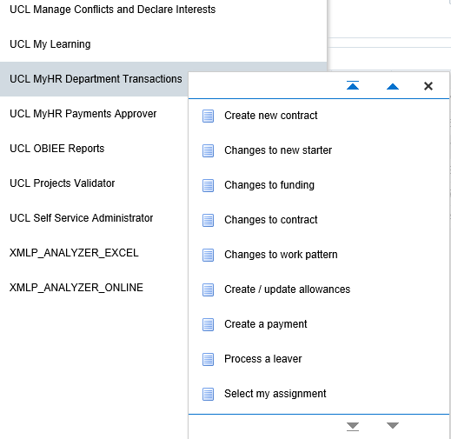
Figure 1: Department Transactions Menu

- Effective date: Enter the leaving date

- Enter the name and / or employee number of the person leaving

- Press the search button

Figure 2: Process a Leaver: Search Screen

• Select the assignment to be terminated from the list, by clicking on the radio button

• Click on the Process a Leaver button

Please note: a box may pop up showing other ‘pending’ transactions. Check that the transaction hasn’t already been entered by a colleague and if you are happy to proceed with entering the payment click ok. If no, click on cancel.

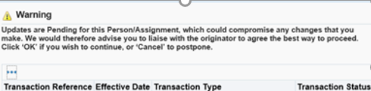
Figure 3: Department Transactions – Proces a Leaver : Pending transactions

Step 1 – Termination

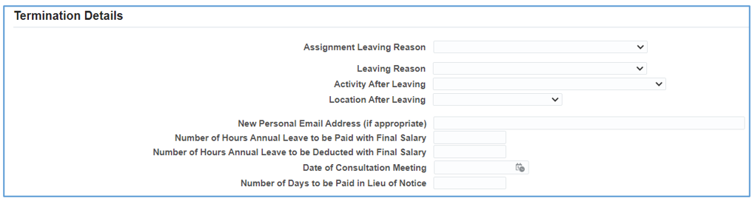

Figure 4: Department Transactions – Process a Leaver – Step 1: Termination

- Assignment Leaving Reason: select the appropriate Assignment Leaving Reason

- Leaving Reason: select the appropriate Leaving Reason (see Appendix A for breakdown of leaving reasons)

- Activity After Leaving: select the appropriate Activity after Leaving

- Fill out the Location After Leaving

- New Personal Email Address (if appropriate) – this gives an opportunity to add or update a personal email address on the leaving individual’s record, ensuring that they will receive their P45 and any other necessary correspondence.

- Number of Hours Annual Leave to be Paid with Final Salary – entering a value into this field will automatically trigger the payment to the leaving individual. It is no longer necessary to add this information into the comments box at the end of the workflow.

- Number of Hours Annual Leave to be Deducted with Final Salary – entering a value into this field will automatically trigger the deduction from the leaving individual’s final payment. It is no longer necessary to add this information into the comments box at the end of the workflow.

- Date of Consultation Meeting – entering a value into this field will ensure that the date is added to the leaver’s letter.

- Number of Days to be Paid in Lieu of Notice – entering a value into this field will trigger the payment to the leaving individual.

- Click Next

Please Note: If the Leaver has multiple active assignments in your department:

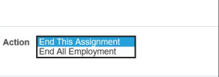
Figure 5: Department Transactions – Process a Leaver – Step 1: End assignment/employment

- Select ‘End Assignment’ to end an individual assignment.

- Select ‘End Employment’ to terminate the employee and all assignments.

Where multiple assignments are held you will only be able to select ‘End All Employment’ where all assignments are within the security hierarchy to which the submitter has access.

Step 2 – Direct Reports

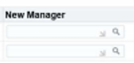

Figure 6: Department Transactions – Process a Leaver – Step 2: Direct Reports

If the individual leaving has direct reports, and is recorded in the core system as their supervisor, these individuals will need to be reassigned before the request can be submitted.

- New Manager: Click and search for the name of the new manager.
- Select the new manager by clicking on the

If the same manager is to be used multiple time’s once the manager has been selected once you can copy and paste the same name in to any of the other ‘New Manager’ fields.

Step 3 – Leavers Termination Elements

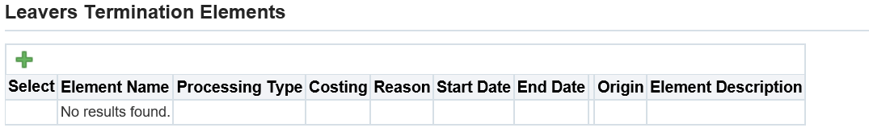
Figure 7: Department Transactions – Process a Leaver – Step 3: Leavers Termination Elements

Please note: This screen is not to be populated when the following payments have been indicated at Step 1:

- Annual Leave is either to be Paid or Deducted with Final Salary
- Payment in lieu of notice is to be made
- Redundancy

When Annual leave is to be Paid or Deducted with Final Salary this screen will be populated with the appropriate pay element after submission of the form.

If another type of payment, different to the above, needs to be made with the leaving then add the element as follows.
- Click to enter a new element

- Element Name: Search for the element name by clicking the icon and select the element

- Start date: this will always populate based on the start and end date of the month in which the leave date falls.

- End date: this will always populate based on the start and end date of the month in which the leave date falls

- Click in the costing and enter the project, task and award to which the payment is to be charged. If the values are known these can be typed in the fields. Otherwise click on the icon

Where the costing field is left blank the cost associated to this element will be charged to the same project, task and award as the basic salary

- Reason: Select New Pay Element

A full break down of the elements is available at MyHR Department Transactions – Pay Element Information

- Values: Enter the appropriate value

Step 4 – Documents

- Click on Create to search the computer and add any relevant documents required, for example, a resignation letter.

- Select the appropriate naming document type

Step 5 – Review and Submit

- If required, enter a message in the message field and click submit

- Click continue to go back to the main menu

The Transaction will now go to the next approver as indicated in the approver field.

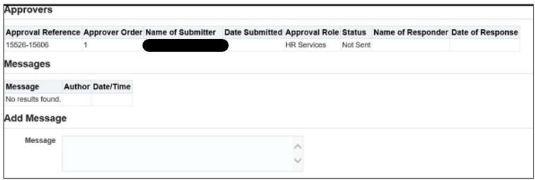
Figure 8: Department Transactions – Process a Leaver:: Review and Submit

Appendix A

Leaving Reasons

 | Leaver Reason | Description
1 | Casual Leaver | Termination of an as and when casual worker arrangement
2 | Deceased | Death of an employee
3 | Did Not Start | Did not take-up job offer, or offer was withdrawn
4 | Did not start – No DBS | Did not take-up job offer, or offer was withdrawn – DBS check not completed or unsuccessful
5 | Did not start – No Right to work | Did not take-up job offer, or offer was withdrawn – RTW check not completed or unsuccessful
6 | Dismissal (No Right to Work) | Dismissal - no right to work e.g., visa expired, security or DBS checks, unsatisfactory or removal of professional license to practice
7 | Dismissal due to Capability | Capability Dismissal because of either:  i) long term sickness absence (excluding ill health retirement)  or/  ii) short term persistent sickness absence following the sickness absence procedure  or/  ii) Performance under the Capability Procedure
8 | Dismissal due to Some Other Substantial Reason | Dismissal of an open-ended contract because of “Some Other Substantial Reason”. Always seek advice from HR if using this reason  Examples of these situations could include:  i) Breakdown of the relationship between UCL and the employee or between 2 employees.  ii) Consulting with the employee over a change to their contract where agreement cannot be reached, and a new contract is offered.  iii) Reputational risk to UCL to continue with the employment of the individual.
9 | Dismissal due to failed probation | Dismissal due to failed probation period
10 | Duplicate Employee on System | Duplicate Employee on System
11 | End of Fixed Term Contract (Redundancy) | Expiry of a fixed term contract because the funding or project has come to an end. The employee may be eligible for a redundancy payment depending on their length of service. Please see here for further details.
12 | End of a Fixed Term Contract (SOSR) | Termination of a fixed term contract where either:  i) the role will still exist because the substantive post holder has returned, for example a maternity leave cover or due to a secondment,  or/  ii) the role will still exist, but the post holder is leaving because the role is linked to studies e.g., PGTA contract, Apprenticeships
13 | Ill Health Retirement | Ill health retirement following pension provider approval
14 | Maternity/Shared Parental Leave Non-returner | Left immediately following maternity or shared parental leave. Also to be used for Adoption Leaver.
15 | Redeployment | Redeployment – only used for transfers
16 | Redundancy (End of funding) | When a redundancy situation occurs because an open-ended contract comes to an end due to an external funding end date or because a long-term project role has come to an end. If notice has been served and the individual wishes to leave before their end date, this should still be recorded as Redundancy, and not a “resignation”.
17 | Redundancy (Org Change) | When an open ended internally funded contract comes to an end because the role ceases to exist due to organisational change
18 | Resignation | Employee resignation
19 | Retirement | Employee retirement
20 | TUPE Transfer | Post holder transferred out to another organisation under TUPE
21 | Transfer Department | Do not use – for HR use only:  Post holder transferred to another department into another assignment
22 | Voluntary Severance | Termination of contract following a signed settlement agreement (unrelated to voluntary redundancy)

Table 1: Department Transactions – Process a Leaver – Leaving Reasons

Version Control

Version | Date Created
1.0 | July 2020
2.0 | June 2021
2.1 | January 2022
3.0 | August 2023

