Department Transactions – One Off Worker Request

General Guidance

This workflow is to be used to process payment for a one off piece of work and where the individual will not engage in regular paid work for UCL. Unlike the ‘Worker’ contract request this transaction will create the employee record, make the payment and terminate the person record in the system at the end of the payment month. The person record will not remain open for future payments to be made. Where regular payments are to be made, on a casual basis, these should be submitted as a worker request.

Please note: this guide is specifically for the one off worker workflow. There is a separate guide for other types of contract requests including new employees, transfers, additional assignments and rehires.

You must use a One Off Worker position, if you do not have one for your department, please email hr-servcies@ucl.ac.uk

Searching and Selecting the Correct New Contract Action

- Select Create new contract from the Department Transaction menu.

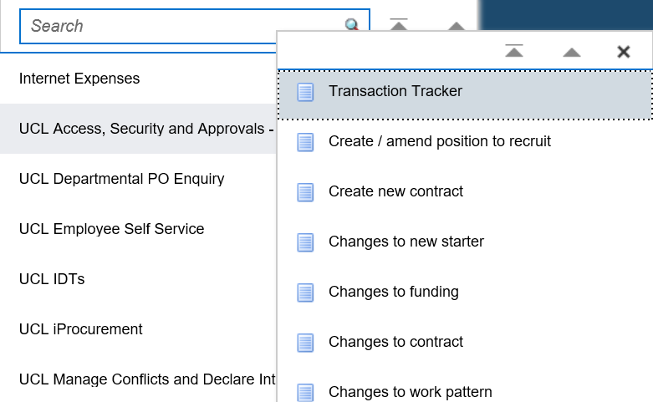
Figure 1: Department Transactions Menu

- Search for your individual to check whether they already have a record in the HR system. To complete the search you must enter the following information:

  - First name
  - Last name
  - Date of birth

Please note: It is important to check that the person does not exist in the database before creating a new person as this will result in a duplicate record being created.

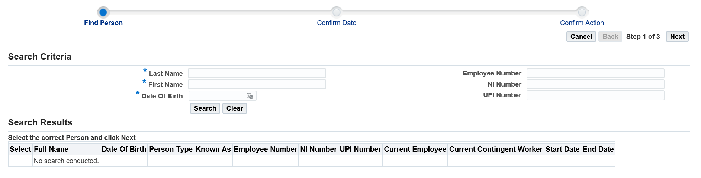
Figure 2: Department Transactions – New Contract Search Screen

The search results will determine the next step you need to take to submit the correct type of contract request:

Where your person exists:

- Select the person by selecting the radio button next to the employee name.

- Click on next in the top right hand corner

- Enter the effective date, which will be the first day of the appointment

- Click on next in the top right hand corner

- Select the record displayed on which the contract request is to be actioned

- Depending on the individual’s current employment status you will be presented with the following options. Select the appropriate action and go to the next step in the process as indicated.

Person Type | Action Button | Next Step to complete
Ex-employee | Rehire ex-employee as one off worker | Step 1
Contingent/Ex-Contingent worker | Rehire contingent worker as one off worker | Step 1
Table 1: Department Transactions: New Contract Search - Actions

Where your person does not exist:

- Click in ‘select’ next the to ‘No Match’ in the search results.

Figure 3: Department Transactions – New Contract Person Search Screen results

Please note: The results are not returned in order of % match so please check all result before selecting ‘No Match’

- Click on next in the top right hand corner

- Enter the effective date, which will be the first day of the appointment

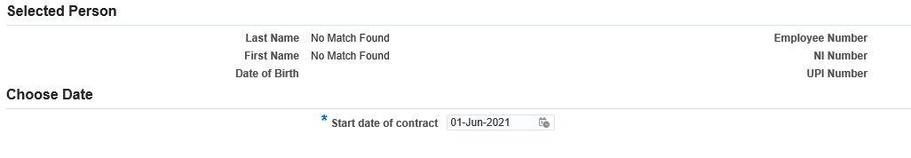
Figure 4: Department Transactions – New Contract Effective Date

- Click on next in the top right hand corner

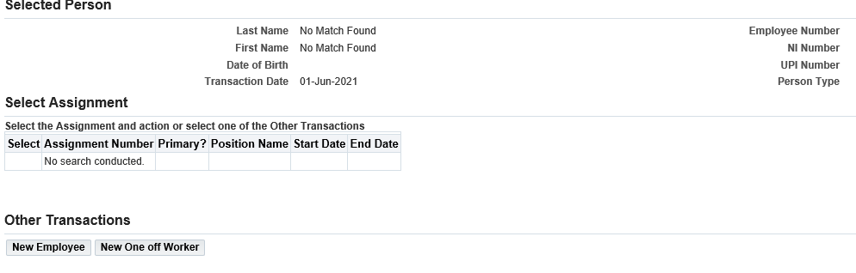
Figure 5: Department Transactions – New Contract options

- Select the New One Off Worker option for a one off worker payment request

- Next you will need to search to see if the individual already has a UPI number with UCL.

The Last Name, First Name and Date of Birth fields will already be completed with the data previously entered.

- Click on search

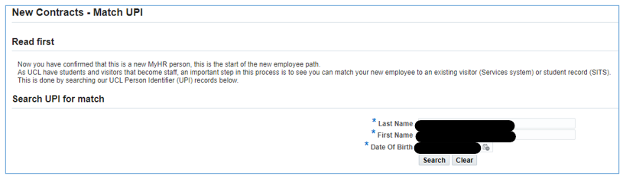
Figure 6: Department Transactions – New Contract UPI Search Screen

- Review the search results and take one of the following actions. Please review all results before deciding on the next action as the correct match may appear anywhere within the list. Where a UPI number already exists for the individual and they are assigned a second UPI number this will cause access issues.

- Where there is a UPI match, select the UPI number and click on next in the top right hand corner

- Where there is no UPI match, click on the ‘Create New UPI number’ button.

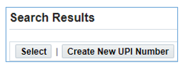

Figure 7: Department Transactions – New Contract UPI Search Screen

Step 1 – Person Details

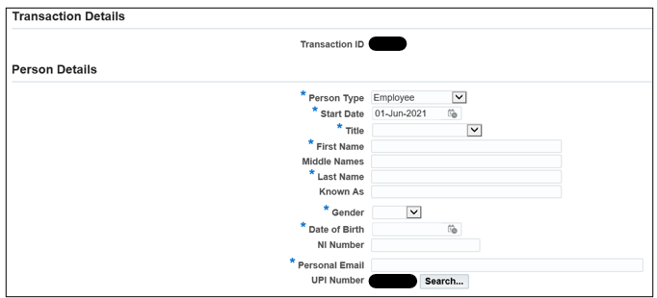
Figure 8: Department Transactions: New one off worker – Person Details

- Person type: This will be prefixed as ‘Worker’.

- Start date: This should be the 1st of the month in which the payment will be made.

Please note: this will be adjusted to reflect the 1st of the month in which the payment will be made when the record is created in the core HR system.

- End date: This will be populated with the last calendar day of the month in which the effective date falls.

Please note: where this is entered in the future, this will be adjusted to reflect the last calendar day of the month in which the payment will be made.

- Complete the following fields:

- Title
- First name
- Middle name
- Last Name
- Known as
- Gender
- Date of Birth
- National insurance number (if known)
- Personal email address.

- Click Next

Step 2 - Address

- Click create

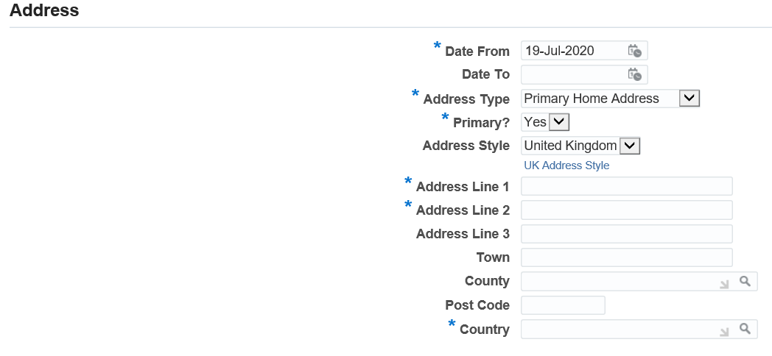
Figure 9: Department Transactions: New one off worker – Address

- Date from: this will populate as the same date as the contract start date

- Address Type: Select the address type

- Primary: for a new contract request this will always be ‘Yes’, unless multiple addresses are being entered. Where there are multiple addresses one must be flagged ‘yes’ in the primary field.

- Address Style: This will auto populate as ‘United Kingdom’ and is not to be updated, even where the address is an overseas address.

- Complete the following fields.

Address Line 1: This field is mandatory
Address Line 2: This field is mandatory
Address Line 3
Town
County
Post Code
Country: This field is mandatory

Please note: These fields will not accept the following symbols: ~:|£\€, Accented characters, characters from non-English scripts, symbols or Emoji.

Where the address only has 2 lines and a post code, enter the Town/Country in address line 2

- Click apply

To add a further address click on and repeat the steps above.

- Click Next

Step 3 - Phone Number

- Click create to add the phone number

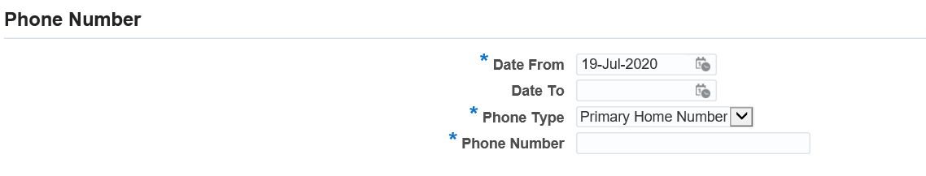
Figure 10: Department Transactions: New one off worker – Phone number

- Date from: this will populate as the same date as the contract start date

- Phone Type: Select the appropriate phone type

- Primary home number
- Personal mobile
- Work number

- Phone number: Enter the phone number

- Click apply

To add a further phone number click on and repeat the steps above.

- To move to the next step click on Next

Step 4 - Assignment Details

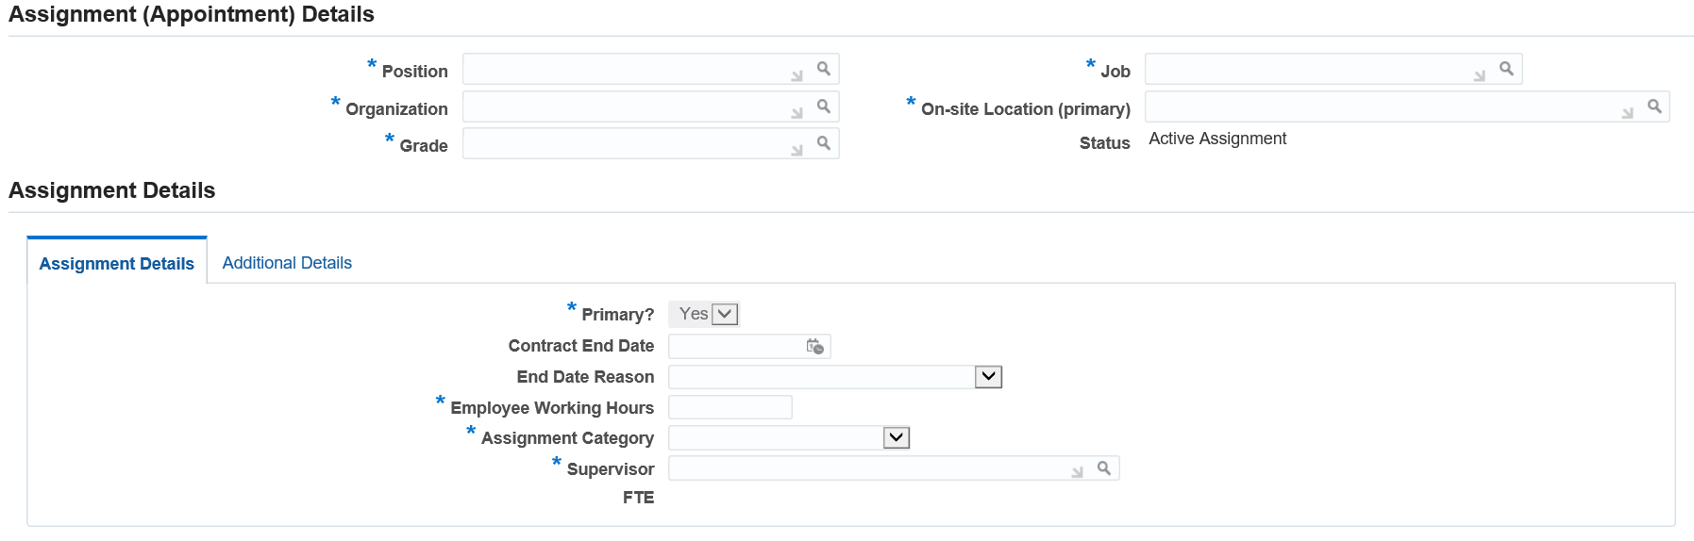
Figure 11: Department Transactions: New one off worker – Assignment Details

- Position:

Where you know the position number:

- Enter a % sign either side of the position number (e.g. %10000%) and press tab.

Where you do not know the position number:
- Click to search
- Search by position for a One Off Worker position. Enter %one off% to list the available positions and click on ‘Go’.
- Identify the One Off Worker position and click ‘Quick Select’

Once a position has been identified the following fields will be populated:

- Organization
- Grade
- Job
- Status
- On-site Location (primary): click to search.

- Enter a % in the search field and click ‘go’
- Return to the search field and enter a part of the building name with a % either side (for example %Bid% for Bidborough House)
- Click go
- Locate the correct building, floor and room and click on ‘Quick Select’ to select the address

- Contract end date: This field does not need to be completed.

- End date reason: This field does not need to be completed.

- Working Hours: Enter ‘0’

- Assignment Category: This will be prepopulated with ‘One off worker’
- Supervisor: click to search

- Enter the surname of the individual’s manager with a % either side (%smith%)
- Click Go
- Select the individual’s manager from the list
- Click on select

- Click on the Additional Details tab.

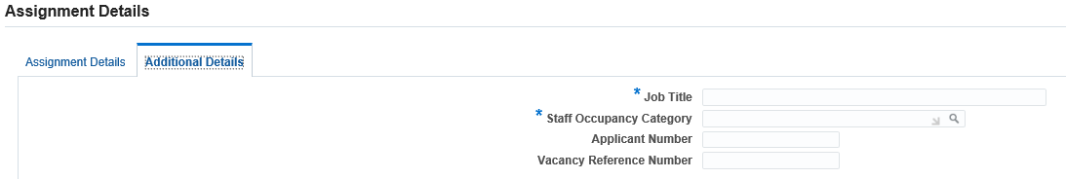
Figure 12: Department Transactions: New one off worker – Assignment Details – Additional Details

- Job Title: Enter the job title for the worker undertaken

- Staff Occupancy Category: Select the staff occupancy category relevant for the piece of work undertaken. The first segment of this value should match the first segment of the ‘Job’ field in the top right of the screen otherwise the request will create a validation error on submission.

- Applicant number: This field does not need to be completed

- Vacancy reference number: This field does not need to be completed

- Click Next

Step 5 – One off Worker Payments

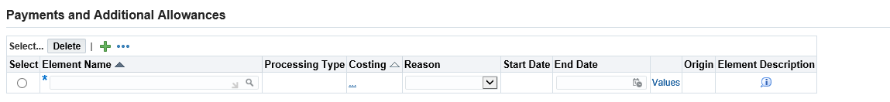
Figure 13: Department Transactions: New one off worker – one off worker payments

- Click to enter a new element
- Element Name: Search for the element name by clicking the icon and click on ‘go’

A description is provided for each element to help select the appropriate element.

A full break down of the elements is available at MyHR Department Transactions – Pay Element Information

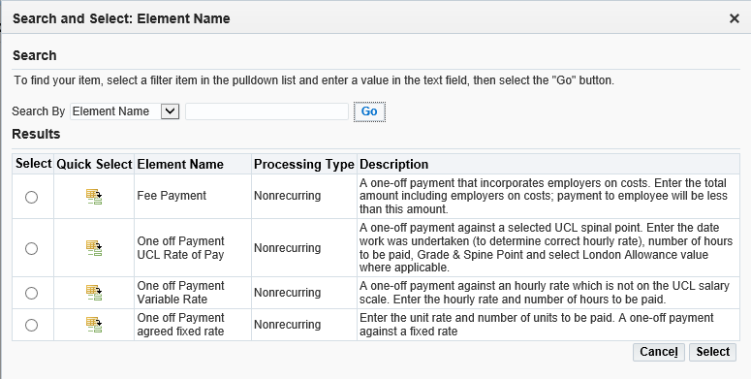
Figure 14: Department Transactions: New one off worker – one off worker element descriptions

- Select the appropriate element.
- Costing: click in the 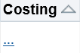 and enter the project, task and award to which this payment is to be charged. Enter the PTAE values in to the fields. Click on the icon to search for a code.

- Reason: Select New Pay Element

- Start Date/ End date: The start date and end date will auto populate as the 1st and last day of the month, based on the effective date.

- Click in ‘Values’ to provide the specific detail of the payment.

Please note: For a reminder of the purpose of the element selected click on the ‘i’ at the end of the screen
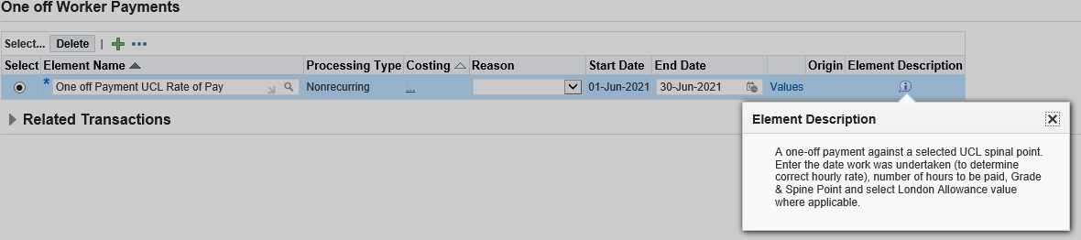
Figure 15: Department Transactions: New one off worker – one off worker element descirptions

- Click next

Step 6 – Timesheet

- Select the month in which the work was completed.

- Enter the total hours worked in each week. In weeks where no hours are worked, enter a 0.

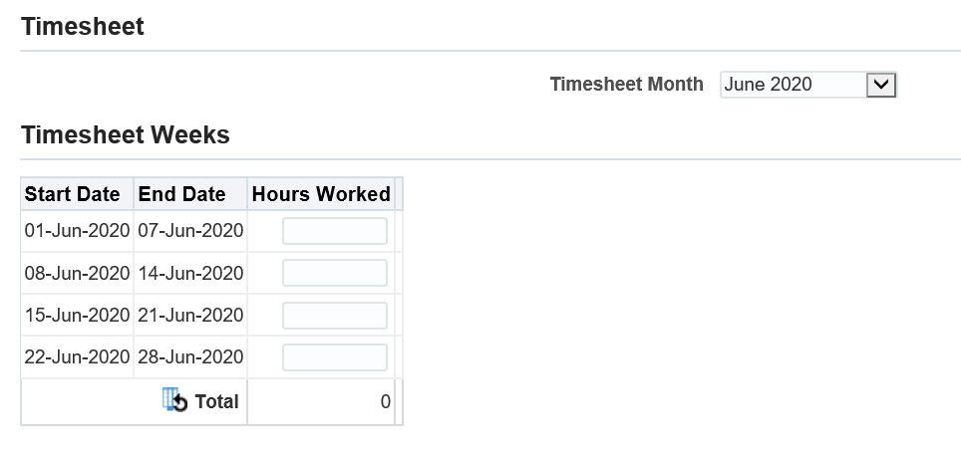
Figure 16: Department Transactions: New one off worker – Timesheets

Step 7 - Right to Work

- Click create

Figure 17: Department Transactions: New one off worker – Right to work

- RTW Status: Click on to search

- Search using % to bring up all values
- Select the correct RTW status based on the right to work documentation that has been checked

- Date checked: Enter the date the right to work documentation was checked

- RTW Expiry Date: where appropriate complete the right to work expiry date

- Passport Expiry Date: where appropriate enter the passport expiry date

- Passport Country : Enter the passport country

- Certificate of Sponsorship Number: where appropriate enter the Certificate of Sponsorship number

- Click apply

- Click next

Step 8 - Disclosure and Barring

Please note: The DBS section must be filled for all requests even where a DBS is not required.

- Click create

Figure 18: Department Transactions: New one off worker – Disclosure and Barring

- Type of check: Select the type of check. Where a check is not required, select not required

- Level of check: Select the level of check. Where a check is not required, select not required

- Ucheck Reference Number: Provide the Ucheck reference number where appropriate

- Status of check: Where a DBS check is required confirm the progress of the check. Where a check is not required, select not required

- Certificate Number: Confirm the DBS Certificate Number where appropriate

- Date of issue: Confirm the date the DBS certificate was issued, where appropriate

- Click Apply

- Click Next

Step 9 – Documents

- Click on Create to browse your computer for the relevant documents to upload.

Please note: Right to work documents are mandatory and it will not be possible to submit the request without the right to work documents attached.

- Select the appropriate naming document type.

- Click Apply

Step 10 – Review and Submit

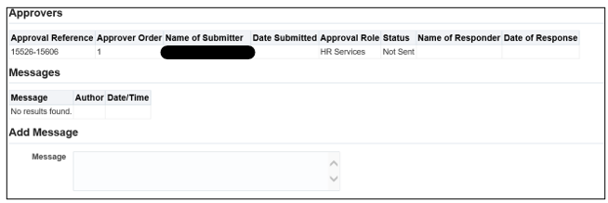
Figure19: Department Transactions: New one off worker – Review and Submit

- If required, enter a message in the message field and click submit.

- Click continue to go back to the main menu.

The Transaction will now go to the Payments Approver and once approved on to HR Services for approval.

Version Control

Version | Date Created
1.0 | July 2020
2.0 | June 2021
3.0 | August 2023

