**Department Transactions – Create New Contract**

New Contract requests are processed either via Department Transactions or TalentLink depending on the nature of the request as follows:

* Department Transactions - Casual, Honorary or One Off Worker
* TalentLink - all other appointments, unless an exemption applies.

The Recruitment team will be able to clarify as to which requests are not to be actioned through TalentLInk.

The ‘Create new contract’ workflow enables a new contract, association or assignment with UCL to be requested, including new employees, new honorary associations, new one off worker, rehires, transfers of appointment and additional assignments.

Please note: There is a separate guide for the completion of the one off worker workflow.

* Select Create New contract from the Department Transaction menu.

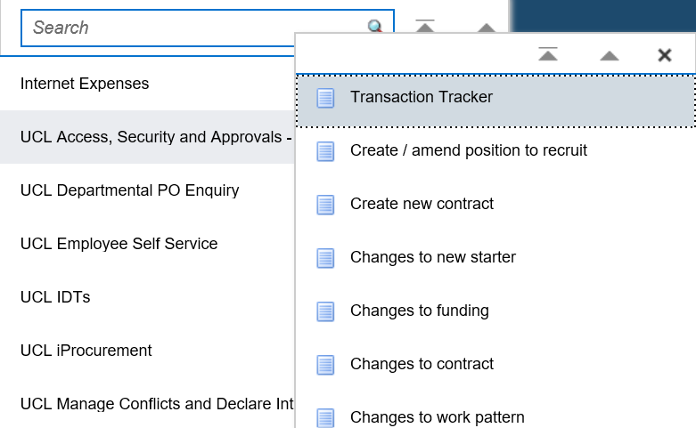

*Figure 1: Department Transactions Menu*

* Search for your individual to check whether they already have a record in the HR system. To complete the search you must enter the following information:
  + First name
  + Last name
  + Date of birth

**Please note:** It is important to check that the person does not exist in the database before creating a new person as this will result in a duplicate record being created.

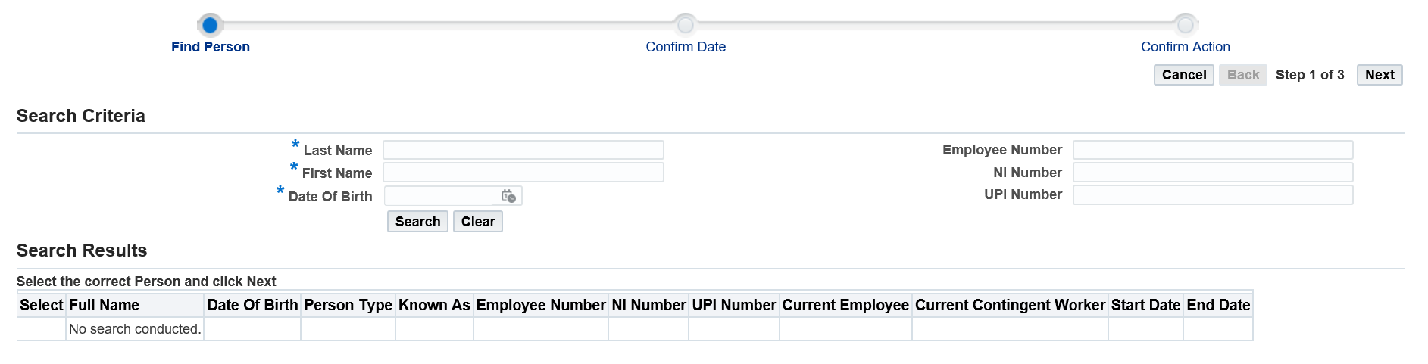

*Figure 2: Department Transactions – New Contract Search Screen*

The search results will determine the next step you need to take to submit the correct type of contract request:

***Where your person exists:***

* Select the person, by selecting the radio button next to the employee name.
* Click on next in the top right hand corner
* Enter the effective date, which will be the first day of the appointment
* Click on next in the top right hand corner
* Review the details and select as follows
* Depending on the individual’s current employment status you will be presented with the following options based upon Person Type. Select the appropriate action. Please also see Appendix 1 for a guide on determining the correct action.
* If you find the employee you are creating a contract for holds a Unitemps assignment, please create an additional assignment, do **NOT** transfer them.

|  |  |  |
| --- | --- | --- |
| **Person Type** | **Action Button** | **Confirm Action** |
| Ex-employee | Rehire ex-employee | Select ‘New Employee (rehire ex-employee)’ |
| Employee | Transfer of Appointment    Additional Assignment | Select the assignment to be transferred from then ‘Transfer of appointment‘  Select ‘Additional Assignment’ |
| Contingent/Ex-Contingent worker | Rehire contingent worker | Select ‘New Employee (rehire contingent worker)’ |

*Table 1: Department Transactions: New Contract – Actions*

* Selecting the Action Button will start the transaction, please proceed to Step 1 below.

***Where your person does not exist:***

* Click in ‘select’ next the to ‘No Match’ in the search results.



*Figure 3: Department Transactions – New Contract Search Screen results*

***Please note:*** *The results are not returned in order of % match so please check all result before selecting ‘No Match’*

* Click on next in the top right hand corner
* Enter the effective date, which will be the first day of the appointment

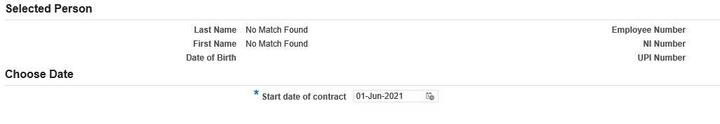

*Figure 4: Department Transactions – New Contract Effective Date*

* Click on next in the top right hand corner

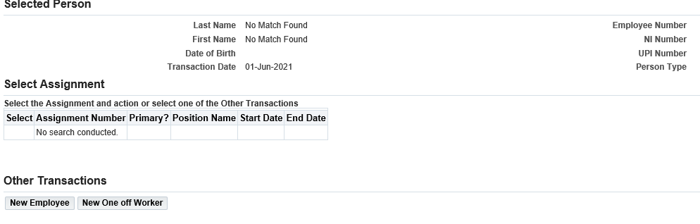

*Figure 5: Department Transactions – New Contract options*

* Select ‘New Employee’.

**Please note:** There is a separate guide for the completion of the one off worker workflow.

* Next you will need to search to see if the individual already has a UPI number with UCL.

The Last Name, First Name and Date of Birth fields will already be completed with the data previously entered.

* Click on search

*Figure 6: Department Transactions – New Contract UPI Search Screen*

Review the search results and take one of the following actions. Please review all results before deciding on the next action as the correct match may appear anywhere within the list. Where a UPI number already for the individual and they are assigned a second UPI number this will cause access issues.

* Where there is a UPI match, select the UPI number and click on next in the top right hand corner
* Where there is no UPI match, click on the ‘Create New UPI number’ button.

*Figure 7: Department Transactions – New Contract UPI Search Screen Results*

**Step 1 – Person Details**

*Fiigure 8: Department Transactions: New Employee – Person Details*

* Select the person type

|  |  |
| --- | --- |
| **Person Type** | **Explanation** |
| Employee | Standard UCL employee – expected use for a TalentLink exemption |
| Honorary/Emeritus | Standard UCL Honorary/Emeritus |
| Worker | As and when casual worker |

*Table 2: Department Transactions: New Employee - Person Types*

* Start date – enter the start date of the appointment
* Complete the following fields:
* Title
* First name
* Middle names
* Last Name
* Known as
* Gender
* Date of Birth
* National insurance number (if known)
* Personal email address.
* UPI number – Do not update the UPI number
* Click Next

**Step 2 – Addresses**

**Please note:** This screen is not present at ‘Additional assignment’ and ‘Transfer of appointment’

* Click create

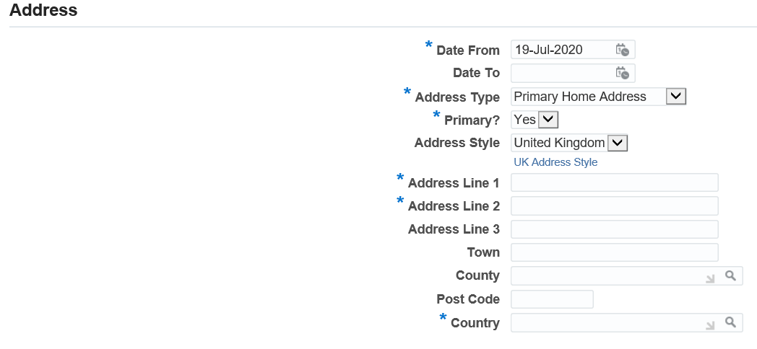

*Figure 9: Department Transactions: New Employee – Address*

* Date from: this will populate as the same date as the contract start date
* Address Type: Select the address type
* Primary: for a new contract request this will always be ‘Yes’, unless multiple addresses are being entered. Where there are multiple addresses one must be flagged ‘yes’ in the primary field.
* Address Style: This will auto populate as ‘United Kingdom’ and is not to be updated, even where the address is an overseas address.
* Complete the following fields.

Address Line 1: This field is mandatory

Address Line 2: This field is mandatory

Address Line 3

Town

County

Post Code

Country: This field is mandatory

**Please note:** These fields will not accept the following symbols: ~:|£\€, Accented characters, characters from non-English scripts, symbols or Emoji.

Where the address only has 2 lines and a post code, enter the Town/Country in address line 2.

An address line entry should be no more than 60 characters including spaces.

* Click apply
* To move to the next step click on Next

To add a further address click on and repeat the steps above.

* Click Next

**Step 3 - Phones**

**Please note:** This screen is not present at ‘Additional assignment’ and ‘Transfer of appointment’

* Click create to add the phone number

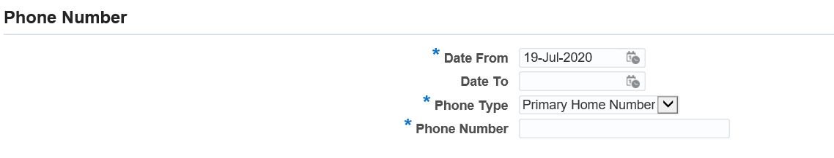

*Figure 10: Department Transactions: New Employee – Phone number*

* Date from: this will populate as the same date as the contract start date
* Phone Type: Select the appropriate phone type
* Primary home number
* Personal mobile
* Work number
* Phone number: Enter the phone number
* Click apply

To add a further phone number click on and repeat the steps above.

* To move to the next step click on Next

**Step 4 - Assignment Details**

*Figure 11: Department Transactions: New Employee – Assignment Details*

**Please note:** Shared Positions with a high headcount are available to use for Worker and Honorary appointments and can be located as follows:

* Worker – search for %Casual Worker% to select from
* Honorary – search for %Honorary% to select from
* Position:

*Where you know the position number:*

* Enter a % sign either side of the position number (e.g. %10000%) and press tab.

*Where you do not know the position number:*

* Click  to search
* Click on ‘Go’. All valid positions will be returned for the Organisations to which you have access.
* Identify the position and click ‘Quick Select’

Once a position has been identified the following fields will be populated:

* Organization
* Grade
* Job
* Status
* On-site Location (primary): if not populated click  to search.
* Enter a % in the search field and click ‘go’
* Return to the search field and enter a part of the building name with a % either side (for example %Bid% for Bidborough House)
* Click go
* Locate the correct building, floor and room and click on ‘Quick Select’ to select the address
* *For Additional assignment – Change Reason : select appropriate reason*
* *For Transfer of appointment – Assignment Leaving Reason : select appropriate reason*
* Contract End Date: if the appointment is of a limited duration enter the end date of the contract
* End Date Reason: Select the reason
* Working Hours: Enter the working hours. The FTE will update automatically
* Assignment Category: Select the correct assignment category from the list:

|  |  |
| --- | --- |
| **Assignment Category** | **Explanation** |
| Full Time | To be selected where the individual is working full time |
| Honorary / Emeritus | To be selected for any Honorary / Emeritus appointments |
| Part time | To be selected where the individual is working part time |
| Term Time Only – Full Time | To be selected where the individual is working full time on a term time contract |
| Term Time Only – Part Time | To be selected where the individual is working part time on a term time contract |
| Worker | To be selected for casual ‘as and when’ appointments |

*Table 3: Department Transactions: New Employee - Assignment Category*

* Fellowship Contract – complete accordingly
* Redeployee – complete accordingly
* End of Redeployment Trial Period – complete when Redeployee selected.
* Supervisor: click  to search
* Enter the surname of the individual’s manager with a % either side (%smith%)
* Click Go
* Select the individual’s manager from the list
* Click on select
* Click on the Additional Details tab.

*Figure 12: Department Transactions: New Employee – Assignment Details – Additional Details*

* Job Title: Enter the job title as it should be reflected as per the contract.
* Applicant number: Add the Applicant Number from the recruitment process (where relevant).
* Vacancy reference number: Add the vacancy reference number for the advert (where relevant).
* UCL East Affiliation – complete accordingly
* Proleptic Appointment – complete accordingly
* Click Next

**Step 5 - Salary Details**

**Please note:** Do not complete this page for Honorary/Emeritus or Worker appointments

*Where the appointment is on a Spinal Salary:*

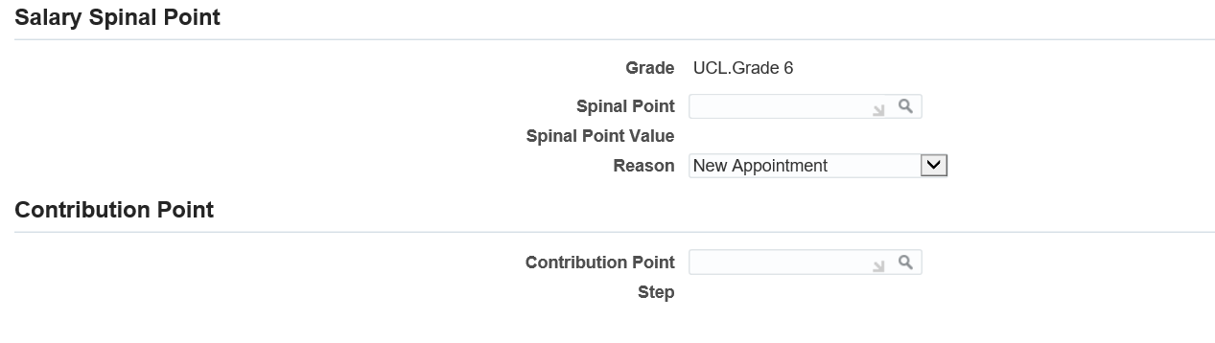

*Figure 13: Department Transactions: New Employee – Assignment Details – Salary Details*

* Reason: Select New Appointment

*Where the salary is within the standard incremental points:*

* Spine point: Select the spine point to which the salary is to be raised to.

*Where the salary is within the contribution points:*

* In the Contribution point field click on the  icon and click on ‘go’

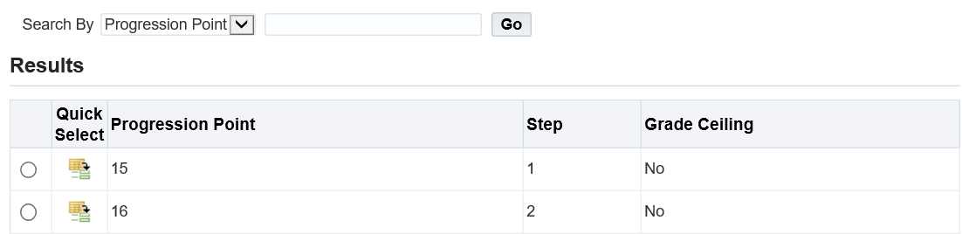

*Figure 14: Department Transactions: New Employee – Salary Details – Grade Ceiling*

* Select the point that you want to raise the salary to by clicking on the  next to the spine point.
* Go back to the spine point in the salary spine point area and the spine point will be available
* Select the spine point on which the appointment is to be made
* Click next

*Where the appointment is on a Non Spinal Salary:*



*Figure 15: Department Transactions: New Employee – Salary Details – Non spinal salary*

* Amount: Enter the full time equivalent of annual value of the non spinal salary excluding London Allowance.

Where the individual works part time the FTE will be applied to the full time amount to pro-rata the salary paid.

**Step 6 – Work Pattern**

**Please note:** For an Honorary/Emeritus or Worker enter a zero in each day of the week.

*Figure 16: Department Transactions: New Employee – Work Pattern*

Enter the hours the individual will work each day. The total working hours must add up to the weekly working hours entered in step 4.

*Where the working week is a multiple week work pattern:*

* Select the number of weeks the working pattern will span
* Enter the hours the individual will work each day over the multiple weeks.

The employee working hours, entered in step 4, will be multiplied by the number of weeks the working pattern covers. The total number of hours entered in to the work pattern screen will need to match the total hours worked over these weeks.

**Step 7 - Cost Allocation**

**Please note:** Do not complete this page for Honorary/Emeritus or Worker appointments

*Figure 17: Department Transactions: New Employee – Cost Allocation*

* Click on the  button.
* Project: Enter in the Project number in to the field
  + Where you do not know the number click the  icon and click on ‘go’
  + Search for the funding. Funding can be searched by either project name, project number or organisation by selecting the correct option in the ‘Search By’ field.
  + Identify the correct project number and clicking  to select.
* Task: Enter the Task. When unknown, follow the same steps to search as the project number
* Award: Enter the Award. When unknown, follow the same steps to search as the project number
* Proportion: Enter the proportion that the cost code will cover as a percentage. For example 50% = 50

Multiple rows of funding, on different Project, Tasks and Awards, with different start and end dates can be entered to cover the period of the contract however the total proportion for each period must always add up to 100%

Please note: where the individual works part time, the funding must still add up to 100%. This represents where 100% of the salary costs will be charged based on the individual’s FTE.

* Effective Start Date: Enter the start date for the PTA being entered.
* Effective End Date: Where the funding is for a limited duration, enter the end date for the funding. Where the funding is open ended, leave the ‘effective end date’ blank.

The value in the Project End Date field will pull through from MyFinance and will reflect the end date of the project funding. The effective end date cannot be after this date.

* Click  to enter a further line of funding.
* Click Next

**Step 8 - Payments and Additional Allowances**

**Please note:** Do not complete this page for Honorary/Emeritus or Worker appointments

The basic salary will automatically be added, based on grade and spine point, but any other allowances including London Allowance must be added here otherwise they will not be paid.

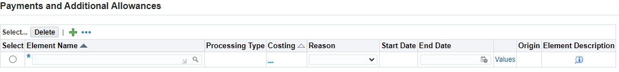

*Figure 18: Department Transactions: New Employee – Payments and Additional Allowances*

* Click  to enter a new element
* Element Name: Search for the element name by clicking the  icon and click on ‘go’

A description is provided for each element to help select the appropriate element.

A full break down of the elements is available at [MyHR Department Transactions – Pay Element Information](https://wiki.ucl.ac.uk/pages/viewpage.action?pageId=153485430)

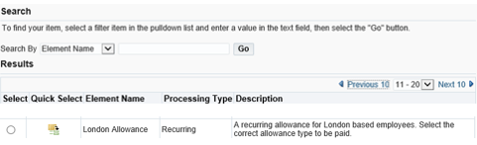

*Figure 19: Department Transactions: New Employee – Payments and Additional Allowances, Description*

* Select the appropriate element.
* Where the costing field is left blank the cost associated to this element will be charged to the same project, task and award as the basic salary.

Where a particular element is to be charged to a different project, task and award to the basic salary, click in the 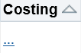 and enter the project, task and award to which this element of the salary to be charged. If the values are known these can be typed in the fields. Otherwise click on the  icon.

* Reason: New Pay Element
* End date: If the element is for a limited duration enter the end date. If the payment is to be made indefinitely, leave the end date blank.

***Please note:***Do not add an end date to any London Allowance elements entered as this could cause an underpayment if the appointment is extended and the London Allowance is ended.

* Click in ‘Values’ to provide the specific detail of the payment.

***Please note:*** *For a reminder of the purpose of the element selected click on the ‘i’ at the end of the row in the Element Description box.*

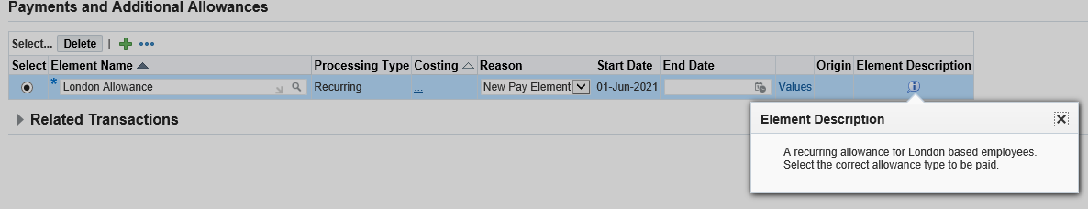

*Figure 20: Department Transactions: New Employee – Payments and Additional Allowances, Pay Element Description*

* Click next

**Step 9 - Right to Work**

* Click create



*Figure 21: Department Transactions : New Employee – Right to work*

* RTW Status: Click on  to search
* Search using % to bring up all values
* Select the correct RTW status based on the right to work documentation that has been checked
* Date checked: Enter the date the right to work documentation was checked
* RTW Expiry Date: where appropriate complete the right to work expiry date
* Passport Expiry Date: where appropriate enter the passport expiry date
* Passport Country : Enter the passport country
* Certificate of Sponsorship Number: where appropriate enter the Certificate of Sponsorship number
* Click apply
* Click next

**Step 10 - Disclosure and Barring**

**Please note:** The DBS section must be filled for all requests even where a DBS is not required.

* Click create



*Figure 22: Department Transactions: New Employee – Disclosure and Barring*

* Type of check: Select the type of check. Where a check is not required, select not required
* Level of check: Select the level of check. Where a check is not required, select not required
* Ucheck Reference Number: Provide the Ucheck reference number where appropriate
* Status of check: Where a DBS check is required confirm the progress of the check. Where a check is not required, select not required
* Certificate Number: Confirm the DBS Certificate Number where appropriate
* Date of issue: Confirm the date the DBS certificate was issued, where appropriate
* Click Apply
* Click Next

Where the appointment is for a Consultant Clinical Academic, complete Steps 11 and 12 and then move to Step 16.

Where the appointment is for a Teaching Fellow go to Step 13.

Where the appointment is for a Fellowship go to Step 14.

Where the appointment is for a Postgraduate Teaching Assistant go to Step 15.

Where the appointment is for none of the above go to Step 16.

**Step 11 - Clinical Contract**

Complete this tab only where the appointment is for Consultant Clinical Academic.

* Click create

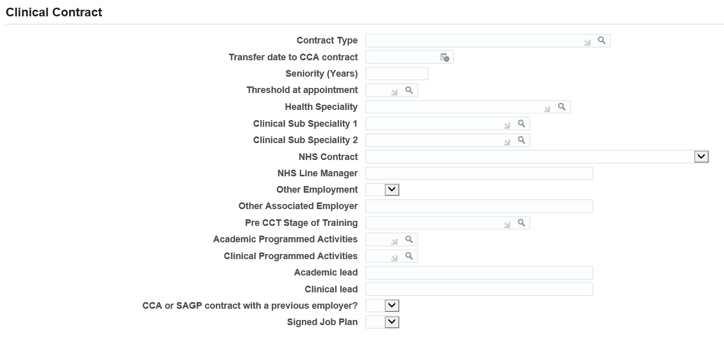

*Figure 23 : Department Transactions: New Employee – Clinical Contract*

* Contract Type: Click on  to search and select the type of contract including Clinical Lecturer, Consultant, General Practitioner or Specialist Registrar
* Transfer date to CCA Contract: Enter date of original transfer to CCA contract
* Seniority (Years): Enter number of years Seniority at appointment
* Threshold at appointment: Enter threshold point held at appointment
* Health Speciality: Click on  to searchand select the health speciality from the list of values
* Clinical Sub Speciality 1: Click on  to search and select the speciality from the list of values
* Clinical Sub Speciality 2: Click on  to search and select the speciality from the list of values
* NHS Contract: Select the relevant value
* NHS Line Manager: Enter name of Manager in the NHS
* Other Employment: Indicate where there is employment elsewhere
* Other Associated Employer: Enter name of other employer
* Pre CCT Stage of Training: Click on  to search to select the current stage of training for a Junior Doctor
* Academic Programmed Activities: Click on  to search the number of Academic PA's per week
* Clinical Programmed Activities: Click on  to search the Number of Clinical PA's per week
* Academic Lead: Enter the name of the Academic lead
* Clinical Lead: Enter the name of the Clinical lead
* CCA or SAGP contract with a previous employer: Indicate where the individual had a contract with a previous employer
* Signed Job plan: Indicate whether there is a signed job plan
* Click apply
* Click next

**Step 12 - Clinical Registration**

Complete this tab only where the appointment is for Consultant Clinical Academic.

* Click create

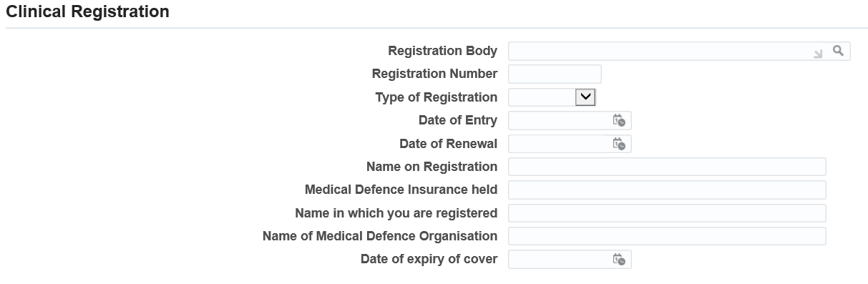

*Figure 24: Department Transactions: New Employee – Clinical Registration*

* Registration Body: Click on  to search. Click on Go and select the correct registration body
* Registration Number: Enter the registration number
* Type of Registration: Select the type of registration
* Date of Entry: Enter the date of entry to the registration body
* Date of Renewal: Enter the date of renewal for the registration
* Name on Registration: Confirm the name in which the individual is registered
* Medical Defence Insurance held: Confirm whether Medical Defence Insurance is held
* Name in which you are registered: Confirm the name registered on the Medical Defence Insurance
* Name of Medical Defence Organisation: Confirm the name of the medical defence organisation
* Date of expiry of cover: Enter the date the medical defence cover will expire
* Click apply
* Click next

**Step 13 - Teaching Fellow**

Complete this tab only where the appointment is for a Teaching Fellow.

* Click create

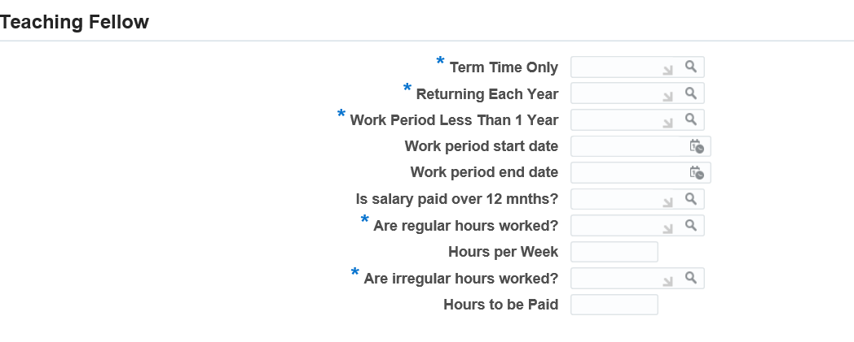

*Figure 25: Department Transactions: New Employee – Teaching Fellow*

* Term Time Only: Indicate whether the contract is to be term time only
* Returning Each Year: Indicate whether the individual will be returning each year. Where Yes is selected an open ended contract will be issued, where No is selected, and the duration is less than 9 months, a fixed term contract will be issued. Where the duration is greater than 9 months an open ended contract will be issued
* Work period less than 1 year: This field indicates where the individual works part of a year but returns each year. Where yes is selected, complete the following work period start and end date fields, where no is selected this confirms that the individual will be working continuously throughout the period of their contract.
* Work period start date: Where appointment is for more than 1 year, confirm the start date of the first period of work
* Work period end date: Where appointment is for more than 1 year, confirm the end date of the first period of work
* Is salary paid over 12 months: confirm if the salary is to be paid over 12 months or the duration of the work period, based on the start and end date
* Are regular hours worked? Where yes, calculate the FTE for the hours worked
* Hours per week: Confirm the hours that are to be worked per week
* Are irregular hours worked? Where yes, calculate the FTE for the hours worked
* Hours to be paid: Confirm the hours that are to be worked per week
* Click apply
* Click next

**Step 14 - Fellowships**

Complete this tab only where the appointment is for a Fellowship.

* Click create

*Figure 26: Department Transactions: New Employee – Fellowships*

* Funder: Select the Funder from the list of values
* Scheme: Select the Scheme from the list of values
* Click apply
* Click next

**Step 15 – Postgraduate Teaching Assistants (UCL_TL_PGTA)**

Complete this tab only where the appointment is for a Postgraduate Teaching Assistant.

* Click create

*Figure 27: Department Transactions: New Employee – Fellowships*

* Contracted Hours Type: Select Averaged Hours or Guaranteed Hours
* Averaged Hours or Guaranteed Minimum Hours: Enter the number of hours
* Hourly Rate: Enter the hourly rate
* Effective Date: Enter the effective date
* Click apply
* Click next

**Step 16 – Documents**

* Click on ‘Create’ to browse your computer and upload any relevant documents required, for example, right to work documents.
* Select the appropriate naming document type.

**Step 17 – Review and Submit**

*Figure 28: Department Transactions: New Employee – Review and Submit*

* If required, enter a message in the message field
* Remedy Ticket Number – **do not** complete, will autofill on routing to HR Services
* Click submit
* Click continue to go back to the main menu.

The Transaction will now go to the next approver as indicated in the approver field.

**Appendix 1: New Employee – Decision Tree for type of action to request**



|  |  |
| --- | --- |
| **Type of Action** | **Individual Current Record Status** |
| New Employee | Only select this where no match is returned.  Where there is a match but this is not selected, and one of the other options followed, this will result in a duplicate employee record being created. |
| Rehire/ Rehire Contingent worker | Where the person type of the record is ‘Ex-employee’ select Rehire  Ex-employee  Where the person type of the record is ‘Ex-contingent worker’ select Rehire Ex-contingent worker |
| Additional Assignment | Only select this where any existing appointments are to remain and an additional assignment is to be set up. Do not select this option where any existing appointment is to be terminated as this will create an additional assignment and potential overpayment. |
| Transfer | Select this where the selected employee is to transfer to your department and their existing assignment is to be ended. |

**Version Control**

|  |  |
| --- | --- |
| **Version** | **Date Created** |
| 1.0 | July 2020 |
| 2.0 | June 2021 |
| 3.0 | August 2023 |