**Department Transactions – Changes to Work Pattern**

The Changes to Work Pattern enables you to change the work pattern recorded against an employee’s record. If the hours worked per week and the work pattern are both changing this should be done via the Change to Contract workflow.

A change to work pattern can also be requested by the employee via Employee Self Service and will be forwarded to the Line Manager, or Self-Service Administrator, for approval.

**Using the Change to Work Pattern workflow**

* Select ‘Changes to Work Pattern’ from the main menu

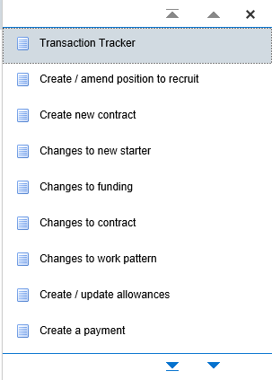

*Figure 1: Department Transactions Menu*

**Step 1 – Assignment Search**

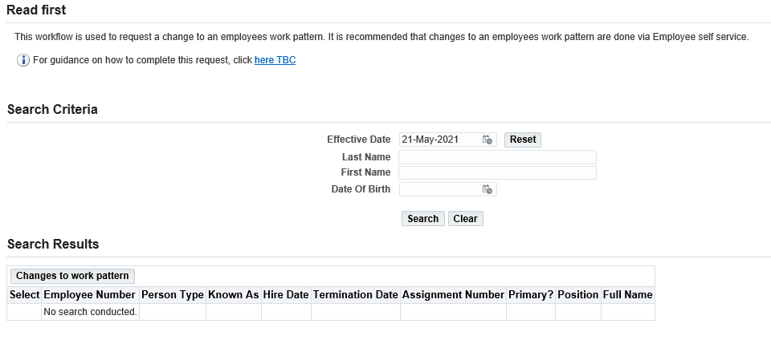

*Figure 2: Change to work pattern: Search Criteria Menu*

* Effective date: Enter the date on which the change is to occur
* Enter the name and / or employee number of the person
* Press the search button.
* Select the employee and the correct assignment to which the change is to be made
* Click on the Change to Work Pattern button

*Please note:* a box may pop up showing other ‘Pending’ transactions. Check that the transaction hasn’t already been entered by a colleague and if you are happy to proceed with entering the transaction click ok. This will show you all types of transactions. If no, click on cancel.

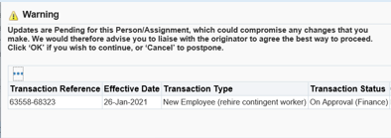

*Figure 3: Change to work pattern: Pending Transactions warning*

**Entering the Work Pattern Change**

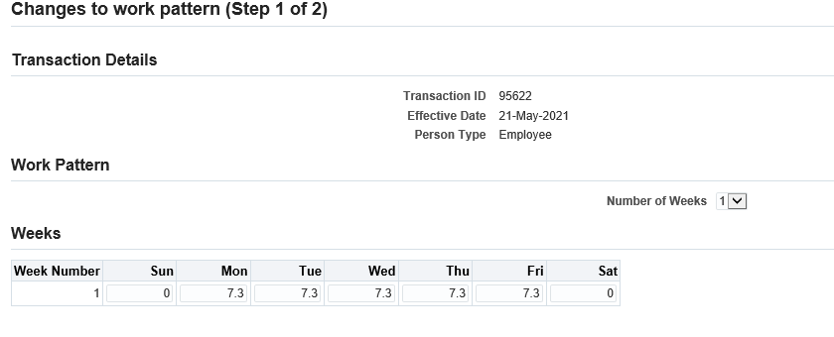

*Figure 4: Department Transactions: Change to Work Pattern*

The screen will display the current work pattern recorded on the employee’s record.

* Update the work pattern to reflect the new working hours per day from the effective date.

The total number of hours entered into the work pattern screen will need to match the hours per week recorded on the employee’s record.

*Where the working week is a multiple week work pattern:*

* Select the number of weeks the working pattern will span
* Enter the hours the individual will work each day over the multiple weeks.

The total number of hours entered into the work pattern screen will need to match the total hours worked over these weeks.

**Step 2 – Review and Submit**

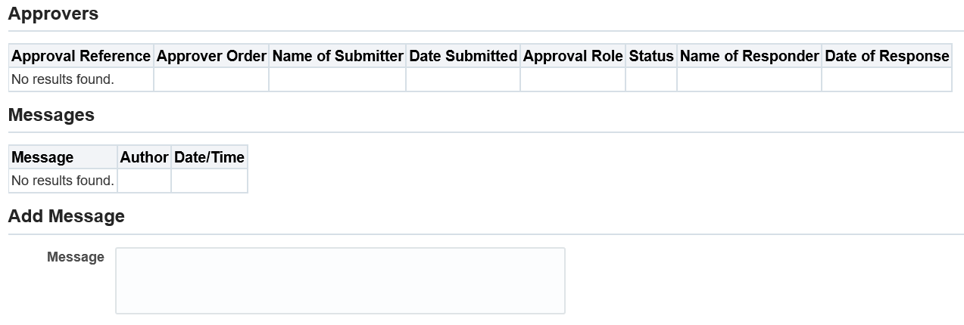

*Figure 4: Department Transactions: Change to Work Pattern: Review and Submit*

* If required, enter a message in the message field
* Click submit
* Click continue to go back to the main menu.

The Transaction will auto-approve on submission and will update the core system.

**Version Control**

|  |  |
| --- | --- |
| **Version** | **Date Created** |
| 1.0 | June 2021 |
|  |  |
|  |  |
|  |  |