Department Transactions – Changes to New Starter

The Changes to New Starter enables you to change either the starting salary or the start date of a new starter prior to them being processed in the payroll.

Where the request to change the contract for a new starter is to change anything other than the starting salary or start date these changes are to be managed with HR Services by emailing hr-services@ucl.ac.uk

Where original request was a transfer of appointment, do not use this transaction and submit a request to HR Services (hr-services@ucl.ac.uk). All other requests for the change to a new starter’s start date or starting salary are to be submitted via Departmental Transactions.

Using the Changes to new starter workflow

- Select ‘Changes to New Starter’ from the main menu
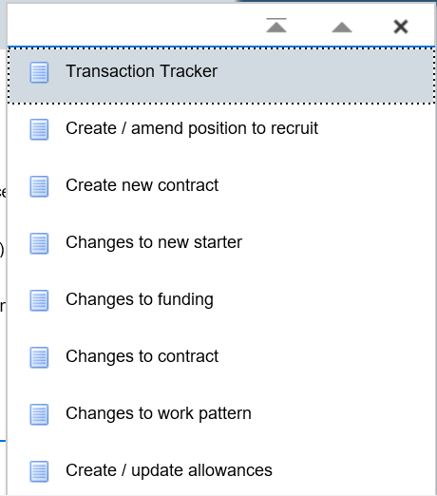
Figure 1: Department Transactions Menu

Assignment Search

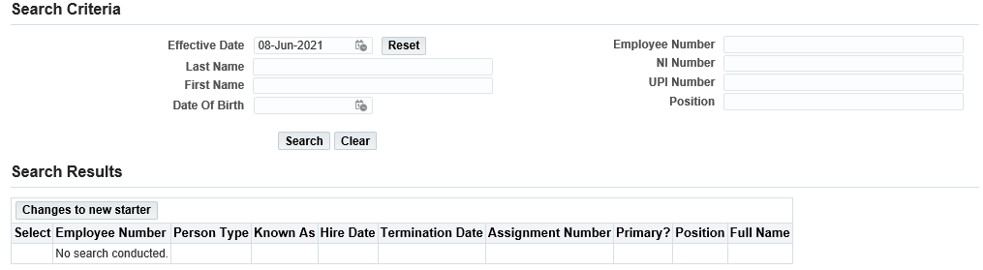

Figure 2: Department Transactions: Changes to new starter: Search Criteria Menu

- Effective date: Enter the date on which the change is to occur. In this case this is likely to be the start date of the contract.

- Enter the name and / or employee number of the person.

- Press the search button.

- Select the employee and the correct assignment to which the change is to be made.

- Click on the Changes to new starter button.

Please note: a box may pop up showing other ‘in flight’ transactions. Check that the transaction hasn’t already been entered by a colleague and if you are happy to proceed with entering the transaction click ok. This will show you all types of transactions. If no, click on cancel.

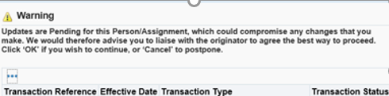
Figure 3: Department Transactions: Changes to new starter: Duplicate transaction warning

Entering the New Details for a New Starter

On entering Step 1 of the Changes to new starter workflow, where the individual has already been processed through a payroll you will receive the warning message below. If this message is received, continue to complete the transaction and submit this to the HR Services, however, this change will be processed manually so that any under or overpayment can be processed.

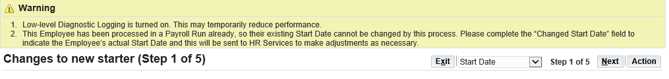
Figure 4: Department Transactions: Changes to new starter: Payroll process warning message

Change to Start Date

To change the individual’s start date:

- Changed Start Date: Enter the new start date

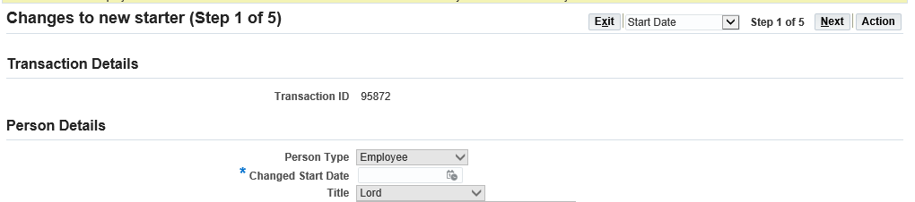
Figure 5: Department Transactions: Changes to new starter: Changing the start date

Change to Start Salary

To change the individual’s starting salary, navigate to Step 3 on the transaction by either clicking on Next or selecting the Salary Details screen in the drop-down list in the top right hand corner of the transaction

- Spinal point: Enter the new spinal point on which the appointment is to commence. The screen will initially show the salary originally submitted.

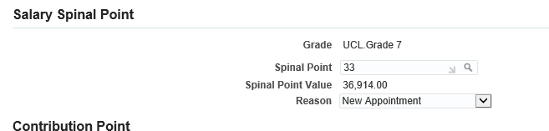
Figure 6: Department Transactions: Changes to new starter: Changing the starting salary

Documents

- Add any relevant documents required.

- Select the appropriate naming document type.

Review and Submit

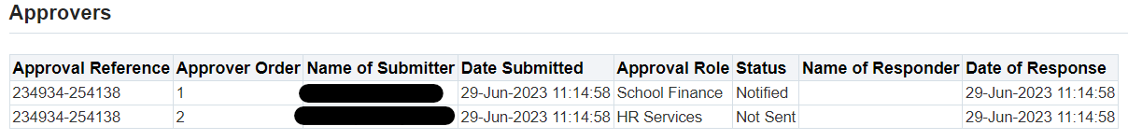
Figure 7: Department Transactions: Changes to new starter– Review Transaction

As well as the approval routing this screen also shows the old and new start date and starting salary values.

- If required, enter a message in the message field

- Click submit

- Click continue to go back to the main menu.

The Transaction will now go to the next approver as indicated in the approver field.

Version Control
Version | Date Created
1.0 | June 2021
2.0 | August 2023

