**Department Transactions – Changes to Contract**

This guidance will cover the following changes:

* Assignment extensions (excluding Honorary assignments)
* FTE changes / changes in hours
* Incremental pay increases
* Clinical threshold increases
* Returning seasonal teaching fellow details
* Returning postgraduate teaching assistant details
* Change of funding in conjunction with any of the above

**Please note:** Regrades are not to be submitted on this request, or via Department Transactions, and are to be requested via the [Remedyforce Self Service form](https://ucl.lightning.force.com/lightning/n/BMCServiceDesk__Remedyforce_Self_Service) and search for ‘Regrade’.

This workflow is not to be used for the extension of an honorary contract. Please email [hr-services@ucl.ac.uk](mailto:hr-services@ucl.ac.uk) where an honorary contract is to be extended.

**General Change to Contract Guidance**

Multiple changes can be submitted on a single transaction where the effective date of all the changes is the same. This is for change of funding, FTE change and extensions which can be submitted on the same transaction. Where the effective date is different, these need to be done separately.

Changes to allowances are to be submitted separately on the Create / update allowances workflow.

*Please note*: Where you are changing cost allocation at the same time as the primary change then the effective date of the transaction must equal the start date of the new line of funding, which must be equal the start date of the primary change. Update the end date of the existing line of funding to the new end date which must be no earlier than one day before the transaction’s effective date.

For example, existing funding to be ended on 30 June 2023 and new line of funding to start on 01 July 2023. The effective date is 01 July 2023.

**Creating a Changes to Contract request**

* Select Changes to contract from the Department Transactions menu

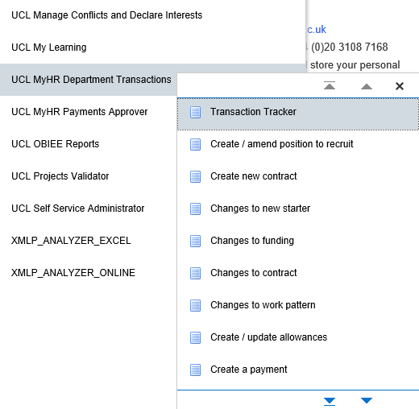

*Figure 1: Department Transactions Menu*

* Effective date: Enter the date on which the change is to occur
* Enter the name and / or employee number of the person
* Press the search button.

*Figure 2: Changes to contract Search Screen*

* Select the employee and the correct assignment to which the change is to be made
* Click on the Changes to Contract button.

*Please note:* a box may pop up showing other ‘Pending’ transactions. Check that the transaction hasn’t already been entered by a colleague and if you are happy to proceed with entering the transaction click ok. This will show you all types of transactions. If no, click on cancel.

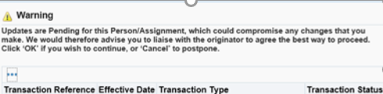

*Figure 3: Department Transactions – Pending transactions*

**Extension to Assignment**

* Navigate to Step 1 of 11 – Assignment Details
* Change reason: Select Extension of appointment. Where multiple changes to be made

select the appropriate combined reason that includes Extension to appointment

* Contract end date: Enter the new end date of the contract
* End date reason: Select the reason for the extension

If no other changes are required, navigate to step 10 of 11 and proceed

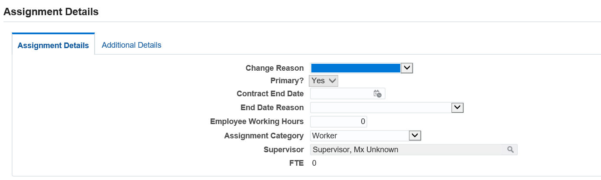

*Figure 4: Department Transactions – Change to contract: extension of assignment*

**Change of Hours**

Navigate to Step 1 of 11 – Assignment Details

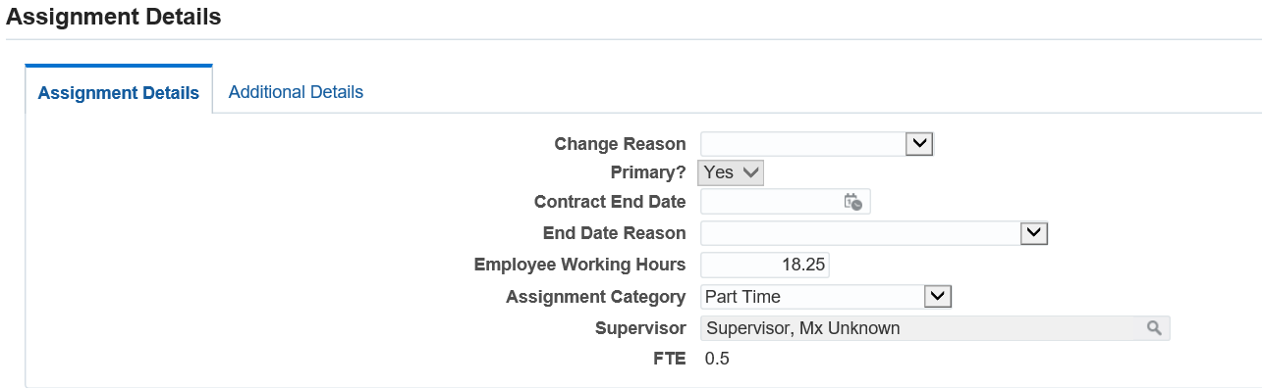

*Figure 5: Department Transactions – Change to contract: Change of Hours*

* Change reason: Select Change of Hours Increase/Decrease as appropriate. Where multiple changes to be made select the appropriate combined reason that includes Change of Hours.
* Working Hours: Enter the new working hours. The FTE will update automatically.
* Assignment Category. Where necessary, update the assignment category to reflect correct category due the new hours per week. *(Table 1)*

|  |  |
| --- | --- |
| **Assignment Category** | **Explanation** |
| Full Time | To be selected where the individual is working full time |
| Part time | To be selected where the individual is working part time |
| Term Time Only – Full Time | To be selected where the individual is working full time on a term time contract |
| Term Time Only – Part Time | To be selected where the individual is working part time on a term time contract |

*Table 1: Department Transactions – Change to contract: Assignment Category*

* Navigate to step 3 of 11 to update the work pattern.

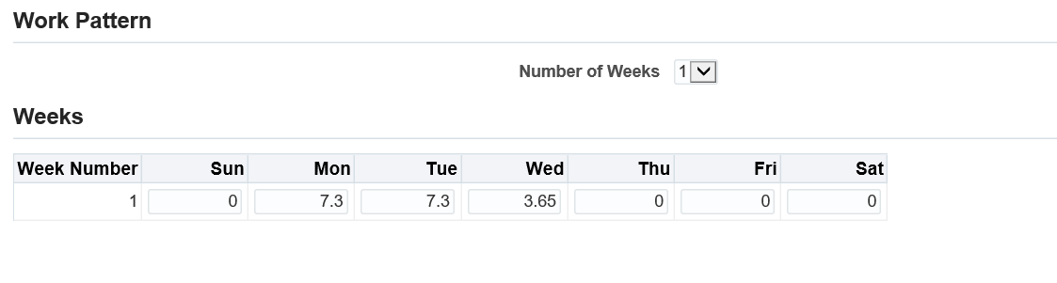

*Figure 6: Department Transactions – Change to contract: Work Pattern*

* Update the hours worked on each day so the hours on the new work pattern match the updated hours per week entered in the previous step.

The employee working hours, entered in step 1, will be multiplied by the number of weeks the working pattern covers. The total number of hours entered in to the work pattern screen will need to match the total hours worked over these weeks.

**Where the change of hours is for a Teaching Fellow**

Review the information on the Teaching Fellow screen where the change in hours is for a Teaching Fellow. These need to be updated:

* Click create

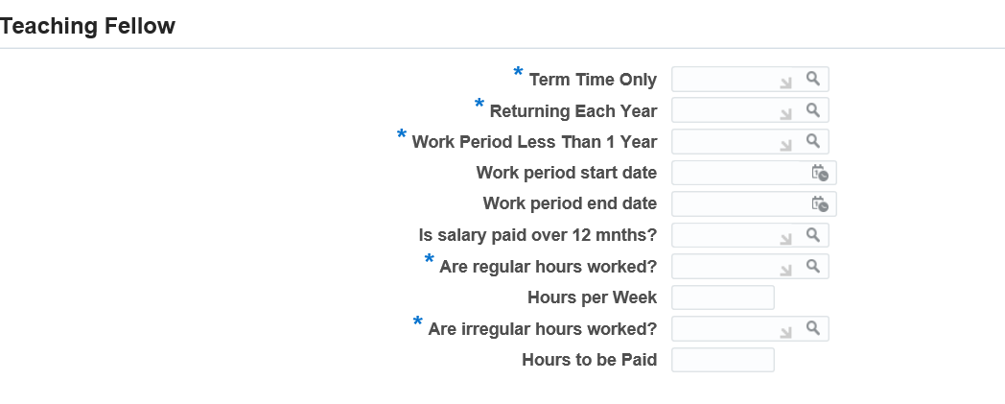

*Figure 7 Department Transactions: Change to contract – Teaching Fellow*

* Term Time Only: Indicate whether the contract is to be term time only
* Returning Each Year: Indicate whether the individual will be returning each year. Where Yes is selected an open ended contract will be issued, where No is selected, and the duration is less than 9 months, a fixed term contract will be issued. Where the duration is greater than 9 months an open ended contract will be issued
* Work period less than 1 year: This field is indicates where the individual works part of a year but returned each year. Where yes is selected, complete the following work period start and end date fields, where no is selected this confirms that the individual will be working continuously throughout the period of their contract.
* Work period start date: Where appointment is for more than 1 year, confirm the start date of the first period of work
* Work period end date: Where appointment is for more than 1 year, confirm the end date of the first period of work
* Is salary paid over 12 months: confirm if the salary is to be paid over 12 months or the duration of the work period, based on the start and end date
* Are regular hours worked? Where yes, calculate the FTE for the hours worked
* Hours per week: Confirm the hours that are to be worked per week
* Are irregular hours worked? Where yes, calculate the FTE for the hours worked
* Hours to be paid: Confirm the hours that are to be worked per week
* Click apply
* If no other changes are required, navigate to step 10 of 11 and proceed

**Where the change of hours is for a Consultant Clinical Academic**

Review the Clinical and Academic Programmed Activities on the Clinical Contract screen and update them accordingly.

**Where the change of hours is for a Fellowship**

Review the Fellowship details on the Fellowship screen and update them accordingly.

**Where the change of hours is for a Postgraduate Teaching Assistant**

Review the Postgraduate Teaching Assistant details on the PGTA screen and update them accordingly.

* Click create

*Figure 8: Department Transactions: New Employee – Fellowships*

* Contracted Hours Type: Select Averaged Hours or Guaranteed Hours
* Averaged Hours or Guaranteed Minimum Hours: Enter the number of hours
* Hourly Rate: Enter the hourly rate
* Effective Date: Enter the effective date
* Click apply
* Click next

**Additional Increments**

Navigate to Step 1 of 11 – Assignment Details

* Change reason: Select the relevant accelerated increment or contribution point reason.

Navigate to Step 2 of 11 – Salary Details

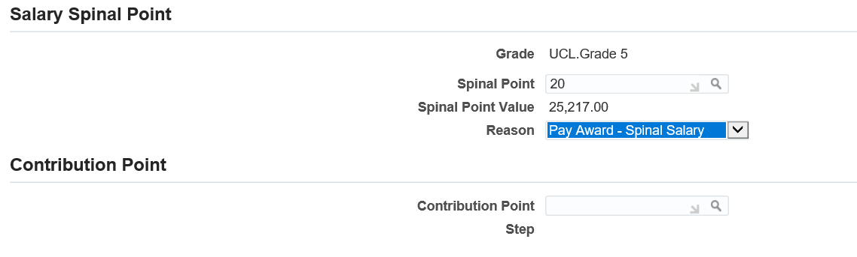

*Figure 9: Department Transactions – Change to contract: Salary Details*

* Reason: Select the relevant accelerated increment or contribution point reason.

*Where the new spine point is within the standard incremental points:*

* Spine point: Select the spine point to which the salary is to be raised to.

*Where the new spine point is within the contribution points:*

* In the Contribution point field click on the  icon and click on ‘go’

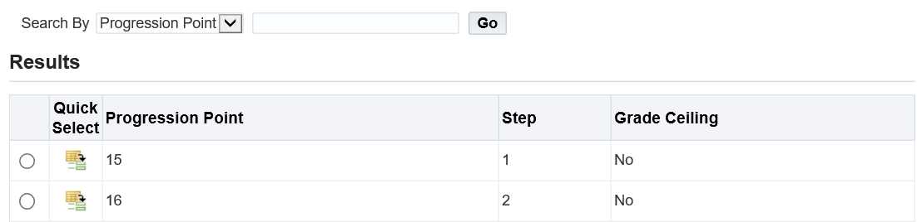

*Figure 10: Department Transactions – Change to contract: Salary Details: Contribution point*

* Select the point to which you want to raise the salary to by clicking on the  next to the spine point.
* Go back to the Spine point in the salary spine point area and this spine point will be available to select.
* If no other changes are required, navigate to step 10 of 11 and proceed

**Cost Allocation**

The cost allocation should only be used in conjunction with another change. Where the cost allocation is the only change, the ‘Changes to funding’ workflow should be used.

Navigate to Step 4 of 11 – Cost Allocation

*Figure 11: Department Transactions – Change to contract: Cost Allocation*

If the Project, Task and Award (PTA) remain unchanged for the existing funding, but the end date of the funding is to be changed, then either add, amend or remove an end date from this funding line.

Where you are changing cost allocation at the same time as the primary change then the effective date of the transaction must equal the start date of the new line of funding, which must be equal the start date of the primary change. Update the end date of the existing line of funding to the new end date which must be no earlier than one day before the transaction’s effective date.

For example, existing funding to be ended on 30 June 2023 and new line of funding to start on 01 July 2023. The effective date is 01 July 2023.

*To add a new line of funding:*

* Click on the  button.
* Enter in the Project number in to the field

If you do not know the number click the  icon and click on ‘go’ to search for the funding. Funding can be searched by either project name, project number or organisation by selecting the correct option in the ‘Search By’ field.

Identify the correct project number and clicking  to select.

* Enter the Task and Award values, by following the same steps as the ‘Project’ number search.
* Enter the proportion that the cost code will cover as a percentage.

Funding can be split over multiple PTA’s however the total proportion for each period of funding must always add up to 100%, even where the individual works part time.

* Enter the Effective Start Date for the funding. This will be the day after the end date of the previous funding.
* Effective End Date: Where the funding is for a limited duration, enter the end date for the funding. Where the funding is open ended, leave the ‘effective end date’ blank.

The value in the Project End Date field will pull through from MyFinance and will reflect the end date of the project funding. The effective end date cannot be after this date.

* Click  to enter a further line of funding.

*Please note:* The yellow dot indicates any existing lines of funding. The green dots will indicate any new lines of funding.

* If no other changes are required, navigate to step 10 of 11 and proceed.

**Payments and Additional Allowances**

Changes to allowances are to be submitted separately on the Create / update allowances workflow.

**Step 10 – Documents**

* Add any relevant documents required.
* Select the appropriate naming document type.

***Please note:*** *If the employee is on a restricted Visa and their hours increase, please ensure you attach new Right to Work (RTW) or completion of study evidence where applicable.*

**Step 11 – Review and Submit**

* If required, enter a message in the message field and click submit.

***Please note:*** on submission of the transaction, where the effective date of the transaction is earlier than the date on which the transaction is being submitted and the change is for either a change in hours or change to salary, the following warning message will be visible on the screen to highlight a potential under or over payment.

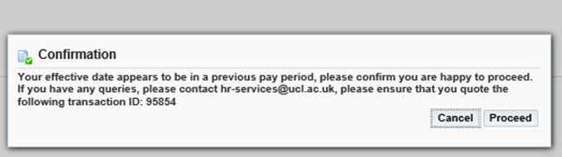

*Figure 12: Department Transactions – Change to contract: Review and Submit Warning Message*

* Click continue to go back to the main menu.

The Transaction will now go to the next approver as indicated in the approver field.

*Figure 13: Department Transactions – Change to contract: Review and Submit*

**Version Control**

|  |  |
| --- | --- |
| **Version** | **Date Created** |
| 1.0 | July 2020 |
| 2.0 | June 2021 |
| 3.0 | August 2023 |