Department Transactions – Changes to Funding

General Guidance

This transaction is only to be used where the only change is to the funding within the existing duration of the contract. Where there are any other changes, for example an extension to the contract, the Changes to Contract request is to be used.

Please note: Set the effective date of the transaction to the date the new funding starts. When either adding an end date to an existing line of open ended funding, or shortening the end date of an existing line of funding to an earlier end date, the applied end date must be no earlier than the day before the new effective date of the transaction.

For example, existing funding to be ended on 30 June 2023 and new line of funding to start on 01 July 2023. The effective date of the transaction is 01 July 2023.

Creating a Changes to Funding request

- Select Changes to funding from the Departmental Transactions menu

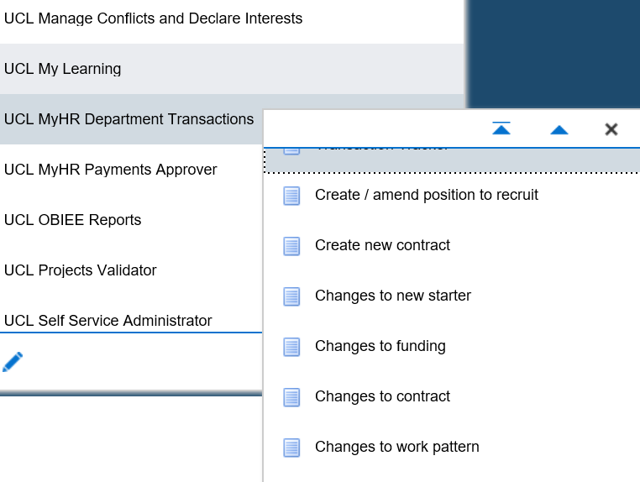
Figure 1: Department Transactions Menu

- Effective date: Enter the date on which the change is to occur

- Enter the name and / or employee number of the person

- Press the search button.

- Select the employee and the correct assignment to which the change is to be made

- Click on the Change to Funding button.

Please note: a box may pop up showing other ‘Pending’ transactions. Check that the transaction hasn’t already been entered by a colleague and if you are happy to proceed with entering the transaction click ok. This will show you all types of transactions. If no, click on cancel.

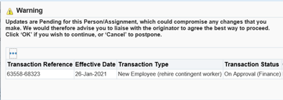
Figure 3: Department Transactions – Transactions Pending Warning

Step 1 – Cost Allocation

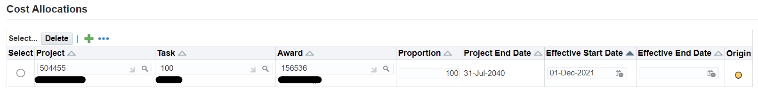
Figure 4: Department Transactions – Changes of funding: Cost Allocations

To update the end date of an existing line of funding:

Where you are shortening the end date of an existing line of funding, or adding an end date to a previously open ended line of funding, update the end date of the existing line to the new end date.

This can be no more than the day before the start date of the transaction’s effective date.

To add a new line of funding:

- Click on the button.

- Enter in the Project number in to the field
If you do not know the number click the icon and click on ‘go’ to search for the funding. Funding can be searched by either project name, project number or organisation by selecting the correct option in the ‘Search By’ field.
Identify the correct project number and click 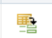 to select.

- Enter the Task and Award values, by following the same steps as the ‘Project’ number search.

- Enter the proportion that the cost code will cover as a percentage.
Funding can be split over multiple PTA however the total proportion for each period of funding must always add up to 100%, even where the individual works part time.

- Enter the Effective Start Date for the funding. This will be the day after the end date of the previous funding.

- Effective End Date: Where the funding is for a limited duration, enter the end date for the funding. Where the funding is open ended, leave the ‘effective end date’ blank.

The value in the Project End Date field will pull through from MyFinance and will reflect the end date of the project funding. The effective end date cannot be after this date.

- Click to enter a further line of funding.

Please note: The yellow dot indicates any existing lines of funding. The green dots will indicate any new lines of funding.

- Click next

Step 2 – Documents

- Add any relevant documents required. As this transaction routes for financial approval only the documents are to be of the type ‘Funding Supporting Information’.

Step 3 – Review and Submit

- If required, enter a message in the message field and click submit.

- Click continue to go back to the main menu.

The Transaction will now go to the next approver as indicated in the approver field.

Please note: Cost allocation changes only go to the relevant finance teams for approval and once approved are closed. The cost allocation request will not go to HR Services.

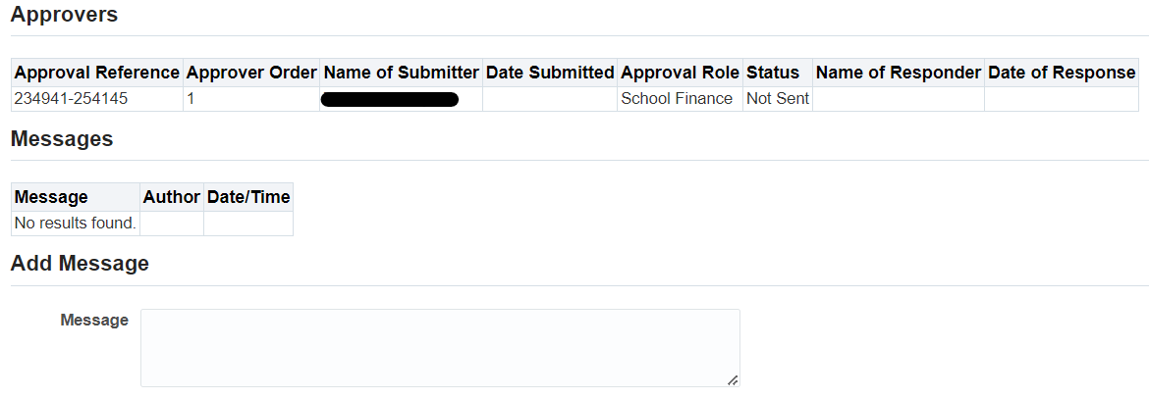

Figure 5: Department Transactions – Changes to funding: Review and Submit

Version Control
Version | Date Created
1.0 | July 2020
2.0 | June 2021
3.0 | August 2023

