Department Transaction – Create/Update Allowances

General Allowance Guidance

An existing allowance should only be updated and should not be deleted. Where an allowance is deleted the system will try to reclaim the monies back to the start date of the allowance.

Creating an Allowance

- Select Create/Update Allowances from the Departmental Transactions menu.
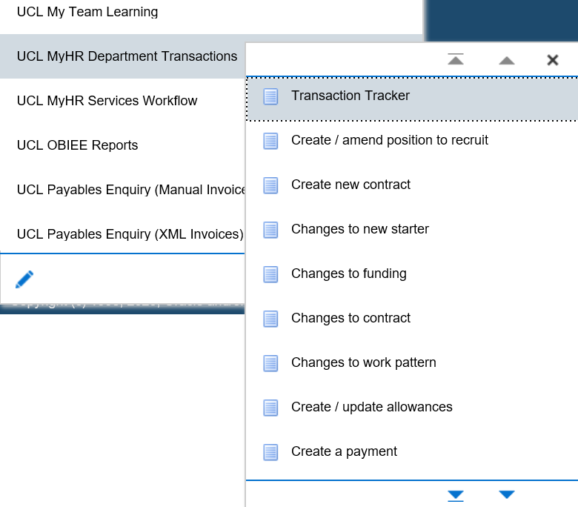
Figure 1: Department Transactions Menu

Enter the search criteria to find the employee who is to receive the allowance

- Effective date: Enter the start date of the allowance

- Enter the name and / or employee number of the person who is to receive the allowance

- Press the search button.

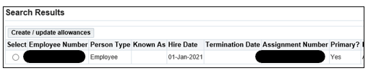
Figure 2: Create/Update Allowances : Allowance Search Screen

- Select the employee and the correct assignment to which the allowance is to be created

- Click on the Create/Update Allowances button.

Please note: a box may pop up showing other ‘pending’ transactions. Check that the transaction hasn’t already been entered by a colleague and if you are happy to proceed with entering the allowance click ok. If no, click on cancel.

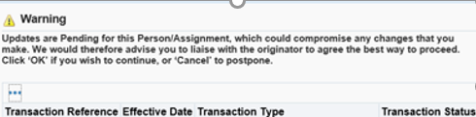
Figure 3: Department Transactions – Pending transactions

Step 1 – Allowance Elements

Please note: Any existing payments or allowances that the individual is already receiving will be visible on entry to the Allowance Elements screen.

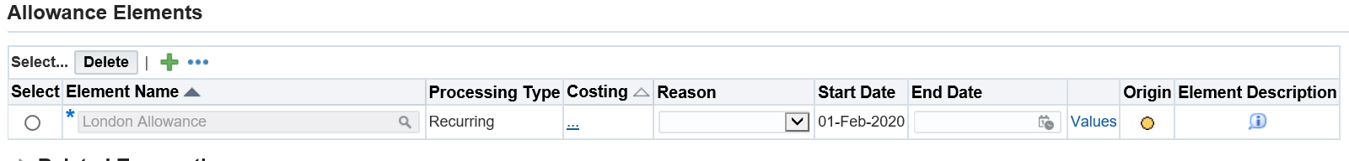
Figure 4: Department Transactions – Create/Update Allowances – Allowance Elements

There are 4 actions that can be undertaken in relation to elements:

- Create a new allowance
- Update the end date of an existing allowance
- Add an end date to an existing element to terminate the allowance
- Change the value of an existing allowance

- Create a New Allowance

- Click the button.
- Search for the relevant allowance element by clicking on the icon

- Either enter the element name or click ‘Go’.

A description is provided for each element to help select the appropriate element.

A full break down of the elements is available at MyHR Department Transactions – Pay Element Information

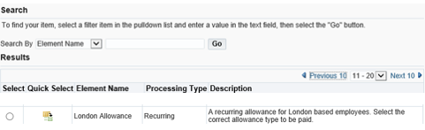
Figure 5: Create/Update Allowances : Allowance Search Screen: Element Description

- Costing: Click in the 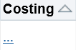 and enter the Project, Task, Award and Expenditure Type.

- Reason: Select New Pay Element.

- Start date: The start date will be automatically entered as the same as the effective date

- End date: Where the allowance is for a fixed duration enter the end date and the allowance will cease on this date. Where the allowance is open ended, leave the end date blank.

- Click in to values and fill in the relevant information.

- Once the element information is completed click Next.

- Update the end date of an existing allowance

When you enter the allowance screen all existing allowances will be shown. If you want to alter the end date of an existing allowance

- Click the radio button next to the allowance that you wish to change

- End date: Update the end date of the allowance to show the new end date

- Click next

- Add an end date to an existing element to terminate the allowance

When you enter the allowance screen all existing allowances will be shown. If you want to alter the end date of an existing allowance

- Click the radio button next to the allowance that you wish to end date

- End date: Enter the end date on which the allowance is to cease

- Click next

- Change the value of an existing element

To change the value of an existing element you should terminate the existing allowance being paid and add a new element to reflect the new value of the allowance:

- Click the radio button next to the allowance that you wish to end date

- End date: Enter the end date on which the allowance is to cease

- Click the button.

- Search for the relevant the allowance element by clicking on the icon

- Either enter the element name or click ‘Go’.

Select the relevant element. See Appendix 1 for pay element breakdown

- Costing: enter the Project, Task, Award and Expenditure Type.

- Reason: Select New Pay Element.

- Start date: The start date will be automatically entered as the same as the effective date

- End date: Where the allowance is for a fixed duration enter the end date and the allowance will cease on this date. Where the allowance is open ended, leave the end date blank.

- Click in to values and fill in the relevant information.

- Once the element information is completed click Next.

Step 3 – Documents

- Add any supporting documents for the payment of the allowance.

- Please ensure that approval documents are attached to the transaction. Documents and approvals can be found online in the policies for each allowance.

- Select the appropriate naming document type.

Step 4 – Review and Submit

- If required, enter a message in the message field and click submit.

- Click continue to go back to the main menu.

The Transaction will now go to the next approver as indicated in the approver field.

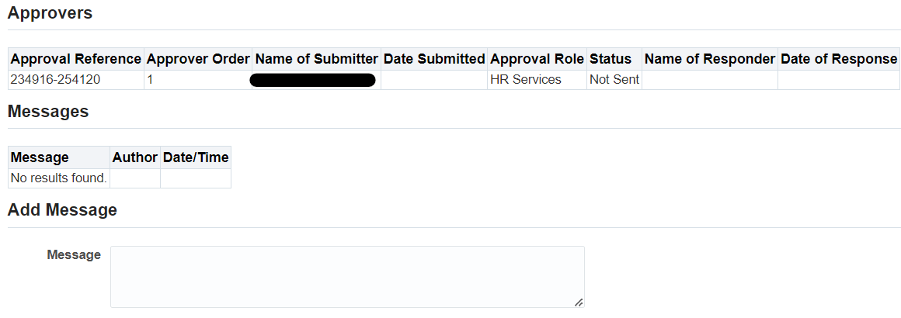
Figure 6: Create/Update Allowances: Step 4 – Review and Submit

Version Control

Version | Date Created
1.0 | July 2020
2.0 | June 2021
3.0 | August 2023

