Employee Self Service - Entering Bank Details

Part 1 of this guide will show you how to view enter your bank details on to MyHR
Part 2 of this guide will show you how to update existing bank details.

Please note:
Bank details can be added or updated via Employee Self Service at any point during the month, however, where bank details are added/updated after the ‘Bank Details Submission Date’ they will be effective from the 1st of the following calendar month.

Part 1 - Entering your bank details on to MyHR

- From the MyHR home screen navigate to UCL Employee Self Service > My Pay > Manage Bank Details

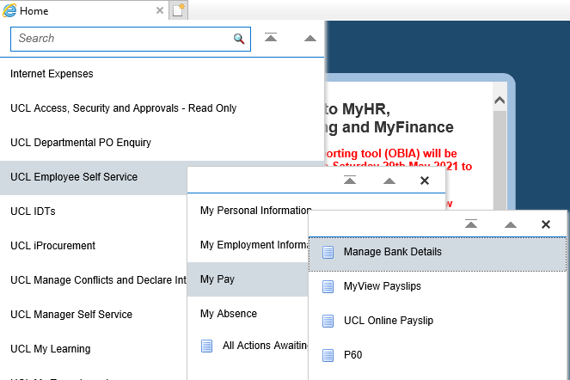
Figure 1: UCL Employee Self Service Menu

- Click on the ‘Add new bank account details’ button

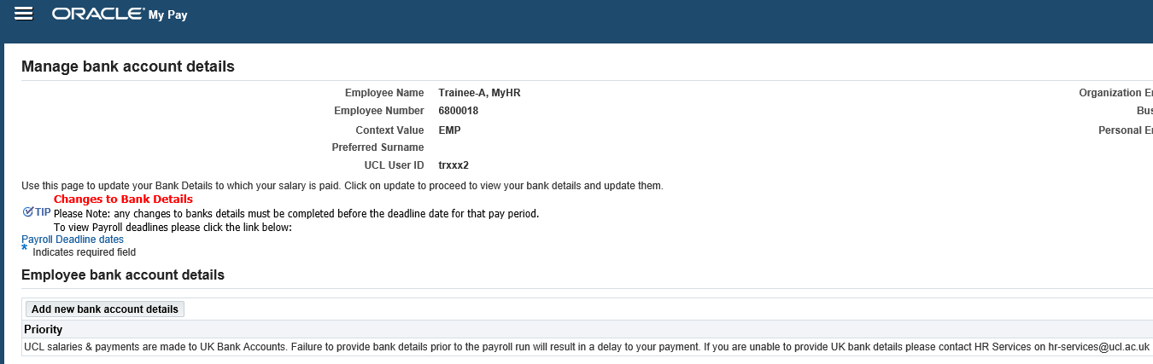
Figure 2: UCL Employee Self Service > MyPay > Manage Bank Details

- Enter the following information:

  - Account Name
  - Account Number
  - Sort Code
  - Bld Society Account Number (if appropriate)

Note: The bank name and branch will populate based on the sort code details entered.

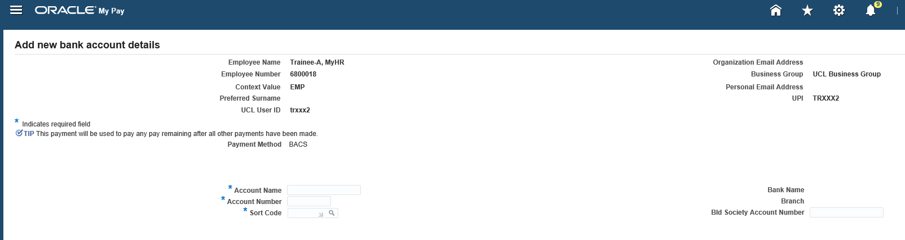
Figure 3: UCL Employee Self Service > MyPay > Manage Bank Details > Add new bank account details

- Click the ‘Apply’ button in the top right hand corner of the screen

Figure 4: UCL Employee Self Service > MyPay > Manage Bank Details > Add new bank account details > Apply

You will be returned to a summary screen which will allow you to ‘Update’ or ‘Delete’ the details if these are incorrect.

- To proceed, click on the ‘Continue’ button in the top right hand corner of the screen
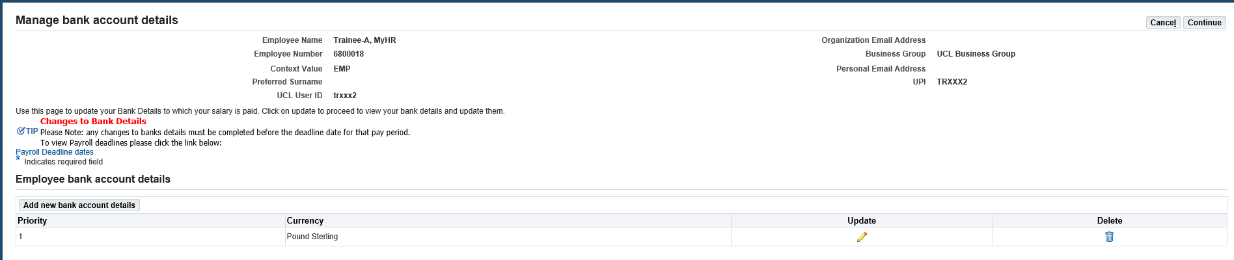
Figure 5: UCL Employee Self Service > MyPay > Manage Bank Details > Add new bank account details > overview

You will be presented with an overview of the changes that are to be made to your bank details

- To proceed with the changes, click on the ‘Submit’ button in the top right hand corner
- To make any further changes, click on the ‘Back’ button in the top right hand corner
- To exit the screen and abort the request click on the ‘Cancel’ button in the top right hand corner.

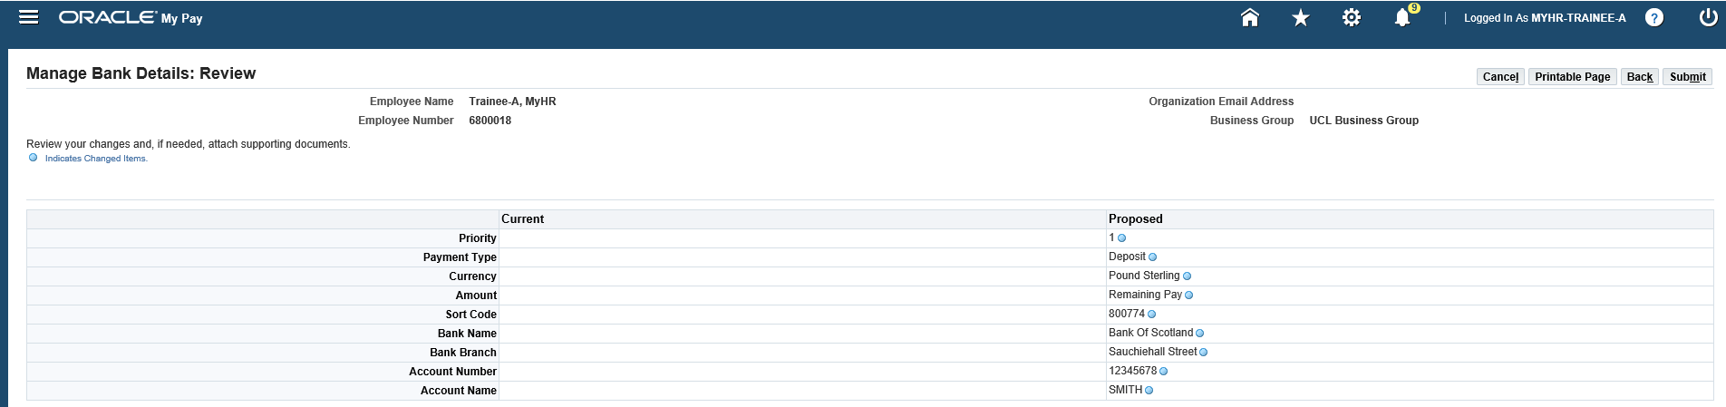
Figure 6: UCL Employee Self Service > MyPay > Manage Bank Details > Add new bank account details > Summary of changes

Part 2 – Updating your bank details on to MyHR

- From the MyHR home screen navigate to UCL Employee Self Service > My Pay > Manage Bank Deatils

Figure 1: UCL Employee Self Service Menu

- Click on the ‘Update’ button

Figure 2: UCL Employee Self Service > MyPay > Update Bank Details

- Update the following information:

  - Account Name
  - Account Number
  - Sort Code
  - Bld Society Account Number (if appropriate)

Note: The bank name and branch will populate based on the sort code details entered.

Figure 3: UCL Employee Self Service > MyPay > Manage Bank Details > Add new bank account details

- Click the ‘Apply’ button in the top right hand corner of the screen

Figure 4: UCL Employee Self Service > MyPay > Manage Bank Details > Add new bank account details > Apply

You will be returned to a summary screen which will allow you to ‘Update’ or ‘Delete’ the details if these are incorrect.

- To proceed, click on the ‘Continue’ button in the top right hand corner of the screen

Figure 5: UCL Employee Self Service > MyPay > Manage Bank Details > Add new bank account details > overview

You will be presented with an overview of the changes that are to be made to your bank details

- To proceed with the changes, click on the ‘Submit’ button in the top right hand corner
- To make any further changes, click on the ‘Back’ button in the top right hand corner
- To exit the screen and abort the request click on the ‘Cancel’ button in the top right hand corner.

Figure 6: UCL Employee Self Service > MyPay > Manage Bank Details > Add new bank account details > Summary of changes

