How to Complete the Voluntary Resignation payment estimator

You will need to complete the following 6 fields only, and the rest will be automatically calculated:

Annual salary (full time equivalent)
Annual London allowance (full-time equivalent)
FTE
Date of birth
Continuous service date
Proposed leave date

Step 1: How to look up your annual salary (full time equivalent)
This is your basic gross annual salary excluding any allowances.
If you are on a published UCL salary scale and know what spine point you are paid at, choose the relevant salary under the heading “August 2022 (excluding London Allowance)”.
OR
Follow the UCL guide to finding your payslip.
Review the ‘Payments’ section of your payslip. The full-time annual Salary is found in the third column of the table.
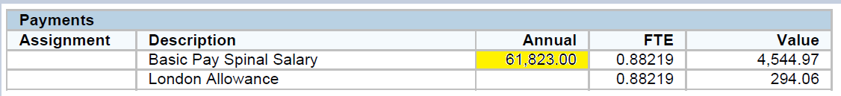

Step 2: How to look up your London allowance (full-time equivalent)
UCL London based: £4000
UCL Fringe London Allowance: £2000
Institute of Education: £2888
MRC: £4000
PRION: £4000
Non-Consultant Clinical Academic Pay Scale, STR and Junior Doctors pay scales: £4000
Consultant pay scale: £2,162
Dentists: £4000
Outside of region: £0

OR
Follow the UCL guide to finding your payslip.
Review the ‘Payments’ section of your payslip, see picture above. London allowance is normally found in the row below basic pay. It does not display the annual amount. To work out the full-time amount, take the monthly amount at the end of that row (under column Value) and multiply it by 12.

If you are part-time, you will need to divide that figure by your FTE, to work out the full-time equivalent.
For example:
£294.06 * 12 = £3,528.72 (pro-rata London allowance)
£3528.72 / 0.88219 = £4,000 (Annual London allowance (full-time equivalent)

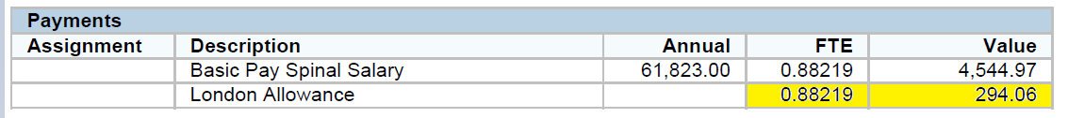

Step 3: How to look up your FTE

This is the proportion of full-time that you work. A full-time employee works 1 FTE.
If you are part-time, you can find your FTE by looking on your payslip.
FTE is in the fourth column of the payments table.

Step 4: Date of birth
Hopefully you know this!

Step 5: Continuous service date
This date is used to calculate how many complete years’ service you have with UCL.
It is the date your current employment with UCL commenced (or the date your employment started with your previous employer(s) for those who TUPE transferred to UCL).
You will find your Continuous Service Date by:
- Logging in to MyHR
- In the top left of the page, click the Navigator button
- Proceed to ‘UCL Employee Self Service’ > ‘My Employee Information’ > ‘My Information’.

Step 6: Proposed leave date
For Grade 6 and below, who are on one month’s notice, the earliest leave date will normally be approximately the end of March. For Grade 7 and above, who are on three months’ notice, the earliest leave date will normally be approximately the end of May, or the end of July for staff with operational or teaching commitments.

This calculator is designed to provide an estimate only. Please note, the last day of service and payment amount will be confirmed in writing once an application is approved.

