GLOBAL TALENT VISA – TEMPLATE LETTERS
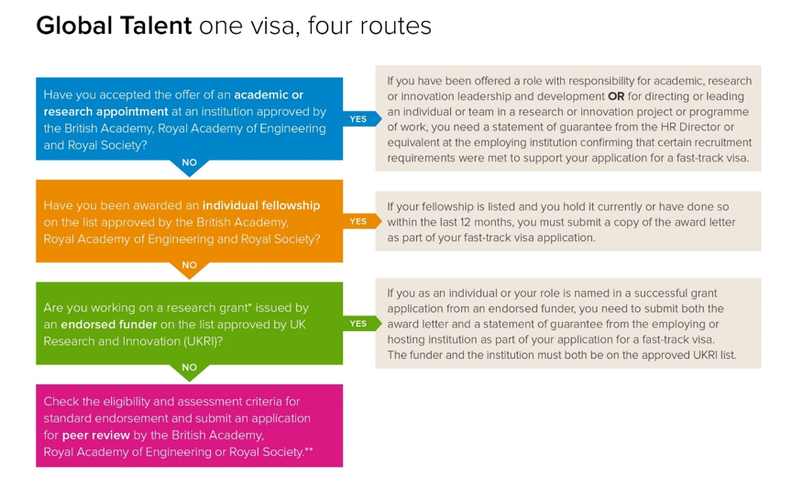

- Academic or Research Appointment at an institution approved by the British Academy, Royal Academy of Engineering and Royal Society
ROUTE ONE REQUIREMENTS
To be considered for endorsement, applicants must submit a statement of guarantee signed by the HR director or equivalent at the employing organisation which clarifies:
- the job was advertised and an open competition was held, or where it was not, an explanation as to why;
- the applicant has accepted the job offer;
- the job title and department in which the applicant will be based;
- at least 2 references were received;
- at least 3 academic representatives from the employing institution were on the interview panel;
- at least 1 expert in the applicant’s field was on the interview panel OR at least 1 relevant expert independent of the employing institution was consulted before the job offer was made

Global Talent Visa - Appointments Route: Statement of Guarantee for insert full name of applicant
I write to confirm support for insert name of applicant’s application for fast-track endorsement under the Global Talent Visa academic and research appointments route. Under the terms of Appendix Global Talent of the Immigration Rules, the above-named individual will be employed at insert name of UK organisation, which is on the Academies’ published list of approved institutions, and is eligible for fast-track endorsement for a Global Talent Visa.
The published listed of approved institutions is available on the Royal Society website
I can confirm, on behalf of insert name of UK organisation, that the role and recruitment process for the appointment meet the list of required criteria as follows:
- Insert name of applicant has accepted the job offer for the position of insert full title of appointment at the insert Department and name of UK organisation. It is confirmed that in this position the applicant will:

  - have responsibility for academic, research or innovation leadership and development; or
  - direct or lead:
    - an individual or team research project or programme of work; or
    - an individual or team innovation project or programme of work.

Applicants must meet a), b)i or b)ii above; you should delete the criteria that do not correspond to the appointment.
You may give further detail in the letter on how the position meets the above criteria (see accompanying guidance below) referring to aspects of the Job Description. As a minimum you should attach the Job Description as a supporting document.

The Academy Endorsing Bodies have published some accompanying guidance as follows:

Applicants will only be considered eligible for the academic and research appointments route if responsibility for academic, research or innovation leadership and development or for directing or leading individual or team research or innovation project or programme of work is a significant function of the role they have been offered.

The 'directs or leads' category is for individuals whose role requires them to act independently in initiating, planning and managing a research or innovation project or programme of work without supervision. This is likely to make applicants ineligible if their role is an entry level postdoctoral research position.

The 'academic, research or innovation leadership and development' category is for individuals in senior leadership roles at a departmental, faculty or institutional level. Typical duties may include strategy development and delivery and overseeing the management of staff and resources. Example roles (not exhaustive) include Vice-Chancellor/Principal, Pro Vice-Chancellor/Vice-Principal, Dean/Associate Dean, Head of School and Research Institute Director.

- This position was advertised and an open competition was held between insert start and end dates in line with our organisation’s recruitment and selection policy.

(Applications where there was not an open competition may be considered providing all other criteria are met and a reasonable explanation is provided here for that decision)

- At least three academic representatives from insert your institution were present on the interview panel as follows: insert positions

(You do not need to include personal names, only positions. The term ‘academic representatives’ is shorthand for an interview panel comprising academic, research or innovation professionals with knowledge of the field or discipline in which the applicant is seeking endorsement. An interview panel comprising human resources and/or other professional services representatives would not meet this criterion.)

- At least one of the above representatives is an expert in the applicant’s field [insert which one of above representatives] OR In addition at least one relevant expert independent of insert your institution was consulted before the job offer was made: insert position and organisation.
(You do not need to include personal name, only position(s). Delete from the above bullet point as appropriate - If the interview panel did not include a relevant expert in the field from your institution, the statement of guarantee must additionally confirm here that at least one external expert, who is not employed by the employing institution, was consulted during the recruitment process prior to the job offer being made.)

- At least two references were required and obtained in support of the above-named applicant.
Please do not hesitate to contact me and/or one of my team (listed below as an alternative contact) should you require further information or verification.
Yours faithfully,
Signature
NAME
JOB TITLE [must be HR Director or equivalent]
Email address
Telephone number

Alternative contact
NAME
JOB TITLE
Email address
Telephone number
Enc. Copy of applicant’s job description

- Individual Fellowship on the list approved by the British Academy, Royal Academy of Engineering and Royal Society (NO ENDORSEMENT LETTER REQUIRED)

ROUTE TWO REQUIREMENTS
You can get fast track endorsement if you have held an eligible fellowship in the last 12 months. Updated to 5 years. The fellowship needs to be approved by the following:

- Royal Society, for science and medicine
- British Academy, for humanities
- Royal Academy of Engineering

You can apply as either a:

- leader in your field (called ‘exceptional talent’)
- potential leader in your field (called ‘exceptional promise’)
Which one you are depends on the fellowship you have.

If your fellowship is not listed or you have another type of grant, you may be able to get endorsement from UK Research and Innovation.

Apply for endorsement
You need to provide a copy of your fellowship award letter.
Once you have the letter, you can apply for endorsement.

- Working on a Research Grant issued by an Endorsed Funder on the list approved by UK Research and Innovation (UKRI)

ROUTE THREE REQUIREMENTS
A declaration from the director of human resources (or equivalent) of your employing or hosting organisation, providing a statement of guarantee detailing the following:
• that you are essential to the execution of a grant or award and your role meets the eligibility criteria
• that your time is at least 50% attributable to the grant or award (individually or from an aggregation of eligible grants)
• that a job offer of an eligible research position at the employing research organisation has been accepted
• the name of the position and the department or group in which you will be based
• details of the recruitment process if you were recruited (this must show that the recruitment met peer review standards)

Global Talent Visa (Endorsed Funder Path) – Statement of Guarantee for NAME

I write to confirm support for NAME’s application for a Global Talent Visa accelerated endorsement under the UKRI endorsed funder path. Under the terms of Appendix W of the Immigration Rules, NAME will be hosted or employed at [UK HEI/UK IRO/UK PSRE], which is a UKRI-approved institution.

I can confirm the following on behalf of [UK HEI/UK IRO/UK PSRE] that the applicant provides critical contributions to work supported by a research grant or award from an endorsed funder, and the grant and the applicant’s role meets the eligibility criteria. This letter sets out how the applicant meets these criteria.

- The applicant’s work is supported by a programme grant/project grant/fellowship/strategic investment/large institutional investment from NAME OF FUNDER, as set out in Appendix W, NAME OF GRANT, GRANT NUMBER and is worth a minimum of £30,000 and covers a minimum period of 2 years.

- The applicant independently directs, or directs under the supervision of a Principal Investigator, a unique research or innovation project. OR The applicant makes critical contributions to research through the provision of core technical or domain excellence, or in developing new technologies and methodologies. The applicant is NAMED/THEIR POST IS LISTED, on the grant/award under ‘directly incurred’ costs.

- The applicant will be employed/hosted as a JOB ROLE (as set out in Appendix W) within the DEPARTMENT/GROUP.

  - The applicant’s time is at least 50% attributable to the grant or award OR The applicant is a Principal investigator/Co-Investigator and they spend at least 50% of their time on an aggregation of eligible grants).

- The applicant has accepted a job offer OR hosting agreement from our organisation and the contract of employment/hosting agreement has at least 1 year remaining at the time of application.

  - [RECRUITMENT] The applicant was recruited in line with MY ORGANISATION’S recruitment and selection policy, dated DATE. The applicant has met all our selection criteria for the role and holds the appropriate professional qualifications (or equivalent) and research experience required, as set out in the UK Immigration Rules. OR

  - [HOSTED OR APPOINTED by role] The applicant was offered a hosting agreement/contract of employment with MY ORGANISATION in line with the award criteria of the FUNDER. OR

  - [NAMED ON GRANT] The applicant, NAME, is specifically named on the grant and was offered a hosting agreement/contract of employment with MY ORGANISATION on that basis.

Please do not hesitate to contact me AND/OR one of my team members should you require any further information.

Yours sincerely,

[SIGNATURE]
NAME
JOB TITLE [must be HR Director or equivalent]
TELEPHONE NUMBER
E-MAIL ADDRESS

Alternative contact
NAME
JOB TITLE
TELEPHONE NUMBER
EMAIL

- Peer Review Endorsement by the British Academy, Royal Academy of Engineering or Royal Society (NO ENDORSEMENT LETTER REQUIRED)
ROUTE FOUR REQUIREMENT
An individual evidencing exceptional talent under full peer review must meet the following:
- has to be an active researcher in an approved field, like related to a university, research institute or directly in the industry; and
- have a PhD or equivalent research experience (including industrial or clinical research); and
Meet 1 of the following requirements:
- the applicant should be a member of the national academy or a foreign member of an academy of any other country; or
- the applicant should have won an award, a prestigious internationally acclaimed prize; or
- The applicant is required to provide a letter of recommendation from a senior member of a known and recognised UK organisation concerned with research in the applicant’s field

An individual evidencing exceptional promise under full peer review must meet the following:
- the applicant should be currently active in research in a relevant field, typically in a university, research institute or in the industry; and
- have a PhD or equivalent research experience (including industrial or clinical research); and
- should be beginning their career or are still in the early stages; and
- have been awarded, or should have held a prestigious UK based research fellowship for the last 5 years or an international fellowship or an advanced post judged by the endorsing body to be equivalent to such a fellowship.
Further information in relation to Peer Review Endorsement. No letter from HR required.

Documents you need to provide
You need to provide a copy of your CV. It must:
- outline your career and any publication history, if applicable
- be typed
- be up to 3 single sides of A4 paper

You also need to include a letter of recommendation from an ‘eminent person’ in the UK. The endorsing body must judge that the person has ‘internationally recognised expertise’ in your field.
The letter must be about your Global Talent application - you cannot use a letter that was written for another reason.

It must say how:
- the eminent person knows you
- they think you show exceptional talent or promise
- you would benefit from being in the UK
- you would contribute to the UK
- It must also explain what plans you have for work in the future.

The letter must:
- be typed and dated
- be up to 3 single sides of A4 paper, excluding the author’s credentials and contact details
- be signed by the author, or by someone on behalf of the organisation recommending you
- include a telephone number and email address, and the organisation’s logo and registered address, if applicable
- come with the author’s CV (or other proof of their credentials that the endorsing body will accept)

If you’re applying with exceptional talent, you also need to provide one of the following:
- proof that you are member of a national academy
- proof of a prize that the endorsing body judges to be ‘prestigious’ and ‘internationally recognised’
- a letter of recommendation from a respected UK organisation linked to your research - it must be signed by someone senior, dated and on headed paper

