**Employee Self Service - View Your P60**

This guide will show you how to view your P60s in MyHR Employee Self Service.

**Please note:**

If you are a casual worker, you will not be able to access your P60s via Employee Self Service. They will be circulated to you separately.

**How to view your P60**

* From the MyHR home screen navigate to UCL Employee Self Service > My Pay > P60

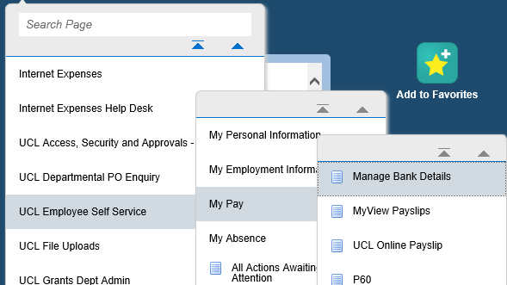

*Figure 1: UCL Employee Self Service Menu*

* The next screen will display the P60s available.

*Figure 2: UCL Employee Self Service : My Pay : P60*

* Select the year for the P60 you would like to view and then click on ‘View Report’ in the top right hand corner.
* A message similar to that shown below will pop up. Select the relevant option to open the P60 document:



*Figure 3: UCL Employee Self Service : My Pay : P60 : Download message*

* Once the option has been selected the P60 will become visible and this can then be either printed or saved.
* Click on  to return to the main MyHR home page.