Employee Self Service - How to Cancel a period of Annual Leave

This guide will show you how to Cancel a period of Annual Leave in Employee Self Service.

Please note:

You will be able to cancel a period of annual leave via Employee Self Service where:

- The start date of the leave is after the date on which you are trying to request the cancellation.
- The start date of the leave is on the date on which you are trying to request the cancellation.
- The start date of the leave is earlier than the date on which you are trying to request the cancellation providing the period of leave has not yet ended.

You will not be able to cancel a period of annual leave via Employee Self Service where:

- The start date of the leave is earlier than the date on which you are trying to request the cancellation and the period of leave has ended.

In these instances contact hr-services@ucl.ac.uk to request the deletion. Please ensure your manager’s approval for the leave to be cancelled is attached to the request.

How to Cancel a Period of Annual Leave

- From the MyHR home screen navigate to UCL Employee Self Service > My Absence > Absence Management

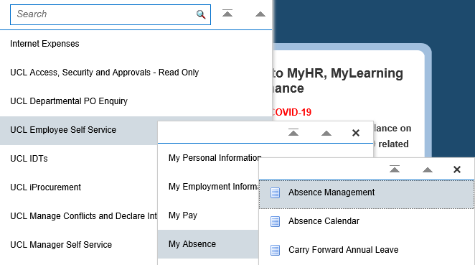
Figure 1: UCL Employee Self Service Menu

- The next screen will display a summary of the absence that you have booked.

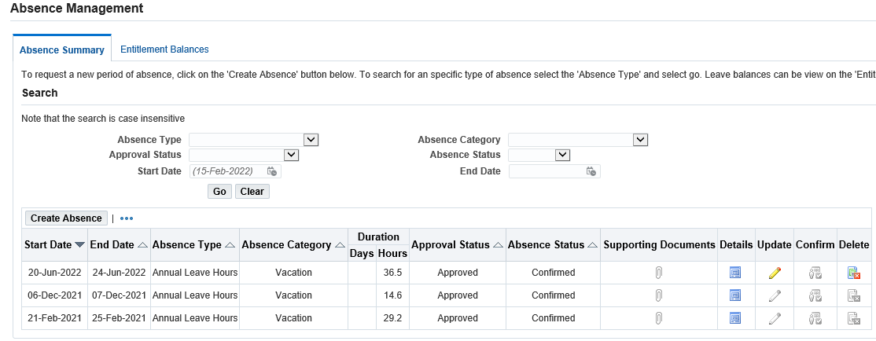
Figure 2: UCL Employee Self Service : My Absence : Absence Summary

- Identify the period of leave which is to be cancelled.

- Click on the icon in the ‘Delete’ column for the period of leave identified.

Please note: where the icon is greyed out the leave will be in the past and cannot be deleted via Employee Self Service.

Figure 3: UCL Employee Self Service : My Absence : Absence Management : Delete

- Once the delete icon has been selected you will be presented with the following option:

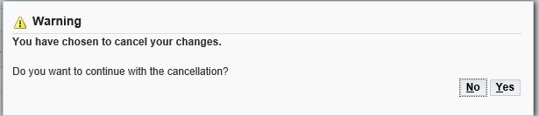
Figure 4: UCL Employee Self Service : My Absence : Absence Management : Cancellation confirmation

To continue with the cancellation request select ‘Yes’.
Alternatively, to cancel the request select ‘No’.

- You will be presented with the ‘Delete Absence Review Screen’ which will summarise the cancellation request to be submitted

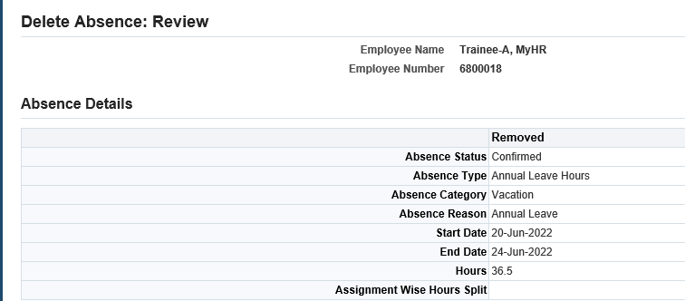
Figure 5: UCL Employee Self Service : My Absence : Absence Management : Delete Absence: Review

- Review the request and where this is correct click on ‘Submit’ in the top right hand corner

- You will be returned to the Absence Management: Summary Screen

The request will be sent to your Manager, and any Self Service Administrators within your department for approval. Once approved, the period of absence will be deleted, this will no longer be visible on the Absence Management: Summary Screen and the leave hours will be added back on to your leave entitlement balance.

