Employee Self Service - How to Book a Period of Annual Leave

This guide will show you how to book Annual Leave in Employee Self Service.

How to Book a Period of Annual Leave

- From the MyHR home screen navigate to UCL Employee Self Service > My Absence > Absence Management

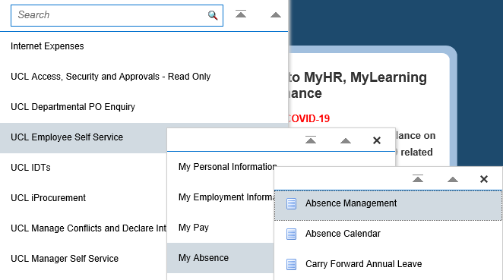
Figure 1: UCL Employee Self Service Menu

- Click on the ‘Create Absence’ button

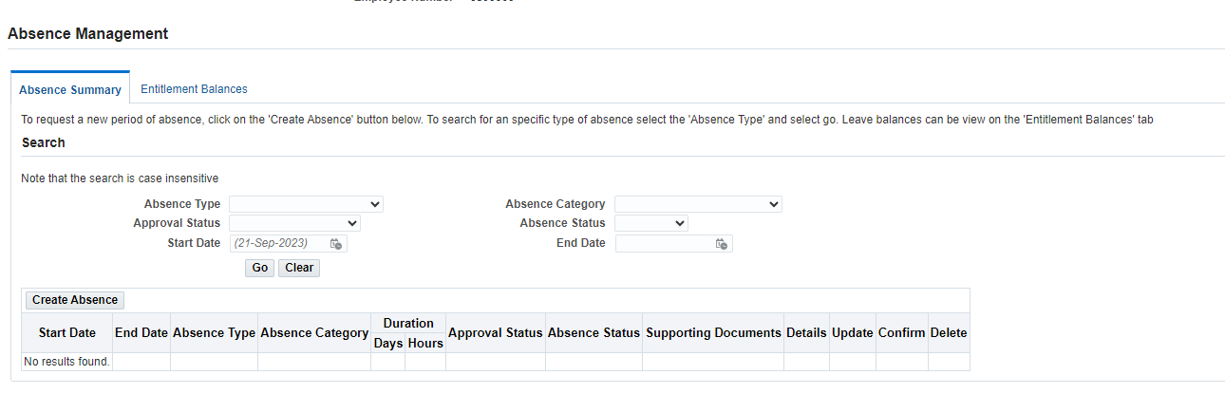
Figure 2: UCL Employee Self Service : My Absence : Absence Management

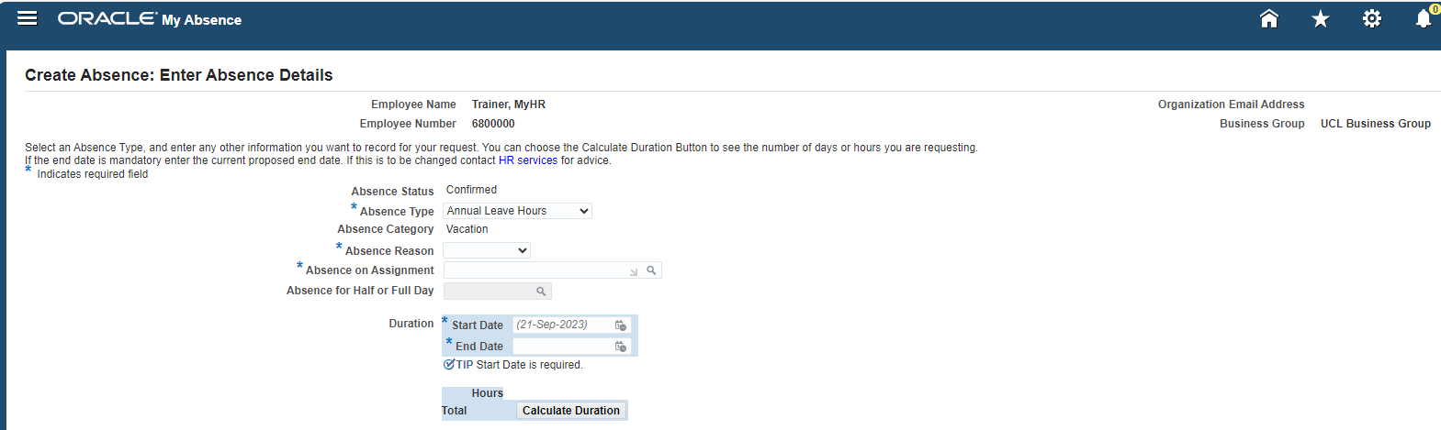
Figure 3: UCL Employee Self Service : My Absence : Absence Management

- Complete the following fields as follows:

- Absence Type: Select Annual Leave Hours

- Absence Category: This will be automatically populated with ‘Vacation’

- Absence Reason: This will be automatically populated with ‘Annual Leave’

- Absence on Assignment: Select the assignment to which the period annual leave relates to.

- By selecting ‘All Assignments’ this will book the annual leave across multiple assignments where they exist. Alternatively by selecting the assignment number the leave will only be booked for the assignment selectd.

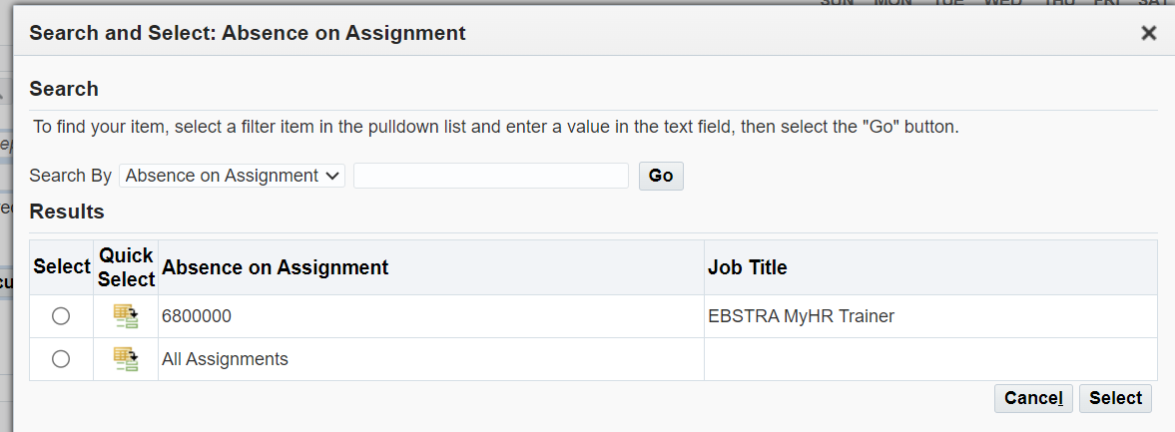
Figure 4: UCL Employee Self Service : My Absence : Enter Absence Details : Absence on Assignment

- Absence for Half Day or Full Day:

Click on ‘Go’ and select ‘Yes’ where the leave being booked is for a half day and ‘No’ where a full day’s leave is to be booked.

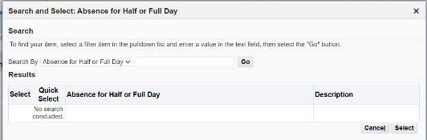

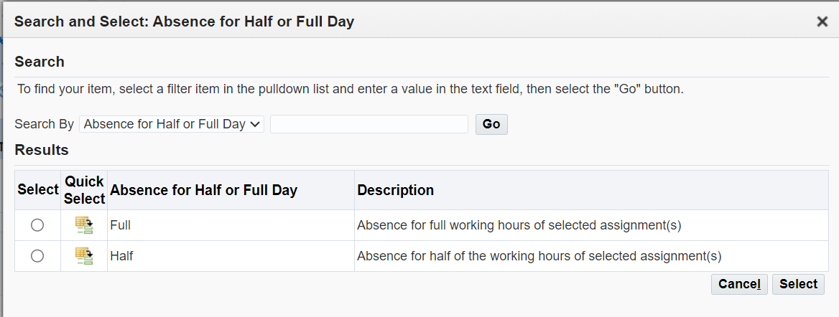

Figure 5: UCL Employee Self Service : My Absence : Absence for Half or Full Day

- Duration:

Start date: Enter the start date of the period of annual leave

End date: Enter the last day of the period of annual leave

Calcuation duration: Click on ‘calculate duration’. The system will calculate how many hours will be deducted based on the days being booked on the day and the working pattern on these days.

- Comments: Enter any comments to support the request for the approver

Click on ‘Next’ in the top right hand corner

Create Absence : Review

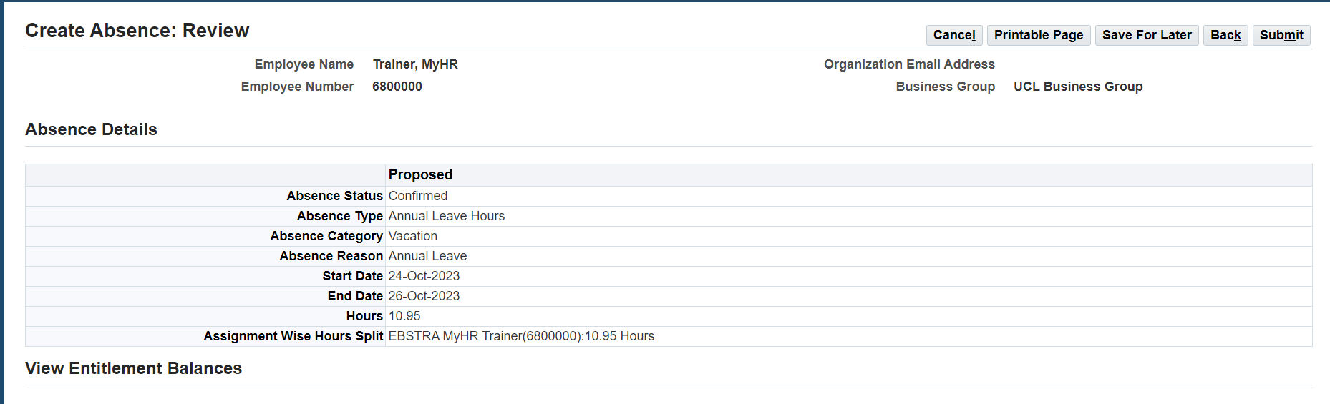
Figure 6 : Create Absence : Review

This page allows for a final review of the request which is to be submitted.

- Review the details and select one of the following options:

- Where the request needs amending click on ‘Back’ in the top right hand corner

- Where the request is to be cancelled click on ‘Cancel’

- Where the request is ready to be submitted click on ‘Submit’ in the top right hand corner

Please note: Where ‘Save for Later’ is selected, the request will be saved in a pending status until this is re-opened and submitted or cancelled.

The request has now been submitted for approval.

