Manager Self Service - Deleting a period of historical leave

This guide will show you how to Delete a period of historical leave in Manager Self Service for the following types of leave only.

Annual Leave Hours
Paid Leave
Paid Public Service Duties
Training Course
Working Off Site

How to delete a period of historical leave

- From the MyHR home screen navigate to UCL Manager Self Service – Cancel Historical Absences > Cancel Historical Absences to launch Oracle Applications.

Figure 1: UCL Manager Self Service – Cancel Historical Absences menu

- Oracle Applications will launch automatically or by opening the resulting downloaded ‘jnlp’ file. Run the application where required to be taken to the Absence Detail screen.

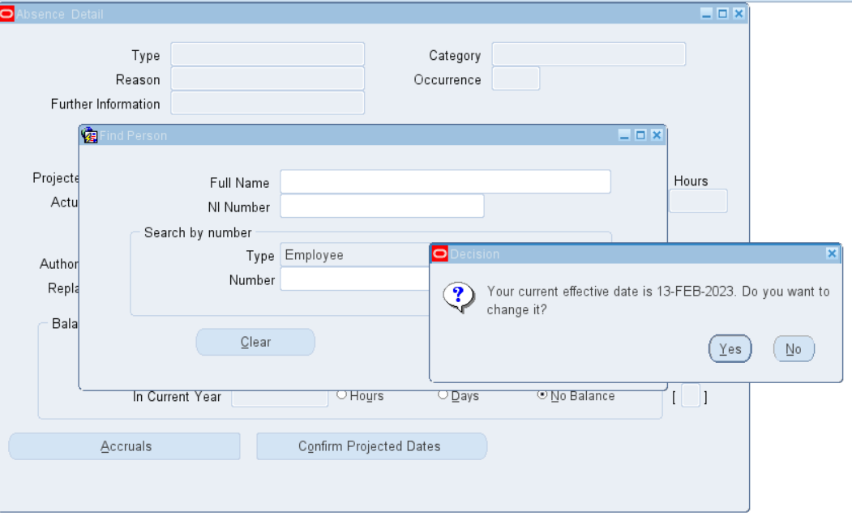
Figure 2: Absence Detail search screen

- Select ‘No’ to keep the effective date as the date of accessing the system.

- Search for the employee. This can be done by either entering the name in the ‘Full name’ or employee number in the ‘Number’

To search name, enter the name in the following format: SURNAME%INITIAL%
For example, Robert Jones would be entered as Jones%R%

- Select ‘Find’

- The latest record of historical leave will be displayed (Annual Leave Hours, aid Leave, Paid Public Service Duties, Training Course and Working Off Site).

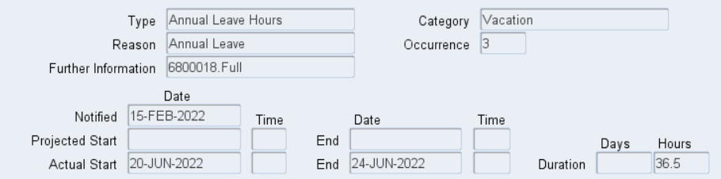
Figure 3: Example of Absence Detail search screen

- If the leave to be deleted is not displayed use your keyboard’s ‘down arrow’ to locate previous absences. These will go in date order from the most recent backwards.

Please note: show the full screen to find the Record number of the absence at the bottom left.
- At the Leave record to be deleted select the delete button from the toolbar towards the top of the screen, review and confirm the action by selecting ‘Yes’ at the pop up box.

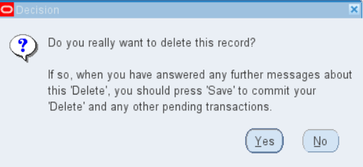
Figure 4: Deletion decision

- At the toolbar press the Save button to commit the deletion.

- Use the ‘up and down’ arrows on the keyboard toggle to any other periods of leave to delete and repeat the deletion and save the actions as described above.

- Depending on the Absence Type the totals displayed in the Balance Information will adjust accordingly.

- On completion of deletion press the button at Absence Detail to exit Absence Detail.

- To exit Oracle Applications press ‘File > Exit Oracle Applications’ and select ‘OK’ to confirm.

