**Coronavirus/ COVID-19 absence recording – guide for self-service administrators**

This guide is for self-service administrators who are logging paid sick leave, Special Leave or Carer’s Leave because of the Coronavirus/ COVID-19 outbreak on behalf of an employee. Please log COVID-19-related paid sickness absence on MyHR when the employee returns to work; records should be kept locally in the meantime.

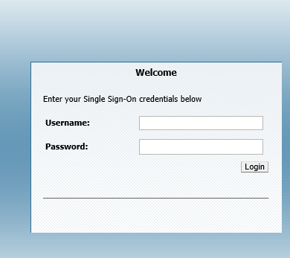Step 1: Log in to [MyHR](https://ebsappxlv-sso.adcom.ucl.ac.uk:4443/oam/server/obrareq.cgi?encquery%3DSuifhkIkHGdiYk9LLqdOyxsjyhc2Lq8ObVEeCRaSN0zv5D4fTf4ZgBbsuKVQvjlLuqqOYD6ve0jABWoNtLUWu9ZhJJODiWmenlY58rG%2BskdmDWClKbQfYrodc5AWAMMY%2Flee5EQW4lcNjrvnQeOTtKAQEjlnQL4JYsZiTnD%2FCjCt37ac6mX5CZdiyjNt4%2FwAckikBrB85HbtEJdqkJe4TW2lExAbWNyMmok%2BSmaguA%2Bh4%2FLPrKzxy5uNWYDBCjaZLgU2ApEYYJBxXIM3LSltW8128l5AazYQgaAL9DU7HhYkAr6ERWGCFHbLGELrPnRvSbBS1IeRHClnqlzFsK%2Fi8j8YFX8BP25UabddYYbf6Rr%2BM47Js9KsVHeJgireXYKqxSj5WkKq2in%2BCSiOG9SMlFEKJFTICha1686HVyYZR%2Fc%3D%20agentid%3DEBSLIV_ebscorelv-liv.adcom.ucl.ac.uk_4444%20ver%3D1%20crmethod%3D2&ECID-Context=1.005cGy2s%5E572vHt_wdO5yW000Edz00004p%3BkXjE) using your UCL user ID and password.

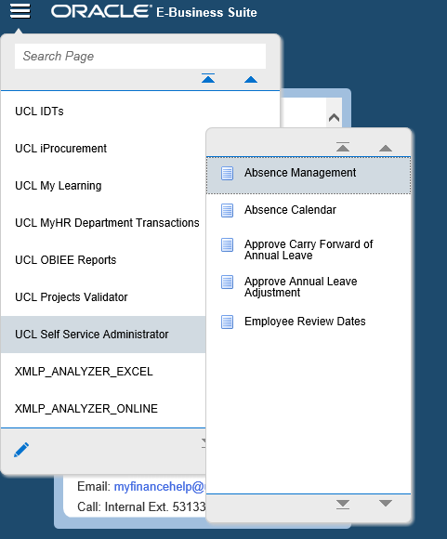Step 2: Select the **Menu** icon (the three horizontal lines) in the top left hand corner of the screen, click **UCL Self Service Administrator** from the left hand side on the drop down menu, then **Absence Management**.

Step 3: A new screen will come up. Search for the employee using the search bar and click **Go.**

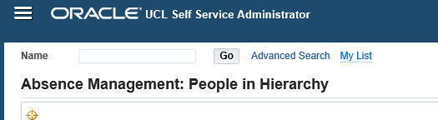

Step 4: When you have found the employee, click the **Action icon** on the right hand side.

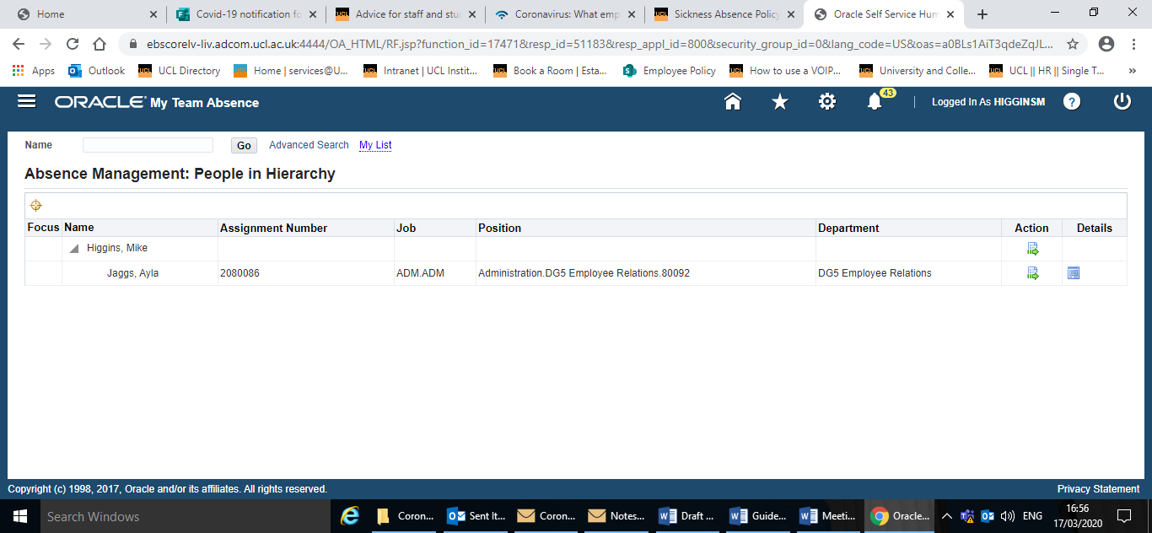

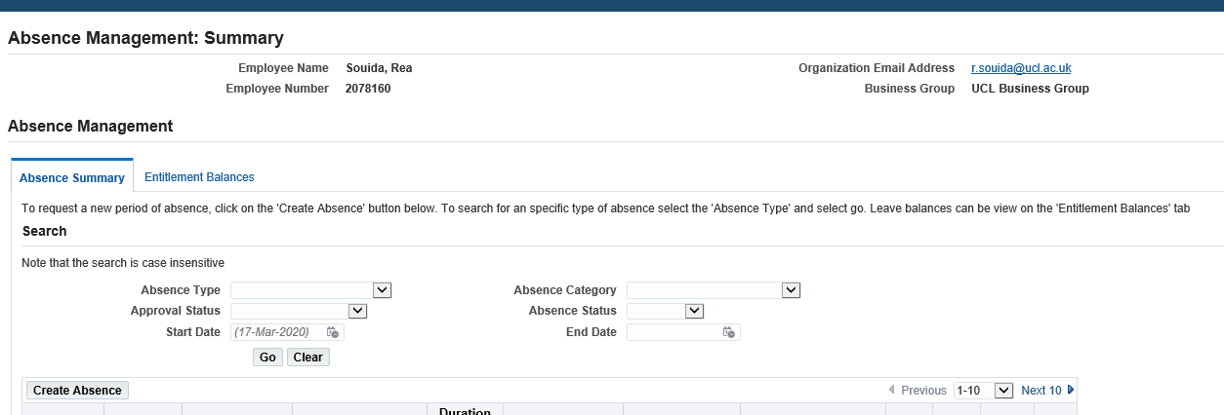Step 5: You will be redirected in a new window where you should click on **Create Absence** on the left hand side.

**Step 6A: To record sickness absence**

For Coronavirus/ COVID-19 related sickness you will need to select **Paid Leave** in the drop-down menu for Absence Type and **Sick leave related to Coronavirus** in the drop-down menu for the Absence Reason. Once you have filled out the other details, such as the relevant dates for this sickness, click **Next** in the top right hand corner of the screen. This will redirect you to a confirmation page where you can submit the leave.

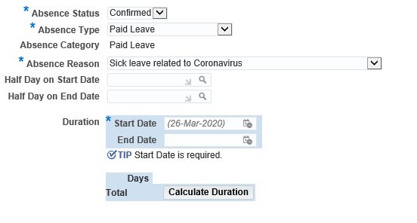

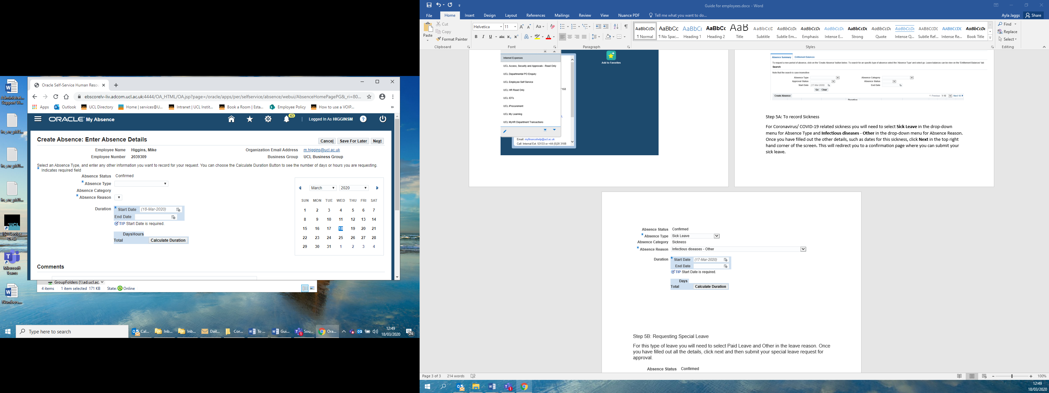

**Step 6B: To record special leave where the employee is unable to work remotely**

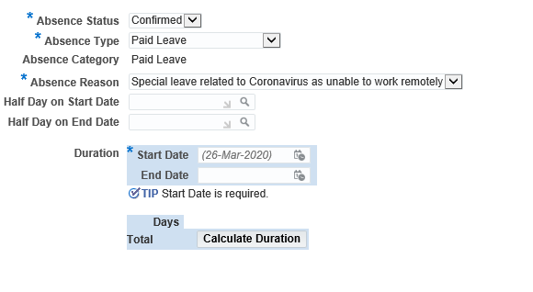For Special Leave, you will need to select **Paid Leave** in the drop-down menu for the Absence Type and **Special leave realted to Coronavirus as unable to work remotely** in the drop-down menu for the Absence Reason. Once you have filled out the other details, such as the relevant dates for this Special Leave, click **Next** in the top right hand corner of the screen. This will redirect you to a confirmation page where you can submit this record.

**STEP 6C: To record Carer’s Leave**

For Carers’ Leave, you will need to select **Paid Leave** in the drop-down menu for the Absence Type and **Carers’ Leave** in the drop-down menu for the Absence Reason. Once you have filled out the other details, such as the relevant dates for this Carers’ Leave, click **Next** in the top right hand corner of the screen. This will redirect you to a confirmation page where you can submit this record.

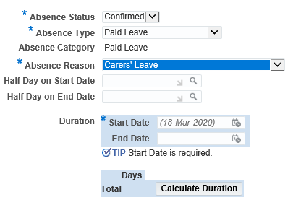



**Considering requests**

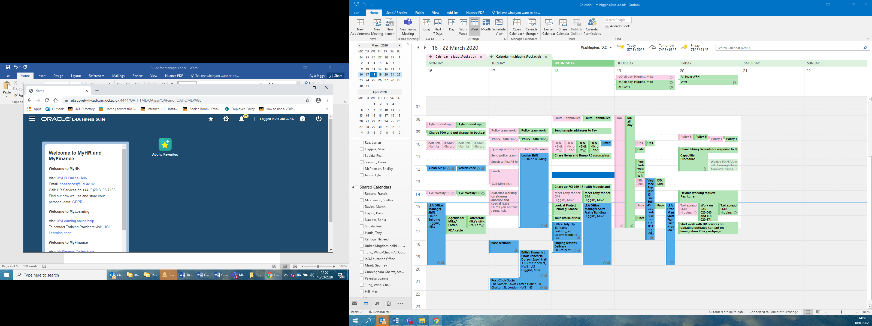If you are considering an employee’s request for leave, you can either accept, decline or request further information most safely and securely via the **MyHR portal** (click on the **Bell** icon on the toolbar at the top of the screen to open your Worklist, where any requests will appear). You will also receive a **MyHR email** when the employee submits their request, which will give you the same options.

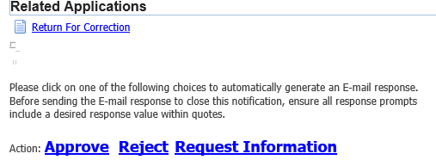

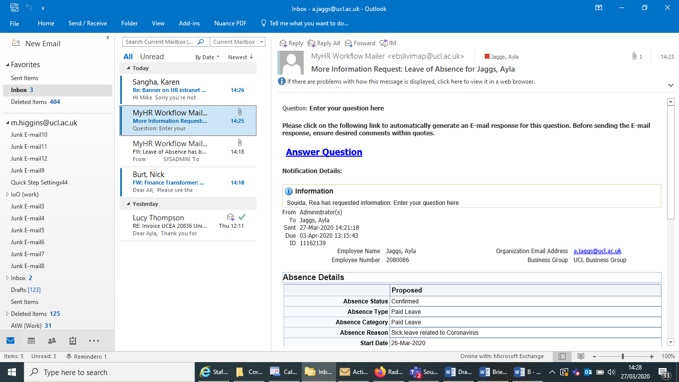If you would like to request further information, you can do so via the **MyHR portal** or by clicking the **Request Information** linkin the email and typing your query.The employee will then be sent an emailwith this query and should click the **Answer Question** link in their email. Their answer will then be sent back to you for your consideration. Alternatively, you can contact the employee directly.