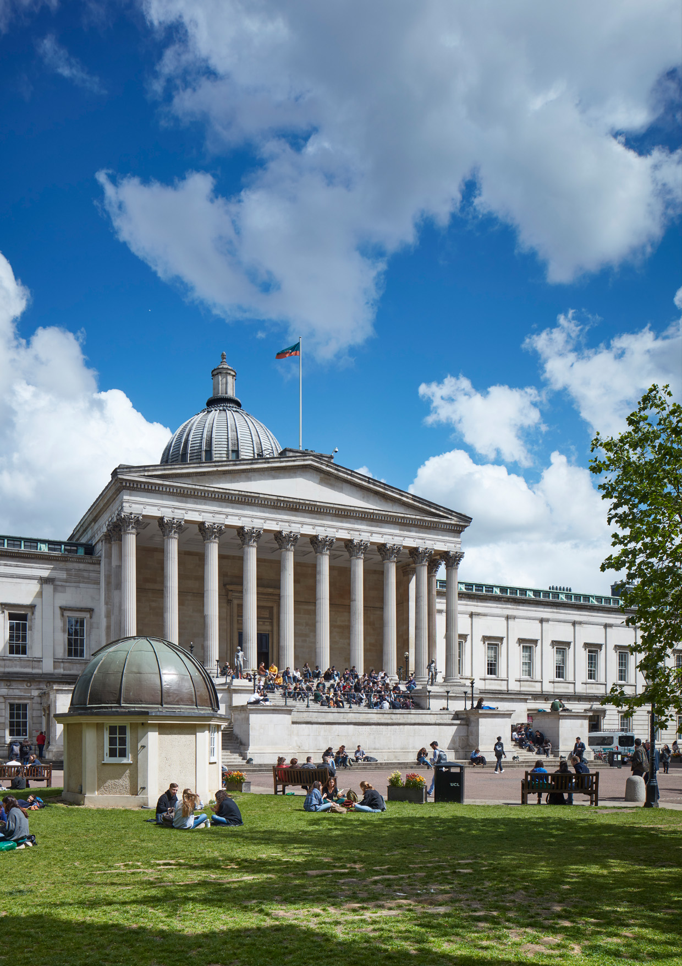
22-23
Course
Catalogue for
Researchers
Organisational Development,
Human Resources

Foreword

Welcome to the Course Catalogue for Researchers. This document provides an overview of researcher development courses planned in the 2022/23 academic year by UCL central training providers.
UCL aims to train researchers from diverse backgrounds to be creative, critical, autonomous intellectual risk takers at the frontiers of research.
(Doctoral Education Strategy: Vision)
The catalogue is meant to provide a convenient and concise source of information on opportunities available to all UCL researchers and should be used in conjunction with the information published on our websites. For course dates and booking links, please visit our UCL Research Staff Development Programme (RSDP) and UCL Doctoral Skills Development Programme (DSDP) respectively, where you will find our termly timetables arranged by the Researcher Development Framework (RDF) domains.

We strongly encourage you to take full advantage of your time at UCL by participating in a variety of initiatives designed to support your growth. All researchers should spend ten days per year (pro rata) on activities furthering their personal and professional development.

For research staff, it is essential that you plan and discuss how to maximise the allocation of your ten developmental days with your Principal Investigator (you can find out more on HR Special Leave Policy).

If you are a postgraduate researcher, your skills development is part of your formal supervisory review process. To learn more on how your funders and department may want you to document your development, please visit our Postgraduate Training Policy website.

As we are continuing to build our training offer, make sure to stay informed on the newest additions to our programme by subscribing to our bi-weekly newsletters for research staff and postdoctoral researchers. Follow us on Twitter @UCL_ODResearch to hear about the latest developments on researcher development opportunities across the sector.

If you have questions on specific training included in this catalogue, please consult the relevant Delivery Provider’s website in the first instance or email them directly (contact details are included in the table below). For general questions, please contact od@ucl.ac.uk (research staff) or docskills@ucl.ac.uk (postgraduate researchers).

Note: unless specifically stated, training included in this catalogue is provided free of charge to UCL researchers, although some sessions are tailored to support specific groups. Please check the course eligibility before booking your place.

We hope you find our training offer helpful and stimulating.
The Organisational Development Team

Table of contents

Foreword 2
Table of contents 3
Researcher Development Framework 4
Your development journey as doctoral researcher 5
Your development journey as a research staff 6
RDF A: Knowledge and intellectual abilities 7
1. Knowledge on critical thinking 7
2. Research design and methodologies 8
3. Tools for research analysis 10
4. Literature review and library methodologies 14
5. Tools for literature review 17
6. Tools for research communication 19
RDF B: Personal effectiveness 23
1. Self-development as a researcher 23
2. Leadership development as a researcher 25
3. Career planning in and out of academia 27
RDF C: Research governance and organisation 29
1. Introduction to research at UCL 29
2. Research funding and management 30
RDF D: Engagement, influence and impact 31
1. Research engagement via enterprises 31
2. Research engagement via PPI 32
3. Research communication via public engagement and impact 33
4. Research communication via writing and presentation 35
5. Research leadership via teaching and supervision 39
A – Z self-paced courses: 41

Researcher Development Framework

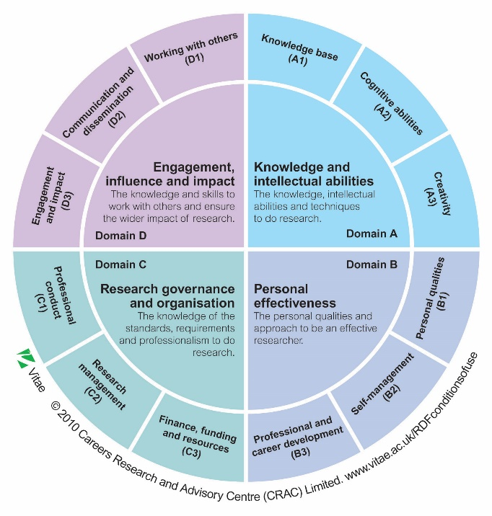
UCL offers the researcher community the opportunity to expand their research and personal transferable skills in order to support research, professional development and future careers through the Doctoral Development Skills Development Programme (DSDP) and Research Staff Development Programme (RSDP).
Both programmes are mapped to Vitae’s Researcher Development Framework (RDF), the national professional development framework that describes the knowledge, behaviours and attributes of successful researchers. The RDF was developed by and for researchers, in consultation with academic and non-academic employers and contains four different domains:

- Domain A: Knowledge and intellectual abilities
- Domain B: Personal effectiveness
- Domain C: Research organisation and governance
- Domain D: Communication, influence and impact
On pages 5 and 6 (below), the RDF has been mapped to create developmental journeys for both doctoral researchers and research staff. Each journey illustrates when researchers may want to or consider taking courses based on their career path. We recognise that this may not be a linear journey for all, but hope it creates a structure to provide guidance.
The graphics are divided into three sections: “before you begin your journey” which covers inductions, “your researcher journey” which includes each RDF in the order we recommend following and “personal development” to become an effective researcher. We encourage you to take the course catalogue to your supervisor during 1:1s, appraisals and developmental conversations and continually refer back to the developmental journey.
The layout is interactive, with useful hyperlinks leading you to resources and additional information. Within “your researcher journey” section, each tile will take you to the termly timetable pages, where you can browse upcoming courses and book directly through our learning platforms (Inkpath for doctoral researchers or MyLearning for research staff).

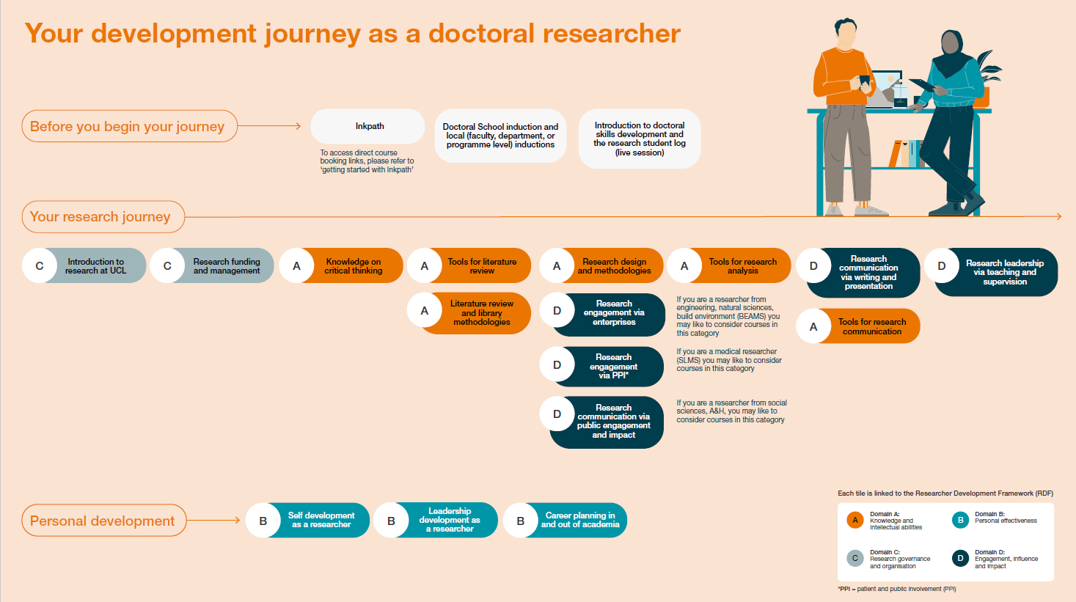
Your development journey as doctoral researcher

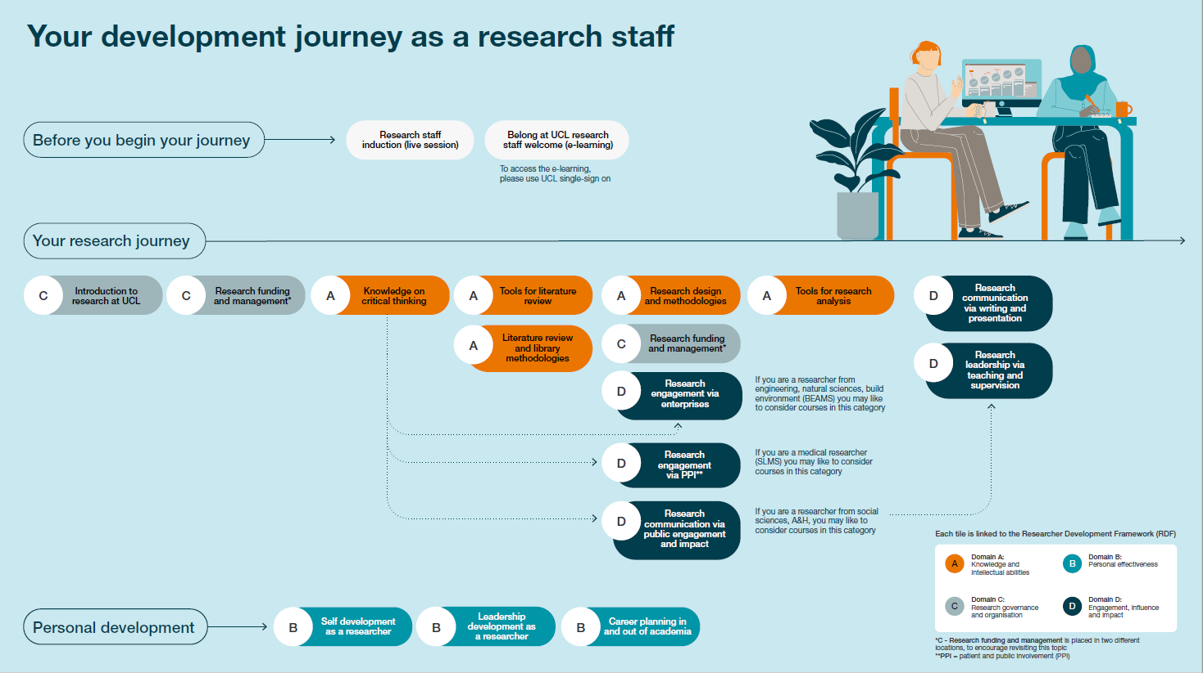
Your development journey as a research staff

RDF A:
Knowledge and intellectual abilities

In this section you will find information on upcoming courses to build knowledge and intellectual abilities

Knowledge on critical thinking
Introduction to science, philosophy, and key concepts to build critical thinking
Course Title: | Target learner: | Training point/s gained after completion: | Number of times the courses is delivered in the 22-23 academic year:
Creativity In Research | Doctoral researcher and research staff | 1 | 2
Critical Thinking: Science and Art | Doctoral researcher and research staff | 1 | 1
Critical Thinking: Science and Decolonisation | Doctoral researcher and research staff | 1 | 1
Critical Thinking: Science and Emerging Technology | Doctoral researcher and research staff | 1 | 1
Critical Thinking: Science and Religion | Doctoral researcher and research staff | 1 | 1
Critical Thinking: Science and the Government | Doctoral researcher and research staff | 1 | 1
Critical Thinking: Science and the Media | Doctoral researcher and research staff | 1 | 1
Philosophy of Science | Doctoral researcher and research staff | 5 | 1

Research design and methodologies
Methodologies for research data collection and analysis (both quantitative and qualitative)
Course Title: | Target learner: | Training point/s gained after completion: | Number of times the courses is delivered in the 22-23 academic year:
Quantitative
Basic Statistics for Research (self-paced) | Doctoral researcher and research staff | 2 | Accessible all year
DSD: Introduction to REDCap for research – demo and Q&A | Doctoral researcher and research staff | 1 | 3
DSD: Software for success: Survey tools | Doctoral researcher and research staff | 1 | 5
Experimental Design & Power Analysis for in vivo scientists | Doctoral researcher | 4 | 2
Longitudinal Data Analysis | Doctoral researcher and research staff | 4 | 1
Missing data and multiple imputation for cross-sectional and longitudinal data | Doctoral researcher and research staff | 5 | 1
Nature Masterclass: Data Analysis: Conducting and Troubleshooting (self-paced) | Doctoral researcher and research staff | 1 | Accessible all year
Nature Masterclass: Data Analysis: Planning and Preparation (self-paced) | Doctoral researcher and research staff | 1 | Accessible all year
Nature Masterclass: Interpreting Scientific Results (self-paced) | Doctoral researcher and research staff | 1 | Accessible all year
Research Methods for Multilevel Data | Doctoral researcher and research staff | 6 | 1
Research Methods for Quantitative Data | Doctoral researcher and research staff | 7 | 1
SPM for fMRI and MRI/VBM | Doctoral researcher | 6 | 2
SPM for MEG/EEG | Doctoral researcher | 6 | 1
Statistical analysis for in vivo scientists | Doctoral researcher | 3 | 1
Statistics for Researchers: Analysis of Data & Graphical Methods | Doctoral researcher and research staff | 3 | 1
Statistics for Researchers: Design of Experiments | Doctoral researcher and research staff | 1 | 1
Statistics for Researchers: Observational Studies | Doctoral researcher and research staff | 3 | 1
Statistics for Researchers: Q&A/Workshop/Clinic | Doctoral researcher and research staff | 1 | 1
Statistics for Researchers: Scientific Method, Probability & Statistics | Doctoral researcher and research staff | 1 | 1
Understanding Statistical Concepts in Research | Doctoral researcher and research staff | 9 | 2
Understanding Statistical Concepts in Research: SPSS add-on | Doctoral researcher and research staff | 4 | 1
Qualitative
Introduction to qualitative analysis: Interviewing | Doctoral researcher and research staff | 1 | 6
Introduction to qualitative research method: thematic analysis | Doctoral researcher | 1 | 6
Mixed method approach in social sciences | Doctoral researcher and research staff | 3 | 1
Rapid ethnography | Doctoral researcher and research staff | 1 | 2
Text Mining for the Humanities and Social Sciences | Doctoral researcher and research staff | 1 | 1
The Brain Meeting | Doctoral researcher and research staff | 1 | 2

Advanced
Beginner
Possible learning paths for this section

Introduction to statistics:
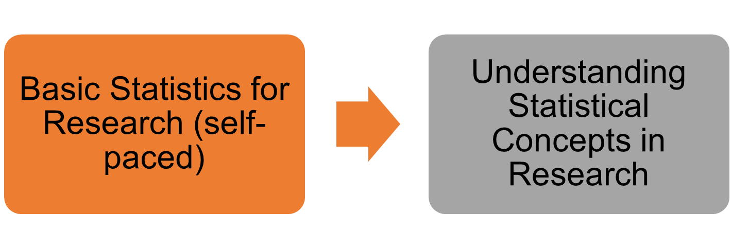

Tools for research analysis
Software and tools for data analysis, graphing and programming
Course Title: | Target learner: | Training point/s gained after completion: | Number of times the courses is delivered in the 22-23 academic year:
Computing skills for reproducible research: Software Carpentry | Doctoral researcher and research staff | 4 | 5
DSD: A Quick Introduction to UNIX | Doctoral researcher and research staff | 1 | 2
DSD: Advanced statistics with Excel 2016 | Doctoral researcher and research staff | 1 | 2
DSD: An Introduction to R with Rstudio - Part 1 | Doctoral researcher and research staff | 1 | 2
DSD: An Introduction to R with Rstudio - Part 2 | Doctoral researcher and research staff | 1 | 2
DSD: An Introduction to R with Rstudio - Part 3 | Doctoral researcher and research staff | 1 | 2
DSD: An Introduction to R with Rstudio - Part 4 | Doctoral researcher and research staff | 1 | 2
DSD: An Introduction to R with Rstudio | Doctoral researcher and research staff | 2 | 4
DSD: Better Tables in R | Doctoral researcher and research staff | 1 | 2
DSD: Charting with Excel 2016 | Doctoral researcher and research staff | 1 | 3
DSD: Data Manipulation in R with Rstudio | Doctoral researcher and research staff | 1 | 2
DSD: Data Visualization in R with ggplot2 | Doctoral researcher and research staff | 1 | 1
DSD: Excel Essential Skills programme - Worksheet 1 Review session | Research staff | N/A | 3
DSD: Excel Essential Skills programme - Worksheet 2 Review session | Research staff | N/A | 3
DSD: Excel Essential Skills programme - Worksheet 3 Review session | Research staff | N/A | 3
DSD: Excel tips and tricks | Doctoral researcher and research staff | 1 | 5
DSD: Further UNIX | Doctoral researcher and research staff | 1 | 2
DSD: Getting Started with SPSS | Doctoral researcher and research staff | 2 | 2
DSD: Getting Started with Stata - Campus based | Doctoral researcher and research staff | 2 | 1
DSD: Getting Started with Stata - Part 1 (Orientation and materials) | Doctoral researcher and research staff | 1 | 2
DSD: Getting Started with Stata - Part 2 (Using Stata) | Doctoral researcher and research staff | 1 | 4
DSD: Getting Started with Stata - Part 3 (Scripting techniques) | Doctoral researcher and research staff | 1 | 4
DSD: Getting Started with Stata - Part 4 (Modelling and reporting) | Doctoral researcher and research staff | 1 | 4
DSD: In a Nutshell: Excel functions we should all know | Doctoral researcher and research staff | 1 | 4
DSD: In a Nutshell: Git version control | Doctoral researcher and research staff | 1 | 3
DSD: In a Nutshell: Starting an Nvivo Project | Doctoral researcher and research staff | 1 | 2
DSD: Intermediate Statistics with Excel 2016 | Doctoral researcher and research staff | 1 | 3
DSD: Introduction to MATLAB (blended) | Doctoral researcher and research staff | 3 | 3
DSD: Pivot Tables in Excel - demo | Doctoral researcher and research staff | 1 | 3
DSD: Pivot Tables in Excel - workshop | Doctoral researcher and research staff | 1 | 5
DSD: Scripting Stata Graphs | Doctoral researcher and research staff | 1 | 2
DSD: Scripting Stata's new Tables and Collections | Doctoral researcher and research staff | 1 | 2
DSD: Software for success: Data analysis & statistical tools | Doctoral researcher and research staff | 1 | 2
DSD: Software for success: Data visualisation | Doctoral researcher and research staff | 1 | 1
DSD: Software for success: Winning with charts | Doctoral researcher and research staff | 1 | 2
DSD: Think like a computer programmer | Doctoral researcher and research staff | 2 | 2
DSD: Vlookup in Excel | Doctoral researcher and research staff | 1 | 5
Introduction to programming with Python for Research | Doctoral researcher and research staff | 2 | 3
Introduction to Research Software Development with Python | Doctoral researcher and research staff | 2 | 3
MATLAB Beginner | Doctoral researcher | 1 | 3
MATLAB Novice | Doctoral researcher | 1 | 3

Excel:
Possible learning paths for this section
Beginner
Advanced
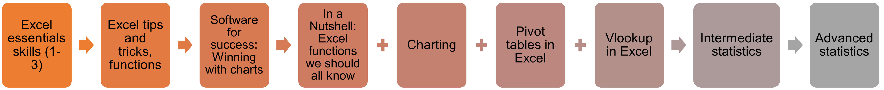

R:

UNIX:

Stata:
Possible learning paths for this section
Advanced
Beginner

Python:

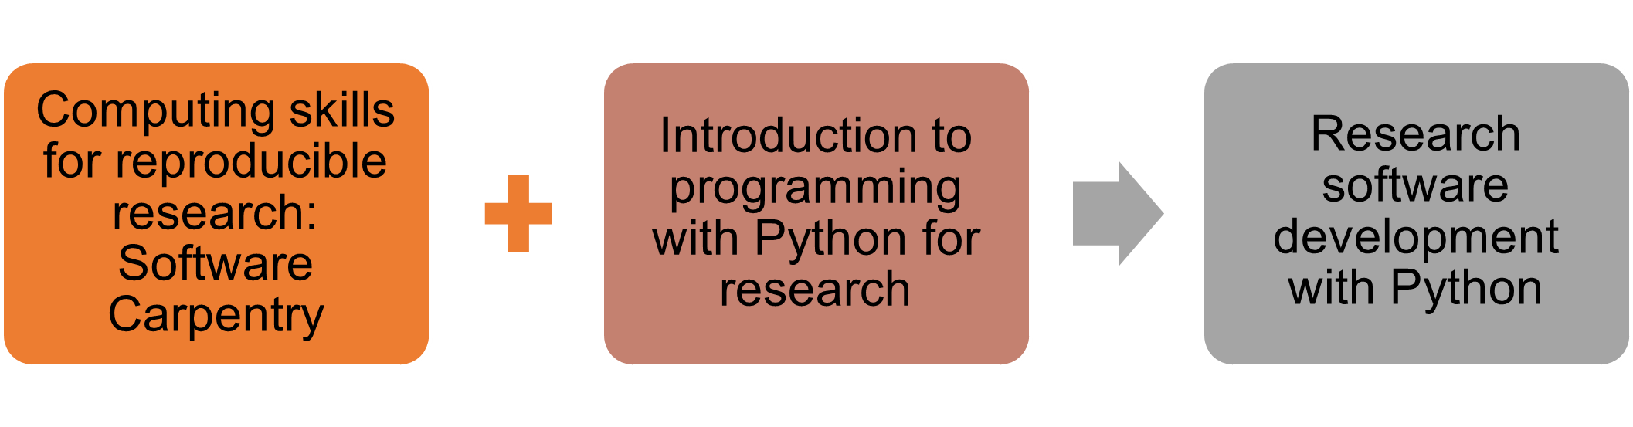

Literature review and library methodologies
Building literature review and library handling skills
Course Title: | Target learner: | Training point/s gained after completion: | Number of times the courses is delivered in the 22-23 academic year:
Literature review
Critical appraisal of a journal article | Doctoral researcher and research staff | 1 | 1
Critical appraisal of a randomised controlled trial for life and medical sciences students and early career researchers (self-paced) | Doctoral researcher and research staff | 1 | Accessible all year
Critical appraisal of qualitative research for life and medical sciences students and early career researchers (self-paced) | Doctoral researcher and research staff | 1 | Accessible all year
Essential search skills for biomedical databases (self-paced) | Doctoral researcher and research staff | 1 | Accessible all year
Evaluating information for essays, assignments and research | Doctoral researcher | 1 | 3
Introduction to finding research literature | Doctoral researcher | 1 | 7
Introduction to searching Ovid databases (Medline, Embase, PsycINFO) | Doctoral researcher and research staff | 1 | 11
Introduction to searching Proquest databases | Doctoral researcher and research staff | 1 | 3
Introduction to PubMed: demonstration | Doctoral researcher and research staff | 1 | 11
Literature searching and databases for biomedicine | Doctoral researcher and research staff | 1 | 5
Literature searching using Ovid databases (Medline, Embase, PsycINFO) | Doctoral researcher and research staff | 1 | 10
Literature searching using PubMed | Doctoral researcher and research staff | 1 | 11
Search strategies for literature searching | Doctoral researcher | 1 | 5
Search strategies for literature searching (self-paced) | Doctoral researcher | 1 | Accessible all year
Searching for systematic reviews: introduction (self-paced) | Doctoral researcher and research staff | 1 | Accessible all year
Sources of socio-economic data (self-paced) | Doctoral researcher and research staff | 1 | Accessible all year
Library methodologies
Getting started with your systematic review | Doctoral researcher and research staff | 1 | 9
Getting started with your systematic review in health and biomedical sciences | Doctoral researcher and research staff | 1 | 7
Handling Rare Books, Archives, Manuscripts and Records | Doctoral researcher and research staff | 1 | 3
Handling Rare Books, Archives, Manuscripts and Records (self-paced) | Doctoral researcher and research staff | 1 | Accessible all year
Introduction to special collections (self-paced) | Doctoral researcher and research staff | 1 | Accessible all year
Introduction to special collections research | Doctoral researcher and research staff | 1 | 1
Introduction to referencing | Doctoral researcher | 1 | 3
Overview of Library Resources for Postgraduates | Doctoral researcher | 1 | 2
Referencing and avoiding plagiarism (self-paced) | Doctoral researcher | 1 | Accessible all year
Referencing: Questions and answers | Doctoral researcher | 1 | 6
Using and Understanding Bibliometrics | Doctoral researcher and research staff | 1 | 1
Using and Understanding Bibliometrics (self-paced) | Doctoral researcher and research staff | 1 | Accessible all year

Beginner

Advanced
Possible learning paths for this section
Evaluating research:

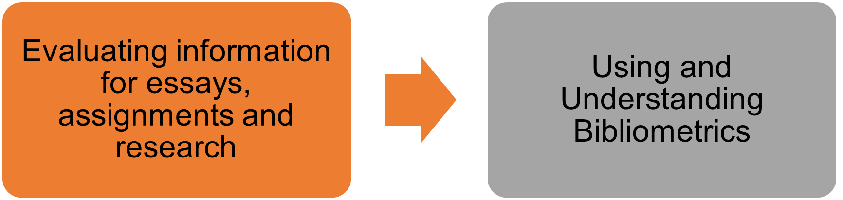

Possible learning paths for this section
Advanced
Beginner

Search skills for systematic reviews:

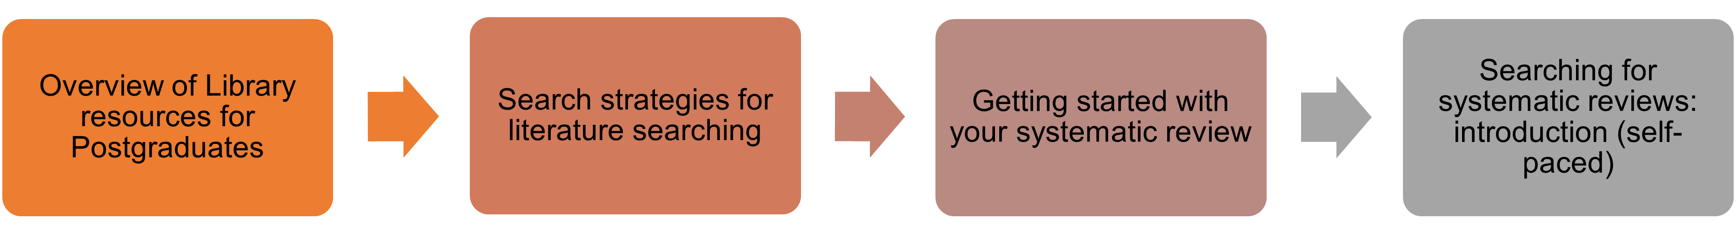

Referencing:
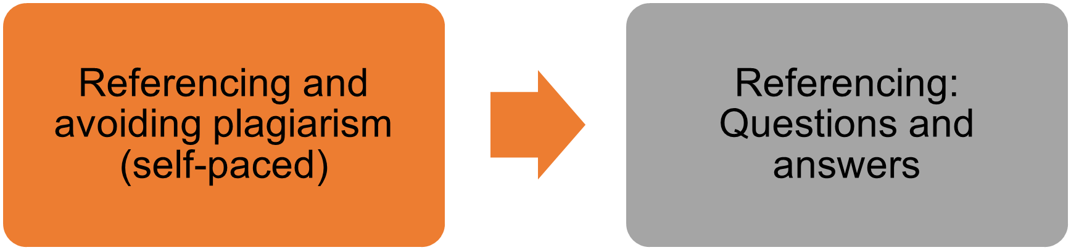

Biomedical literature review:
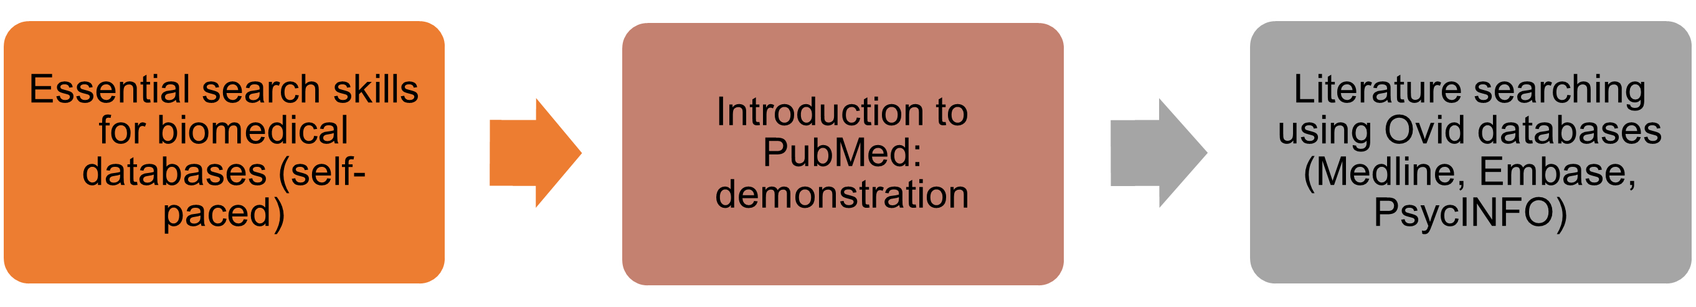

Tools for literature review
Software and tools to assist with writing and bibliography
Course Title: | Target learner: | Training point/s gained after completion: | Number of times the courses is delivered in the 22-23 academic year:
DSD: Dissertation clinics | Doctoral researcher and research staff | 1 | 6
DSD: Kick-starting your literature review | Doctoral researcher and research staff | 1 | 2
DSD: Software for success: Working with Bibliography and Citation Apps | Doctoral researcher and research staff | 1 | 2
Getting more out of EndNote: Questions and answers | Doctoral researcher and research staff | 1 | 7
Getting more out of Mendeley: Questions and answers | Doctoral researcher and research staff | 1 | 6
Getting more out of Zotero: Questions and answers | Doctoral researcher and research staff | 1 | 3
Introduction to EndNote | Doctoral researcher and research staff | 1 | 20
Introduction to EndNote: demonstration | Doctoral researcher and research staff | 1 | 10
Introduction to EndNote: demonstration (Mac) | Doctoral researcher and research staff | 1 | 3
Introduction to EndNote: training activities (self-paced) | Doctoral researcher and research staff | 1 | Accessible all year
Introduction to Mendeley | Doctoral researcher and research staff | 1 | 9
Introduction to Mendeley: Demonstration | Doctoral researcher and research staff | 1 | 8
Introduction to Mendeley: training activities (self-paced) | Doctoral researcher and research staff | 1 | Accessible all year
Introduction to Zotero | Doctoral researcher and research staff | 1 | 2
Introduction to Zotero: demonstration | Doctoral researcher and research staff | 1 | 5

EndNote:
Possible learning paths for this section
Advanced
Beginner
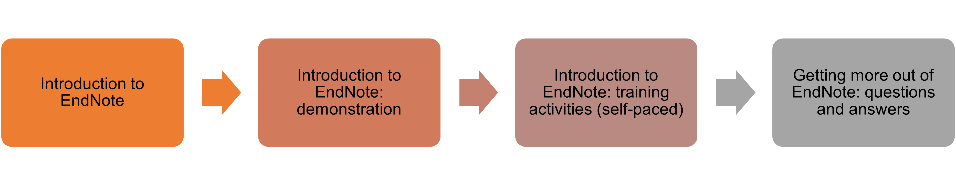

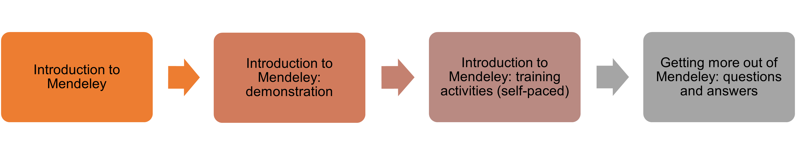
Mendeley:

Zotero:
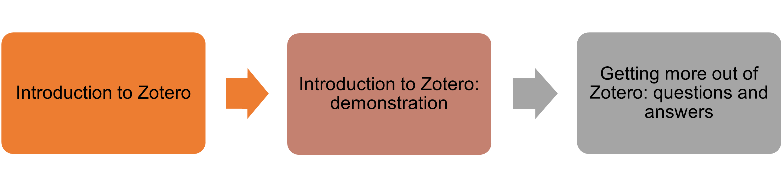

Tools for research communication
Software and tools to help you communicate your research in an engaging and accessible manner (via presentations, image, podcast, videos)
Course Title: | Target learner: | Training point/s gained after completion: | Number of times the courses is delivered in the 22-23 academic year:
Microsoft
DSD: Microsoft Forms demo | Doctoral researcher and research staff | 1 | 3
DSD: Microsoft Teams Introduction (Prerequisite Course for Advanced Workshops) | Doctoral researcher and research staff | 1 | 4
DSD: Microsoft Teams Workshop 1 - Beyond Basics overview | Doctoral researcher and research staff | 1 | 4
DSD: Microsoft Teams Workshop 2 - Managing and Participating in Meetings | Doctoral researcher and research staff | 1 | 4
DSD: Microsoft Teams Workshop 3 - Document Management and Collaboration | Doctoral researcher and research staff | 1 | 3
DSD: Microsoft Teams Workshop 4 - Forms Polling in Channels, Chats and Meetings | Doctoral researcher and research staff | 1 | 1
DSD: OneDrive for sharing files | Doctoral researcher and research staff | 1 | 3
DSD: OneNote 2016 – workshop | Doctoral researcher and research staff | 1 | 2
Document
DSD: Creating accessible Word documents | Doctoral researcher and research staff | 1 | 5
DSD: Digital book making | Doctoral researcher and research staff | 1 | 2
The Writing Series: Format your thesis (Mac) | Doctoral researcher and research staff | 1 | 3
DSD: Format your Thesis (Windows) | Doctoral researcher and research staff | 1 | 4
DSD: Getting Started with Markdown | Doctoral researcher and research staff | 1 | 1
DSD: LaTeX: Demo of Overleaf | Doctoral researcher and research staff | 1 | 2
DSD: Software for success: Writing tools | Doctoral researcher and research staff | 1 | 2
DSD: Styles and Table of contents in word – workshop | Doctoral researcher and research staff | 1 | 3
DSD: Word Tips and Tricks | Doctoral researcher and research staff | 1 | 5
DSD: XMind mind mapping tool – workshop | Doctoral researcher and research staff | 1 | 1
PowerPoint/presentation
DSD: Creating accessible PowerPoint presentations | Doctoral researcher and research staff | 1 | 5
DSD: PowerPoint for researchers (Windows) | Doctoral researcher and research staff | 1 | 3
PowerPoint for Researchers (Mac) | Doctoral researcher and research staff | 1 | 2
DSD: Record a narration over your PowerPoint on a PC | Doctoral researcher and research staff | 1 | 3
DSD: Sway, Microsoft's modern presentation tool – Demo | Doctoral researcher and research staff | 1 | 1
DSD: Sway, Microsoft's modern presentation tool – workshop | Doctoral researcher and research staff | 1 | 5
Multimedia
DSD: An introduction to free graphic design tools | Doctoral researcher and research staff | 1 | 3
DSD: Basic video editing using iMovie on a Mac | Doctoral researcher and research staff | 1 | 3
DSD: Best practice for video captions and transcripts | Doctoral researcher and research staff | 1 | 3
DSD: Basic Image Editing using free tools - Demo | Doctoral researcher and research staff | 1 | 3
DSD: Creating Infographics using free web based tools | Doctoral researcher and research staff | 1 | 3
DSD: Design an impactful research poster using UCL templates | Doctoral researcher and research staff | 1 | 3
DSD: Explore the potential of UCL Media Central | Doctoral researcher and research staff | 1 | 3
DSD: Filming advice for a short film | Doctoral researcher and research staff | 1 | 3
DSD: Introduction to stop motion animation | Doctoral researcher and research staff | 1 | 3
DSD: Make a short film using your iPhone | Doctoral researcher and research staff | 1 | 3
DSD: Photo editing with Pixlr X - Workshop | Doctoral researcher and research staff | 1 | 1
DSD: Planning a short film | Doctoral researcher and research staff | 1 | 3
DSD: Podcasting made easy | Doctoral researcher and research staff | 1 | 3
Interaction/collaboration
DSD: Managing your digital profile and social media presence | Doctoral researcher and research staff | 1 | 2
DSD: Mentimeter: Encourage online student interaction | Doctoral researcher and research staff | 1 | 2
DSD: Online social interaction environments | Doctoral researcher and research staff | 1 | 2
DSD: Use online whiteboards to encourage student interaction | Doctoral researcher and research staff | 1 | 1

Microsoft:
Possible learning paths for this section
Advanced
Beginner

Document:

PowerPoint:

Multimedia:
Possible learning paths for this section
Advanced
Beginner

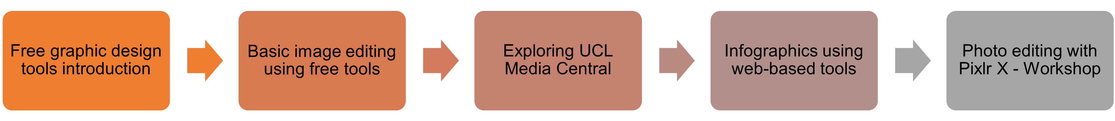

Interaction/collaboration:

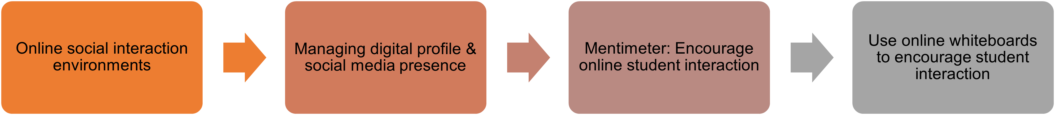

RDF B:
Personal effectiveness

In this section you will find information on upcoming courses to build your personal effectiveness
- Self-development as a researcher
Personal development in your PhD journey, time management and wellbeing
Course Title: | Target learner: | Training point/s gained after completion: | Number of times the courses is delivered in the 22-23 academic year:
Action learning sets
Action Learning Course for Early Researchers | Doctoral researcher and research staff | 6 | 2
Advanced Action Learning Course for Early Researchers | Doctoral researcher and research staff | 6 | 1
Time management
Balancing competing commitments for academics and researchers | Doctoral researcher and research staff | 1 | 3
Balancing Research and Life | Doctoral researcher and research staff | 1 | 2
Productivity and managing your workload | Research staff | N/A | 1
Productivity and managing your workload | Doctoral researcher | 1 | 2
Time for Research - Taking control of your time | Doctoral researcher and research staff | 1 | 3
Wellbeing
Staying Well During Your Research Career | Doctoral researcher and research staff | 1 | 1
Stress-reducing techniques for academics and researchers | Research staff | N/A | 2
Succeeding as a part-time doctoral researcher | Doctoral researcher | 2 | 2
Sweet Dreams: Cultivating Strategies for a Restful Sleep | Doctoral researcher | 1 | 2
Resilience
Defeating Self-Sabotage | Doctoral researcher and research staff | 1 | 3
Moving forward: how to overcome research career setbacks | Doctoral researcher | 1 | 2
Moving forward: how to overcome research career setbacks | Research staff | N/A | 1
Overcoming Imposter Syndrome | Doctoral researcher | 1 | 2
Overcoming Low Confidence | Doctoral researcher and research staff | 2 | 2
Interpersonal skills
Influencing and Negotiating | Doctoral researcher | 2 | 3
Influencing and Negotiating | Research staff | N/A | 2
Nature Masterclass: Networking for Researchers (self-paced) | Doctoral researcher and research staff | 1 | Accessible all year
Networking Naturally | Doctoral researcher and research staff | 1 | 3
Networking Skills | Doctoral researcher and research staff | 1 | 3
The PhD journey
The PhD Journey: 7 methods for common challenges | Doctoral researcher | 1 | 3
The PhD journey: maintaining motivation | Doctoral researcher | 1 | 4
The PhD journey: managing as a researcher | Doctoral researcher | 1 | 6
The PhD journey: preparing for transfer | Doctoral researcher | 1 | 3
The PhD journey: producing thesis and reports | Doctoral researcher | 1 | 6
The PhD journey: reading and literature review | Doctoral researcher | 1 | 6
The PhD journey: start your PhD | Doctoral researcher | 1 | 5
The PhD journey: techniques to reduce stress | Doctoral researcher | 1 | 2
The PhD journey: troubleshooting 1:1 Clinics | Doctoral researcher | 3 | 4

Action learning sets:
Possible learning paths for this section
Advanced
Beginner
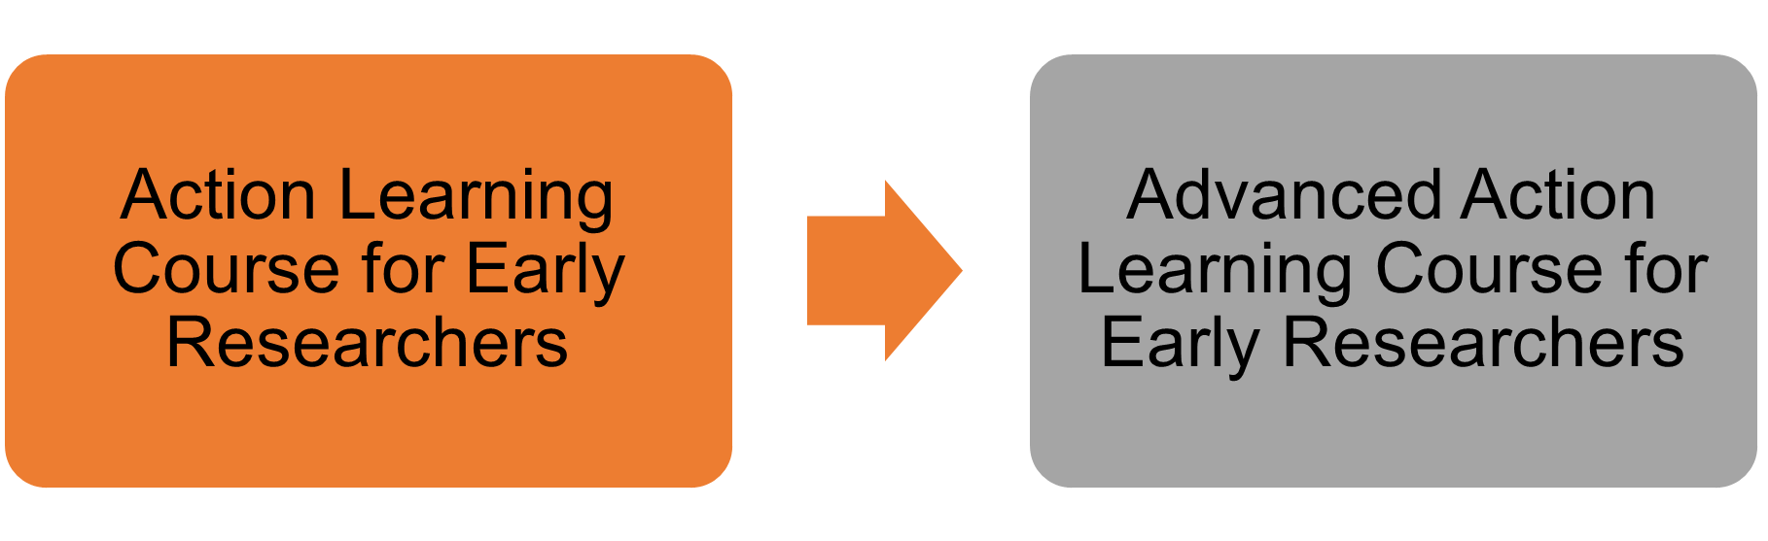
- Leadership development as a researcher
Leadership skills development as a researcher, building creativity and professional relationships
Course Title: | Target learner: | Training point/s gained after completion: | Number of times the courses is delivered in the 22-23 academic year:
Professional relationships
Being Assertive in Academic Relationships | Doctoral researcher | 1 | 2
Being Assertive in Academic Relationships | Research staff | N/A | 1
Confidence to collaborate | Doctoral researcher and research staff | 1 | 3
Empowered Interactions: How to Enhance Your Professional Relationships | Doctoral researcher | 1 | 2
Empowered Interactions: How to Enhance Your Professional Relationships | Research staff | N/A | 1
How to Build Compassionate Resilience | Doctoral researcher and research staff | 1 | 3
Nature Masterclass: Effective Collaboration for Research (self-paced) | Doctoral researcher and research staff | 1 | Accessible all year
Researchers Skills Beyond Academia - Leadership | Doctoral researcher and research staff | 1 | 1
Women in Research
Women in Research: Masterclass 1 - The future of research- exploring open science, funding sources and the role of technology to increase your impact and reach | Doctoral researcher and research staff | 1 | 1
Women in Research: Masterclass 2 - Working in teams and leading upwards to increase impact and nurture an inclusive and collaborative environment | Doctoral researcher and research staff | 1 | 1
Women in Research: Masterclass 3 - Solving current and future challenges through transdisciplinary research and partnerships | Doctoral researcher and research staff | 1 | 1
Women in Research: Masterclass 4 - At a crossroad? The art of building alliances and knowledge networks across sectors and disciplines for impact | Doctoral researcher and research staff | 1 | 1
Women in Research: Masterclass 5 - Boost your creative mindset and increase your problem solving skills and power to innovate! | Doctoral researcher and research staff | 1 | 1
Women in Research: small-group coaching 1 | Doctoral researcher and research staff | 1 | 1
Women in Research: small-group coaching 2 | Doctoral researcher and research staff | 1 | 1
Women in Research: small-group coaching 3 | Doctoral researcher and research staff | 1 | 1

- Career planning in and out of academia
Helping you work towards your professional and career development goals
Course Title: | Target learner: | Training point/s gained after completion: | Number of times the courses is delivered in the 22-23 academic year:
Introduction to career planning
Academic Career Planning for PhDs | Doctoral researcher | 1 | 6
Academic Career Planning for Research Staff | Research staff | N/A | 5
How Do I Know What I'll Like? Identifying Your Motivator, Strengths and Interests | Doctoral researcher and research staff | 1 | 6
Career preparation
Effective Academic Applications | Doctoral researcher and research staff | 1 | 6
Effective Academic Interviews | Doctoral researcher and research staff | 1 | 6
How to Decide What to Do Next | Doctoral researcher and research staff | 1 | 3
Making the Leap: How Researchers find Non-Academic Jobs | Doctoral researcher and research staff | 1 | 3
Managing your career change emotions | Doctoral researcher and research staff | 1 | 3
Marketing Yourself in Person: Non Academic Interview Skills | Doctoral researcher and research staff | 1 | 3
Marketing yourself online: LinkedIn lab | Doctoral researcher and research staff | 1 | 3
Marketing Yourself to Non Academic Recruiters: Cover letters and Personal Statements | Doctoral researcher and research staff | 1 | 3
Presenting your skills to Non Academic Recruiters: CVs and Application form questions | Doctoral researcher and research staff | 1 | 3
Race and Identity in Academic Careers | Doctoral researcher and research staff | 1 | 1
Researchers Prepare for A Career Beyond Academia – CVs & Applications Q&A | Doctoral researcher and research staff | 1 | 1
What's the story with Narrative CVs? | Doctoral researcher and research staff | 1 | 1
Career paths beyond academia
How to use a Humanities/Social Science PhD beyond academia | Doctoral researcher and research staff | 1 | 1
Researchers Careers in Communication: Publishing, Editorial & Writing Panel | Doctoral researcher and research staff | 1 | 1
Researchers Careers Beyond Academia Taster Session in Consultancy | Doctoral researcher and research staff | 1 | 1
Researchers Careers Beyond Academia Taster Session in Data | Doctoral researcher and research staff | 1 | 1
Researchers Careers Beyond Academia Taster Session in Medical Writing | Doctoral researcher and research staff | 1 | 1
Researchers Careers in Consultancy Panel | Doctoral researcher and research staff | 1 | 1
Researchers Careers in Data Science & Data Analysis Panel | Doctoral researcher and research staff | 1 | 1
Researchers Careers in Economics, Finance & Quantitative Analysis Panel | Doctoral researcher and research staff | 1 | 1
Researchers Careers in Government, Policy & Professional Bodies Panel | Doctoral researcher and research staff | 1 | 1
Researchers Careers in Museums & Cultural Heritage Panel | Doctoral researcher and research staff | 1 | 1
Researchers Careers in Not-For-Profit, Research Management, & Funding Panel | Doctoral researcher and research staff | 1 | 1
Researchers Careers in Public Health Panel | Doctoral researcher and research staff | 1 | 1
Researchers Careers in Research Outside of Academia Panel – Lab & Desk Based Research | Doctoral researcher and research staff | 1 | 1
Researchers Prepare for A Career Beyond Academia – Employer & Alumni Networking Session | Doctoral researcher and research staff | 1 | 1
Researchers Prepare for A Career Beyond Academia Interviews Q&A Session | Doctoral researcher and research staff | 1 | 2
Researchers Professional Careers Beyond Academia Conference | Doctoral researcher and research staff | 5 | 2
Researchers Skills Beyond Academia – Developing a Network | Doctoral researcher and research staff | 1 | 1
Researchers Skills Beyond Academia – Developing Business Skills and Navigating the Corporate World | Doctoral researcher and research staff | 1 | 1
WriteFest - Careers in writing for researchers panel | Doctoral researcher and research staff | 1 | 1

RDF C:
Research governance and organisation

In this section will find information on upcoming courses to build and further enhance your research governance and funding at UCL

Introduction to research at UCL
Key information about research policies, requirements, conduct and behaviour
Course Title: | Target learner: | Training point/s gained after completion: | Number of times the courses is delivered in the 22-23 academic year:
Animal Research: Critical, Challenging & Creative Thinking | Doctoral researcher | 4 | 2
Copyright for Postgraduates | Doctoral researcher | 1 | 3
Copyright for Research Staff | Research staff | N/A | 3
Introduction to Research Integrity & Support | Doctoral researcher | 6 | 3
Open Science and Scholarship (self-paced) | Doctoral researcher and research staff | 1 | Accessible all year
Professional research conduct and behaviour | Doctoral researcher and research staff | 1 | 2
Research Ethics | Doctoral researcher and research staff | 2 | 3
Research Integrity at UCL (self-paced) | Doctoral researcher and research staff | 1 | Accessible all year
Nature Masterclass: Managing Research Data to Unlock its Full Potential (self-paced) | Doctoral researcher and research staff | 1 | Accessible all year
Sustainability in Science | Doctoral researcher and research staff | 1 | 3
Transparency in Research (self-paced) | Doctoral researcher and research staff | 2 | Accessible all year
Writing Data Management Plans | Doctoral researcher and research staff | 1 | 6
Writing Data Management Plans (self-paced) | Doctoral researcher and research staff | 1 | Accessible all year

Research funding and management
How to get funding and project manage your research

Course Title: | Target learner: | Training point/s gained after completion: | Number of times the courses is delivered in the 22-23 academic year:
Funding
Applying for an Early Career Research Fellowship (in collaboration with UCL Research Facilitators) | Doctoral researcher and research staff | 1 | 3
Grant and Charity Funding for PGRs | Doctoral researcher | 2 | 3
Nature Masterclass: Finding Funding Opportunities (self-paced) | Doctoral researcher and research staff | 1 | Accessible all year
Nature Masterclass: Persuasive Grant Writing (self-paced) | Doctoral researcher and research staff | 1 | Accessible all year
Project management
Managing complex and multiple research projects | Research staff | N/A | 3
Research project management in an uncertain world | Doctoral researcher and research staff | 2 | 3

RDF D:
Engagement, influence and impact

In this section you will find information on upcoming courses to further engagement, influence and impact

Research engagement via enterprises
Creating partnerships and developing your entrepreneur skills
Course Title: | Target learner: | Training point/s gained after completion: | Number of times the courses is delivered in the 22-23 academic year:
SPERO: Introduction to thinking entrepreneurially about your career | Doctoral researcher and research staff | 1 | 13
SPERO 1 – Develop your entrepreneurial knowledge, skills and mindset | Doctoral researcher and research staff | 2 | 12
SPERO 2 – Learn how to turn an idea into an enterprise | Doctoral researcher and research staff | 4 | 8
SPERO 3 – Build your enterprise; management and negotiation skills | Doctoral researcher and research staff | 4 | 4
SPERO 4 - Turn your idea into reality | Doctoral researcher and research staff | 10 | 1
Effective management of Industry Academia Partnerships | Research staff | N/A | 1
Beginner
Advanced
Possible learning paths for this section
SPERO:

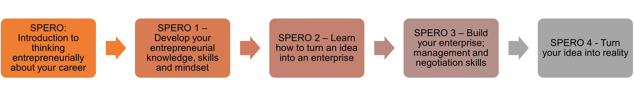

Research engagement via PPI
What is Patient and Public Involvement (PPI) and how to do PPI
Course Title: | Target learner: | Training point/s gained after completion: | Number of times the courses is delivered in the 22-23 academic year:
Facilitation: how to get the most out of your PPI activities | Doctoral researcher and research staff | 1 | 9
How to do PPI: focus groups and more | Doctoral researcher and research staff | 1 | 9
How to fill in the PPI section of grant form and write a lay summary | Doctoral researcher and research staff | 1 | 9
How to find patient partners, and keep them involved​ | Doctoral researcher and research staff | 1 | 9
Intro to PPI: what can PPI do for you? | Doctoral researcher and research staff | 1 | 9

Research communication via public engagement and impact
What is public and media engagement and how to generate research impact

Course Title: | Target learner: | Training point/s gained after completion: | Number of times the courses is delivered in the 22-23 academic year:
Engagement & Impact: An Introduction | Doctoral researcher and research staff | 1 | 1
Engagement & Impact: Co-creating with Creatives | Doctoral researcher and research staff | 1 | 1
Engagement & Impact: Evidencing Impact | Doctoral researcher and research staff | 1 | 1
Engagement & Impact: Inclusive Practice | Doctoral researcher and research staff | 1 | 1
Engagement & Impact: Introduction to Impact | Doctoral researcher and research staff | 1 | 1
Engagement & Impact: Planning for Impact | Doctoral researcher and research staff | 1 | 1
Engagement & Impact: Policy in Practice | Doctoral researcher and research staff | 1 | 1
Engagement & Impact: Teaching with Communities | Doctoral researcher and research staff | 1 | 1
Engagement & Impact: The Voluntary Sector | Doctoral researcher and research staff | 1 | 1
Engagement & Impact: Values for Involvement | Doctoral researcher and research staff | 1 | 1
Engagement & Impact: Evaluation | Doctoral researcher and research staff | 1 | 1
Introduction to volunteering for PGRs | Doctoral researcher | 1 | 3
Public Engagement (self-paced) | Doctoral researcher and research staff | 4 | Accessible all year
Public Policy (self-paced) | Doctoral researcher and research staff | 4 | Accessible all year

Possible learning paths for this section
Advanced
Beginner

Impact:
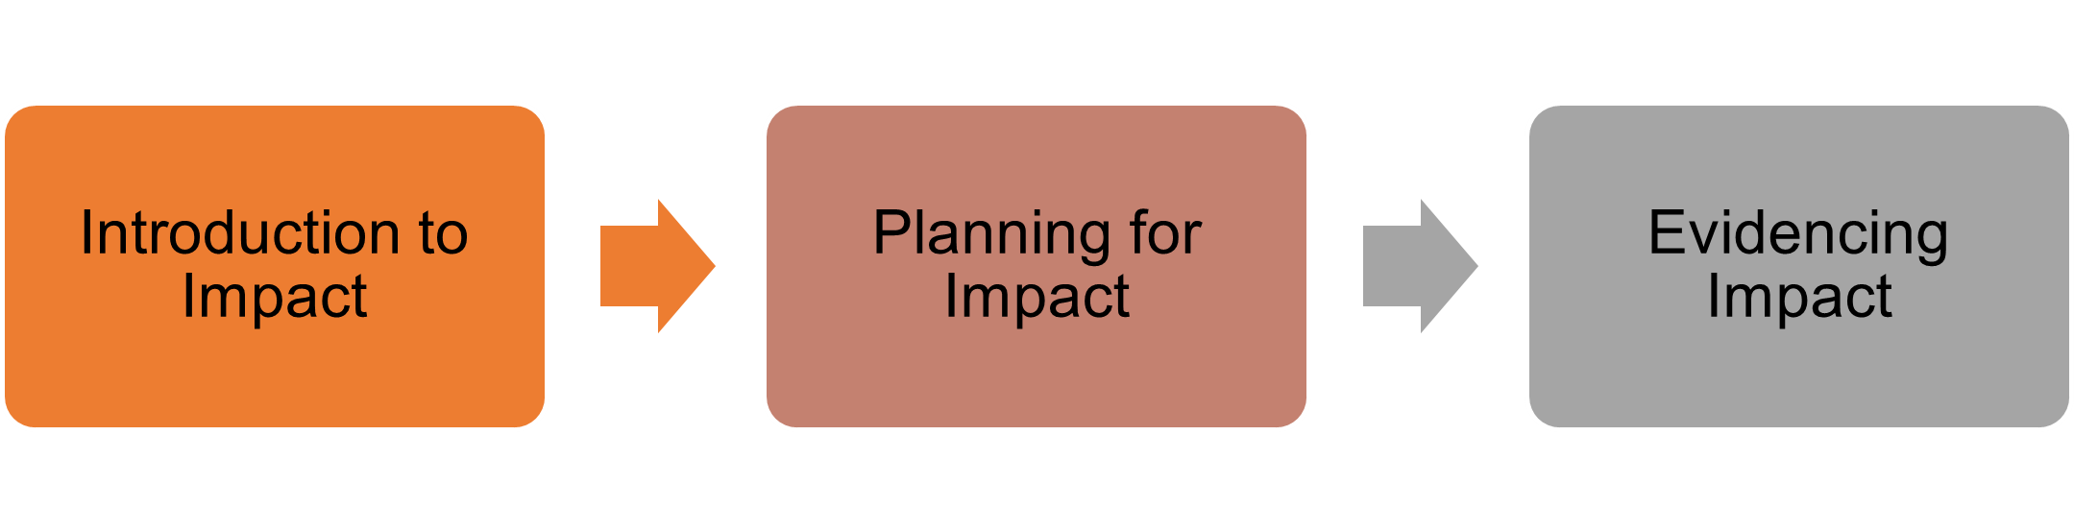

Engagement:

Research communication via writing and presentation
Strengthen writing, pronunciation and presentation skills to better communicate your research
Course Title: | Target learner: | Training point/s gained after completion: | Number of times the courses is delivered in the 22-23 academic year:
Presentation and public speaking
1:1 Coaching for Public Speaking | Doctoral researcher | 1 | 10
Introduction to Public Speaking | Doctoral researcher | 1 | 3
Voice Training: Specific Heat Capacity | Doctoral researcher and research staff | 1 | 3
Effective Presentations: Potential Energy | Doctoral researcher and research staff | 1 | 3
Nature Masterclass: Advancing your Scientific Presentations (self-paced) | Doctoral researcher and research staff | 1 | Accessible all year
Pronunciation
Pronunciation and Academic Discussions for Non-native speakers | Doctoral researcher | 9 | 4
Academic Presentations and Pronunciation for Non-native speakers | Doctoral researcher | 10 | 3
Writing
BioNews Writing Scheme | Doctoral researcher and research staff | 10 | 6
Introduction to Writing your PhD Thesis | Doctoral researcher | 17 | 3
Beyond "publish and perish": a strategic approach to building your research visibility in academia and beyond | Doctoral researcher and research staff | 2 | 3
The Writing Series: Abstracts | Doctoral researcher and research staff | 1 | 3
The Writing Series: Academic Writing Logic | Doctoral researcher and research staff | 1 | 3
The Writing Series: Book Proposals: A Practical Guide | Doctoral researcher and research staff | 1 | 1
The Writing Series: Business of Books: Contracts & Marketing Information | Doctoral researcher and research staff | 1 | 1
The Writing Series: Choosing a Journal | Doctoral researcher and research staff | 1 | 3
The Writing Series: Critical Thinking | Doctoral researcher and research staff | 1 | 1
The Writing Series: Delivering Your Manuscript | Doctoral researcher and research staff | 1 | 1
The Writing Series: Editing for Publication | Doctoral researcher and research staff | 1 | 3
The Writing Series: Editorial Workshop for Interview Series (self-paced) | Doctoral researcher and research staff | 1 | Accessible all year
The Writing Series: Finding Your Audience | Doctoral researcher and research staff | 1 | 1
The Writing Series: Guide to Editing Your Writing (self-paced) | Doctoral researcher and research staff | 1 | Accessible all year
The Writing Series: Healthy writing habits | Doctoral researcher and research staff | 1 | 4
The Writing Series: Literature Review | Doctoral researcher | 1 | 6
The Writing Series: Live Thesis to Publication Diary (self-paced) | Doctoral researcher and research staff | 1 | Accessible all year
The Writing Series: Maintaining Momentum | Doctoral researcher and research staff | 2 | 1
The Writing Series: Mentorship & Networks | Doctoral researcher and research staff | 1 | 1
Nature Masterclass: Narrative Tools for Researchers (self-paced) | Doctoral researcher and research staff | 1 | Accessible all year
The Writing Series: Peer Review | Doctoral researcher and research staff | 1 | 3
The Writing Series: Peer Review Process: Proposals & Manuscripts | Doctoral researcher and research staff | 1 | 1
Nature Masterclass: Focus on Peer Review (self-paced) | Doctoral researcher and research staff | 1 | Accessible all year
The Writing Series: Presenting Research Arguments and Findings | Doctoral researcher and research staff | 1 | 3
The Writing Series: Publishing & Publishers: The Inside Track | Doctoral researcher and research staff | 1 | 1
The Writing Series: Publishing Outside Academia | Doctoral researcher and research staff | 1 | 1
The Writing Series: Science and Publishing | Doctoral researcher and research staff | 1 | 1
Nature Masterclass: Scientific Writing and Publishing (self-paced) | Doctoral researcher and research staff | 1 | Accessible all year
The Writing Series: Self-Editing | Doctoral researcher and research staff | 2 | 6
The Writing Series: Voice in Narrative and Reflective Writing | Doctoral researcher and research staff | 2 | 3
The Writing Series: Weekly Writing Retreats | Doctoral researcher and research staff | 1 | 40
The Writing Series: Writing and publishing a research paper (self-paced) | Doctoral researcher and research staff | 2 | Accessible all year
The Writing Series: Writing PhD thesis impact statement | Doctoral researcher | 1 | 5
The Writing Series: Writing PhD thesis impact statement – 1:1 clinic | Doctoral researcher | 1 | 3
The Writing Series: Writing Style and Process | Doctoral researcher and research staff | 1 | 3
Preparing For Your Viva | Doctoral researcher | 2 | 3
Preparing for your Viva for Non-Native Speakers | Doctoral researcher | 2 | 4

Beginner
Advanced
Possible learning paths for this section
Presentation and public speaking:

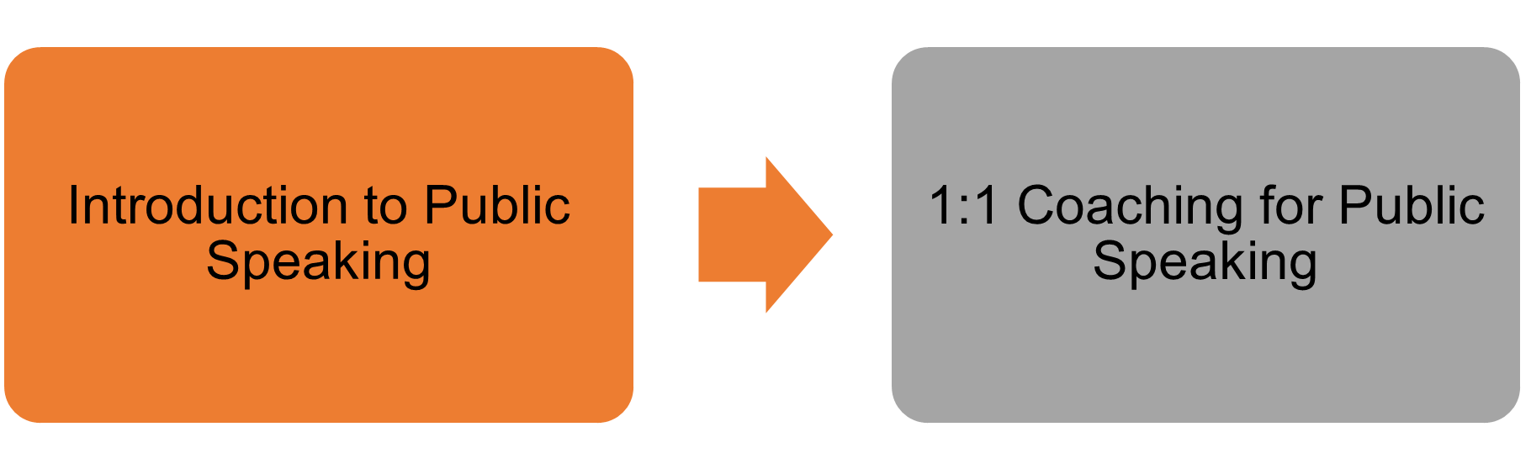

Pronunciation:
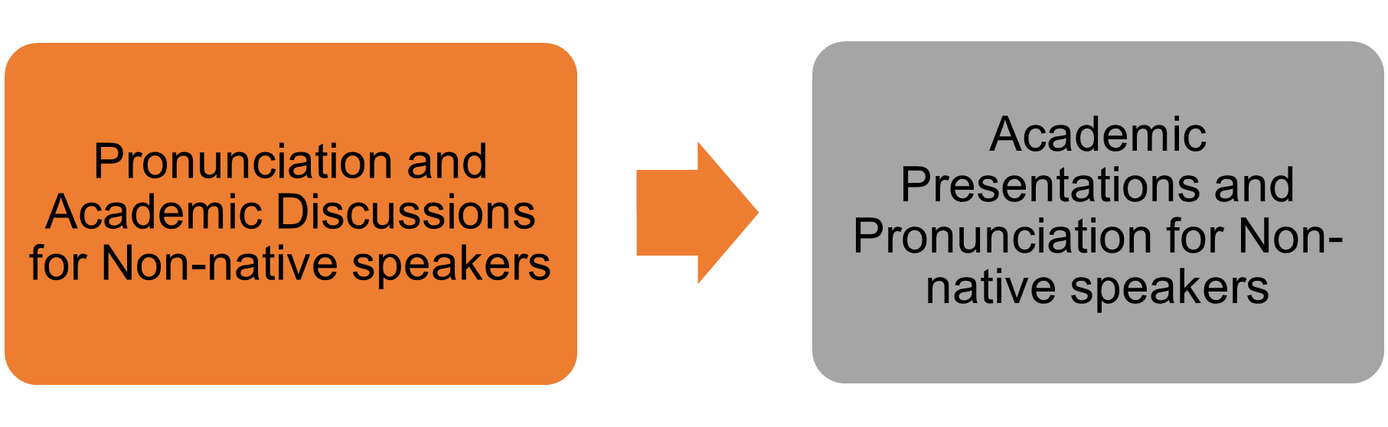

Writing techniques:
Advanced
Beginner
Possible learning paths for this section

Writing thesis (PhD):

Research leadership via teaching and supervision
Essential skills to teach, supervise, assess and support students' learning inside or outside academia
Course Title: | Target learner: | Training point/s gained after completion: | Number of times the courses is delivered in the 22-23 academic year:
Teaching
Arena for PGTAs: Gateway | Doctoral researcher | 1 | 18
Arena for PGTAs: Teaching Associate Programme | Doctoral researcher | 4 | 7
Arena for Postdocs | Research staff | N/A | 4
Intercultural Competency Project (self-paced) | Doctoral researcher and research staff | 1 | Accessible all year
IDEAs Workshop | Doctoral researcher and research staff | 1 | 6
Supervision
Developing as a UCL Research Supervisor | Research staff | N/A | 12
Effective Co-Supervision | Research staff | N/A | 2
Examining Research Doctorates | Research staff | N/A | 3
Supervising undergraduate and postgraduate taught students | Doctoral researcher and research staff | 1 | 3
Supporting PGR's Wellbeing | Research staff | N/A | 2
Supporting PGR's Writing | Research staff | N/A | 2
The Brilliant Club
The Brilliant Club: Communicating Complex Concepts to a Non-Expert Audience | Doctoral researcher and research staff | 1 | 1
The Brilliant Club: Engaging and Effective Online Delivery | Doctoral researcher and research staff | 1 | 1
The Brilliant Club: Information Session | Doctoral researcher and research staff | 1 | 3
The Brilliant Club: Planning Engaging and Interactive Sessions | Doctoral researcher and research staff | 1 | 1
The Brilliant Club: Succeeding at Assessment Centres | Doctoral researcher | 1 | 1

Possible learning paths for this section
Advanced
Beginner
Supervision (core skills):

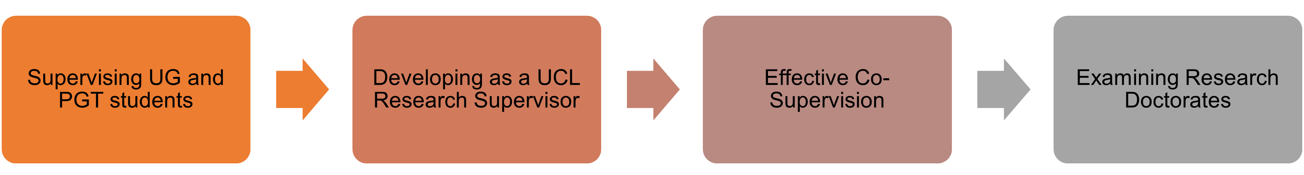

Supervision (enhancements):

Teaching:

A – Z self-paced courses:

Course Title: | Target learner: | Training point/s gained after completion:
Basic Statistics for Research (self-paced) | Doctoral researcher and research staff | 2
Critical appraisal of a randomised controlled trial for life and medical sciences students and early career researchers (self-paced) | Doctoral researcher and research staff | 1
Critical appraisal of qualitative research for life and medical sciences students and early career researchers (self-paced) | Doctoral researcher and research staff | 1
Essential search skills for biomedical databases (self-paced) | Doctoral researcher and research staff | 1
Handling Rare Books, Archives, Manuscripts and Records (self-paced) | Doctoral researcher and research staff | 1
Intercultural Competency Project (self-paced) | Doctoral researcher and research staff | 1
Introduction to EndNote: training activities (self-paced) | Doctoral researcher and research staff | 1
Introduction to Mendeley: training activities (self-paced) | Doctoral researcher and research staff | 1
Introduction to Special Collections (self-paced) | Doctoral researcher and research staff | 1
Nature Masterclass: Advancing your Scientific Presentations (self-paced) | Doctoral researcher and research staff | 1
Nature Masterclass: Data Analysis: Conducting and Troubleshooting (self-paced) | Doctoral researcher and research staff | 1
Nature Masterclass: Data Analysis: Planning and Preparation (self-paced) | Doctoral researcher and research staff | 1
Nature Masterclass: Effective Collaboration for Research (self-paced) | Doctoral researcher and research staff | 1
Nature Masterclass: Finding Funding Opportunities (self-paced) | Doctoral researcher and research staff | 1
Nature Masterclass: Focus on Peer Review (self-paced) | Doctoral researcher and research staff | 1
Nature Masterclass: Interpreting Scientific Results (self-paced) | Doctoral researcher and research staff | 1
Nature Masterclass: Managing Research Data to Unlock its Full Potential (self-paced) | Doctoral researcher and research staff | 1
Nature Masterclass: Narrative Tools for Researchers (self-paced) | Doctoral researcher and research staff | 1
Nature Masterclass: Networking for Researchers (self-paced) | Doctoral researcher and research staff | 1
Nature Masterclass: Persuasive Grant Writing (self-paced) | Doctoral researcher and research staff | 1
Nature Masterclass: Scientific Writing and Publishing (self-paced) | Doctoral researcher and research staff | 1
Open Science and Scholarship (self-paced) | Doctoral researcher and research staff | 1
Public Engagement (self-paced) | Doctoral researcher and research staff | 4
Public Policy (self-paced) | Doctoral researcher and research staff | 4
Referencing and avoiding plagiarism (self-paced) | Doctoral researcher | 1
Research Integrity at UCL (self-paced) | Doctoral researcher and research staff | 1
Search strategies for literature searching (self-paced) | Doctoral researcher | 1
Searching for systematic reviews: introduction (self-paced) | Doctoral researcher and research staff | 1
Sources of socio-economic data (self-paced) | Doctoral researcher and research staff | 1
The Writing Series: Editorial Workshop for Interview Series (self-paced) | Doctoral researcher and research staff | 1
The Writing Series: Guide to Editing Your Writing (self-paced) | Doctoral researcher and research staff | 1
The Writing Series: Live Thesis to Publication Diary (self-paced) | Doctoral researcher and research staff | 1
The Writing Series: Writing and publishing a research paper (self-paced) | Doctoral researcher and research staff | 2
Transparency in Research (self-paced) | Doctoral researcher and research staff | 2
Using and understanding bibliometrics (self-paced) | Doctoral researcher and research staff | 1
Writing Data Management Plans (self-paced) | Doctoral researcher and research staff | 1

The research staff journey shows an alternative route with the dotted lines

