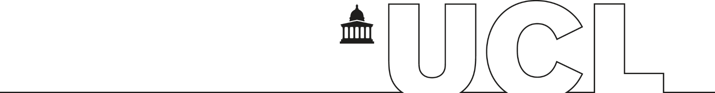
UCL HUMAN RESOURCES DIVISION
Form: PLN(V)

Shared Parental Leave
Period of Leave Variation Notice
Please complete the details below confirming your intention to take a period of Shared Parental Leave.
UCL Employee Personal Details
Surname: | Forenames:
Email: | Tel:
UCL Employee Number:
UCL Department / Division
Line Manager:
Confirmation of Entitlement:
I confirm that my partner and I continue to be entitled to take shared parental leave, as previously declared.
Requested variation to shared parental leave:
Please note to change any period of leave, 8 weeks of notification must be given.
By submitting this variation request, you will forfeit any right to enhanced pay and will receive only statutory pay.
I intend to vary my period of Shared Parental Leave and to take it as follows:
 |  | No of weeks | Running total of weeks
Start date | End date
Start date | End date
Start date | End date
Intended final date of return to work:
My partner will be taking shared parental leave as follows
 |  | No of weeks | Running total of weeks
Start date | End date
Start date | End date
Start date | End date
Details:
Please provide any additional details in relation to your shared parental leave, including the sharing of pay if, for example, you are taking leave at the same time:
Declaration:
Employee Signature:
Dated:
Received and approved:
Line Manager:
Dated:
Please forward a copy to your Departmental Manager/Administrator and pass to HR Services promptly.

Employment Contracts Administration Team

