Coronavirus/ COVID-19 absence recording - guide for employee self-service
This guide is for employees who are requesting paid sick leave, Special Leave or Carer’s Leave because of the Coronavirus/ COVID-19 outbreak. Please request COVID-19-related paid sickness absence on MyHR when you return to work. Records should be kept locally in the meantime.

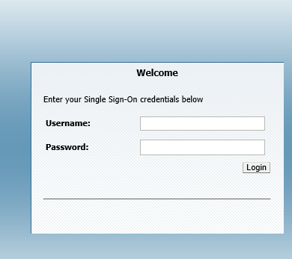
Step 1: Log into MyHR using your UCL user ID and password.

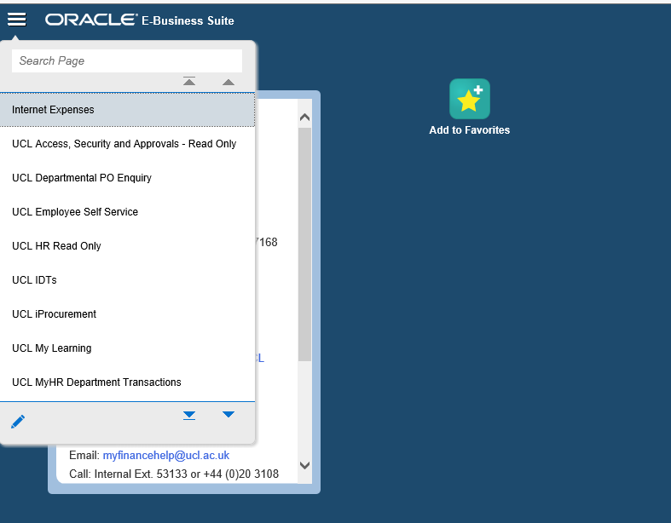
Step 2: Select the Menu icon (the three horizontal lines) in the top left hand corner of the screen.
Step 3: Click UCL Employee Self Service from the drop down menu. A new list of options will appear. Click My Absence and then Absence Management.
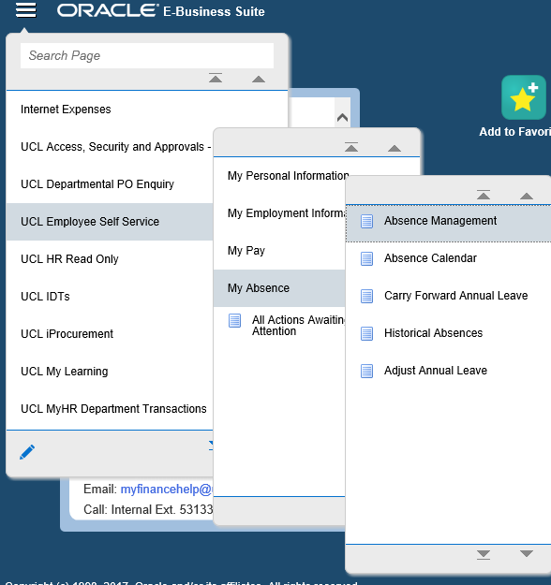

Step 4: You will be redirected to a new window where you should click on Create Absence on the left hand side.

Step 5A: To request paid sickness absence
For Coronavirus/ COVID-19 related sickness you will need to select Paid Leave in the drop-down menu for Absence Type and Sick leave related to Coronavirus in the drop-down menu for the Absence Reason. Once you have filled out the other details, such as the relevant dates for this sickness, click Next in the top right hand corner of the screen. This will redirect you to a confirmation page where you can request your leave.
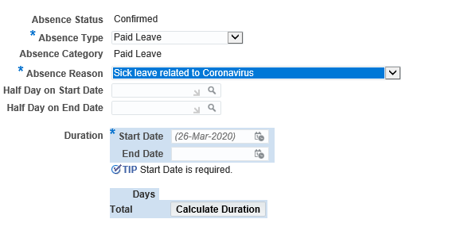

Step 5B: To request special leave where you are unable to work remotely
For Special Leave, you will need to select Paid Leave in the drop-down menu for the Absence Type and Special leave related to Coronavirus as unable to work remotely in the drop-down menu for the Absence Reason. Once you have filled out the other details, such as the relevant dates for this Special Leave, click Next in the top right hand corner of the screen. This will redirect you to a confirmation page where you can submit your request.
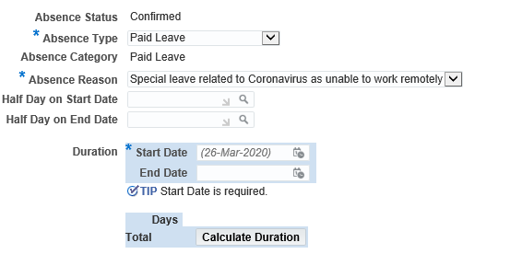

STEP 5C: To request Carer’s Leave
For Carers’ Leave, you will need to select Paid Leave in the drop-down menu for the Absence Type and Carers’ Leave in the drop-down menu for the Absence Reason. Once you have filled out the other details, such as the relevant dates for this Carers’ Leave, click Next in the top right hand corner of the screen. This will redirect you to a confirmation page where you can submit this request.
