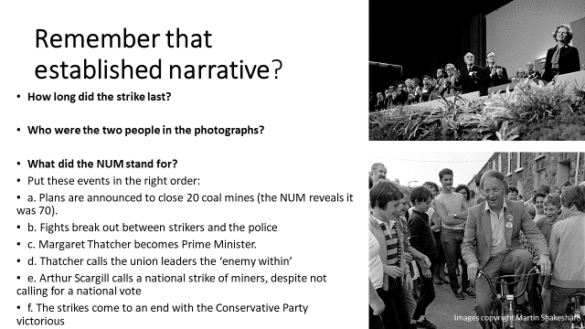

Slides 1 and 2: revisit the established narrative one more time to ensure it is secure – every pupil will need it to be secure so they can make judgements about the relationship between it and the oral accounts.

Slide 3: reminder of the overall enquiry and emphasis that today will involve answering the question they have had in mind throughout.

Slide 4: hand out the worksheet for the lesson and put pupils into groups of 4-6 (there must be at least four different women’s accounts within the group). The pupils are going to introduce their interviewed women to the group, so as to give life to the names that they will be discussing for the rest of the lesson.

Slide 5: thus far the pupils have conducted a really nice research project and found out some information about the women who experienced the strikes. This phase of the lesson is where these oral histories are analysed for what they can tell historians. There are three criteria for the pupils to grapple with, each of which is integral to a historian grapple with oral testimony:

* Oral historians ask how the interview **complicates** the established narrative
* Oral historians think about the intersubjectivity of the interview to see which questions were asked and when. You could explain intersubjectivity as interactivity if it is easier for your pupils to grasp.
* Oral historians analyse the **fallibility** of the interviewee in a positive way to see what issues of memory, perspective, context tell us about what they are saying.

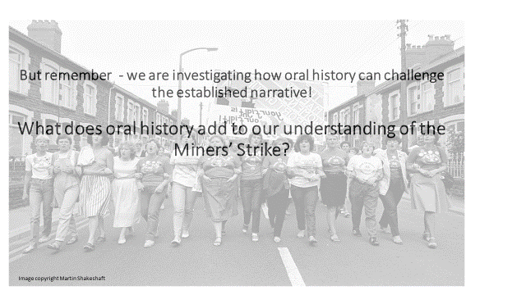

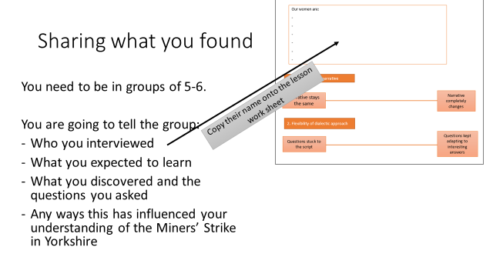

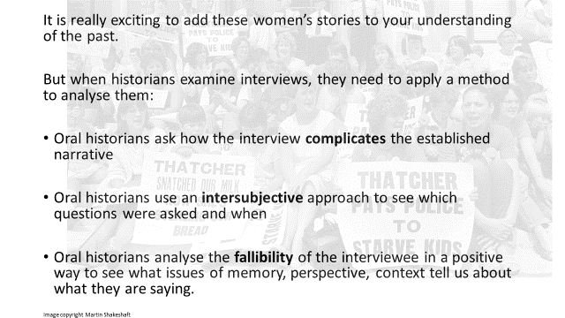

Slide 6: with this in mind, the pupils, still in their groups, need to discuss their interviewed women against these three criterion. For each one they need to discuss how far the interview they conducted revealed a woman’s experience that ‘complicated the established narrative’. On one end of the spectrum the narrative completely changes – so this might involve the women playing a major role in the strikes, or a role that hadn’t been mentioned in their lessons before, or some powerful insight into what it was like to actually live through the strikes. On the other end of the spectrum, the interviewed woman’s account might keep the narrative the same if she revealed her husband was really annoyed for a year and she supported him through domestic work.

It would be really interesting to take a range of feedback on this to start building up a picture of complexity and diverse experience.

If you did the **alternative homework** from lesson 2, you can instead tailor this activity so it revolves around the interview clip(s) pupils listened to at home.

Slide 7: the second criteria involves evaluating the methodological approach (which might be new to many KS3 pupils). The pupils have to discuss the intersubjective approach because oral history is dependent on knowing what the historian wanted to find out, what questions they asked, and what lines of enquiry they began to pursue one the interview was talking. In order to support the pupils with this, the spectrum is simply: questions stuck to the script – questions kept adapting to interesting answers.

Again this would raise some really interesting classroom discussion afterwards – like how the varying approaches led to different sorts of testimony and emphasises.

Slide 8: this is by far the most complicated thinking that the pupils will have to engage with thus far, and something that might be completely alien to them. With oral history, interviewees will often forget things or make factual errors and it is the job of the historian to try and analyse what the fallibility of the interviewee tells us about the history.











It is worth giving them some really concrete examples of this. A simple example might be: if your interviewee said that the government actions completely ruined their lives, yet the interviewer knows that actually the interviewee had many nice moments after the 1985 and/or found employment elsewhere etc, then their memory of events might tell the historian a little bit about the way the strike is remembered within the community.

Give the difficulty in tackling this, it might be worth doing it as a whole group.

Slide 9: finally a chance to bring everything together and see what the pupils took from this sequence as a whole. By answering the overall enquiry question, the pupils are encouraged to draw upon the substantive knowledge of the past (including the oral testimony) as well as the methodological approach they undertook.

Hearing some answers will be really interesting if there is time.

Slide 10: in order to make this sequence as powerful as possible within the school community, a final suggestion is to turn the accounts of these women into a display. The display might include images and quotes from the established narrative, but also for homework (or in a history club) pupils have to choose one extract from their interview to include on the display and to justify why. These oral histories could then be added to the display to show the power of oral history in complicating an established narrative.