Why did the strike begin?

_____________________________________________________________________________________________________________________________

Who was the Prime Minister who wanted to close the mines?

_________________________

Why did she want to close mines?

___________________________________________________________________________

Who was the leader of the strike? _________________________

Why did the government call the strike illegal?

___________________________________________________________________________

Why was there high levels of violence?

____________________________________________________________________________________________________

Why did the strike come to an end?

____________________________________________________________________________________________________

The coal mining industry was traditionally one of the most important parts of the British economy. Government statistics show that in 1920, over one million people (nearly all men) worked in coal mines. By the 1970s this had fallen to 247,000 – but still whole communities in big areas like Yorkshire and Wales were utterly dependent on the coal mines for employment.

When Margaret Thatcher became Prime Minister in 1979, as leader of the Conservative Party, she had two aims with the coal mines: to reduce the money the government spent on running them and to reduce the power of the trade unions who represented the workers in the mines. In 1984, the government announced that 20 mines would close; however the National Union of Miners (NUM - above) revealed the plan was actually to close 70 (nearly half).

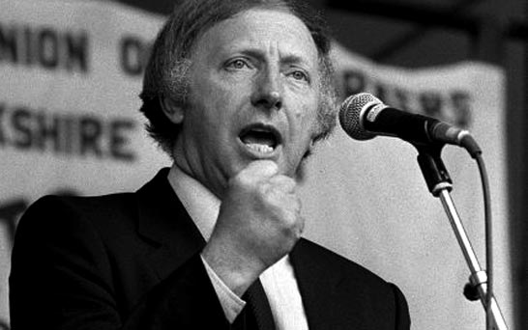

The NUM leader, Arthur Scargill (above), called for a national strike. He did not ask all miners to vote on whether they wanted to go on strike – partly because when they had voted in the early 1980s, the majority of miners did not want to go on strike as it meant they did not get paid. On 6 March 1984, several mines in Yorkshire went on strike. Other mines across the country followed suit.

Margaret Thatcher believed the strikes were illegal because the NUM and Scargill had not achieved 50% of miners’ approval in a national vote of all NUM members. Thatcher even called Scargill and the Trade Union leaders: ‘the enemy within’. Thatcher encouraged as many miners as possible to ignore the strike and go to work – she sent lots of police to try and protect the miners who did not want to strike. This led to several high profile fights at picket lines (places outside the mines where strikers would go to protest). Most of the national newspapers agreed with Thatcher and published stories and headlines that attacked the strikers and Scargill. The news was full of stories of violence.

As the strike continued, the strikers ran out of money. Their wives and girlfriends often had to support them, or raise money for their striking. On 3 March 1985, a year later, the miners returned to work. Thatcher and the government now felt confident to close mines and limit the power of trade unions. By 2009, there were only six coal mines left open in the UK.