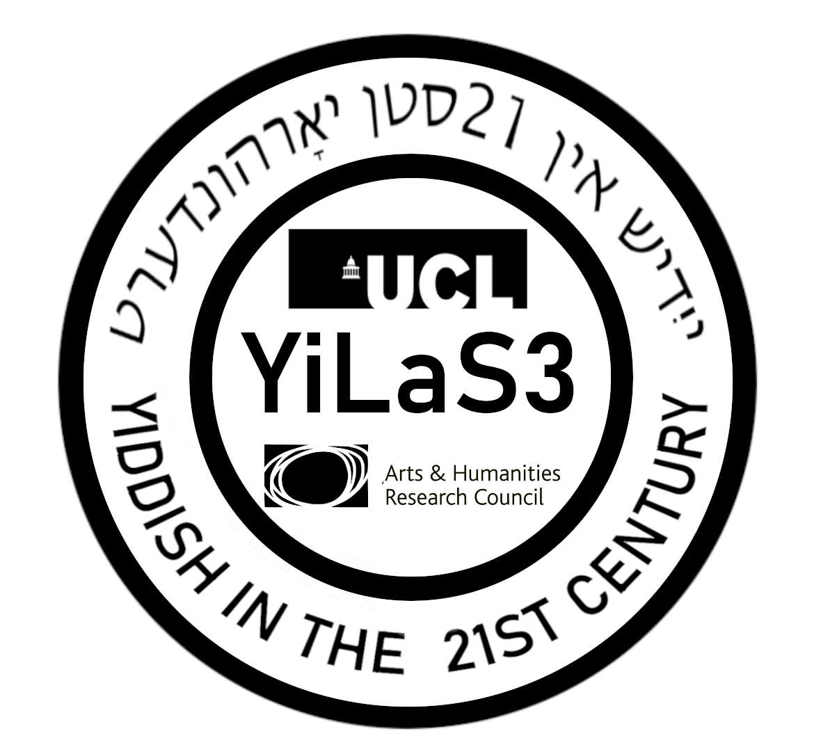
YiLaS 3: Yiddish in the 21st Century International Conference
University College London
27-29 March 2023

All talks take place at UCL, Malet Place Engineering Building, Room 1.03. Enter UCL Main Campus from the Gower Street entrance.

Monday 27 March 2023
08:45 – 9:45 Registration (Malet Place Engineering Building, Room 1.20)
09:45 – 10:00 Welcoming Remarks
10:00 – 11:00 Keynote: Lea Schäffer, Philipps University of Marburg
Dynamics of Yiddish Dialects

11:00 – 11:30 Coffee Break (Room 1.20)
11:30 – 13:00 Panel 1: Sociolinguistics
- Ilya Uchitel, Friedrich Schiller University Jena
The Media as a Diachronic Language Vitality Index: the Cases of Yiddish in the USSR and the US in 20th and 21st Centuries
- Esther Jahns, Carl von Ossietzky University of Oldenburg
The Role of Yiddish in the Linguistic Repertoire of German-Speaking Jews in Contemporary Berlin
- Sonya Yampolskaya, University College London; University of Haifa
Hebrew-Yiddish Diglossia: Past and Present
13:00 – 14:30 Lunch Break
14:30 – 16:40 Panel 2: Language Contact
- Dalit Assouline, University of Haifa
The Borrowing of Hebrew Verbs in Israeli Hasidic Yiddish
- Steffen Krogh, Aarhus University
Germanisms in Spoken Eastern Yiddish
--short break--
- Tamara Gleason Freidberg, University College London / Anayeli Hernández Cruz School of Anthropology and History of Northern Mexico
Cultural Adaptations: Yiddish and Spanish as Key Resources in the Process of Adaptation and Integration of Ashkenazi Immigrants to Mexico
- Ber Kotlerman, Bar Ilan University
לשון-קודשדיקע ציטאטן אינעם סאָוועטישן ייִדיש: דער פּרעצעדענט פון נתן זאבארע [Hebrew-Aramaic Quotations in Soviet Yiddish: Natan Zabara's Precedent]
16:40 – 17:00 Coffee Break (Room 1.20)
17:00 – 18:00 Public Lecture: Rebecca Margolis presenting her new book Yiddish Lives On: Strategies of Language Transmission
20:00 – 21:30 Yiddish Cabaret with Mendy Cahan (UCL, Main Campus, Wilkins Building, Haldane Room)
Tuesday 28 March 2023
10:00 – 13:40 Panel 3: Hasidic Yiddish
10:00 – 11:00 Chaya Nove, University of California, Berkeley
דער חסידישער צוגאנג צו שפראך אמאל און הײנט[The Hasidic approach to language in the past and present]

11:00 – 11:30 Coffee Break (Room 1.20)
11:30 – 13:40
- Shmuel Hiley
An Overlooked Feature in Yiddish Phonology
- Athina Vasileiadou, London Borough of Redbridge: Department of Education and Inclusion
First Language Acquisition of Yiddish Morpho-syntax: an Empirical Study on the Acquisition of Subject-Verb Agreement and Verb Placement in the Spontaneous Speech of Yiddish-Speaking Toddlers
--short break--
- Noah Ley, University of Edinburgh
The Case of Self-Identity and Cultural Pluralism: How Do Yiddish Speakers Use Language to Construct Their Identity in Contrasting Domains
- Eli Benedict, League for Yiddish
שפראך־אידיאלאגיע: צווישן ליטווישע און חסידים [Language ideology: between Litvish and Hasidish]
13:40 – 15:00 Lunch Break
15:00 – 16:00 Panel 4a: Yiddish Pop Culture
- Zehavit Stern, Tel Aviv University
הללויה ייִדיש? אָפּשפּילן ׳דרך הש״ס׳ אין אַ גלאָבאַלער סביבה [Halleluja Yiddish? – Performing “The Talmudic Path” in a Global Environment]
- Sarah Bunin Benor, Hebrew Union College
Jewbellish and YidLife Crisis: Contemporary Engagement with Yiddish
16:00 – 16:30 Coffee Break (Room 1.20)
16:30 – 17:30 Panel 4b: Yiddish Pop Culture
- Rebecca Margolis, Australian Centre for Jewish Civilisation
די ייִדישע שפּראַך אויף דעם אַמעריקאַנער עקראַן [The Yiddish language on the American screen]
- Mendy Cahan, YUNG YiDiSH Library and Cultural Centre, Tel Aviv, Israel
Yiddish in Israel today: the story of YUNG YiDiSH
19:00 – 22:00 Special Conference Dinner: A Tish with Ashkenazic food from Stamford Hill (UCL, Main Campus, Wilkins Building, Haldane Room)
Wednesday 29 March 2023
10:00 – 11:00 Keynote: Isaac Bleaman, University of California, Berkeley
Contemporary and Historical Perspectives on Sociolinguistic Variation in Yiddish

11:00 – 11:30 Coffee Break (Room 1.20)
11:30 – 14:00 Panel 6: Syntax
- Zoë Belk, University College London
Negative Concord in Contemporary Hasidic Yiddish
- Isaac Bleaman, University of California, Berkeley / Georg Höhn, Georg August University of Göttingen; Humboldt University
Definiteness Type as a Predictor of Preposition-Determiner Interactions in a Yiddish Corpus
---short break---
- Moshe Taube, Hebrew University of Jerusalem
טענות-ומענות: ווי אַזוי טענה׳ט מען זיך אויס אף יידיש [Argumentative clauses in Yiddish]
- Simon Neuberg, University of Trier
דעם סינטַאקס צו אַרומרעדן [An examination of the syntax of the particle tsu]
Lightening Talks
- Daniel Boukhny, Yiddish Bivalent Verbs from an Areal Perspective
- Izzy Posen, Teaching physics in Hasidic Yiddish

14:00 – 15:00 Lunch Break
15:00 – 16:00 Closing Roundtable with coffee: Yiddish in the 21st Century
16:00 – onwards Walk in Stamford Hill

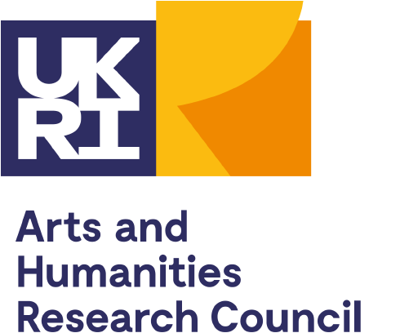

This conference is funded by a UKRI AHRC grant for the research project Contemporary Hasidic Yiddish and held at UCL in association with the Jewish Language Project and our long-term partner YUNG YiDiSH Tel Aviv.

