Title: Developing tools and technique for minimally invasive implantation of a novel neuromodulation device to control the bladder following neurological injury
Supervisors: Dr Tacson Fernandez, Dr Lynsey Duffell, Dr. Anne Vanhoestenberghe, Dr. Sean Doherty
Proposed Length: 8 weeks (The project can be completed remotely if required)
Expected outcome: Design specifications and initial prototypes of a minimally invasive implantation tool (introducer) to facilitate the implantation of a novel stimulation device.
Background:
Neurogenic detrusor overactivity (NDO) is common post spinal cord injury (SCI). NDO is characterised by involuntary detrusor (bladder wall muscle contractions whilst storing low volumes of urine causing a sudden release of urine and dangerously high pressures in the kidneys. Initial treatment for NDO is antimuscarinic medication; however this presents systemic side effects and has limited efficacy leading to low 1 year persistence rates of only 12-25% [1]. More invasive options include regular injections of Botox into the bladder wall and open surgery where a segment of bowel is used to enlarge the bladder.
Stimulation of the sensory nerves that feed into the sacral spinal cord has a suppressive effect on the bladder and may be used to treat severe detrusor overactivity and restore continence. Neuromodulation may be achieved by invasive electrical stimulation of the nerve roots close to the spinal cord [2] or by non-invasive stimulation of specific distal branches, the dorsal genital nerve [3]. Both have been investigated with success at UCL and RNOH yet come with drawbacks of either being too invasive or being difficult to apply on a daily basis. A minimally invasive solution, targeting the relatively superficial genital nerve close to the pubic bone, may overcome the limitations, allowing patients and urologists to apply an effective solution in surgery lasting minutes rather than hours. For a device to be safely implanted in a minimally invasive way, there is a need for a new introducer to facilitate implantation of a suitable electrode for this part of the body. To do this, I propose a series of requirements gathering exercises and prototype design activities within this project as outlined below.
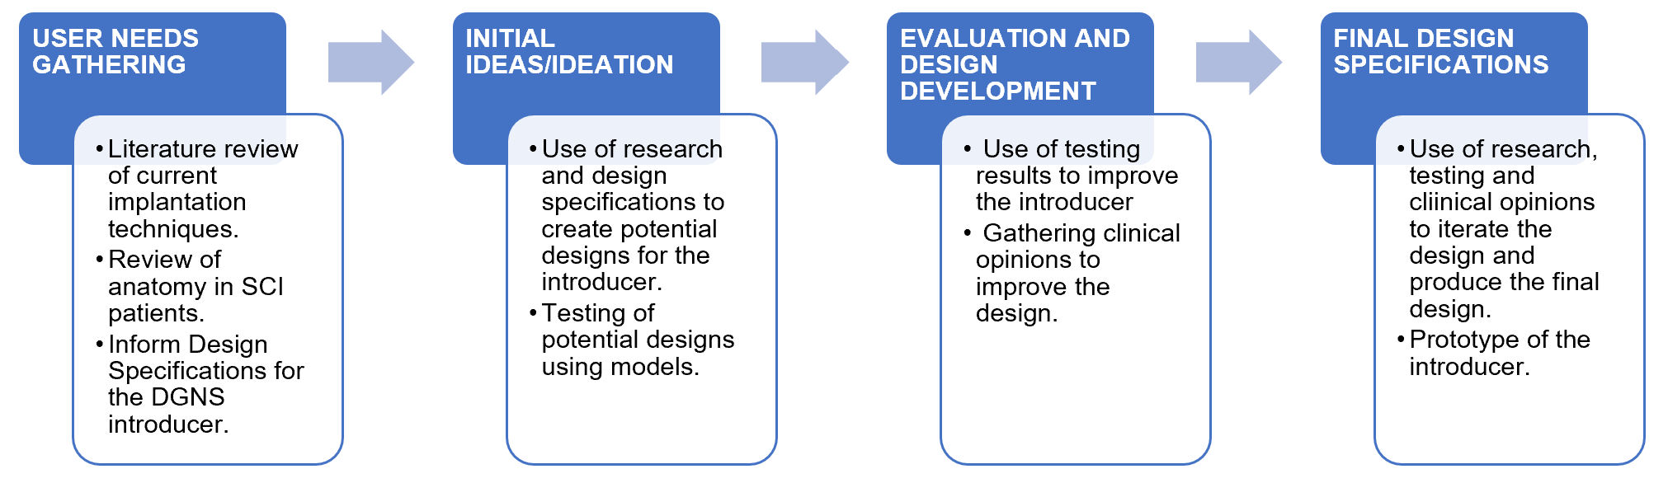
Aim: Research into surgical techniques for implantation and pelvic anatomy in spinal cord injury (SCI) patients will inform the design specifications of an introducer for a novel stimulation implant. Using this research, the project aims to develop a potential design and iterate it based on clinical opinions from experts in the field and results from testing using models to produce a final prototype of the introducer.
Skills: The medical device design process relies on traceability from user needs to end product, this project will provide practical experience of the research involved in several of these key steps. It will provide experience of interfacing as an engineer with clinical colleagues and in design development.
- Yeowell, G. et al. Real-world persistence and adherence to oral antimuscarinics and mirabegron in patients with overactive bladder (OAB): A systematic literature review. BMJ Open 8, e021889 (2018).
- Kirkham, S. Knight, M. Craggs, et al. Neuromodulation through sacral nerve roots 2 to 4 with a finetech-brindley sacral posterior and anterior root stimulator. Spinal Cord, 40:272–281, 2002
- Doherty SP, Vanhoestenberghe A, Duffell L, Hamid R, Knight SL. Ambulatory urodynamic monitoring assessment of dorsal genital nerve stimulation for suppression of involuntary detrusor contractions following spinal cord injury: a pilot study. Spinal Cord Ser. 2020: 6(30).

