UCL BEng Summer Project 2021
Project Title:
The use of 3D printed anatomical models to aid surgical planning of hip replacement.
Academic Supervisor: Dr Anna Di Laura, Implant Imaging Fellow, anna.dilaura@nhs.net

Clinical Supervisor: Mr Johann Henckel, johann.henckel@nhs.net

2nd Clinical Supervisor: Professor Alister Hart

Location: Surgical Technology Laboratory, Royal National Orthopaedic Hospital, Stanmore

Background to project
Complex elective surgery requires detailed pre-operative evaluation, expensive intra-operative equipment, and meticulous surgical technique. Medical imaging constitutes the starting point of this all and has historically been limited to 2D media such as textbooks and computer screens. Shape, depth and relative size cannot be comprehended on the computer screen.
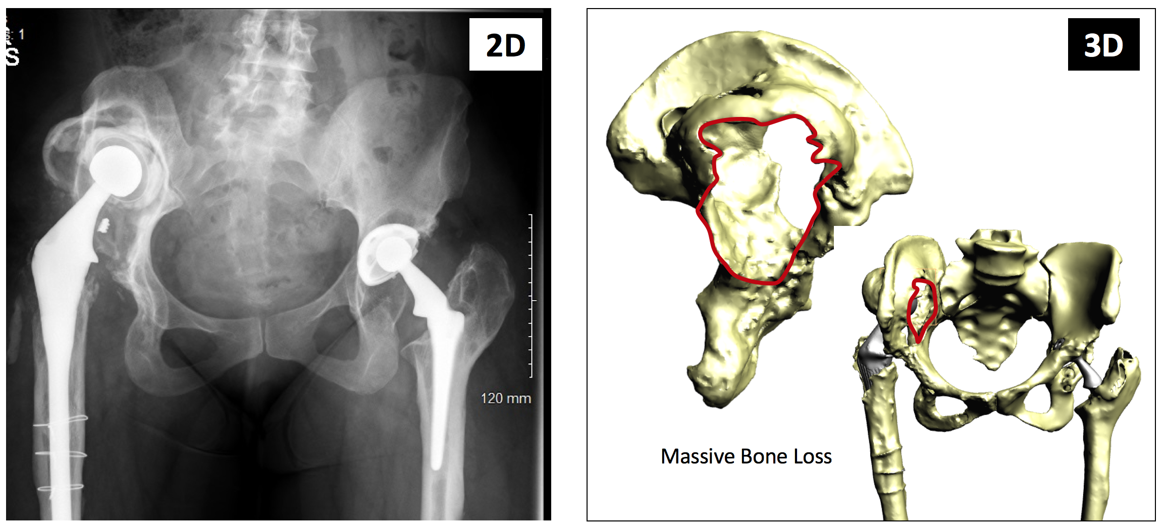

Fig 1. Shows pre-operative X-Ray of patient with massive acetabular defect and superiorly migrated implant on the right side (left image) and the 3D reconstruction of the pelvis from CT scan showing the defect (right image).

Three-dimensional (3D) printing of real-sized human models provides a realistic tool to aid planning and execution of the surgical plan. The surgical management of congenital bone deformities and significant bony deficiencies in hip reconstruction is challenging even for the most experienced orthopaedic surgeon. Complex surgery requires detailed pre-operative evaluation, intra-operative inventory, planning and meticulous delivery.
3D printing is becoming increasingly important in surgery. Although the use of 3D printed human models has been showed to increase the understanding of pathological conditions, there is little evidence to demonstrate that the use of 3D printed anatomical models by surgeons improves patient outcome and secondly there has been no evidenced-based adoption in complex, elective orthopaedic surgery.

Project Aim: To better understand patient outcome from the use of 3D printed physical models aiding surgical planning and execution.

Methods: Radiological assessment of surgical outcome by means of pre-op and immediate post-op 3D image analysis (planned Vs achieved) of implant position and orientation.

The student will be given the opportunity to attend two out-patient clinics (COVID-19 permitting) and offered a virtual visit to the operating theatres.
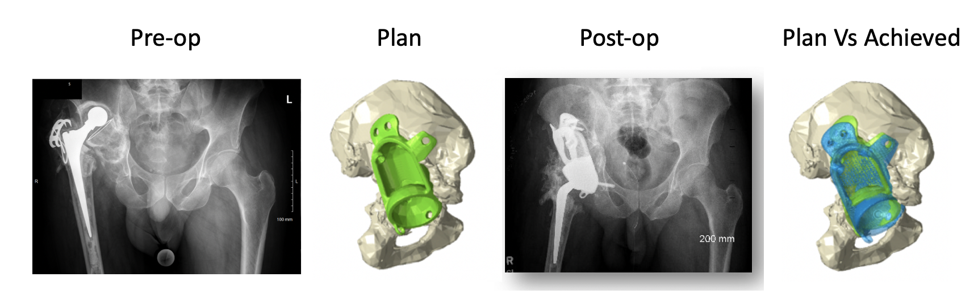
Fig 2. Shows pre-operative X-Ray of patient with massive acetabular defect and superiorly migrated implant on the right side, 3D reconstruction of the hemipelvis pelvis and implant designed for the patient in planned position; post-operative X-Ray and 3D reconstruction of the hemipelvis showing planned and achieved implant position (from left to right).

Potential impact of the project
The impacts of the project include i) better patient outcome due to an increased quality of surgical planning; ii) better surgical outcome due to a decreased risk of intra-operative complications; iii) improved patient explanation of musculoskeletal conditions.

Proposed Work Plan

Week 1: Literature search on the background work to this subject (remote supervision)
Week 2&3: Software training for segmentation of medical CT & 3D printing of bony anatomy (face to face)

Week 4-6: Collection of data & attend out-patient clinics (Covid-19 secure)

Week 7: Analysis of all results & remote operating theatre visit (remote supervision)

Week 8: Writing up of report (remote supervision)

