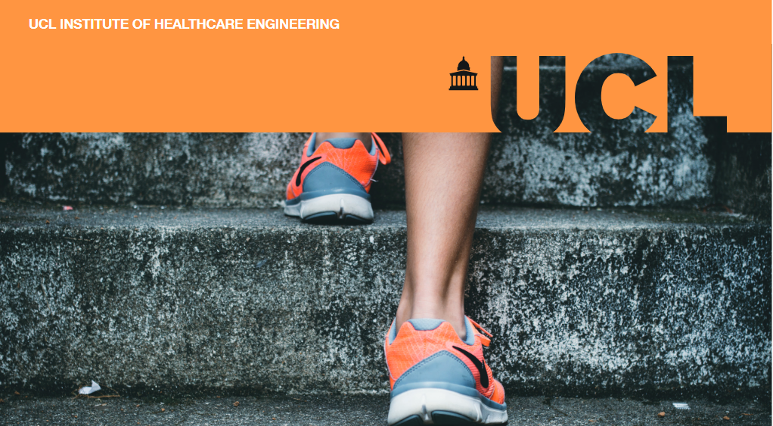

Sustaining Physical Activity

Why is it important to sustain physical activity across our lifetimes?
Physical activity (PA) plays a major role when it comes to the promotion of a healthy lifestyle. Physical inactivity is considered one of the leading causes of death worldwide (1). However, around 39% of UK adults are still failing to meet Government recommendations for PA (2), and the numbers look even worse when we consider older adults or the poorest quintile of the population (3).
PA is linked to increased life expectancy, and better quality of life. For example, there is an increased risk of cancer, heart disease, stroke and diabetes in people with higher amounts of sedentary behaviour (5). Additionally, PA also has a positive impact on mental health (6), and balance and functional exercises have shown to reduce the rate of falls by 24% (7).
In order to better design policies and interventions that lead to sustained behaviour change, and increased PA throughout life, there is a need to understand people’s relationship with PA. In particular, what motivates or prevents them from being more active.

Why now?
The COVID-19 pandemic has disproportionately impacted older people. Measures such as “social distancing” and “self-isolation” forced a lifestyle change which, in most cases, resulted in a reduction of PA. During lockdown one in five 50-70 year olds said their physical health had worsened (8). This can be easily linked to a reduction of incidental and planned PA such as participation in community activities and structured exercise. It is important to explore how much physical function older adults have lost during the pandemic.

On the other hand, the coronavirus crisis has raised the profile of PA (for example two thirds of adults in the UK consider PA more important now than before the pandemic (9)). There is a ‘window of opportunity’ to build on this increased interest and design strategies to both boost PA in those people whose levels of activity were low and to sustain new good habits that were acquired during lockdown.

About this briefing
An expert community from Government and its agencies, the health and social care sectors, charities and academia were invited to come together for a co-development workshop to identify research questions of interest to both the policy and the research communities. Participants identified three big challenges in this space, and three research questions that could help to understand and address inactivity in older adults.

Challenge 1: How do we tailor initiatives to encourage behaviour change?
- What are people’s perceptions of PA and how do these change throughout a person’s life?
- How do social and cultural factors affect PA?
- What are the motivations for behaviour change in relation to PA?
Workshop participants recognised that tailored interventions are likely to be needed to encourage behaviour change. To do this, we need to build a better understanding of users.
Participants suggested studying how perceptions of PA might change throughout a person’s life. There are a lot of misconceptions around what constitutes PA (for example, in older adults it tends to be less structured, and includes activities such as walks and gardening, whereas younger people tend to relate PA with a sport).
A second area for further investigation was to build an understanding of the barriers that exist to PA and how these might vary according to age or cultural background. For example, in some cultures there is bias that we should relax as we get older (10). There are also significant differences in levels of activity between countries, (11)
Finally, there is the need to map out the motivators for behaviour change across different age groups to get a better understanding of what these are and how they can be used to encourage behaviour change to make PA appealing.

Challenge 2: How do you improve the design of research to provide the data for evidence-based strategies?
- How can we ensure data sets are more inclusive and representative?
- How can we harmonise data by standardising measurement methods?
- How can we best pool data?
Participants noted that research studies around PA have tended to focus more on some groups of people than others. Minority ethnic groups in particular were highlighted as a group that were not adequately represented by the research. Research that focuses on groups that are currently under-represented in existing datasets would help in the design of better targeted policies.
Participants highlighted the need to investigate how measurement methods can be standardised across studies to build on the pool of knowledge. This would maximise the impact of comparative studies on what works in different settings and allow us to learn from smaller scale interventions around the country, for example in care homes, and then scale up those interventions to the rest of the population.
There are also opportunities for better data that could be achieved through improving linkages between different datasets. For example, studying the relationship between PA and the Hospital Episode Statistics (HES) database, which details all admissions, A&E attendances, and outpatient appointments at NHS hospitals in England.

Challenge 3: How can we measure and track physical activity?
- How do we study sedentary behaviour?
- How could we use PA data from wearables across different stages of life?
- How can we measure strength and balance training?
Measuring and tracking PA is a global challenge, but it is even more difficult in older adults because of the volume of movement for non-traditional sports and activities they are more likely to do (for example, gardening). Workshop participants emphasised the importance of studying sedentary behaviour, but further thinking is needed about how this might be done in practice (for example, it is difficult to measure inactivity).
One option is to make use of the numerous wearable products and wellbeing services that are on the market. Harmonising data from wearable devices and improved capture of movement from non-traditional sports and activities could be very useful in understanding PA. The issue is that these products are rarely targeted at older consumers. This results in a lower uptake of such products by older consumers in comparison to younger people (12, 13). This means that less data for this age group will be available. Further thinking is needed about how it might be possible to increase the use of wearable devices by older people.
Measuring strength and balance is also extremely important, especially because older people are at a higher risk of falls. Improved measurement and tracking of strength and balance in relation to the built environment could be very helpful for designing cities and homes that are more age-friendly (7, 14).

References
- Kohl HW, 3rd, Craig CL, Lambert EV, Inoue S, Alkandari JR, Leetongin G, et al. The pandemic of physical inactivity: global action for public health. Lancet. 2012;380(9838):294-305.
- Foundation BH. Physical Inactivity and Sedentary Behaviour. 2017.
- Smith JAaNA-. The Dynamics of Ageing: Evidence from the English Longitudinal Study of Ageing, Wave 8: 2002-2016 2018.
- Dep. for Business EIS. Policy paper: The Grand Challenge missions 2021 [Available from: https://www.gov.uk/government/publications/industrial-strategy-the-grand-challenges/industrial-strategy-the-grand-challenges.
- WHO. WHO Guidelines On Physical Activity And Sedentary Behaviour. 2020.
- Hallal PC, Andersen LB, Bull FC, Guthold R, Haskell W, Ekelund U. Global physical activity levels: surveillance progress, pitfalls, and prospects. Lancet. 2012;380(9838):247-57.
- Sherrington C, Fairhall NJ, Wallbank GK, Tiedemann A, Michaleff ZA, Howard K, et al. Exercise for preventing falls in older people living in the community. Cochrane Database of Systematic Reviews. 2019(1).
- MORI CfABaI. The experience of people approaching later life in lockdown. 2020.
- England S. New exercise habits forming during coronavirus crisis 2020 [Available from: https://www.sportengland.org/news/new-exercise-habits-forming-during-coronavirus-crisis.
- Löckenhoff CE, De Fruyt F, Terracciano A, McCrae RR, De Bolle M, Costa PT, Jr., et al. Perceptions of aging across 26 cultures and their culture-level associates. Psychol Aging. 2009;24(4):941-54.
- WHO. World report on Ageing and Health. 2015.
- Better CfA. Industrial Strategy Challenge Fund - Healthy ageing innovation and investment in the UK. 2019.
- NICE. Physical activity: encouraging activity in the general population. 2019.
- Consortium UUA. A Research & Evaluation Framework for Age-friendly Cities. 2014.

Our research
This workshop and report were produced in partnership with UCL Engineering’s Policy Impact Unit (PIU), the UCL Institute of Healthcare Engineering (IHE), and CelebrAGE network. To find out more about:
- PIU please visit www.ucl.ac.uk/steapp/collaborate/policy-impact-unit-1
- IHE please visit www.ucl.ac.uk/healthcare-engineering
- CelebrAGE please visit www.ucl.ac.uk/pharmacy/research/celebrage

Contributors
The workshop was organised by the PIU in partnership with the IHE Engagement Delivery group and CelebrAGE. Dr Ana Rita Pinho (ana.pinho.14@ucl.ac.uk) is a Policy Engagement Specialist in the PIU. Prof Rebecca Shipley OBE (rebecca.shipley@ucl.ac.uk) is a Professor of Healthcare Engineering in UCL Mechanical Engineering and Director of the IHE, Georgie Cade (g.cade@ucl.ac.uk) is IHE Communications & Impact Manager, and Alice Hardy is Content Marketing Manager. Dr Mine Orlu (m.orlu@ucl.ac.uk) is the Founder of CelebrAGE and an Associate Professor in Pharmaceutics at the UCL School of Pharmacy, and Dr Janneke van Leeuwen is CelebrAGE co-lead.

