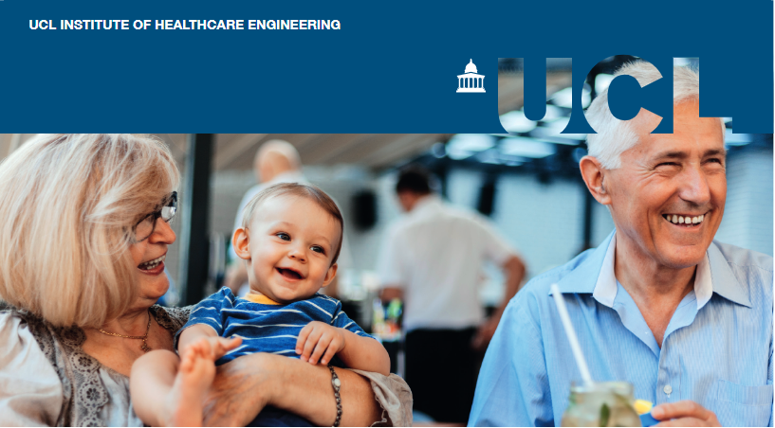

Social Connections

Why is it important to support social connections?
It has been shown that sustained social connections can increase life satisfaction and wellbeing. In older people, social isolation and loneliness are associated with worse physical and mental health outcomes (1-3). Although people aged over 65 are not more likely to report feeling lonely than other age groups, they are more exposed to other risk factors that might decrease their level of social interaction, including long-term health conditions, bereavement and caring responsibilities (4). Moreover, two million people over the age of 75 in the UK live alone and could be at risk of loneliness (5).

Why now?
Even before the pandemic, there was an increasing recognition of loneliness and social isolation as critical societal issues: in 2018 the UK was the first country in the world to appoint a Minister for Loneliness. There has also been a significant focus on integrated care and social prescription.
Unfortunately, COVID-19, as an airborne contagious disease, meant that social distancing was made mandatory and that face-to-face interactions became rare or non-existent. This led to increased levels of loneliness for those already experiencing it, but also increased loneliness in general across the rest of the population, especially in older adults (6).

The role for digital technologies in supporting social connection
During the lockdown, digital communication increased among 50-70-year-olds. However, it has been shown that digital socialising is not a qualitatively equivalent alternative to face-to-face interaction and can even increase loneliness (7).

Older people account for a section of the population that is more likely to be digitally excluded (8). Even though many digital technologies have been developed to facilitate social connections, they are often not designed with older users in mind, making older people question their usefulness (9). Many barriers have been identified, such as a lack of digital skills, affordability of the products and access to the internet. For example, 20% of households with one adult aged 65 years or older do not have an internet connection (10, 11). More than half of the 4 million people who have said they never used the internet were over 75 (12).

Community services, planning and housing all play a role in helping our social connections to thrive. For example, it is known that people who help out in their community – from everyday acts of neighbourliness to more formal volunteering roles – tend to be happier and develop a better quality and quantity of relationships and sense of purpose in their community lives (13).

About this briefing
An expert community from Government and its agencies, the health and social care sectors, charities and academia were invited to come together for a co-development workshop to identify research questions of interest to both the policy and the research communities. Participants identified three big challenges in this space and three research questions that could help sustain and increase social connections.

Challenge 1: How might we rebuild community services that have been lost during the pandemic?
- Which services have been lost, who led those services, what has been missed most by older people and what should be prioritised as part of pandemic recovery?
- Has the pandemic highlighted a need for changes to existing services?
- Which new services have emerged during the pandemic and what are the benefits of sustaining them beyond the immediate crisis?
During the workshop, participants highlighted the fact that many services (such as local community services that enabled older adults to socialise with each other face to face, and receive help with everyday life tasks) have been lost or put on hold during the pandemic. It was suggested that mapping those services and investigating attitudes among older people about which had been missed the most would help to restore the most important services. At the same time, new services have evolved as a result of the crisis, which might offer new types of benefit. Research could help identify which services should be prioritised as we transition to a post-pandemic world.

Challenge 2: How can planning, housing, and the built environment enable social connections?
- How can public transport infrastructure be designed to facilitate social connections – both generally speaking and specifically for older people?
- What types of housing targeted at older people provide the best social environments?
- How can we embed considerations of social connectedness into the planning of new developments and refurbishments of existing spaces?
Participants noted that many factors of our built environment – including housing, transport infrastructure, high streets, green space and so on – can significantly affect people’s ability to make social connectedness. However, there is little evidence on ‘what works’ and how places and spaces can be designed to help rather than hinder social connectedness.

Challenge 3: How can we ensure tailored digital support and accessible infrastructure for everyone who wants it?
- What lessons can be learned on how digital inclusion supports or hinders social connections?
- What are the facilitators or barriers to accessing digital support, and how can we best assist people in overcoming those?
- What offline solutions are needed to ensure no one is locked out of service, information or opportunities?
Ensuring tailored digital support and accessible infrastructures is a challenge, but it is also crucial to map out those who do not want or cannot be part of the digital world. There is the need to investigate the lessons learned from the pandemic on how digital inclusion can promote or hinder social connections, and how from now on this can best complement face-to-face interaction.
It is also important to continue researching the needs of those who are still excluded. There is a lot of evidence on what works but less research on how to promote this at scale and on the actual barriers encountered when it comes to accessing digital support. Not only to promote digital accessibility but also to ensure offline provision of key services for those for whom online services are not suitable. Linking up the insights and practical know-how that is generated by people working on the ground (in close contact with the communities that they serve), and academic researchers and policy makers who are further removed from the everyday realities of older people's lives, but who set out long-term research and policy agenda's remains a challenge.

References
- Leigh-Hunt N, Bagguley, D, Bask, K, Turner, V, Turnbull, S, Valtorta, N, Caan, W. An overview of systematic reviews on the public health consequences of social isolation and loneliness. 2017.
- Olaya B, Bobak M, Haro JM, Demakakos P. Trajectories of Verbal Episodic Memory in Middle-Aged and Older Adults: Evidence from the English Longitudinal Study of Ageing. J Am Geriatr Soc. 2017;65(6):1274-81.
- Sommerlad A, Sabia S, Singh-Manoux A, Lewis G, Livingston G. Association of social contact with dementia and cognition: 28-year follow-up of the Whitehall II cohort study. PLOS Medicine. 2019;16(8):e1002862.
- UK C. The world shrinks: Carer loneliness. Report for Jo Cox Loneliness Commission; 2017.
- NHS. Loneliness in older people [Available from: https://www.nhs.uk/mental-health/feelings-symptoms-behaviours/feelings-and-symptoms/loneliness-in-older-people/.
- UCL WWWipw. How has Covid and associated lockdown measures affected loneliness in the UK? . 2020.
- Hu Y, Qian Y. COVID-19, Inter-household Contact and Mental Well-Being Among Older Adults in the US and the UK. Frontiers in Sociology. 2021;6(143).
- Digital N. What we mean by digital inclusion [Available from: https://digital.nhs.uk/about-nhs-digital/our-work/digital-inclusion/what-digital-inclusion-is.
- Science GOf. Future of an Ageing Population. 2016.
- ageUK. Digital Inclusion (UK) 2018 [Available from: https://www.ageuk.org.uk/globalassets/age-uk/documents/policy-positions/active-communities/ppp_digital-_inclusion_uk.pdf.
- Statistics OfN. Internet access – households and individuals, Great Britain. 2020.
- Statistics OfN. Internet users, UK 2019 [Available from: https://www.ons.gov.uk/businessindustryandtrade/itandinternetindustry/bulletins/internetusers/2019.
- Better CfA. Volunteering and community participation [Available from: https://www.ageing-better.org.uk/volunteering-and-community-participation.

Our research
This workshop and report were produced in partnership with UCL Engineering’s Policy Impact Unit (PIU), the UCL Institute of Healthcare Engineering (IHE), and CelebrAGE network. To find out more about:
- PIU please visit www.ucl.ac.uk/steapp/collaborate/policy-impact-unit-1
- IHE please visit www.ucl.ac.uk/healthcare-engineering
- CelebrAGE please visit www.ucl.ac.uk/pharmacy/research/celebrage

Contributors
The workshop was organised by the PIU in partnership with the IHE Engagement Delivery group and CelebrAGE. Dr Ana Rita Pinho (ana.pinho.14@ucl.ac.uk) is a Policy Engagement Specialist in the PIU. Prof Rebecca Shipley OBE (rebecca.shipley@ucl.ac.uk) is a Professor of Healthcare Engineering in UCL Mechanical Engineering and Director of the IHE, Georgie Cade (g.cade@ucl.ac.uk) is IHE Communications & Impact Manager, and Alice Hardy is Content Marketing Manager. Dr Mine Orlu (m.orlu@ucl.ac.uk) is the Founder of CelebrAGE and an Associate Professor in Pharmaceutics at the UCL School of Pharmacy, and Dr Janneke van Leeuwen is CelebrAGE co-lead.

