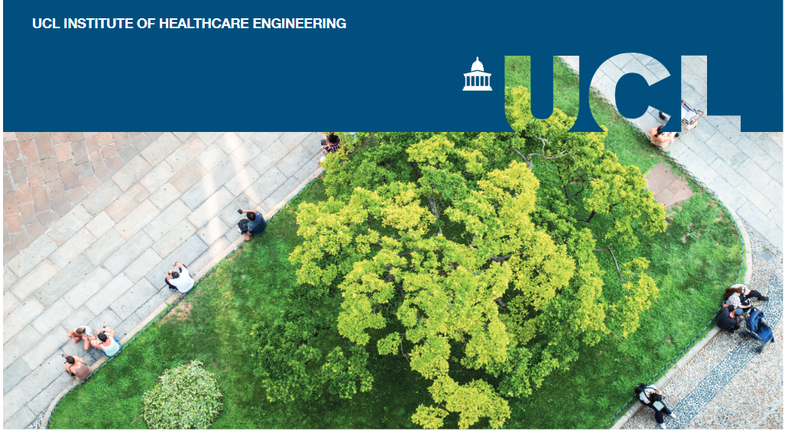

Healthy and Active Spaces

Why do we need healthy and active places?
As we grow older, we can only remain healthy, independent, and autonomous as long as the services, structures and spaces around us are adapted to be inclusive for varying needs and capacities. At the same time, physical environments can impact on our health, for example through exposure to pollution or access to active transport options.
This is a space with multiple market failures, and where innovation must be stimulated in pursuit of longer, healthier lives (1). It covers many different aspects including landscape design, environmental pollution, pavement and road condition, city planning, green spaces and transport provision, to name but a few (2). It has also been shown that interventions in the built environment have a higher potential to influence people’s behaviour across the socioeconomic spectrum than interventions aimed at individuals (3), thus strengthening the importance of this area.

Why now?
The COVID-19 pandemic has changed the way we live and presented some of the greatest challenges we have ever faced. However, this crisis has also highlighted numerous opportunities to advance the health and social care sector. Communities have come together and stepped up to provide support to one another, which in turn has increased awareness of inequalities (including in areas such as health, access to green space and digital exclusion) (4). It has also raised the profile of carers and their responsibilities. Heightened awareness of these issues presents a ‘window of opportunity’ to address some of the challenges of healthy aging.

About this briefing
An expert community from Government and its agencies, the health and social care sectors, charities and academia were invited to come together for a co-development workshop to identify research questions of interest to both the policy and the research communities. Participants identified three big challenges in this space, and three research questions that could help to bring the reality of healthy and active places a step closer.

Challenge 1: How can we take a systems approach (and avoid working in silos)?
- Is it possible to take a systems approach within our existing institutional and funding structures? Or are these barriers too great to overcome?
- Gaining a better understanding of the existing structures; What are the different services an individual might need to access in older age and how well (or not) are they connected?
- Where are the gaps? Are there other services that would be useful but that are not currently available? How might these connect with existing provision?
One of the three key challenges identified during the workshop was the aspiration to take a systems approach, rather than continuing to address needs in silos. This includes joining up different services that might be accessed by the same individuals as well as incorporating preventative measures (rather than just treating problems once they have arisen). It also means not just thinking about individuals, but also the social structures around them (for example, considering the needs of carers as well as patients).
The potential benefits are clear: more effective and efficient use of public funds and a better experience for service users. However, these arguments are well-known. The challenge is how to identify and overcome the barriers that are preventing a more holistic approach.
Research that examines the barriers to joined-up interventions could help to unlock investment in prevention and early intervention (areas that are currently often underfunded) and to create more efficient and effective health programmes.
At the same time, there is a need to identify gaps in services and infrastructures and to consider how these could be integrated with existing provision.

Challenge 2: How can we bring all the relevant voices to the discussion on the creation of healthy and active places?
- Which approaches promote the involvement of vulnerable and under-represented groups in co-creation initiatives, and how can we establish equity in this involvement?
- What are the barriers that prevent some groups of people from involvement in this type of exercise?
- How can we improve our understanding of what barriers prevent engineers (and other researchers) from using co-creation in research projects?
Older people are a group as diverse as any other sector of the population. Ensuring that the diversity of experience, living conditions, characteristics and health outcomes are reflected in discussions is essential to creating healthy and active places that work for everyone.
This discussion is not only about economic inequalities – for example the prevalence of disabilities in older people is widely dependent on socioeconomic factors (5), but also about including underrepresented voices. LGBT people, for example, are less likely to have children, and more likely to live alone so might be considered more vulnerable among older people (6). Some groups might face barriers to participating in political debate (such as people who migrated to the UK in the 60s and who will soon enter retirement).
While there is a lot of support for the principle of co-designing services and infrastructure with users, it is not always easy to do this in practice. It is important to understand the barriers to involvement.
In addition, improving understanding of what prevents researchers from building in co-creation to their work could help to make this more routine in the future. For example, what additional support is needed for engineers who wish to involve users effectively in product design? Should we work to produce ‘off the shelf’ co-creation methodologies?

Challenge 3: How can physical infrastructure encourage physical and mental wellbeing and bring people together?
- What interventions bring benefits for both physical and mental health to different age groups, and how effective is each one?
- Are these activities desirable to the users?
- What are suitable platforms to link people together remotely? And what new opportunities might 5G technology offer?
It is widely recognised that physical infrastructure, such as public and open spaces, is linked to older people’s physical and mental health through its impact on people’s ability to get out an about and interact with others (7-9).
Interventions such as improved walking spaces, wider access to green and all-weather spaces, appropriate seating, and accessible public toilets, have all featured regularly in the discourse (10, 11). However, there is still the need to map how effective and impactful these interventions are in improving physical and mental health across different age groups. There is also a need to understand how desirable they are for this sector of the population.
The rapid increase in digital communication technologies brought on by the COVID-19 pandemic has focused attention on how online platforms might be used to reduce social isolation and to link communities together. The fast speed and low latency provided by 5G has the potential to facilitate the use of new applications, such as live medication reminders or fall detection that could allow healthcare providers to monitor and care for older people proactively and predictively. Workshop participants highlighted this as an area where further exploration of the opportunities could be beneficial.

References
- Industrial Strategy Challenge Fund - Healthy Ageing Challenge Framework. Centre for Ageing Better; 2019.
- McNeill LH, Kreuter MW, Subramanian SV. Social Environment and Physical activity: A review of concepts and evidence. Social Science & Medicine. 2006;63(4):1011-22.
- White M, Adams J, Heywood P, editors. How and why do interventions that increase health overall widen inequalities within populations2009.
- Digital inclusion and older people – how have things changed in a Covid-19 world? : age UK; 2021.
- Robertson G. Ageing: the silver lining -The opportunities and challenges of an ageing society for local government. Local Government Association; 2015.
- Lesbian, gay and bisexual people in later life. Stonewall; 2011.
- Traynor V, Fernandez R, Caldwell K. The effects of spending time outdoors in daylight on the psychosocial wellbeing of older people and family carers: a comprehensive systematic review protocol. JBI Evidence Synthesis. 2013;11(9):36-55.
- Frank LD, Schmid TL, Sallis JF, Chapman J, Saelens BE. Linking objectively measured physical activity with objectively measured urban form: findings from SMARTRAQ. Am J Prev Med. 2005;28(2 Suppl 2):117-25.
- Prohaska T, Belansky E, Belza B, Buchner D, Marshall V, McTigue K, et al. Physical activity, public health, and aging: critical issues and research priorities. J Gerontol B Psychol Sci Soc Sci. 2006;61(5):S267-73.
- Handler S. A Research and Evaluation Framework for Age Friendly Cities. UK Urban Ageing Consortium; 2014.
- Outdoors IDfG. The Design of Streets with older people in mind: Public Toilets. 2012.

Our research
This workshop and report were produced in partnership with UCL Engineering’s Policy Impact Unit (PIU), the UCL Institute of Healthcare Engineering (IHE), and CelebrAGE network. To find out more about:
- PIU please visit www.ucl.ac.uk/steapp/collaborate/policy-impact-unit-1
- IHE please visit www.ucl.ac.uk/healthcare-engineering
- CelebrAGE please visit www.ucl.ac.uk/pharmacy/research/celebrage

Contributors
The workshop was organised by the PIU in partnership with the IHE Engagement Delivery group and CelebrAGE. Dr Ana Rita Pinho (ana.pinho.14@ucl.ac.uk) is a Policy Engagement Specialist in the PIU. Prof Rebecca Shipley OBE (rebecca.shipley@ucl.ac.uk) is a Professor of Healthcare Engineering in UCL Mechanical Engineering and Director of the IHE, Georgie Cade (g.cade@ucl.ac.uk) is IHE Communications & Impact Manager, and Alice Hardy is Content Marketing Manager. Dr Mine Orlu (m.orlu@ucl.ac.uk) is the Founder of CelebrAGE and an Associate Professor in Pharmaceutics at the UCL School of Pharmacy, and Dr Janneke van Leeuwen is CelebrAGE co-lead.

