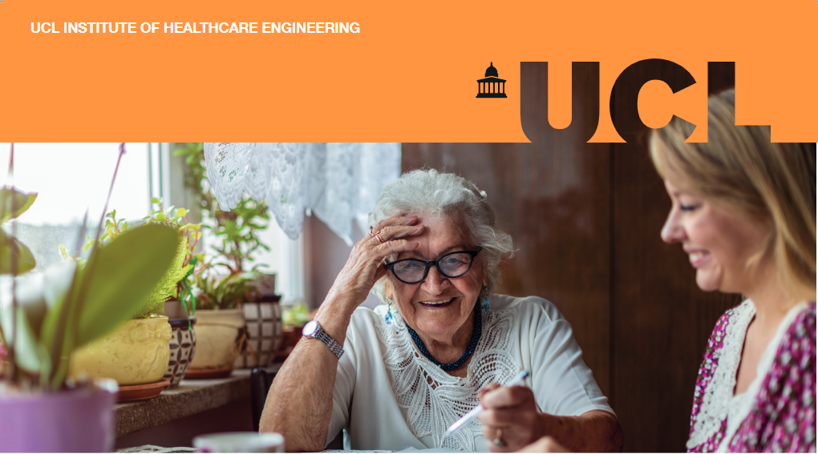

Age-friendly Homes

Why should we design age-friendly homes?
Currently, in the UK, the majority of over 65s lives in mainstream housing, with only 0.6 per cent living in housing with care (1, 2). Predictions from the ONS state that in 50 years there will be an additional 8.6 million people aged 65 and over living in the UK (3).For this reason, designing for age-friendly homes must be a priority considering 80% of older people say they want to stay in their own home as they age (4). The longer people can live in their homes, the less people will move into specialised housing which might alleviate the pressure on the social care system.
Most homes that will exist in 2050 have already been built and they are largely unsuitable to address the needs of an ageing population (5). For instance, more than 90% of UK homes fail to meet accessibility standards (6). Common problems in the current housing stock include the risk of falls on the stairs and excess cold. The Building Research Establishment (BRE) has estimated that the cost of poor housing to the NHS is £624 million per year (7). The Committee on Climate Change has also highlighted the growing risk of overheating in the summer, with forecasts showing that heat-related mortality could increase from the current level of 2,000 per year to 5,000 per year by 2050 if no action is taken (8).
Unfortunately, there is still a lack of investment to improve and retrofit homes even though the potential benefits are well known (9).

Why now?
National lockdowns and the requirement to “stay at home” during the COVID-19 pandemic have brought the challenges faced by older people who live alone or who require continued care into sharp relief. There are many benefits to helping people stay healthy and independent for longer in their communities and we need to work towards a more age-friendly housing stock if this is to be achieved.

About this briefing
An expert community from Government and its agencies, the health and social care sectors, charities and academia were invited to come together for a co-development workshop to identify research questions of interest to both the policy and the research communities. Participants identified three big challenges in this space, and three research questions that are essential to consider in the design of new houses, and in the retrofitting of existing ones to become age-friendly and support older adults to age in place.

Challenge 1: How can we incentivise people to retrofit their homes?
- Review policies that reimbursed people who retrofit their houses.
- Explore equity release schemes to fund home improvements for owners.
- Analyse whether home improvements could count as tax relief.
Since most of the houses where we will live in 2050 have already been built (5), incentivising people to retrofit their homes could be an important route to improving the quality of the housing stock. There is the need for a joined-up approach to design measures that lead to reduced carbon emissions (for example, energy efficiency) by the housing stock, that adapt to climate impacts (such as cooling measures) and that make homes more accessible (like reducing the risk of falls).
Participants called for a review of recent policies, such as the schemes run by government that tried to incentivise homeowners to install energy efficiency measures – most recently the Green Homes Grant and before that the Green Deal. This is essential to understand what works, and what does not work to ensure lessons are learnt in future.
There is also the need to explore new financial products and innovations to enable homeowners to use equity to adapt and retrofit the spaces to accommodate different needs. In Germany, for example, this is already a reality and those who require long-term care can apply for home-modification subsidies (10).
Finally, taking on some of the management responsibilities of home-modifications was seen as an important aid to those considering embarking on it. Considering whether these home improvements must be considered from an earlier age, and how improvement works could potentially count as tax relief were seen as points that need further investigation on the impact of boosting home fit and accessibility around the UK.

Challenge 2: What is the role for building standards in delivering age-friendly housing stock?
- How to explain and measure quality of life (QoL) in relation to technology and housing improvements?
- Can QoL metrics be developed and incorporated into building standards?
- What approaches have worked in other countries?
The second challenge identified in this space was understanding the role of building standards in delivering age-friendly housing. Research is need on standards to measure QoL, and on the impact of home improvements, and technologies on it.

There is the need to explain QoL in relation to technology and housing improvements, and to investigate how these metrics can be incorporated into building standards.
At the moment, there is not a strong business case to implement healthy ageing design thinking and innovation in the delivery of new homes, and in the retrofitting of current ones. To overcome this, a research study to review policies in other countries that specify housing standards and technologies as part of the planning process was suggested. France’s minimum standard for technology that goes into new builds was given as an example.

Challenge 3: What methods are most effective in delivering a people-centred rather than tech-centred approach to innovation and development of new technologies?
- Review current engagement methodologies to understand what works.
- Design methodologies to involve end users in a bottom-up way.
- Evaluate impact of new co-design methodologies in the uptake of new technologies.
Finally, the workshop highlighted the need to investigate what methods are most effective in delivering a people-centred approach to innovation. For example, there is the need to create integrative models for house planning, and additional research is needed on methods to promote this involvement from the outset. A clear example is the need to ensure technology improves independence without increasing isolation. Real co-designing and input is vital, stakeholders cannot keep assuming what is best for people. Technology should be designed to maximise ability not just to overcome disability.
Workshop participants highlighted the importance of reviewing previous policies in this space to understand what works, and in light of that, design new methodologies to involve users from the beginning in the development of new technologies.
Evaluating the impact of new design methodologies is also crucial to understand their impact in future technology uptake.

References
- Adams S. Housing Opportunities & Challenges for Local Government: Practical Housing Solutions. London; 2014.
- Association LG. Housing our ageing population.
- ONS. Living longer - Office for National Statistics. 2018.
- Lloyd JP, Will. Older owners: research on the lives, aspirations and housing outcomes of older homeowners in the UK. 2015.
- Boardman B aDSea. Chapter 5: Building fabric and housing stock, in ‘40% house’,. Environmental Change Institute, Univ of Oxford: UK. 2005.
- Ministry of Housing CLG. English Housing Survey 2014 to 2015: adaptations and accessibility of homes report. 2016.
- Garrett H BS. Homes and ageing in England IHS BRE Press: PHE; 2015.
- Change CoC. UK housing: Fit for the future? . 2019.
- Stark S, Keglovits M, Arbesman M, Lieberman D. Effect of Home Modification Interventions on the Participation of Community-Dwelling Adults With Health Conditions: A Systematic Review. Am J Occup Ther. 2017;71(2):7102290010p1-p11.
- WHO. World report on Ageing and Health. 2015.

Our research
This workshop and report were produced in partnership with UCL Engineering’s Policy Impact Unit (PIU), the UCL Institute of Healthcare Engineering (IHE), and CelebrAGE network. To find out more about:
- PIU please visit www.ucl.ac.uk/steapp/collaborate/policy-impact-unit-1
- IHE please visit www.ucl.ac.uk/healthcare-engineering
- CelebrAGE please visit www.ucl.ac.uk/pharmacy/research/celebrage

Contributors
The workshop was organised by the PIU in partnership with the IHE Engagement Delivery group and CelebrAGE. Dr Ana Rita Pinho (ana.pinho.14@ucl.ac.uk) is a Policy Engagement Specialist in the PIU. Prof Rebecca Shipley OBE (rebecca.shipley@ucl.ac.uk) is a Professor of Healthcare Engineering in UCL Mechanical Engineering and Director of the IHE, Georgie Cade (g.cade@ucl.ac.uk) is IHE Communications & Impact Manager, and Alice Hardy is Content Marketing Manager. Dr Mine Orlu (m.orlu@ucl.ac.uk) is the Founder of CelebrAGE and an Associate Professor in Pharmaceutics at the UCL School of Pharmacy, and Dr Janneke van Leeuwen is CelebrAGE co-lead.

