UCL BEng Summer Project 2021 (HH)

Project Title: Design Characterisation of 3D Printed Orthopaedic Implants

Academic Supervisor: Dr Harry Hothi, Implant Science Fellow RNOH , harry.hothi@nhs.net

Clinical Supervisor: Mr Johann Henckel, johann.henckel@nhs.net

2nd Clinical Supervisors: Professor John Skinner & Professor Alister Hart

Location: Implant Science Centre, Royal National Orthopaedic Hospital, Stanmore

Background to the Implant Science Centre

The Implant Science Centre, based at the Royal National Orthopaedic Hospital (RNOH) is the largest centre in Europe for the analysis of implants retrieved from patients. The centre has collected over 10,000 spine, hip and knee implants from patients across 29 countries and published over 150 papers on this subject.

Background to the Project

3D printing is rapidly changing and revolutionising orthopaedic implant engineering: 3D printing methods are taking over from conventional subtractive methods in all manufacturers. The benefits include greater control over the production of highly porous surfaces that can better adhere to bone; thinner implants, allowing the surgeon to preserve the patient’s bone stock, and the design and production of complex shaped implants to fit the patient including bespoke / customised implants for complex bone loss.

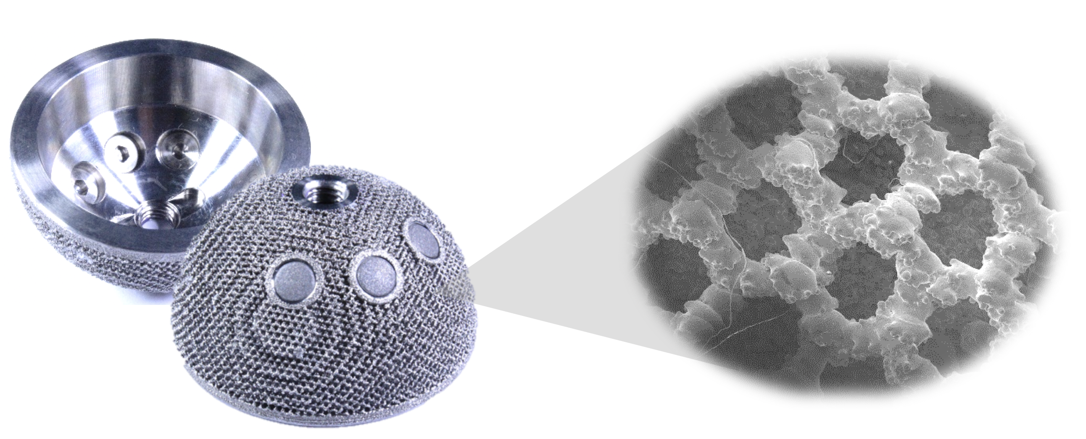

Figure 1: Example of a 3D printed acetabular cup used in hip replacement surgery

However, all new methods have risks, which are high for 3D printed orthopaedic implants particularly because over a short time period there has been rapid adoption of this technology, which previously was mainly used for ‘rapid prototyping’. Over 300,000 patients receive an orthopaedic implant (knee, hip, spine) every year in the UK alone, at a cost of over £2.5Bn; 15% of revision hips are now 3D printed, a 3-fold increase over the past decade, with a 20% year-on-year increase in spend projected over the next decade.

Independent characterisation of the design features of these implants will help us understand any variability that may exist between implants of the same design and between different manufacturers.

Project Aim

The aim of this project is to use metrology methods to characterise the size, shape and porous features of 3D printed implants that are have either been retrieved from patients or are new.

Methods

The student will be trained in the use of metrology equipment including coordinate measurement machines, a roundness measurement machine, an optical profilometer and light microscopy.

These methods will be applied to the analysis of retrieved 3D printed implants. The student will also gain an understanding of the steps involved in retrieval analysis, including the importance of obtaining patient consent and the safe handling of patient implants.

The student will be given the opportunity to attend two out-patient’s clinics (COVID-19 permitting) and offered a virtual visit to the operating theatres.

Proposed Work Plan

Week 1: Literature search on the background work to this subject (remote supervision)

Week 2&3: Training in the use of measurement equipment and software (face to face)

Week 4-6: Collection of data & attend out-patient’s clinics (Covid-19 secure)

Week 7: Analysis of all results & remote operating theatre visit (remote supervision)

Week 8: Writing up of report – (remote supervision)

