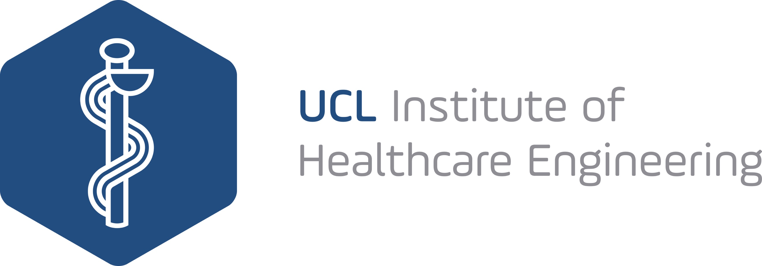

IHE PhD Studentship Application: Frugal Innovation

The IHE is supporting a fully-funded PhD studentship for a new project arising from the Interdisciplinary Approaches to Frugal Innovation Workshop. The studentship will be 4 years in duration (or 6 years for part-time candidates), starting Autumn 2018. It will cover UK/ EU fees, minimum RCUK stipend and a small allowance for consumables.

APPLICANT DETAILS:

Full Names of Applicants:

Primary Supervisor:

UCL Affiliation(s):

Email(s):

PROJECT DETAILS:

Description of Project (max. 500 words):

Please provide a brief description of the proposed project, including any interdisciplinary aspects.

Clinical Unmet Need at AIIMS (max. 500 words):

Please explain how the studentship will tackle a clinical unmet need at the All India Institute of Medical Science

Link to NHS (max. 500 words):

Please explain whether there will be potential benefits to the NHS, and how you will explore these options and opportunities

Student Recruitment (max. 200 words):

Please give a brief summary of how you will recruit a PhD student to this post

Budget (max. 200 words):

Please provide a breakdown of consumable costs needed to support this project

Signature:

Date:

