UKRI have announced the call for Round 8 of the UKRI Future Leaders Fellowships (FLF). This document outlines the key initial points to consider for those interested in applying.
FLF key scope and eligibility criteria
- Applications can be from any research and innovation discipline, including clinical applicants, from across UKRI’s remit.
- This scheme is open to early career researchers who are transitioning to or establishing independence; senior academics are not eligible.
  - Please note: UKRI have indicated that, in more recent rounds, candidates who appear to have already achieved, or are close to achieving, research independence have been less successful, indicating a shift in emphasis on funding less established researchers.
  - UKRI indicate that applicants who have been PI on a grant where research/career development and leadership is an integral part of the assessment may be deemed to already be independent, and hence less competitive for this call.
  - Candidates cannot apply for other Research Council Fellowships at the same as submitting an application for the FLF.
- Applicants who already hold permanent/open-ended academic positions are eligible to apply, those on fixed-term contracts are also eligible to apply.
- Applicants and Faculties should be aware of the UKRI FLF assessment criteria.
Key financial and employment commitments required
- Fellows must be either guaranteed an open-ended independent research position by the end of the fellowship (the post is subject to the institution’s standard performance review processes) OR the department/division/institute must identify positions to be available for the fellow to apply to over the Fellowship period. Further, the department/division/institute must demonstrate how they will encourage and support the fellow to apply for such position(s).
- For those already in permanent positions, the department/division/institute must confirm the fellow will be relieved of all other duties to focus and conduct the fellowship
- The host Department/Division/Institutes will also need to cover an increasing proportion of the fellow’s salary from year 3 onwards please see page 28 and 32 of the UKRI guidance here for further details, but a summary below
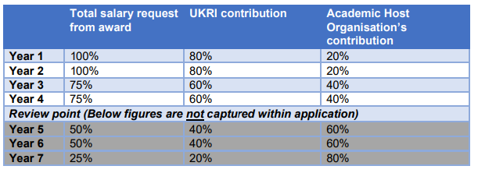
Equality, Diversity and Inclusion (EDI)
Applicants from underrepresented groups are encouraged to apply for this scheme. UKRI have stated that they encourage a diversity of applicants applying to the FLF programme and that host organisations play a critical role in ensuring that all potential applicants have a fair chance of being supported through a transparent selection process based on their ability and potential.
Applicants are strongly encouraged to read the full UKRI guidance on their webpages and the call page here.

