UKRI have pre-announced the call for Round 9 of the UKRI Future Leaders Fellowships (FLF). This document outlines the key initial points to consider for those interested in applying.
Note: At time of publishing the internal process, UKRI are still referring to Round 8 guidance. We don’t expect there to be any great changes and want to give everyone more time. Applicants and Departments/Divisions/Institutes should refer to Round 8 guidance and we will update this when UKRI do, for Round 9.

FLF key scope and eligibility criteria
- Applications can be from any research and innovation discipline, including clinical applicants, from across UKRI’s remit.
- This scheme is open to early career researchers who are transitioning to or establishing independence; senior academics are not eligible.
  - Please note: UKRI have indicated that, in more recent rounds, candidates who appear to have already achieved, or are close to achieving, research independence have been less successful, indicating a shift in emphasis on funding less established researchers.
  - UKRI indicate that applicants who have been Principal Investigators/ Project Leads on a grant where research/ career development and leadership is an integral part of the assessment may be deemed to already be independent, and hence less competitive for this call.
  - Candidates cannot apply for other Research Council Fellowships at the same time as submitting an application for the FLF.
- Applicants who already hold permanent/ open-ended academic positions are eligible to apply, those on fixed-term contracts are also eligible to apply.
- Applicants, Department/Division/Institutes and Faculties should be aware of the UKRI Future Leaders Fellowships Assessment Criteria. Please note a subset of the criteria is used for the central selection process (please see details under internally managed calls webpage under BEAMS, LMS, LASH and IOE Research Coordination Offices) and is encouraged to be used for selection at devolved stages.
- Scope and eligibility criteria in practice: UKRI have indicated that the key element for candidates to be a strong fit for the scheme is to justify how the UKRI FLF award will have a significant impact on the fellow's career and development as a research leader in their chosen discipline.

Key financial and employment commitments required
- Fellows must be either guaranteed an open-ended independent research position by the end of the fellowship (the post is subject to the institution’s standard performance review processes) OR the Department/Division/Institute must identify positions to be available for the fellow to apply to over the Fellowship period. Further, the department/division/institute must demonstrate how they will encourage and support the fellow to apply for such position(s).
- For those already in permanent positions, the Department/Division/Institute must confirm the fellow will be relieved of all other duties to focus on and conduct the fellowship
- The host Department/Division/Institutes will also need to cover an increasing proportion of the fellow’s salary from Year 3 onwards please see page 28 of the Round 8 UKRI guidance here for further details, a summary is given below.
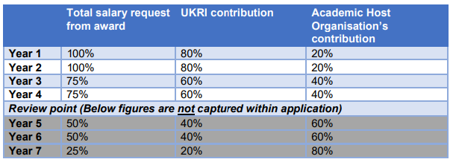

Equality, Diversity and Inclusion (EDI)
Applicants from underrepresented groups are encouraged to apply for this scheme. UKRI have stated that they encourage a diversity of applicants applying to the FLF programme and that host organisations play a critical role in ensuring that all potential applicants have a fair chance of being supported through a transparent selection process based on their ability and potential.
Applicants are strongly encouraged to read the full UKRI guidance on their webpages and the call page here.

